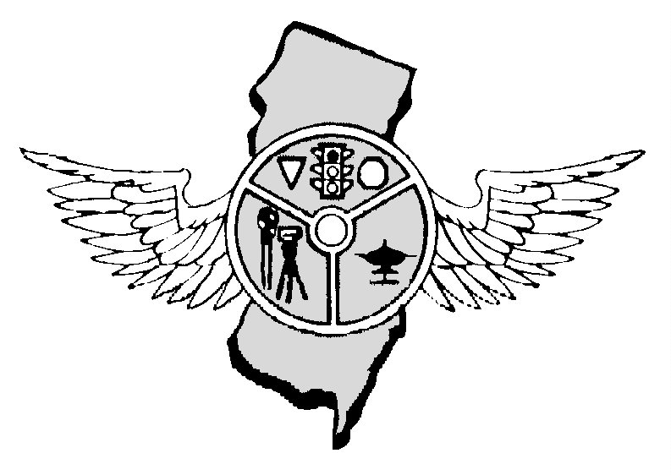

MAY 2018 OUR 43rd YEAR

Nicholas Schock, President Tony Parenti, Executive Director, Editor Frank Fiore, First Vice-President Mark Wilson, Operations Secretary
N.J.P.T.O. A. P.0. Box 664, Voorhees, NJ 08043 - 856-220-1433 - NJPTOA.ORG or NJPTOA@HOTMAIL.COM SPEAKERS
Maria Esteves from MADD NJ and Dominic Magnolo, Blue Line Solutions on a Distracted Driving Device
PRESIDENTS MESSAGE: As Spring and the warmer weather slowly rolls into our area, it is sure to bring an increased pedestrian and motorcycle presence on our roadways. The month of May is National Motorcycle Safety Awareness Month. Please be alert for motorcycles while on patrol, and be vigilant for motorists who do not share the road properly with them. I have attended several recent meetings with NHTSA regarding pedestrian safety initiatives. The pedestrian fatality rate in New Jersey has consistently been above the national average. If you have any thoughts or suggestions to reduce pedestrian fatalities, please contact any executive board member, or prepare your ideas for discussion at our next meeting on May 2. Thanks, Nick.
MVC ADVISORY: Motor Vehicle Commission issued advisory 2018-01 dealing with temporary tags. If you did not receive the advisory notify tparenti@comcast.net for a copy. FALLEN POLICE OFFICERS: This year, they will be adding the names of 360 fallen law enforcement officers—129 of which are the names of officers we lost in the line of duty last year. Two hundred and thirty-one are the names of officers who fell in years prior who are now being recognized. On May 13, they will officially dedicate these names during the 30th Annual Candlelight Vigil, and we hope you will be able to attend in honoring the sacrifice that each of these officers made for their community. Even if you can’t make it to Washington, DC, to experience the Vigil in person, you can take part through the United By Light campaign. Register to watch the Vigil webcast with your friends and family and light a Virtual Candle in honor of a special officer. The Vigil webcast will be available live on Sunday, May 13, at 8:00 pm ET, and an archive of the video will be temporarily available to those who register to watch if you’d like to organize an event at a later date. After registration watch the Vigil webcast, remember to ask others to join you. Whether you invite a few close friends to watch at home, or organize an event at the town auditorium, the key is to watch the Vigil together and honor those we’ve lost. Help us honor the 900,000 law officers who put their lives on the line every day for the safety and protection of others. AUTONOMOUS VEHICLE: A fatal accident in Arizona is forcing rideshare giant Uber to suspend their autonomous vehicle taxi program in four cities. A crash occurred in Tempe, Arizona when a self-driving Uber vehicle hit a female pedestrian on March 18 at around 10 p.m. The Uber vehicle was heading north when it struck a woman walking outside of a crosswalk. The 49-year old was taken to a local hospital before succumbing to the injuries. After the accident, the company announced that they are halting the testing of autonomous driving operations in Phoenix, Pittsburg, San Francisco and Toronto. According to the Temple police, the vehicle was in autonomous mode with a vehicle operator behind the wheel and no other passengers in the vehicle. The National Transportation Safety Board said it was sending a team to investigate the incident. According to the ABC report, Uber began testing self-driving cars in Phoenix in February 2017, after California banned a fleet of self-driving Volvos over safety concerns. Last March, a self-driving SUV was involved in another accident in Tempe when a car failed to yield to the autonomous vehicle. According to Yahoo Finance, federal regulations allow for companies like Uber and Lyft to test autonomous vehicles, with individual states providing most of the specific regulations. Yahoo also reported that in 2017 33 states introduce legislation related to autonomous vehicles. The U.S. Department of Transportation is also considering implementing other voluntary guidelines in an effort to help foster innovation in the field. In recent years, Uber has made a push in the autonomous vehicle market space by testing the technology as the future of ride sharing. Last year, Uber’s Head announced that the company plans to test an aerial taxi service by 2020 in Los Angeles, Dallas-Fort Worth and Dubai. Uber also signed a Space Act Agreement with NASA to create a new air traffic control system that would manage the low-flying and possibly autonomous aerial taxis.

As of April 20, 2018 there were 143 fatalities on NJ roads compared to 98 during the same period in 2017, AN INCREASE OF 45 DEATHS.
COUNTY | 2018 | 2017 | CHANGE | COUNTY | 2018 | 2017 | CHANGE
Atlantic | 05 | 09 | -04 | Bergen | 05 | 02 | +03
Burlington | 15 | 08 | +07 | Camden | 13 | 08 | +05
Cape May | 04 | 01 | +03 | Cumberland | 08 | 02 | +06
Essex | 12 | 09 | +03 | Gloucester | 10 | 06 | +04
Hudson | 07 | 03 | +04 | Hunterdon | 00 | -0- | 00
Mercer | 08 | 07 | -01 | Middlesex | 15 | 08 | +07
Monmouth | 07 | 02 | +05 | Morris | 07 | 03 | +04
Ocean | 12 | 08 | +04 | Passaic | 02 | 03 | -01
Salem | 02 | 06 | -04 | Somerset | 07 | 04 | +03
Sussex | 01 | 01 | 00 | Union | 02 | 06 | -04
Warren | 01 | 02 | -01
Deaths: Driver,73; Passenger, 24; Pedalcyclist, 02; Pedestrian, 44. Crashes, 133.
WORKING WITH HEARING IMPAIRED: Get persons attention first. Maintain eye contact with person while speaking. Speak clearly and slowly. A hearing aid or cochlear implant does not allow person to understand everything. Shining a flashlight in persons face will make it hard person to understand you. HEAT-STOKE PREVENTION: National Heatstroke Prevention Day is July 31, 2018. Find and share campaign information for parents, caregivers, schools and organizations, and remind everyone to Look Before You Lock! Total number of children that have died from heatstroke from 1998 - present: 742. Number of children that have died from heatstroke in 2017: 42. Number of children that died from heatstroke in 2016: 39. Average number of child heatstroke fatalities per year since 1998: 37. BACKING OVER: Many children are killed or seriously injured in back over incidents. A back over incident typically occurs when a vehicle coming out of a driveway or parking space backs over an unattended child because the driver did not see him or her. Prevention Tips: Teach children not to play in or around cars. Always walk around your vehicle and check the area around it before backing up. Be aware of small children—the smaller a child, the more likely it is you will not see them. Teach children to move away from a vehicle when a driver gets in it or if the car is started. Have children in the area stand to the side of the driveway or sidewalk so you can see them as you are backing out of a driveway or parking space. Make sure to look behind you while backing up slowly in case a child dashes behind your vehicle unexpectedly. Roll down your windows while backing out of your driveway or parking space so that you'll be able to hear what is happening outside of your vehicle. Teach your children to keep their toys and bikes out of the driveway. Because kids can move unpredictably, you should actively check your mirrors while backing up. Many cars are equipped with detection devices that provide rearview video or warning sounds, but they cannot completely take the place of actively walking around your car to make sure children are safely out of the way. Do not rely solely on these devices to detect what is behind your vehicle. What You Need to Know, Now. Back over can happen when you least expect it. Never leave a child alone in or around a vehicle. POWER WINDOW: Children can hurt themselves with power windows. Many kids are injured when a window closes on their finger, wrist, or hand. Some kids have been strangled by power windows. Prevention Tips: Teach your children not to play with window switches. Teach your children not to stand on passenger door arm rests. Properly restrain your children in car seats or seat belts to prevent them from accidentally activating power windows and sunroofs. Look and make sure your kids' hands, feet, and head, are clear of windows before raising the windows. Never leave the key in the ignition or in the "on" or "accessory" position when you walk away from your car. If available, activate the power window lock switch so that your children cannot play with the windows. What You Need to Know, Now. Your car may have child safety settings for power windows, but that doesn’t mean your child will not find a way to test the system. Never leave your children alone in a vehicle for any reason. All model year 2010 vehicles and newer will have "pull to close" switches, which require you to pull up on them to close the window. Older vehicles may have window switches that a child can accidentally step or put weight on, easily causing a window to close. Some vehicles have power windows that automatically reverse when an object (such as your child's arm or neck) is in the path of a closing window. Check both the individual vehicle rating pages on nhtsa.gov and your owner's manual to see if a vehicle is equipped with this safety technology. RADAR TUNING FORKS: NJ Weights and Measures will be at the May 2nd meeting testing Radar Tuning Forks for Departments M-Z. NEXT REGULAR MEETING MAY 2, 2018 AT AAA MID-ATLANTIC, HAMILTON, NJ

NJ Police Traffic Officers Association
PO Box 664
Voorhees, NJ 008043
856-220-1433
E-MAIL: njptoa@hotmail.com

2018 INVOICE

DATE | ITEM | AMOUNT
1/1/2018 | Annual Membership Dues for Police Department | $50.00
 | TOTAL: | $50.00

DATE: 1/1/2018 SIGNED: NICHOLAS SCHOCK, President
Our Tax ID number is 22-2344113
Copies of purchase orders can be faxed to 856-783-0012 or scanned for an e-mail and sent to NJPTOA@Hotmail.com.

Note: If you would like to receive the newsletter by e-mail instead of by postal mail, please send your request to njptoa.tparenti@gmail.com

(Please check mailing label. Correct if necessary by phone call, text, or e-mail)

