Saturday & Sunday,
April 18 & April 19, 2026
Good Shepherd Sunday
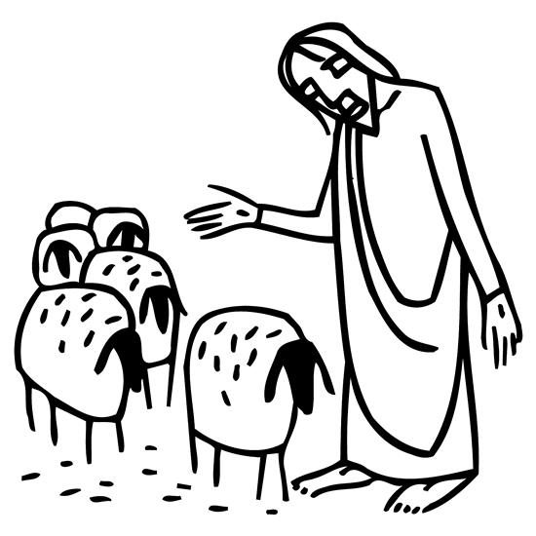
Christ Lutheran Church
“A Place Where You are Always Welcome”
Services: Saturday 5:30 pm and Sunday 10:00 am
Sunday School: 9:00 am (September- May)
600 North Main Street, Stockton, IL 61085 Office: 815-947-2033
Email: christlutheranchurch70@gmail.com http://www.christlutheranstockton.com
Ministers: ALL members of the congregation
Pastor: Rev. Chrissy Salser chrissytherev@att.net 815-988-9450
From Sundays and Seasons.com. Copyright 2017 Augsburg Fortress. All rights reserved. Reprinted by permission under Augsburg Fortress Liturgies Annual License #40643.New Revised Standard Version Bible, copyright 1989, Division of Christian Education of the National Council of the Churches of Christ in the United States of America. Used by permission. All rights reserved.
WELCOME: Thank you for joining us for worship today. We are glad you are with us. Communion will be served in the aisle or in your pew. All are welcome to share this meal. Jesus is our host and invites everyone. Those who would like to come forward, bread and wine will also be available in the front. When directed by the usher, come forward down the center aisle, Pr Chrissy will give you bread (she will be masked and wearing cloves) and then you will take a cup of wine (grape juice) from the tray. After taking communion, you will return to your seat by the side aisle. For those who are unable to come forward, communion elements can be found as you entered worship. At that part of the service, you are invited to take the bread and wine (or grape juice) when Pr. Chrissy leads. On Saturday’s offering is collected as you enter or leave worship. On Sunday we will pass the plate as a response to God’s grace. Online giving is available. Please see QR code on back of bulletin or visit our website.

Introduction: Today is sometimes called “Good Shepherd Sunday.” Jesus is called the “gate” of the sheep in today’s gospel. The risen Christ opens the way to abundant life. He anoints our heads with oil and guides us beside the still waters of our baptism. Each Sunday he spreads a feast before us amid the world’s violence and war. We go forth to be signs of the resurrection and extend God’s tender care to all creation.
PRELUDE
WELCOME AND ANNOUNCEMENTS
CALL TO WORSHIP
P: The Lord is our Shepherd, and he takes perfect care of us.
C: Our Lord is the Good Shepherd. He leads us into safety
and gives us strength for the journey.
P: The Lord is our Shepherd, who grants us rest and restores our souls.
C: Our Lord is the Good Shepherd.
P: He sought us out when we were lost, calling us by our names.
C: The Lord is our Shepherd, and he has carried us home. Amen.

PRAYER OF CONFESSION
P: Day by day, God would lead us to the places of hope and healing, while moment by moment, we continue to follow sin down all the wrong paths. Let us confess our lives, as we draw near to the One who would restore us to wholeness. Join me as we pray together, saying,
C: We know all too well that wrong paths lead to foolish lives and repeated mistakes. We confess that stirring up the waters often comes too easy for us. We admit that closing off our hearts can become second-nature to us. Merciful God, forgives us. May our hearts overflow with hope for others, as you anoint us with healing oil. May we share from our abundance with all who hunger for life. May we follow Jesus Christ, our Lord and Savior, to the places of service and live with you forever. Silence is kept
P: Our Comforter leads us to that place where God's Table is spread with
forgiveness and overflowing with grace. Here, we are called to life and love. By the grace of God, we will live as God’s people: forgiven to serve, blessed to share, and loved so that we may share with all the world. Thanks be to God for being our Good shepherd.
C: Amen.
GATHERING HYMN Come, Thou Fount of Every Blessing ELW 807
GREETING:
P: The Grace of our Lord Jesus Christ, the love of God and the communion of the Holy Spirit be with you all.
C: And also with you
PRAYER OF THE DAY:
P: Let us pray together: Loving Shepherd, C: you know our names; you care for us. When we face darkness and death, walk beside us. When we hunger for your love, fill us with your presence. When we are fearful, feed us at your table. May we dwell in the house of the goodness and mercy all the days of our lives. Amen.
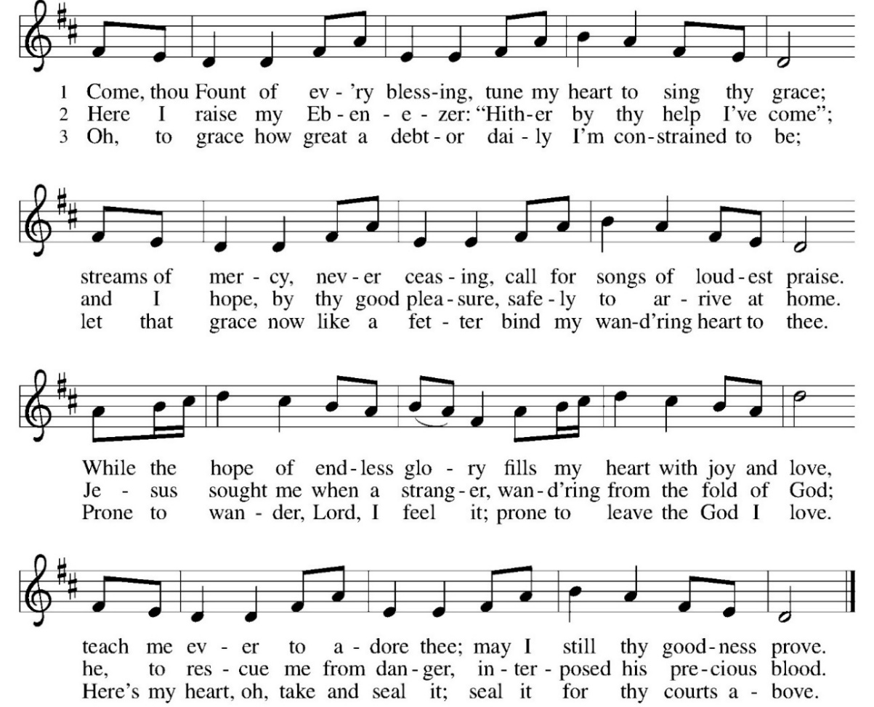

Word: God speaks to us in scripture reading, preaching, and song.

First Reading: Acts 2:42-47
Today’s reading is a description of life in the community following Peter’s sermon on the day of Pentecost, when the Spirit was poured out on God’s people. The new community is sustained in worship and fellowship, shares what they have, and ensures that everyone has enough.
⁴² [The baptized] devoted themselves to the apostles’ teaching and fellowship, to the breaking of bread and the prayers.
⁴³ Awe came upon everyone because many wonders and signs were being done through the apostles. ⁴⁴ All who believed were together and had all things in common; ⁴⁵ they would sell their possessions and goods and distribute the proceeds to all, as any had need.
⁴⁶ Day by day, as they spent much time together in the temple, they broke bread at home and ate their food with glad and generous hearts, ⁴⁷ praising God and having the goodwill of all the people. And day by day the Lord added to their number those who were being saved.
R: The Word of the Lord. C: Thanks be to God.

Psalm: Psalm 23
¹ The Lord is my shepherd; I shall not be in want.
² The Lord makes me lie down in green pastures
and leads me beside still waters.
³ You restore my soul, O Lord,
and guide me along right pathways for your name’s sake.
⁴ Though I walk through the valley of the shadow of death,
I shall fear no evil;
for you are with me; your rod and your staff, they comfort me.
⁵ You prepare a table before me in the presence of my enemies;
you anoint my head with oil, and my cup is running over.
⁶ Surely goodness and mercy shall follow me all the days of my life,
and I will dwell in the house of the Lord forever.

Second Reading: 1 Peter 2:19-25
Doing the right things does not guarantee that one will not experience difficulties, hardships, rejection, or even suffering. Here Christ is presented as the model for our path of endurance and loyalty to God, particularly amid adversity.
¹⁹ It is a commendable thing if, being aware of God, a person endures pain while suffering unjustly. ²⁰ If you endure when you are beaten for doing wrong, what credit is that? But if you endure when you do good and suffer for it, this is a commendable thing before God. ²¹ For to this you have been called, because Christ also suffered for you, leaving you an example, so that you should follow in his steps. ²² “He committed no sin, and no deceit was found in his mouth.”
²³ When he was abused, he did not return abuse; when he suffered, he did not threaten, but he entrusted himself to the one who judges justly. ²⁴ He himself bore our sins in his body on the cross, so that, having died to sins, we might live for righteousness; by his wounds you have been healed. ²⁵ For you were going astray like sheep, but now you have returned to the shepherd and guardian of your souls.
R: The Word of the Lord. C: Thanks be to God.
GOSPEL ACCLAMATION Thine is the Glory ELW 376
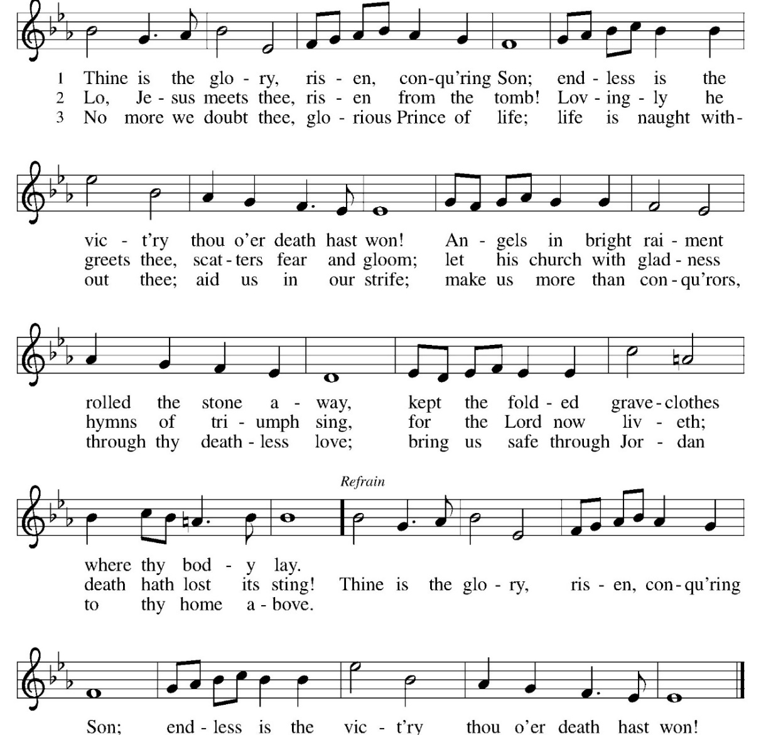
Gospel: John 10:1-10

P: The Gospel according to John C: Glory to you, O Lord.
Jesus uses an image familiar to the people of his day to make a point about spiritual leadership. Those who listen to Jesus are led to abundant life.
[Jesus said:] ¹ “Very truly, I tell you, anyone who does not enter the sheepfold by the gate but climbs in by another way is a thief and a bandit. ² The one who enters by the gate is the shepherd of the sheep. ³ The gatekeeper opens the gate for him, and the sheep hear his voice. He calls his own sheep by name and leads them out. ⁴ When he has brought out all his own, he goes ahead of them, and the sheep follow him because they know his voice. ⁵ They will not follow a stranger, but they will run from him because they do not know the voice of strangers.” ⁶ Jesus used this figure of speech with them, but they did not understand what he was saying to them.
⁷ So again Jesus said to them, “Very truly, I tell you, I am the gate for the sheep. ⁸ All who came before me are thieves and bandits, but the sheep did not listen to them. ⁹ I am the gate. Whoever enters by me will be saved and will come in and go out and find pasture. ¹⁰ The thief comes only to steal and kill and destroy. I came that they may have life and have it abundantly.”
P: The Gospel of Our Lord. C. Praise to you, O Christ.
CHILDREN’S MESSAGE
MESSAGE Lutheran Social Services of Illinois
HYMN OF THE DAY Have No Fear Little Flock ELW 764

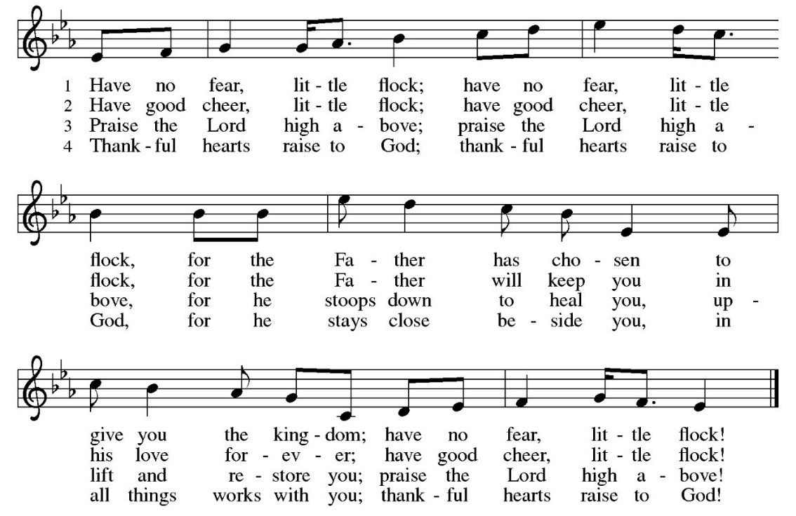
AFFIRMATION: THIS I BELIEVE
I believe I need a shepherd.
Because I am sometimes timid and other times overconfident, because I often don't know the best path yet pretend I do, because I rush into dead ends or lead others into hazardous places, because my brightest ideas are seamed with darkness, because the things I crave may not be what is good for me, I need a shepherd.
I believe in Jesus, the best possible shepherd; his wisdom leads me to the best opportunities, his word comforts me when I'm anxious or afraid, his arm steadies me when I feel weary and heavy-laden, his wounded body displays the cost of my rescue.
I believe in Jesus, the best possible shepherd. I believe that I do not find him but he finds me, that under his care by virtue of sheer grace, the love he gives me is to be shared with others, that he treasures my name and prepares a place for me, that his fold transfixes earth and heaven. I trust Jesus, the good shepherd. Amen.
PRAYERS OF INTERCESSION:
P: Merciful God, C: Receive our prayer.
PEACE
P: The peace of Christ be with you always. C. And also, with you.
OFFERING: Our offering is a significant act of worship; we worship God through our giving. The ministry of this congregation is completely dependent upon your partnership and generosity. Offering is collected as you enter worship on Saturday. We will pass the offering plate on Sundays. Online giving is available.
OFFERING HYMN: You Are My ALL in ALL

- You are my strength when I am weak; You are the treasure that I seek. You are my all in all.
Seeking you as a precious jewel: Lord, to give up, I’d be a fool.
You are my all in all. Refrain

Refrain:
Jesus, Lamb of God. Worthy is Your name.
Jesus, Lamb of God. Worthy is Your name.

- Taking my sin, my cross my shame: Rising again I bless Your name. You are my all in all.
When I fall down, You pick me up; When I am dry you fill my cup.
You are my all in all. Refrain

OFFERING PRAYER:
P: God of love, you abide with us; you provide for all our needs and guide us in your ways. Out of gratitude for your care, we bring our gifts before you. Use them for your work of caring, that all may feast at the table of abundance, walk without fear, and drink deeply from the cup of compassion. Amen
COMMUNION LITURGY:
In the night in which he was betrayed, our Lord Jesus took bread, and gave thanks, broke it and gave it to his disciples, saying: take and eat; this is my body, given for you. Do this for the remembrance of me. Again, after supper, he took the cup, gave thanks and gave it for all the drink, saying: this cup is the new covenant in my blood, shed for you and for all people for the forgiveness of sin. Do this for the remembrance of me.
THE LORD’S PRAYER:
Our Father, who art in heaven, hallowed be thy name, thy kingdom come, thy will be done on earth as it is in heaven. Give us this day our daily bread; and forgive us our trespasses, as we forgive those who trespass against us; and lead us not into temptation but deliver us from evil. For thine is the kingdom, and power, and the glory, forever and ever. Amen
INVITATION TO COMMUNION:
P: Come to the table of new life. Receive the risen Lord.
Please come down the center aisle, take the bread, then receive a cup (wine is dark, juice is light, return to your seats via side aisle.) Those who prefer to take communion in your pews, we will take all together after all are served.
DISTRIBUTION OF COMMUNION:
P: This is the body of Christ given for you. (All take bread).
P: This is the blood of Christ shed for you. (All take the wine).

COMMUNION HYMN Savior, Like a Shepherd Lead Us ELW 789

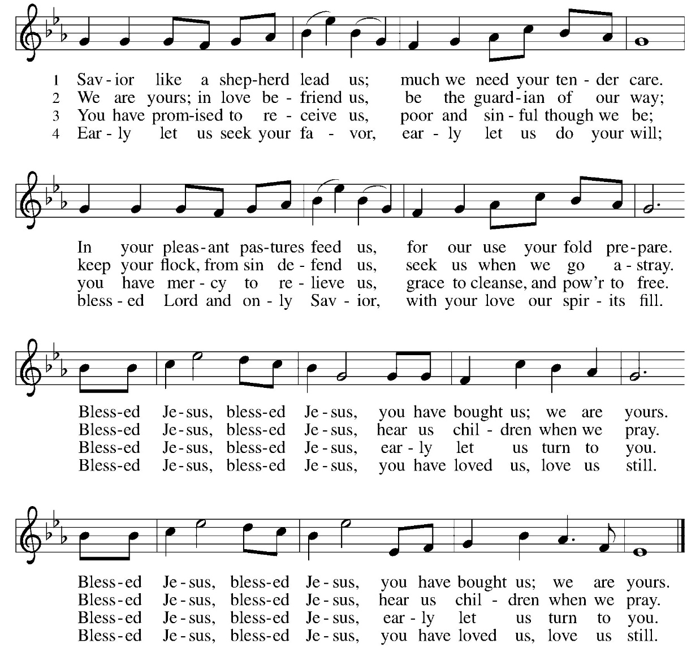
TABLE BLESSING:
P: May the body and blood of our Lord Jesus Christ strengthen you and keep you in God’s grace. C: Amen.
PRAYER AFTER COMMUNION:
P: Shepherding God, C: you have prepared a table before us and nourished us with your love. Send us forth from this banquet to proclaim your goodness and share the abundant mercy of Jesus, our redeemer and friend. Amen
SENDING: God blesses us and sends us in mission to the world.
BLESSING:
P: God Almighty, who is the beginning and the end, Jesus Christ, the firstborn of the dead, and the Spirit, our advocate and peace, ☩ bless you now and forever. C: Amen.
SENDING HYMN What a Fellowship, What a Joy Divine ELW 774
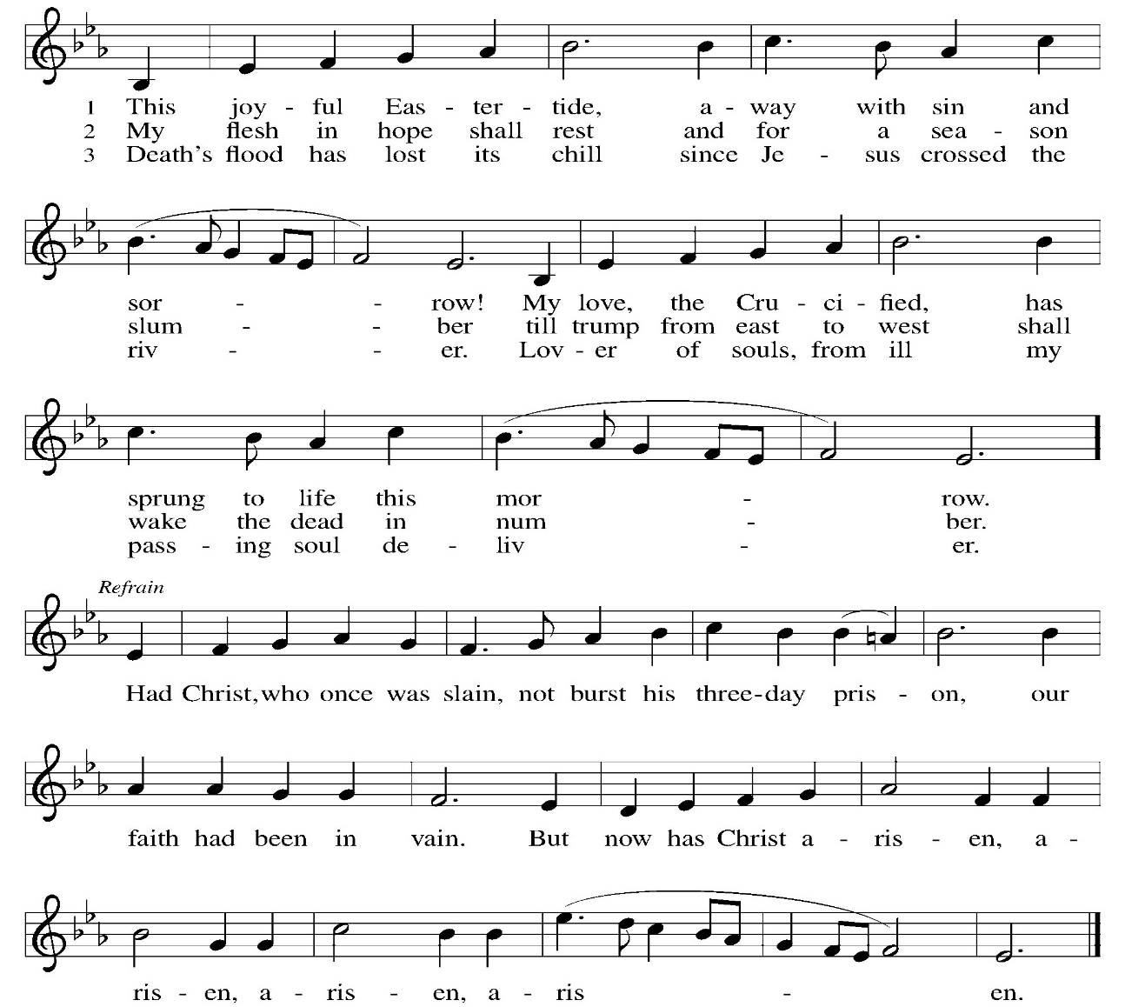

DISMISSAL:
P: Go in peace. Praise the Lord. Alleluia!
C: Thanks be to God. Alleluia!
POSTLUDE

ONLINE GIVING: Your gift has a big impact on our ministries and those we serve. Scan this code or visit our website to give online today
IN OUR PRAYERS TODAY: Teresa Hesselbacher, Elaine Schlicting, Darlene and Walt Steffes, Bob Schreck, Delores Wampfler, Marge and Gerald Arnold, Don & Judy Brudi, Pat Lawfer, Nancy Dittmar, Karen Dick, Angie Broshous, Grayson Raab, , Christine Happ, Kay Hesselbacher, Mary Lou Bunker, Lillian Sefford, Cindy Kerchner, Josaiah, Jeanie Taggart, Brian Schiess, Russ Synder, Don Kunz, Johnny Blair, Jim Sullivan, John Becker, Cheri Broge, Nancy Bailey, Terry Calhoun, Jesse Tipton, Pastor Lee Leubke (Allure, Mt Carroll), family and friends of Lisa Law To add someone to the prayer list please contact Pastor Chrissy
Anderson House Birthdays: Christine May 22, Robert May 22, Becky May 29 Please mail cards or drop off at Anderson House 200 E King Ave. Stockton, IL 61085 or drop off in basket in the back of the church
CELEBRATING BIRTHDAYS / ANNIVERSARIES: Dakota Pfile, Cecelia Staver, Leslie Coppas, Joseph Brudi, Tessa Tucker, Matt Harmston.

March Totals: As a way to improve communication around finances, we are sharing following information: *these numbers reflect online giving contribution
March
2026
 | March | Year to date
Offerings: | $14,376 | $30,827
Expenses: | $11,416 | $33,413
Overall Gain / Loss | $2,960 | ($2,586)

Thanks be to God for your gifts for the ministry of  Christ Lutheran Church *these numbers do not reflect online giving- only offering in worship |  |  |  | Attendance
Current Expense | $1229.00 | Building Fund | $10.00 | April 11  April 12 | 14  45
Benevolence  Sunday School | $10.00  $20.00 | Folder | $10.00 | Sunday School | 16
 |  | Total | $1279.00
READINGS FOR NEXT WEEK: Acts 2:14a, 36-41; Psalm 116:1-4; Peter 1:17-23; Luke 24:13-35
ANNOUNCEMENTS
THE COMMUNITY TABLE: The Community Table is an opportunity for outreach to the local community. This is a bi-weekly meal on the first and third Tuesday of the month at 11:30, here at Christ to gather for food, fellowship and fun. Join us Tuesday April 21st. Members of the church make donations to cover the cost of the food. A free will offering is collected each meal to support a local organization.
WELCA QUILTERS: We need hand towels, mild hand soap and flannel sheets.
WELCA QUILTERS: There will be no more quilting until next Fall 2026

WELCA SPRING EVENT: Proclamation isn’t shouting louder than hate…it’s speaking, living, and standing in love, truth, and justice as people claimed by Christ. Join the Northern Illinois Synod Women of the ELCA for the 2026 Spring Retreat on Saturday, April 25, 2026, from 9:00 am to 3:00 pm at Lutheran Outdoor Ministries Center in Oregon, IL. Cost $30 per person, scholarships are available. Forms are in the back of the church.
AMAZON WISH LIST: did you know that everyday items used at the church are items you could contribute? Find our list here or on our Facebook page. Thank you!
VICTORIAN AFTERNOON TEA: WELCA is coordinating a Mother’s Day High tea event for Saturday, May 9th at 2 pm. Enjoy a demonstration by Littlehuggs Reenactment Costumes (Civil War Ladies Dress from top to bottom). Cost $8 at the door. Questions talk to Karen Brose.
COWORKERS IN THE GOSPEL: Consider being a part of one our leadership teams. As of this month, three teams will be helping connect council and congregation as we work together to do ministry together. If you are interested in being a part of one of the teams, please see Pr Chrissy or someone on the team.
- Worship team leader is Patsy Holland -anyone who is interested in serving in any area of worship, especially baking communion bread, communion set up, serving or clean up.
- The building team will access, and address issues related to the building. Please see Cory Haas, team leader, if you would like to help with the building.

- The Education Team over sees Confirmation, Sunday School and Vacation Bible School. Vacation Bible School is going to happen June 1-5 from 9-11:30If you would like to be a part of the education team please see Leisa Hubb (team leader)
Upcoming Events
- April 18 – 8 am Breaking Bread at Copperleaf Café
- April 18 – 5:30 pm Worship LSSI Good Shepherd Sunday
- April 19 – 8:30 am Confirmation Class
- April 19 – 9am Sunday School
- April 19- 10 am LSSI Good Shepherd Sunday
- April 19- 2 pm Northwest Conference Assembly at St. John, Massbach
- April 19- 2-5 Youth Worship at LOMC with Bishop Fidlar
- April 23- WELCA Spring Gathering Event in Lanark
- April 25 9-3 WELCA Spring Retreat at LOMC
- April 25/26 Worship No Communion Debbie Goebel Preaching
- May 3- 2pm Stockton Baccalaureate here at Christ Lutheran Church
- May 9- 2 pm Mother’s Day High Tea sponsored by WELCA
- June 1-6 Vacation Bible School – Road Trip with Jesus
This weekend is Good Shepard Weekend. We will celebrate Lutheran Social Services of Illinois. We will collect a special offering to support their ministry. On Saturday we will hear the Gospel preached by Mark Stutrud, President and CEO of LSSI. On Sunday, David Novak, Chief Advancement Officer will be present to Preach and answer questions.

Pastor Chrissy will be on vacation from April 24 – 29. For assistance, please call David Heller @ 815-541-9447.

