1/22/2017 The Culmination of Years Part 3

The Hebrew month of Av is the 5th biblical month. It was during the month of Av, especially 9th of Av, that many bad things happened to Israel, such as the destruction of the Temple in Jerusalem.

In 2008, 2009, and 2010 there were total solar eclipses that marked the precise astronomical beginning of the Hebrew month of Av. It's very rare for there to be 1st Av solar eclipses in 3 consecutive years.

According to the Hebrew Sages, solar eclipses are indications of YaHuWaH Elohim's warning to all nations except Israel. The bible reveals that when YaHuWaH Elohim repeats something, such as a dream, it means the event is coming soon. The 3 first Av solar eclipses in a row in 2008-2010 were an important warning to the nations.

The 200 Year Wide Coherent Lunar Eclipse Series

We know that order does not arise out of chaos without the intervention of an intelligent being who can take the chaotic elements and arrange them in a meaningful structure. The letters and words of this sentence would be a jumble without someone to arrange them in meaningful order. Once the letters are arranged in meaningful order, ideas can be transferred from the writer to you.

On December 8, 2009, YaHuWaH Elohim revealed a 200 year wide coherent sequence of lunar and solar eclipses that began in 1910-1911. It just happens that 1911 is precisely 6,000 prophetic years from 4004 BC. Embedded in the sequence of lunar and solar eclipses is a series of 1st Av solar eclipses, of which the 3 mentioned above in 2008-2010 are a part.

The 1st Av Eclipses Began in 1945

The lunar eclipses in the 200 year coherent sequence began in 1910. The very first, 1st Av solar eclipse embedded inside the lunar sequence by our Creator Elohim occurred on 7/9/1945. Remember that 1st Av solar eclipses are a warning to the nations.

On 7/16/1945, 7 days after the very first, 1st Av solar eclipse of 7/9/1945, the very first atomic device, named Trinity, was tested in New Mexico. The flash was seen, and some automobiles curiously stopped running, in a city about 200 miles away.

The North Pole is Symbolic of the Throne of YaHuWaH Elohim

We communicate with each other through sequences of signs and symbols. The letters on this page are symbols that are arranged into words and sentences that bring ideas, thoughts, and images into our minds.

Psalms 48:1 Great is YaHuWaH , and greatly to be praised in the city of our Elohim, in the mountain of His holiness.
2 Beautiful for situation, the joy of the whole earth, is mount Zion, on the sides of the north, the city of the great King.

Isaiah 14:12 How art thou fallen from heaven, O Lucifer, son of the morning! how art thou cut down to the ground, which didst weaken the nations!
13 For thou hast said in thine heart, I will ascend into heaven, I will exalt my throne above the stars of Elohim: I will sit also upon the appointed mountain, in the sides of the north:
14 I will ascend above the heights of the clouds; I will be like the most High.

Our Elohim is Thrice Holy

Isaiah 6:1 In the year that king Uzziah died I saw also YaHuWaH sitting upon a throne, high and lifted up, and His train filled the temple.
2 Above it stood the seraphims: each one had six wings; with twain he covered his face, and with twain he covered his feet, and with twain he did fly.
3 And one cried unto another, and said, Holy, holy, holy, is YaHuWaH of armies: the whole earth is full of His glory.

Below is a graphic showing the paths of the first 3, 1st Av solar eclipses, embedded in the 200 year wide coherent lunar eclipse series.

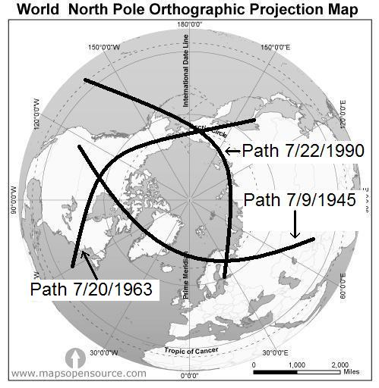
Holy, Holy, Holy
Above: The sides of the north, the sanctification, the setting-apart of the North Pole by the paths of first 3, 1st Av, solar eclipses.

The Three Regions Sanctified by YaHuWaH Elohim

The 3 regions of the earth indicated in the graphic below have been sanctified, set apart, by YaHuWaH Elohim. Our Creator Elohim has used total solar eclipses to inscribe boundaries on the earth.

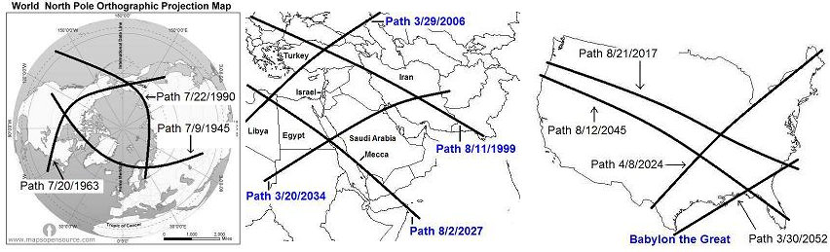
Further information concerning the graphic above at this link: http://www.joybysurprise.com/the-four-tavs.html

The Total Solar Eclipse of 3/20/2015

And now we fast forward to the solar eclipse of 3/20/2015. I wept, sometimes uncontrollably, for 3 days when I saw that particular eclipse on a map in 2009, because I realized that it meant that millions of people would die. Link: http://www.joybysurprise.com/the-153-fish.html

The North Pole had been symbolically "sanctified" by the very first, 1st Av solar eclipses.

Now for the addition of the path of the total solar eclipse of 3/20/2015, labeled by scientists as a "once in 100,000 year eclipse" because it ended precisely at the North Pole and also precisely on the Springtime equinox. The path of the solar eclipse of 3/20/2015 left the face of the earth and lifted into the heavens when it precisely reached the earth's North Pole.

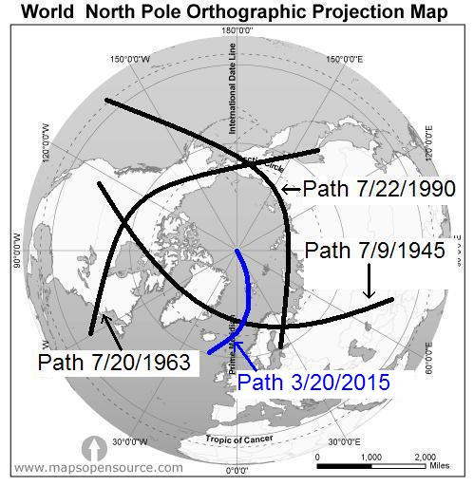
The sides of the north, and the extreme north, symbolic of YaHuWaH 's throne, with the path of the eclipse of 3/20/2015 lifting into the heavens from the North Pole.

The total solar eclipse of 3/20/2015 was found to be relevant to John chapter 21 and the 153 great fish mentioned there. Link: http://www.joybysurprise.com/the-153-fish.html

If we add 6 x 153 days (918 days) to 3/202015, we arrive at 9/23/2017 and the sign in heaven of the Woman Clothed with the Sun travailing, giving birth to the man child. Link: http://www.joybysurprise.com/the-sun-clothed-woman.html

The number 153 is the 17th triangular number. Link: https://en.wikipedia.org/wiki/Triangular_number

Methuselah, the Oldest Living Human

Methuselah is the oldest living human of record in the bible. Adam lived 930 years, but Methuselah lived 969 years.

The meaning of Methuselah's name is "when he dies it will come". When Methuselah died at 969 years old, Noah's flood came upon the earth.

If we use 3/20/2015 as a reference timeline "zero" marker and count 969 days, one day for each year of Methuselah's life, we arrive at 11/13/2017. Remember this important date.

The number 969 is the 17th tetrahedral number. Link: https://en.wikipedia.org/wiki/Tetrahedral_number

Enter the Dragon

Accompanying the sign of the Woman Clothed with the Sun on 9/23/2017 is the constellation Draco the Dragon.
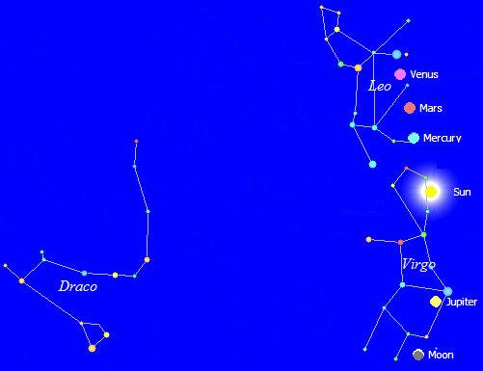
Draco the serpent waiting at the feet of the Sun Clothed Woman on 9/23/2017 to devour her man child.

Revelation 12:1 And there appeared a great wonder in heaven; a woman clothed with the sun, and the moon under her feet, and upon her head a crown of twelve stars:
2 And she being with child cried, travailing in birth, and pained to be delivered.
3 And there appeared another wonder in heaven; and behold a great red dragon, having seven heads and ten horns, and seven crowns upon his heads.
4 And his tail drew the third part of the stars of heaven, and did cast them to the earth: and the dragon stood before the woman which was ready to be delivered, for to devour her child as soon as it was born.

In 2804 BC, the earth's North Pole made its closest approach to the star Thuban in the tail of Draco the Dragon, being 4 minutes of arc away. "Thuban" in Arabic means "snake". Noah's flood would have been around 2348 BC, about 456 years after Thuban in the tail of the dragon was the Pole Star.

If we regard 4004 BC as the date of Creation, then 2804 BC would have been exactly 1200 years after the Creation event. Messiah YAHUSHUA was born in about 4 BC, exactly 4,000 years after the Creation event. Then 1996 AD would have been exactly 6,000 years after the Creation event.
Revelation 12:5 And she brought forth a man child, who was to rule all nations with a rod of iron: and her child was caught up unto Elohim, and to His throne.
6 And the woman fled into the wilderness, where she hath a place prepared of Elohim, that they should feed her there a thousand two hundred and threescore days.

The Symbolic Flood from the Dragon's Mouth

Revelation 12:15 And the serpent cast out of his mouth water as a flood after the woman, that he might cause her to be carried away of the flood.
16 And the earth helped the woman, and the earth opened her mouth, and swallowed up the flood which the dragon cast out of his mouth.
17 And the dragon was wroth with the woman, and went to make war with the remnant of her seed, which keep the commandments of Elohim, and have the testimony of YAHUSHUA the Messiah.

After the birth of the man child on 9/23/2017 there will be an event known as the Draconid meteor shower. On the evening of October 7 and the morning of October 8, 2017, a shower of meteors, shooting stars, will appear to come from the head of the constellation Draco. Click on the Draconid Shower at this Link: http://earthsky.org/astronomy-essentials/earthskys-meteor-shower-guide

In the bible, stars are symbolic of angelic beings, spirits. The Draconid meteor shower on October 7-8, 14 days (7x 2 days) after 9/23/2017, will symbolize a flood of stars (devils) being cast out of the Dragon's mouth with the intent of destroying the symbolic Woman as mentioned in Revelation 12:15 above.

The Draconid meteor shower is caused by Comet 21P Giacobini-Zinner. The next perihelion, the closest approach to the sun, of Comet 21P Giacobini-Zinner will be on September 10, 2018, the Hebrew Day of Trumpets. Link: https://en.wikipedia.org/wiki/21P/Giacobini%E2%80%93Zinner

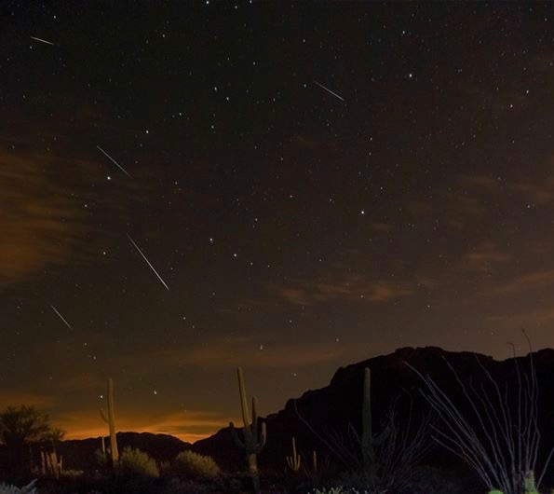
The Draconid Meteor shower of 10/7/2013. Image Courtesy Sean Parker

Below is a graphic indicating the birth of the man child on 9/23/2017, the circumcision of the man child on the 8th day, the Day of Atonement on 9/30/2017, and the Draconid meteor shower on 10/7-8/2017.

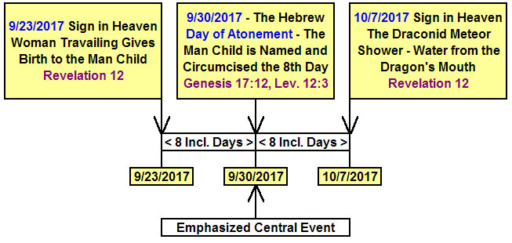

Few Witnesses are Allowed

Very few people have been allowed by YaHuWaH Elohim to witness some of the greatest events in history.

Below is a graphic depicting similarities in the timelines of events around the birth and resurrection of Messiah. Notice the few people who were allowed to witness these events.

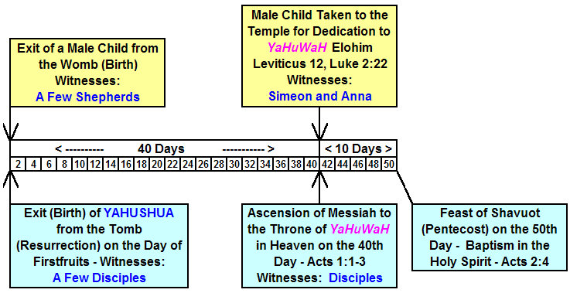

We might expect few people to actually witness the events of 9/23/2017 and beyond. To most people, the taking of the man child by force to heaven will probably be a non-event. But at least two people selected by YaHuWaH Elohim will observe it, whatever it is that happens.

In the case of Elijah, an entire school of prophets knew that Elijah was going to be taken away to heaven on a certain day, but only one man, Elisha, actually saw it happen. The rest of the group of prophets then doubted that it did happen and set out searching for Elijah in the wilderness. II Kings chapter 2

If we apply the date 9/23/2017 at the beginning of the graphic above, we find 11/2/2017 to be at the 40 day mark, and 11/12/2017 at the 50 day mark. The events of 11/12-14/2017 are listed further above and below.

Empowered by the Red Dragon

Daniel 9:26 identifies Antichrist as a Prince of the people who destroyed the Temple.

On 11/13/2017, Prince Charles, whose official title is the Prince of Wales, will completely fill 69 years of his life from birth. Remember that 11/13/2017 was 969 days from the Nroth Pole solar eclipse of 3/20/2015, the 969 days being symbolic of the 969 years of the life of Methuselah (when he dies, it will come). 11/14/2017 will be Prince Charles' 69th birthday anniversary, and the very 1st day of his 70th year. He is a Roman Prince through his father's lineage, of the same people who destroyed the Temple in Jerusalem in 70 AD. Reference Daniel 9:26

At his coronation, Prince Charles sat on a chair with a red dragon emblazoned on it. During his coronation ceremony his mother Queen Elizabeth II said "This dragon gives you your power, your throne, and your authority". Link: http://www.theforbiddenknowledge.com/hardtruth/calculate_the_number.htm

Revelation 12:15 And the serpent cast out of his mouth water as a flood after the woman, that he might cause her to be carried away of the flood.
16 And the earth helped the woman, and the earth opened her mouth, and swallowed up the flood which the dragon cast out of his mouth.
17 And the dragon was wroth with the woman, and went to make war with the remnant of her seed, which keep the commandments of Elohim, and have the testimony of YAHUSHUA the Messiah.

