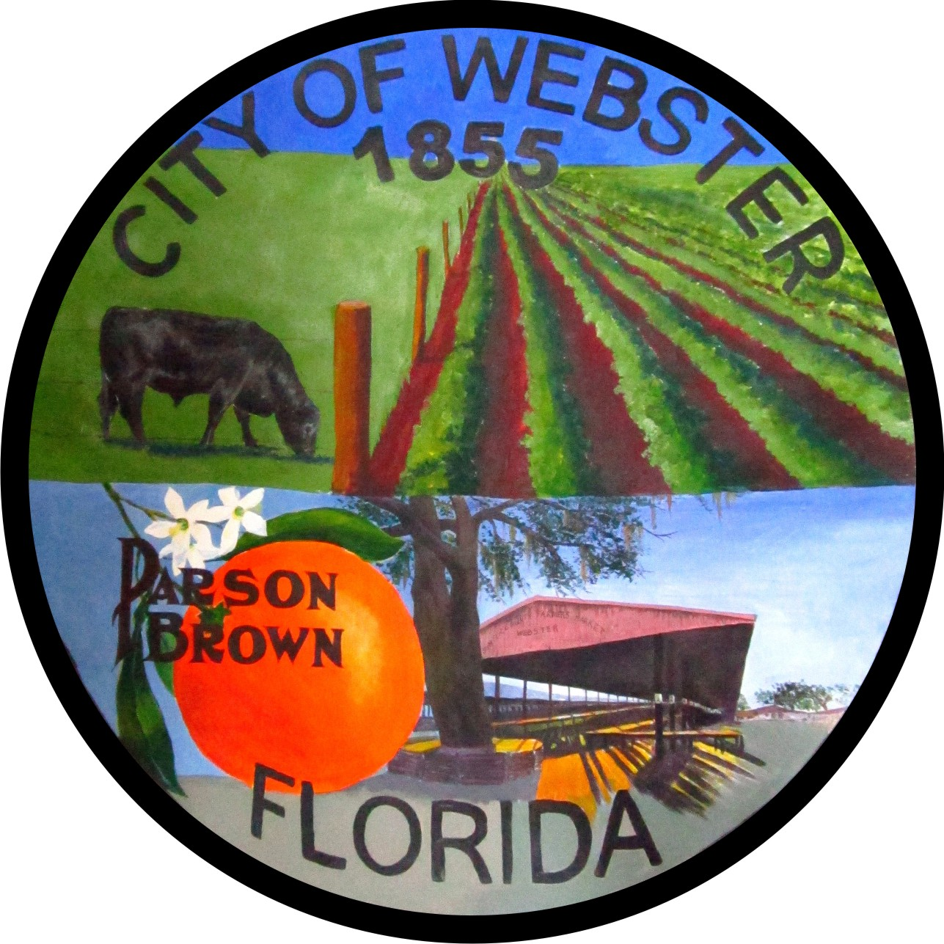

AGENDA
PLANNING AND ZONING BOARD
CITY OF WEBSTER
Webster City Hall, 85 E. Central Avenue
October 12, 2023 - 6:00 P.M.

I. CALL TO ORDER

Pledge of Allegiance, Invocation
Roll Call and Determination of Quorum

Note. All public comment will be limited to 3 minutes per speaker. Anyone wishing to speak during citizen’s forum or on an agenda item must fill out a speaker card and present it to the City Clerk prior to being recognized. All comments will be addressed after all speakers have spoken during citizen’s forum or on a particular agenda item.

II. APPROVAL OF MINUTES

Planning & Zoning – September 14, 2023
M_______________S_______________ Roll Call Vote

III. PUBLIC HEARING

Approval of Ordinance 2023-24 Comp Plan Amendment-Parcel ID Q19-070 and Q19-091-Southern Properties LLC, and Robert Sanchez
M_______________S_______________ Roll Call Vote

Approval of Ordinance 2023-25 Rezoning-Parcel ID Q19-070 and Q19-091-Southern Properties LLC, and Robert Sanchez
M_______________S_______________ Roll Call Vote

Approval of Ordinance 2023-26 Chapter 13 Amendment for R4M and R4C Residential Zoning Districts
M_______________S_______________ Roll Call Vote

IV. ADJOURNMENT

M_______________S_______________ Roll Call Vote

PLEASE NOTE IN ACCORDANCE WITH FLORIDA STATUTE 286.105, ANY PERSON WHO DESIRES TO APPEAL ANY DECISION AT THIS MEETING WILL NEED A RECORD OF THE PROCEEDINGS AND FOR THIS PURPOSE MAY NEED TO ENSURE THAT A VERBATIM RECORD OF THE PROCEEDINGS IS MADE WHICH INCLUDES THE TESTIMONY AND EVIDENCE UPON WHICH THE APPEAL IS BASED. ALSO, IN ACCORDANCE WITH FLORIDA STATUTE 286.26; PERSONS WITH DISABILITIES NEEDING ASSISTANCE TO PARTICIPATE IN ANY OF THE PROCEEDINGS SHOULD CONTACT THE OFFICE OF THE CITY CLERK; 85 E. CENTRAL AVENUE; WEBSTER, FLORIDA; (352) 793-2073; 48 HOURS IN ADVANCE.

