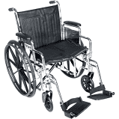
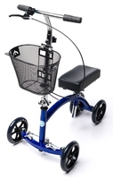
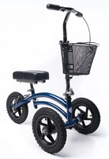
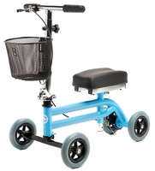
Want to Learn More?
Call (817) 874-7165 to speak directly to a mobility specialist
Visit www.ExpressHomeMedical.com to learn more about our rental program
Free Delivery throughout DFW
Available for Purchase
Visa, Mastercard and AMEX accepted
No Prescription required
Wheelchairs
Weight Capacity: 350 lb
Elevated Leg Rests available
Several sizes available
$85 / Monthly Rental
Weight Capacity: 350 lb
Height Range: 4’11” to 6’6”
Several models available
$75 / Monthly Rental
Standard Knee Scooters
DFW’s Premier Mobility Equipment Provider
EMAIL: CustomerService@ExpressHomeMedical.com PHONE: (817) 874-7165 WEBSITE: www.ExpressHomeMedical.com FAX: (817) 290-2202
All-Terrain Knee Scooters
Weight Capacity: 350 lb
Height Range: 5’6” to 6’8”
Ideal for heavy outdoor use
$125 / Monthly Rental
Weight Capacity: 160 lb
Height Range: 3’6” to 5’4”
Very lightweight at only 18 lbs
$85 / Monthly Rental
Pediatric Knee Scooters
EXPRESS HOME MEDICAL

