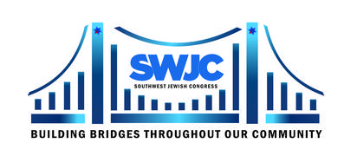 | SWJC 2023 BUILDING BRIDGES GRANT INITIATIVE APPLICATION  $2,000 Grant – Submission Deadline: May 5, 2023  Applicants must agree with SWJC’s Mission Statement.  Submit completed application via email to susan@swjc.org or mail to address below.

SWJC 2022 Grant Recipients are not eligible to apply.

- Name of Organization:
- Contact Person: Title:
- EIN: Year Formed: Date IRS Approval:
- Organization Physical Address:
- Organization Mailing Address:
- Phone: Cell:
- Email: Website address:

SUBMIT BRIEF ANSWERS FOR THE FOLLOWING QUESTIONS ON A SEPARATE PAGE OR PAGES.
INCLUDE A COPY OF YOUR ORGANIZATION’S LATEST TAX FILING WITH THE IRS.

ABOUT YOUR PROJECT
- What project would be covered by this grant?
- Why is this project necessary?
- Describe the impact this grant would make.

ABOUT YOUR ORGANIZATION
- What is/are the location(s) in the DFW area where grant funds will be used?
- What is your organization’s purpose/mission?
- What are your main activities and how many people are served?
- Demographics of people who benefit from services you provide:
- Number of employees: Full time: Part time:
- If you are a membership organization, how many members do you have and how much are dues?
- What are the Volunteer opportunities with your organization?
- Number of Volunteers?
- Budget for last fiscal year
- How much was spent last year?
- Amount budgeted/projected to spend this year?

ABOUT THE PROCESS
- How did you hear about this grant?
- How will you document the use of these grant funds?
- Anything else you want to tell us about your organization or how the grant will be used that may be of interest?
- If your organization received a grant from SWJC in the past, give us an account of how the grant was spent and the impact the grant made.
- Grants will be awarded in June 2023 at the SWJC Annual Meeting. Applicants will be notified if selected. Representatives are required be in attendance for the grant presentation, date to be announced.

SWJC Mission Statement  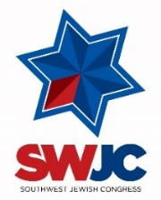  Southwest Jewish Congress (SWJC) is a membership organization open to all that welcomes diversity and builds bridges throughout our community. We provide quality educational programs and events:  - supporting US Constitutional and human rights;  - regarding Jewish culture and history;  - promoting Israel and its role in the world; and  - honoring those who have significantly contributed to the advancement of our society, culture and lives. | Submit Grant Applications  via email to: susan@swjc.org  or mail to:  Southwest Jewish Congress  Attn: Grant Committee  P.O. Box 700116 | Dallas, Texas 75370  214-361-0018 | susan@swjc.org  www.swjc.org

