Solo Hiking and the Search for Solitude
(Provided by: HighCountryExplorations.com)

Those of us who go alone do so of necessity, or perhaps because we enjoy the solitary pleasures of thinking our own thoughts, adjusting to our own schedules and needs, and having total, silent connection with the nature which surrounds us. The price we pay is a slightly heavier pack and perhaps an additional element of risk. But hiking alone also carries with it more excitement and less adjustment to the moods and needs of others.
—Fred Coleman, as quoted by Ray Jardine, Beyond Backpacking:
Guide to Lightweight Hiking, page 440

My dad is a backpacker. He hikes the Pacific Coast [sic] Trail every year. He goes alone, and my mom and I hate it.
—unknown contributor on Backpacker.com forum

There is something extraordinary about being alone on a mountain. Vulnerability sharpens every sense. Fear visits the body with a physical coldness. Moments of bliss are intensified and made melancholy by the realization that the moment will be yours alone and never shared. Only solo do you understand the indiscriminate power of the mountain and feel to your humble bones the insignificance of a human voice raised upon it.
—Bruce Barcott, The Measure of a Mountain, page 6

Central Issues Addressed in This Article
Why go solo? Why adopt this hiking style knowing the potential risks and problems involved? How should an experienced and conscientious hiker assess this practice? Should solo hiking be analyzed as an ethical and societal issue? What about soloists who have no responsibilities to others? What are the best ways to increase the sense of solitude while hiking in groups or in populated areas?

Introduction
By its very nature, solo hiking personifies a style very different from the norm. Some hikers embrace this style and indulge in it whenever they can. Others will not seriously consider it. Poets, philosophers, wilderness travelers and others often sing the praises of solitude. Others go into the backcountry primarily because of the camaraderie, which obviously minimizes solitude. Where are you on this continuum?
I had not seriously examined the practice of hiking solo until writing this article. When I felt like going solo, I just did it. I was usually careful and did not take chances. My wife gradually gained confidence in my abilities and my promises to return when I said I would. Some family members were not convinced and continually counseled me against this practice. As I write on this subject, I wonder if it will be an elaborate rationalization of past behavior or an objective analysis of this subject. The latter is my goal.
In this article, I first delve into the common and not so common motivations and rationales (rationalizations?) for solo hiking (the variety of motivations is mind-boggling). I then argue that this is not just a personal and family issue, but also an issue with ethical implications for society. I go on to share my own experiences and conclusions regarding solo activities in general and hiking in particular. I share some suggestions for increasing the amount of solitude when hiking with others. Finally, I share several additional issues for further reflection.

Motivations for Solo Hiking and Backpacking: Thumbnail Sketches
Why go solo? Following are numerous sketches of the different motivations (reasons, rationales, philosophies) given by solo hikers and backpackers. When a good quote is available, I let soloists speak for themselves.

Silence, Sounds and Solitude: These three “Ss” are quite important. Solo hiking involves many opportunities for solitude and quiet time. It involves a profound sense of quiet undisturbed by the always-present background hum and noise of people and civilization. When I experience this kind of solitude and silence, it gives me the opportunity to fully tune in to the delicate sounds and smells of nature. My going solo for an hour, a day, a week or longer is the ultimate in this kind of experience.
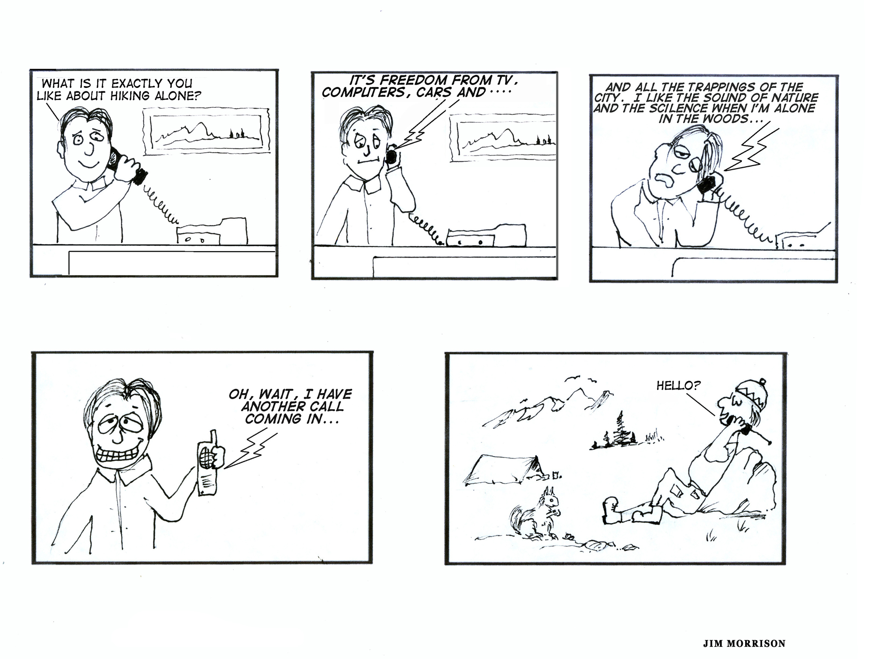

Out of Necessity: I can’t find others who fit my personal style of hiking. I very much want to hike my own hike. Here is one statement of this motivation from an unknown author:

For me the issue is simple; go solo or stay at home. I was born before WW II and among people my age, there are few that are interested in anything more strenuous than golf. So basically, there are no potential hiking companions in my age group, at least not that I'm prepared to take the trouble to meet. Moreover, younger people have tastes different enough from mine in life experience, music and philosophy that I don't really enjoy prolonged ‘togetherness’ with them.

And a different expression of the same philosophy, also by an unknown author:

I love hiking by myself and solitude does not bother me. I am the only one outta my group of backpackers left that hike in a lightweight manner. I also like to hike most of the day and stop for sleep after 12-20 miles in a day. I don't have peer pressure to hike further or faster than I want.

Freedom and Spontaneity: An extension of the previous motivation is that of increased freedom. Solo hiking means being able to make last minute decisions on leaving time, destination and goals. It means few complications, compromises and coordinations. How liberating it is to just grab my pack and go. I don’t have to adjust to the moods and needs of others. When backpacking, I get up when I want, eat what and when I want, hike at my own pace, etc. I also prefer to hike long days (sitting around alone is often boring), so I go to sleep when I have finished my camp chores. Here is a summary statement of this motivation from an unknown author:

Ideally, if I could clone myself I would have the ideal hiking partner. Then he could get off work when I do, rest when I want to, push hard when I want to, even stop to pee when I want to. I would love to have a hiking partner like that. But I'm not sure if I'd want to talk to the guy. I love going solo and can't imagine ever giving up the freedom that I have gained.

Here is a statement of this same motivation, also by an unknown author:

I would prefer to have a partner but reality gets in the way. I can't clone myself. I want to do my trip, not someone else's. Not that mine is any better but just that it's mine. That's why most of my major trips are solo. Actually when hiking I often become very introspective and internally focused. I can reach a state of mind not obtainable in the company of others. Sometimes I like that. There is much to be said for human companionship but sometimes long days on the trail are not the best place for it.

Go Against Conventional Wisdom: The following quote from an unknown author expresses this motivation eloquently:

I am convinced that some of the greatest moments of backpacking come when we break conventional rules. Hiking with a partner, for example, is wise and safe. But there are times when going it alone allows each of us some of the deepest self-reflection possible. Maybe this desire in me to be alone arises from my childhood in upstate New York, a rural, agricultural homeland set in the hills and valleys of North America’s glacial retreat twelve thousand years ago. Perhaps it developed as a yearning to be more like my humble, hardworking grandfather who used to fish for bullhead by himself, and make maple syrup in the shack that he built with his hands and spent hours alone in seeking refuge. In this day of backpacker education courses and backcountry responsibility, there still remain some few times when I like to shake off conventional wisdom and hike solo.

Reject Social Customs: Rejecting social customs is much easier to do when traveling solo. The following expresses this philosophy quite explicitly:

I become an eccentric. I revel in the pungency of my own body scents. I scratch in inappropriate places, talk to myself, sleep when tired and eat with my fingers when I’m hungry. The longer I am out, the more the layers of social custom are stripped away. I feel released from the pressures of human convention.
—Amy Racina, “The Lure of the Solo Experience,” Angels in the Wilderness

Self-Reflection: Following up on a theme expressed in the previous quote:

We go into the wilderness to discover more about ourselves, about who we really are. I think the influences of modern society keep many of us from being our real selves. . . . But when we step into the wilderness, we free ourselves of those influences, at least temporarily, and we begin to discover more about ourselves.
—Ray Jardine, Beyond Backpacking:
Guide to Lightweight Hiking, page 15

Fully Experience the Wilderness: Chris Townsend, a well-known backpacking author and solo hiker, expresses this motivation as follows:

I knew well the argument that solo hiking in a remote wilderness was foolhardy, dangerous, even irresponsible, but I knew even more the great rewards that awaited, rewards that could hardly be glimpsed by those who walk in groups. Alone, I would be able to open myself up to the wilderness, to ready my senses for what was offered, to learn what the mountains and forests, the rivers and lakes, had to teach me.
—The Advanced Backpacker, page 10

Here is a similar quote placing more emphasis on personal relationships with nature:

There are no other voices to interrupt the ecstatic union of self with nature. I feel myself to have a personal relationship with the natural world, and I love the intimacy of being alone in the wild.
—Amy Racina, “The Lure of the Solo Experience,” Angels in the Wilderness

Enhanced Levels of Self-Awareness: When alone in the backcountry, I quickly get into a mental state that is different from that of everyday life. I drop into different spaces of awareness. I become at once less self-conscious and more conscious of myself. I have only myself to please. I no longer think about how I appear to others. I do not see my reflection in their eyes. I do not wonder what they think of me, whether they find me acceptable, how we might relate. Following is a more dramatic expression of this motivation.

I found the mirror (into my own demons) in the wilderness; I realized that raw, untamed land is the best reflector of a person’s strengths and character, but also of his weaknesses, flaws, and insecurities. Spend enough time Out There alone and you’ll see things about yourself that you can hide while in a crowd or with a hiking partner.
—Tom Shealey, executive editor of Backpacker, December 2000

Enhanced Awareness of One’s Own Mortality: The following quote relates one person’s solo experiences with a graphic response to his own mortality:

Since the passing of my partner in ‘96 I've been solo. Now responsible to a family I have not gone down the path of a PLBs [Personal Locator Beacons], I also have not told them they exist. I do provide life insurance coverage. I typically push fast to a remote cirque and spend my time nicking off peaks. I have no problem turning back from weather or daylight or skill level. If anything the fast and lighter equipment available has allowed me an increased level of safety. These trips are deeply personal experiences to me that at this point in my life I cannot share. We all need to define our mortality, we all need to recognize the abyss. I have left instruction that a S&R [Search and Rescue] is not to be triggered. This life we live turns on a dime; my life, my dime.
—Larry Savage, Backpackinglight.com forum, 5.09.08

Intelligent Conversation: I also get much more intelligent conversation now that I hike solo. I am a solitary and internal type person. I enjoy the solitary pleasures of thinking my own thoughts.

Provides Variety: Solo hiking is something quite different from my normal mode of hiking. Occasionally, I feel the need for more variety. Solo hiking definitely fulfills this need.

Feel Less Alone: As Amy Racina says, “I am rarely lonely during days of solo hiking. I feel less alone than I do amidst the trappings and companionship of civilized society.”

Adrenaline Rush: I am an adrenaline junky. I know there are increased risks from hiking solo and they get my heart pumping. Sometimes I take more risks than I should, but I can’t help it. Solo hiking is a real rush.

Appreciation of Frontcountry Social Experiences: Homecomings are usually very joyous occasions. Like the intense enjoyment of a hot shower upon returning to civilization, I find my experiences with family and friends to be more intense upon returning from longer solo adventures.

I Am a Loner: I hike solo because I generally feel like an outcast, a black sheep. Even in the frontcountry I live and keep to myself. Because of my past experiences, I do not like people and they seem not to like me.

Reader Participation: Most Compelling Motivations for Soloing
First, add any motivations left out of the above sketches, especially those that come from your own experience. Second, select the most compelling reasons and motivations for you to hike solo, whether or not you currently indulge in this practice. Third, evaluate the importance of solo hiking from 0-10 relative to all kinds and styles of hiking that you do (10 = highest priority; 0 = never hike solo).

Author’s Experiences and Motivations
Over the years, I have done a lot of solo hiking. Most of my solo trips have been day hiking during the summer or early fall on popular trails. Much of this was done when hiking companions were not available on the spur of the moment on a nice weather day. I am also motivated by the peace and quiet without others around. (Most of my hiking partners like to talk a lot in the backcountry.) In short, I just enjoy taking jaunts that are a totally different experience from my hiking with others.
Some of my solo hiking has involved off-trail scrambling. Many short overnights have been taken in the mountains (but no extended solo backpacking trips). During the winter, I have done a significant amount of solo cross-country skiing and snowshoeing, usually on roads or established trails. My solo hiking has decreased considerably since being retired because I have found other retirees with similar flexibility and interests. When doing solo day hikes, I am conservative in my decision making. I always carry overnight survival and emergency gear (the ten essentials, plus). I generally restrict my solo hiking to regularly traveled and well-maintained trails. In the past, I have generally avoided the temptation of solo multi-day trips because of the potential time lag between encountering a serious problem and my expected time of return. When solo, both a cell phone and personal locator beacon (PLB) are carried for emergencies. I use the cell phone mostly to let loved ones know of any change in plans before I get into the backcountry where cell phones seldom work. With the PLB (a gift from a concerned family member), I plan on taking longer solo trips (not what the family member expected).
I enjoy doing things by myself. Many of my regular life activities are done solo: writing for this website, exercising, hiking, sailing, reading, and daily chores. Even when I am around people, they are not usually interested in what I am involved in and I generally choose not to get involved in what they are doing. I do not crave social contact; I am not into socializing for its own sake. However, many of my life activities do involve interaction with others on an intimate basis: being in a committed marriage relationship, being with friends and family, teaching, doing volunteer work, sailing, hiking, etc. I am not a loner. I enjoy these interactions. I desire balance in this area and often achieve it.

Regarding the Dangers of Solo Hiking
What about the potential dangers involved in solo hiking? I have not had any close calls while solo hiking. My worst experiences were two moderately sprained ankles (I hobbled back to the trailheads) and a mild allergic reaction from multiple bee stings. I now carry injectable medication to counter allergic reactions. Once I got temporarily lost while wandering solo around in the fog for an hour (with my compass) until I was able to make sense of the landmarks. My assessment of my own solo hiking is that it has been low risk and not particularly dangerous. However, for an objective, in-depth analysis of this specific issue, click on the article “How Dangerous Is Solo Hiking, Really?” Furthermore, I follow most of the strategies suggested in the article “Strategies to Make Solo Hiking Safer.”

**********************************************

Legal Disclaimer: Nothing in this website article can substitute for experience, careful planning, the right equipment, and appropriate training. There is inherent danger hiking and backpacking and viewers must assume full responsibility for their own actions and safety. The Author will not be responsible for the safety of those who visit this site.
**********************************************

Soloing as an Ethical and Societal Issue
Even though some see solo hiking as only a personal issue that is no one else’s business, I see it as an important ethical issue. Let me be specific. At minimum, ethical issues are those that involve conflicts of interest and values. Assuming this definition as a starting point, there are at least the following potential conflicts (there may be more) involved in the “ethics” of this behavior:

- Between my interests and values as a potential solo hiker and the interests of my close friends and loved ones;

- Between my interests and values and those with whom I work or volunteer that depend upon me in one way or other;

- Between my interests and values and those of search and rescue personnel who might end up risking their lives for me;

- Between my interests and values and those of taxpayers who will likely foot most of the bill if something serious happens to me while soloing ( Should I be billed if I cost taxpayer money because of my soloing?);

- Between a highly self-oriented society (especially when compared to other cultures) and those who believe strongly in the importance of family and community and in working and playing together;

- Between my interests and values as a solo hiker and my other interests and values (e.g., developing a rewarding career, becoming a good parent, having a successful marriage, having a long life filled with quality activities).

The point of this section is not to say that solo hiking is morally or ethically right or wrong. The point is to establish that it is a serious ethical issue worthy of careful examination. If one accepts the starting definition that “ethical” issues involve conflicts of values and interests, then the first four potential conflicts listed above are obvious in their ethical implications. The last two conflicts are more controversial, but need to be added to the mix. By way of summary, just because there are potential conflicts of interest that should not, by itself, dictate my ultimate actions as a solo hiker. It only sets the stage for further thought and discussion of the rights and wrongs of recreating solo.
Personally, the area of conflict to which I give the most consideration is the conflict between my solo hiking interests and the interests of loved ones who depend upon me. There are at least two sub-issues here: how dangerous is my solo hiking and what would be the impact on close friends and loved ones if I were no longer around? The first sub-issue is dealt with in depth in this website article: “How dangerous is solo hiking, really?” The second sub-issue has too many facets to examine in depth in this context. For one to examine it, two critical questions must be answered. First, has my behavior towards my loved ones helped to maximize their independence (financially, emotionally, physically, spiritually, and so on)? Second, how important is it for me and my loved ones to follow our life passions, even those involving significant risk? My current position on both of these questions comes down on the side of solo hiking.

What About Solo Hikers with No Responsibilities to Others?
Consider the following thought provoking quote from an unknown soloist.

I do not carry a PLB—for no end of reasons. However, if one had responsibilities that exceeded ones desires to adventure on the edge, which could not be resolved by carrying accidental death insurance, then it would be wise to consider it. But since I don't have children, sick parents, a girlfriend who I exclusively can care for, a farm, my own business with great employees, or my youth to protect, i am pretty free of further responsibility as to what happens to me beyond the immediate physical consequences. Having lived a long and gloriously blessed life, if I go into the woods someday, and do not come out, well that will be a fine day too. I don't even tell my family where i am exactly trying to go, so rescue is not an option. Some individuals may not have orchestrated their lives in like manner and for them, a PLB may be the magical item that allows them to explore the remoter corners of our world. So see, for some people it's the wings of freedom, while for others it is a ball and chain.

I see no obvious answer or response to this scenario. Since I have multiple responsibilities to others, I have a hard time even wrapping my head around it. For those who can at least relate to this scenario (i.e., minimal responsibilities to others?), what is your response?

Suggestions for Increasing Solitude in the Backcountry
Solitude—Silence—Remoteness. For many, these are experiences to seek out even when hiking with others. Here are some suggestions for increasing the sense of personal solitude when hiking with others or by oneself.

- Hike with smaller groups (no more than three or four), especially with those of a like mind regarding solitude.

- Tactfully discuss your needs for solitude and silence with fellow hikers; discuss and agree upon some of these strategies.

- Encourage your group to agree to practice total silence for short periods (e.g., one half-hour).

- When appropriate, drop back from others for a while on the trail; agree to connect back together at least once every hour or when the group comes to trail junctions.

- Hike with those who are not obsessed with hiking in tandem, who do not have to keep the group together.

- At the sound of approaching hikers, take a break a short distance off the trail.

- Camp away from popular trails; avoid well-used campsites.

- Get out more in the fall, winter and spring seasons—less in midsummer.

- Plan on getting off-trail for at least part of most hikes.

- Plan longer backpacks to more out-of-the-way places.

- Plan some alpine traverses and scrambles where there are few if any maintained trails.

These are just some of the tactics one can use to achieve more solitude. Which are especially appealing? Can you think of more? Is it possible to experience a real sense of solitude while hiking in small groups, especially with fellow hikers who like to talk?

Additional Issues for Reflection
- Should I decide this alone or allow others to have input?

- Should I encourage, discourage or remain neutral regarding solo hiking among my family and friends?

- Should I marry and have children with a person who strongly believes in and practices solitary adventures?

- How dangerous and risky really is solo hiking? Do the benefits and rewards of solo hiking outweigh the risks? Are the risks significantly different for females compared to males?

- Is it good to exaggerate the risks and dangers of solo hiking, especially when around inexperienced hikers?

- How well do most of us do at identifying and analyzing the various risks of our life’s activities?

- How important is it to objectively and logically examine the practice of solo hiking?

- Is my need for isolation pathological? Should I seek the services of a mental health professional?

- Is it true that an eremitic life (as a hermit or recluse) is the best way to truly know God?

- How important is it for serious solo hikers to carry an emergency communication device (e.g., a satellite phone or personal locator beacon)?

- Do loners who do not want to be rescued if they get into trouble have any responsibilities to society?

- When is it appropriate to try to educate inexperienced solo hikers about the many strategies that can and should be undertaken to minimize the risks?

- What should I do about a loved one who worries a lot about my solo adventures even when I am being very conservative and believe there is little reason to worry? Is it appropriate not to share the specifics of my solo adventures with them?

- What about promising a worrisome loved one that you will carry a cell phone for emergencies knowing full well it will be unlikely to get service in case of emergency?

- Is it ever right to lie to a loved one about my solo hiking? About the risks of a specific solo adventure? If not outright lying, is it right to withhold that kind of information (i.e., commit a “sin of omission”)?

- Regarding the ethics of soloing, do ethical conflicts always involve others or can they also occur within oneself?

