3/21/2018 Daniel’s 70th Week and the 7 Wheat Harvests

In the previous article a double witness (Passover and Shavuot) helped to confirm the validity of the Decree issued by the Israeli Knesset on 4/1/1969 to rebuild Jerusalem. A decree to restore and build Jerusalem is mentioned in Daniel 9:25.

Daniel 9:25 Know therefore and understand, that from the going forth of the commandment to restore and to build Jerusalem unto the Messiah the Prince shall be seven weeks, and threescore and two weeks: the street shall be built again, and the wall, even in troublous times.

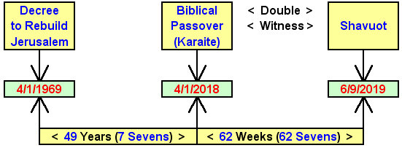

Above: YaHuWaH 's two appointed feast days of Passover and Shavuot confirm the validity of the decree of 4/1/1969 to rebuild Jerusalem.

The 70th Seven

The thought came to me after I awoke this morning that if the graphic above is indeed valid, then there must be a 70th seven (Hebrew - Shabua) to complete the graphic and the message of Daniel 9:24.

Daniel 9:24 Seventy weeks (Shabua) are determined upon thy people and upon thy holy city, to finish the transgression, and to make an end of sins, and to make reconciliation for iniquity, and to bring in everlasting righteousness, and to seal up the vision and prophecy, and to anoint the most Holy.

I looked for 7 days, 7 weeks, 7 months, and then 7 years to complete what is commonly known as "Daniel's 70th week".

Below: A graphic that shows a third witness to the decree of 4/1/1969 to rebuild Jerusalem.

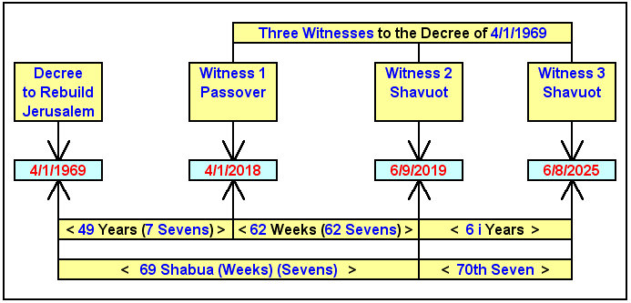

Note in the graphic above that although 62 weeks from 4/1/2018 end on 6/9/2019, 62 complete and inclusive weeks end on 6/8/2019. Also be aware that the Feast of Shavuot on 6/9/2019 begins at sunset on 6/8/2019.

Note in the graphic above that this iteration of Daniel's 70th week of sevens occupies exactly 6 inclusive years of history.

This iteration of Daniel's 70th week is not 7 years, as many think, but precisely 7 Shabua, seven observations of the Feast of Shavuot as indicated below.

Note that prophecy is cyclical and can have multiple fulfillments.

Below: A graphic showing an iteration of the seven Shabua of Daniel's 70th "seven" (week), completed in precisely 6 inclusive years.
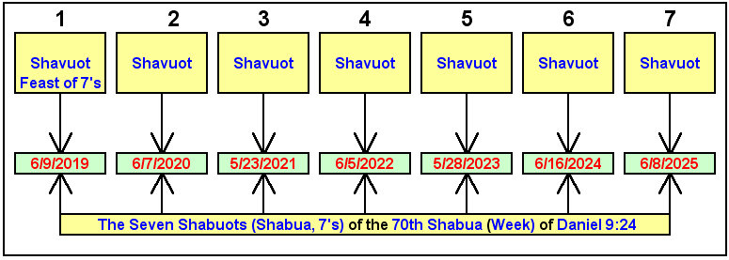
Note that YaHuWaH 's Feast of Shavuot is actually the Feast of Shabuot, spelled with a "b", the "b" being pronounced as a "v" because it's in the middle of the word. Middle b's are generally pronounced as v's, but beginning and ending b's are pronounced as b's.

Indications of the Coming Tribulation Period

YaHuWaH Elohim's Feast of Shavuot occurs at the beginning of the wheat harvest in Israel. In ancient times stalks of wheat were gathered to the threshing floor and an oxen would walk over and trample the wheat with their hooves in order to separate the chaff from the grain.

The combination of chaff and wheat was then thrown into the air and the wind would carry the lighter chaff away, leaving the useful grain to fall to the floor to be gathered into storage for food.

In some instances a device called a tribulum, a device resembling a flat wooden door with sharp flint stone knives on the bottom, would be dragged over the harvested wheat in order to separate the chaff from the wheat. The word "tribulation" is derived from the ancient harvesting machine used in the wheat harvest, the tribulum.

"Tribulation" via the tribulum accompanied the wheat harvest. The later olive, fruit, and grape harvests didn't require a tribulum, or ox hooves, to process the fruit of the trees.

However, the grape harvest did require a human being to tread the grapes and bring forth the wine (wine is a biblical symbol of blood).

Below: A graphic showing the time relationship between the USA total solar eclipse of 6/8/1918 and the end of the above iteration of Daniel's "70th Week".
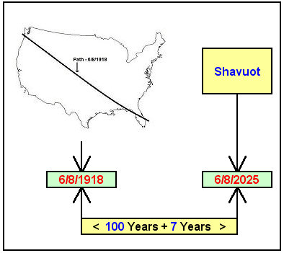

Above: In the bible, the quantity 7 denotes completeness and the quantity 100 denotes perfect completeness.

Below: A graphic that shows a curious relationship between the launch of Apollo 11, carrying the first men to walk on the moon, with the end date of the above iteration of Daniel's 70th "week".

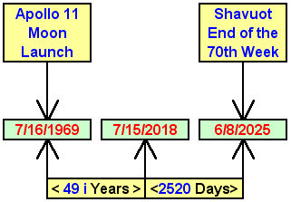

Note that in the bible, the Moon is symbolic of the nation of Israel. Israel is to reflect the light (instructions) of YaHuWaH Elohim, as the Moon reflects the light of the Sun.

The Apollo moon missions were named for Apolloyon the Destroyer Angel, Hebrew - Abaddon, the Angel of the bottomless pit.

Therefore the globally significant Apollo 11 moon mission signified Israel's first visit by Apollyon the Destroyer, the Angel who is so bad that demons want nothing to do with him.

The above message is not a prophecy. It's merely a representation of timely events that appear to relate with scripture. It is what it is.

