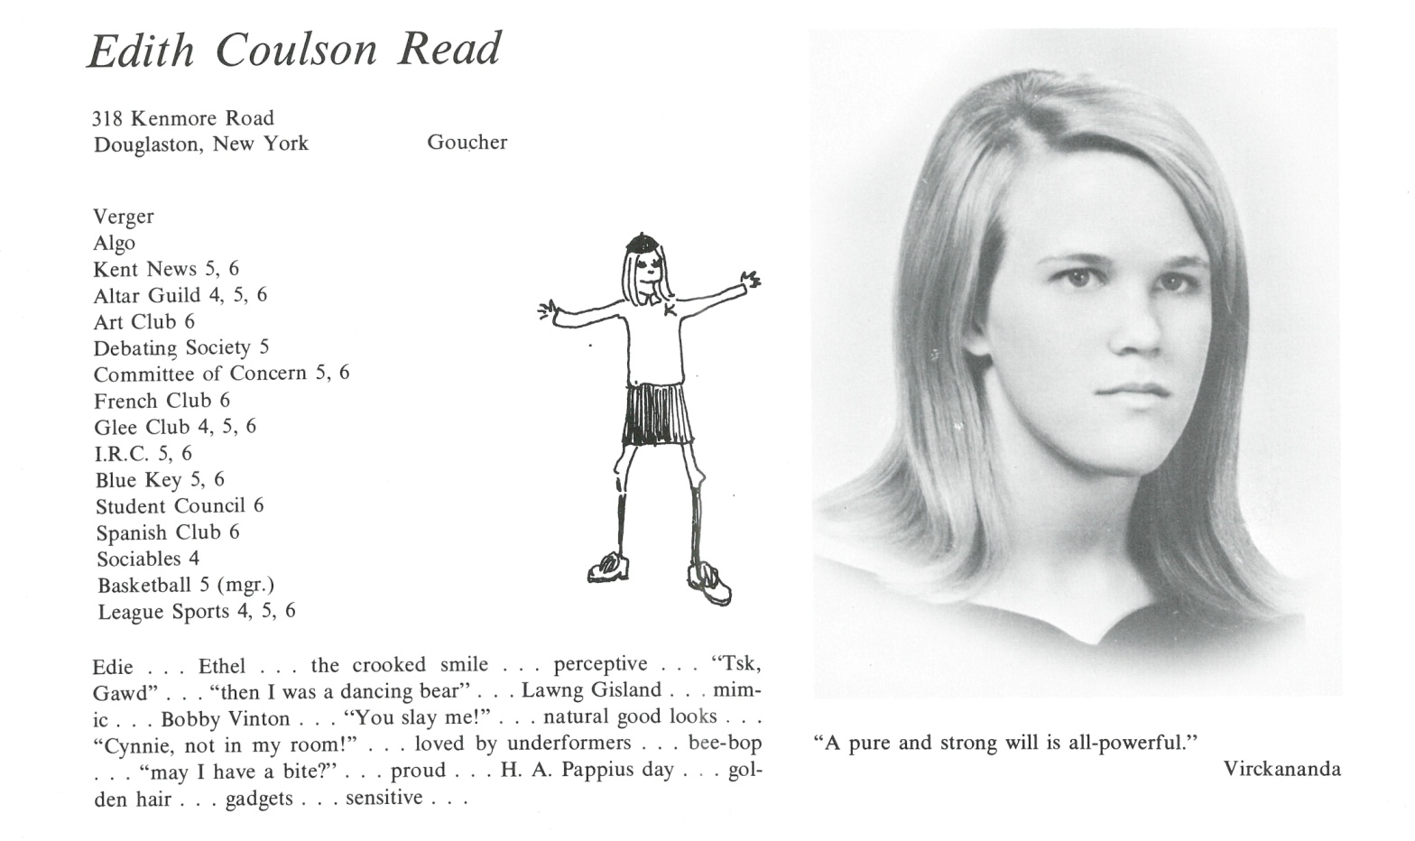

Edith C. Reed

I just realized I am (we are?) the same age as the year of our graduation – 67. Nice conjunction there.

At present I’m a working artist, retired from professing studio art at the college level and 2 years of coordinating a craft’s program at Rosie’s Place, a shelter in Boston for poor and homeless women. Came to studio art via an art history degree, then much later an MFA in painting. I’d realized in college that artists and their language were the heart of my interest in art history. It had never ever occurred to me that I or anyone else I knew would become an artist.

Marriage lasted about 18 years and 2 wonderful sons emerged – 32 and 26 years old. Sam is 32 and an opera singer (who knew??), married to another opera singer, Cecelia. I totally lucked out with Cecelia as a daughter-in-law. They will be moving to Frankfurt, Germany in Sept. for work. Jonathan is 26 and will be starting grad school in Raleigh, NC in Aug. He balances restaurant work for money, music interests, volunteering and classes. No kidding – I am incredibly grateful for and to them. I bet that sentiment is shared by a lot of us.

Those are the facts. If I say more it would be hard to know just where to stop. Gifts of the last 50 years would have to include an interest in pursuing self-awareness and appreciation of it in others, deep friendships and, not least, being startled by art – visual, literary, musical, dramatic.

One final note – thank heavens for coming up during the strife of the 60’s. We discovered then we could not take for granted that basic human rights would be distributed equally. We envisioned what *could* be and know now some jobs are never done.

Best wishes to all! Edie



______________________________________________________________

______________________________________________________________ ______________________________________________________________ ______________________________________________________________ ______________________________________________________________ ______________________________________________________________ ______________________________________________________________ ______________________________________________________________ ______________________________________________________________

Attach Picture in .jpg Format

______________________________________________________________

______________________________________________________________

___________________________________________________________________________________ _________________________________________________________________________________________________________________________________________________________________________________________________________________________________________________________________________________________________________________________________________________________________________________________________________________________________________________________________________________________________________________________________________________________________________________________________________________________________________________________________________________________________________________________________________________________________________________________________________________________________________________________________________________________________________________________________________________________________________________________________________________________________________________________________________________________________________________________________________________________________________________________________________________________________________________________________________________________________________________________________________________________________________________________________________________________________________________________________________________________________________________________________________________________________________________________________________________________________________

___________________________________________________________________________________