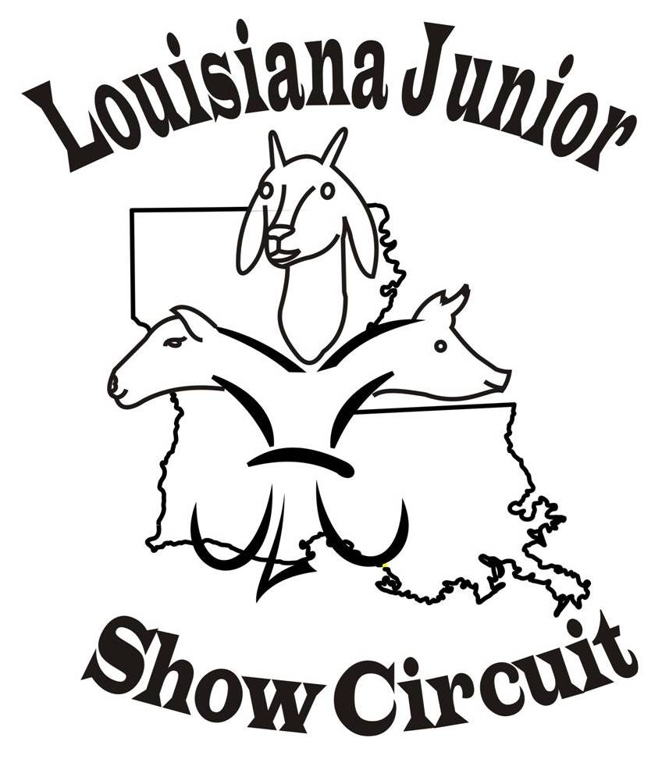
2016 LJSC SHOW Schedule

June 24th & 25th Watermelon Festival DeRidder, LA
NO LJSC SHOWS ON July 4th weekend
July 8th & 9th Red River Showdown, Coushatta, LA
July 16th Cane River Classic, Alexandria, LA
Deep South Showdown July 22nd & 23rd Claiborne Classic & Honor’s Show Clinic, Haynesville, LA
August 5th & 6th Allen Parish Showdown, Oberlin, LA
August 12th & 13th Purple & Gold Showdown, Coushatta, LA (Brandi)
August 20th Winn Sizzler, Winnfield, LA
Website (www.ljsc.org.) and facebook Louisiana Junior Show Circuit
(page and group) for updates. If interested in hosted a sanctioned show
please contact Nancy Nettles.
LJSC Contact Information
For Comments or questions concerning Louisiana Junior Show Circuit (LJSC) ~~~ Contacts:
Nancy Nettles-President Allison Landry – Secretary
(318) 932-5435 Home (337) 276-4995
(318) 455-2905 Cell (337) 201-0431
Membynancy1@aol.com AllisonLandry@aol.com

Vice-President- Lauribeth Padgett Judy Latiolais – Treasurer

Board Members: Dana Broussard, Brandi Lipsey, Stephanie Chamberlin,
Josh Johnson, Angie Baker
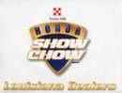

Louisiana Junior Show Circuit
Diamond Sponsor:

