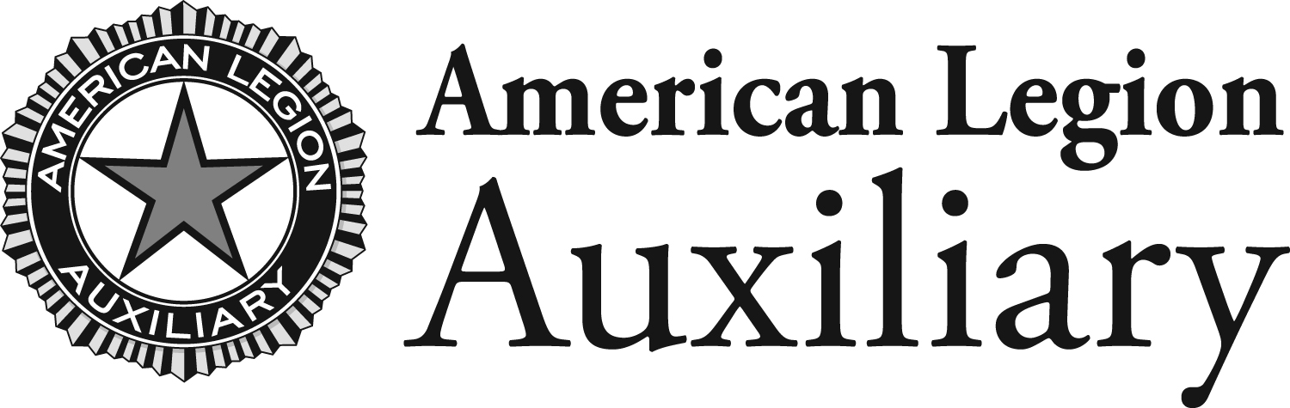

Approval Request – American Legion Auxiliary
Emblem Use

The American Legion owns the names and trademarks of the American Legion Auxiliary. The American Legion Auxiliary is entrusted by The American Legion to protect the name and official marks of the organization. Use of the emblem must be approved by the ALA national secretary for printing. The following information must be completed in full and submitted to natlsecy@ALAforVeterans.org.

Request Date:

Requesting Member Name & Unit:

State Department & Secretary Name:

Manufacturer/Vendor Name:

Vendor Address:

City: State: Zip:

Vendor Contact Email:

Name of Product(s) Emblem is to be Used on:

Intended use:

Exact Quantity of Item(s) to be Ordered*:

*Ordering new quantities requires a new authorization.

Please submit this form and include a sample or vendor proof
of American Legion Auxiliary emblem use.

For Office Use Only

Recommend Approval
Recommend Denial

Department Secretary Date

Approved
Denied

Approval (if granted), is a one-time, limited use permission granted to approve manufacture. Additional quantities/items require a new authorization.

National Secretary Date

Cc: Requester
Department Secretary
National Secretary File

© American Legion Auxiliary National Headquarters 06/2017

