RSAI Position Paper: State Supplemental Assistance (SSA) for 2018
Background: The Iowa Legislature annually determines the state cost per pupil, known as SSA, which pays for the annual cost of doing business in Iowa schools. During the 2017 Session, Iowa Code Section 257.8 was changed to require action within 30 days of the Governor’s budget, effectively one month before school district publishing deadlines and four months before the start of the school year. In 7 of the last 8 years, the rate of growth has been lower than cost increases typically experienced by school districts.
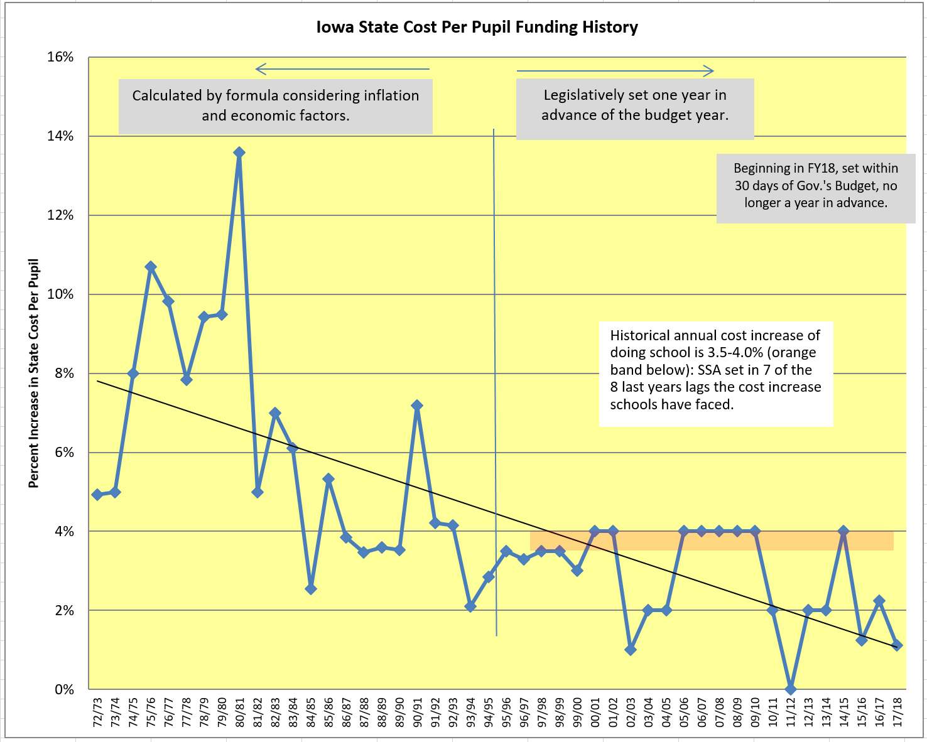
Current Reality:
- SSA for FY2018 was set at 1.11%, another historically low benchmark, although the decision was set within the new 30-day window, which was appreciated.
- Changes to collective bargaining in 2017 session gives school districts flexibility in balancing budgets, but may have the unintended consequence of making it even harder for rural districts to attract, retain, and compensate teachers and other school employees.
- Investments for the teacher leadership and compensation system are appreciated but appear to be in lieu of regular program funding. TLC has further contributed to teacher shortages, with the impact magnified in rural schools.
- Costs continue to rise, staff salaries and benefits, curriculum, textbooks, utilities, transportation, utilities, and supplies. Additional requirements demand more resources: early literacy efforts, before- and after-school programs, needy school populations, increasing STEM and CTE opportunities, computer science courses, implementation of higher expectations with a new state test and the goal to graduate every student college or career ready for a successful future.
- Since Iowa’s funding formula is based on enrollment, districts with fewer students every year are doubly challenged to provide great programs and supports. Formula funding is especially critical to rural Iowa due to transportation costs, economies of scale, unique needs of students, mandates and compliance, the need for quality AEA services, and the challenge to attract and retain quality staff in rural Iowa.
State Supplemental Assistance: Formula funding is especially critical to students in rural Iowa due to transportation costs, economies of scale, unique needs of students, mandates and compliance, the need for quality AEA services, and the ability to attract and retain staff in rural Iowa. The sustainability of a quality education in rural schools depends on the return of education as the state’s top priority with an investment of meaningful new resources to improve opportunities for students. The resurrection of this priority will take several years of significant investment while ensuring that new mandates are funded outside of the formula and not instead of it.

