3/4/2019 Signs of Babylon’s Coming Demise

Signs of Babylon's Coming Demise

This article is short but important. The society of the United States of America and the entire world is now changing rapidly. The information below is revealed to us by YaHuWaH Elohim so that we might more fully understand the extremely dangerous times we're in the process of entering.

The names Kim Jong Un and Ilhan Omar have been aquiring a lot of major media attention lately.

Ilhan Omar is a newly appointed (1/3/2019) Muslim congress woman who has been making anti-semitic remarks. She might be removed from the media spotlight soon, but the attention she has received lately sparked an investigation into her relationship with the end times timeline of events below.

YaHuWaH Elohim works in the affairs of nations, ordains births and deaths, etc.
It has been noted in previous articles that the number 2520 was encoded into the Handwriting on the Wall that the prophet Daniel decoded for the King of Babylon on the evening of October 11, 539 BC. Babylon was taken over that very night by an army of Persians who had secretly entered the city underneath the wall on a riverbed. Info link: https://www.joybysurprise.com/it-s-all-about-the-walls.html

Below: It happens that Muslim congress woman Ilhan Omar was born on October 4, 1981, the very first day of the 2520th year from October 11, 539 BC.

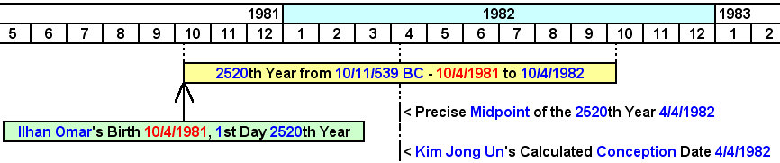

Above: Kim Jong Un and Ilhan Omar share an intimate and curious timing relationship with the Handwriting on the Wall and the fall of ancient Babylon 2520 years (920,410 days) earlier in 539 BC. The 2520th year from 539 BC begins on October 4, 1981, not October 11, 1981, because of the change from the Roman Julian calendar to the Roman Gregorian calendar in 1582 AD.

Below: Birth dates and calculated conception dates for Kim Jong Un and Ilhan Omar.

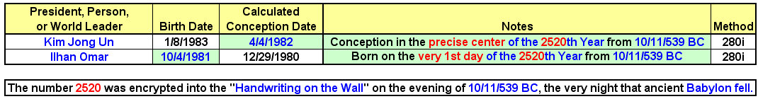

The current major media attention might move away from the politically active people mentioned above, but remember that the Handwriting on the Wall, written by a supernatural hand in ancient Babylon cryptically pointed directly and precisely to those very people. Just something to keep in mind as we move into the future.

May YaHuWaH Elohim have mercy on us all.

