Book Giving Partners

WIC (Women, Infants, & Children) of Summit County
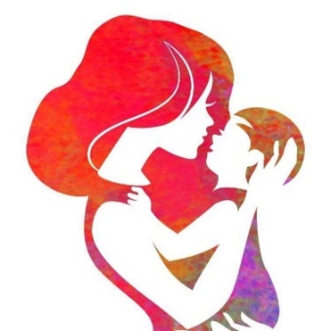
WIC (federal program) is a nutrition education program-operated by Summit County Public Health-that provides supplemental nutritious foods that promote good health for pregnant women, new mothers, breastfeeding moms, and parents with infants and children up to age five.
Bright Star Books gives books to WIC’s child clients twice a year during their clinic visits. Also, our program coordinator reads to children at WIC clinics weekly and distributes books about at WIC Farmers’ Markets and WIC and SCPH (collectively)-sponsored baby showers.
https://www.scph.org/wic
https://odh.ohio.gov/wps/portal/gov/odh/know-our-programs/wic-farmers-market-nutrition-program/resources/wic-farmers-market-nutrition-program

WIC (Women, Infants, & Children) of Portage County
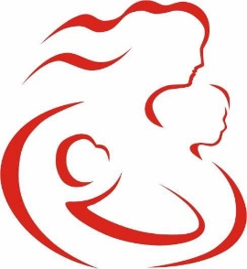
Bright Star Books supplies each child client with one age-appropriate book per visit, provides children with holiday-themed books during holiday seasons (Halloween, Thanksgiving, and Christmas), and distributes books to children at WIC-sponsored events (e.g., Farmers’ Markets).
https://www.co.portage.oh.us/women-infants-children-wic
https://odh.ohio.gov/wps/portal/gov/odh/know-our-programs/wic-farmers-market-nutrition-program/resources/wic-farmers-market-nutrition-program
WIC (Women, Infants, & Children) of Medina County
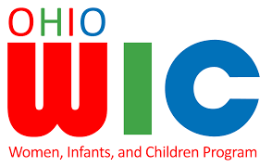
Bright Star Books supplies each child client with one age-appropriate book per visit, provides children with holiday-themed books during holiday seasons (Halloween, Thanksgiving, and Christmas), and distributes books to children at WIC-sponsored events (e.g., Farmers’ Markets).
https://medinahealth.org/people/wic/
https://odh.ohio.gov/wps/portal/gov/odh/know-our-programs/wic-farmers-market-nutrition-program/resources/wic-farmers-market-nutrition-program

Akron Public Schools
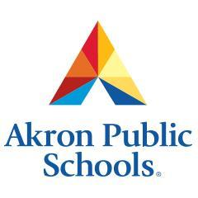
Akron Public Schools (APS), the fifth largest district in Ohio, offers innovative curriculum and programs that help prepare children and teenagers living in Akron for the real-world.
Bright Star Books has hosted 7 free book fairs-at elementary schools in the APS system-at which students, with assistance from their teachers and our volunteers, pick and keep five age-appropriate books that interest them, at no cost to them and their schools.
https://www.akronschools.com/

Summit County Public Health
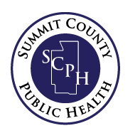
The goal of Summit County Public Health (SCPH) is to protect and advance the health of the entire community through its policies, programs and activities that protect the safety, health and wellbeing of Summit County residents.
Bright Star Books stocks the bookshelves of the SCPH Dental and Immunization Clinics, and partakes in SCPH-sponsored events (e.g., Farmers’ Markets and baby showers).
https://www.scph.org/
https://www.scph.org/dental
https://www.scph.org/immunizations

Access Homeless Shelter
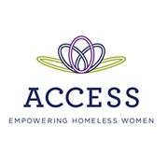
Access Homeless Shelter (AHS) is dedicated to addressing the struggles of homeless women and children in Akron by offering a safe and supportive environment and programs that provide advocacy, housing, and empowerment.
Our program coordinator reads to children at AHS weekly through our Story Time program.
https://www.access-shelter.org/

The City of Akron
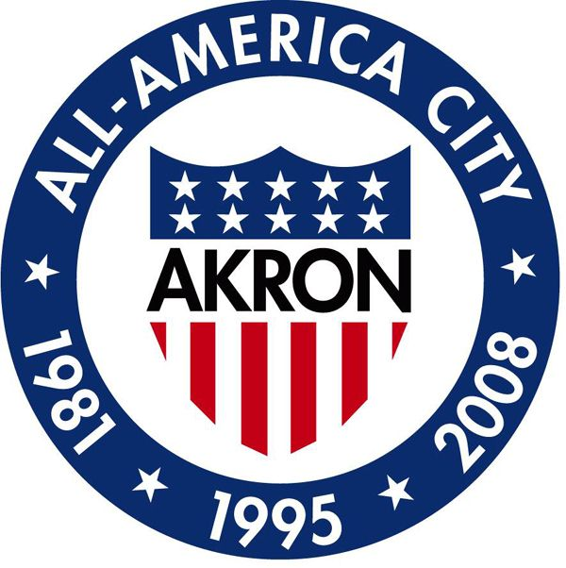
The Summer Reading Program involves community volunteers helping Kindergarten, first, and second grade children enrolled in Akron Public Schools practice their reading skills throughout the summer. The City of Akron, Summit Education Initiative, University of Akron’s Experiential Learning Center, and Akron Public Schools collectively administer the program.
Bright Star Books has provided over 7,000 books for the Summer Reading Program since 2015.
https://www.akronohio.gov/

Urban Vision
Urban Vision (non-profit) spreads gospel through its outreach/educational programs, and provides financial coaching and necessities (during Christmas time) to families in need.
Bright Star Books gives bags of 4-5 books annually to the (usually 50) students enrolled in Urban Vision’s “On Your Mark Program,” which helps immigrant children catch-up on their Kindergarten readiness skills.
http://www.urbanvisionministry.org/

Early Head Start of Summit County
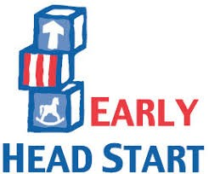
Early Head Start (EHS) (federal program) provides high-quality early childhood education for limited-resource infants, toddlers, and preschoolers living in Summit County.
Twice a year, Bright Star Books provides 16 bags of infant-appropriate books for toddlers enrolled in EHS of Summit.
https://www.ca-akron.org/head-start

The Highlands Teen Pregnancy Shelter
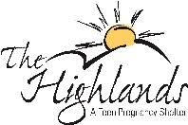
The primary purpose of The Highlands is to provide residential services for adolescent girls who are pregnant or parenting an infant and find themselves homeless. Girls ages 14 through 20 may enter the program at any time during their pregnancies or with their infants, and may remain in residency until their babies reach 3 years of age. The Highlands is part of Shelter Care, Inc.
Bright Star Books built the pilot library at The Highlands, and partners with The Highlands to give personal children’s libraries to their clients as they transition to independent living.
http://www.sc72.org/programsministries/the-highlands/

Good Neighbors of Goodyear
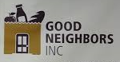
Good Neighbors of Goodyear (non-profit organization) runs a major food pantry in Akron that accommodates the various dietary needs of limited-resource families living in Akron.
Bright Star Books regularly supplies its clients with young adult and adult books, as well as children’s books in fair condition.
http://www.good-neighbors.org/good-neighbors-central-office.html

Good Neighbors of Green
Good Neighbors of Green (non-profit) provides limited-resource families with food, clothing, furniture, hygiene items, toys, decorations, and electronic devices for free.
Bright Star Books regularly supplies its clients with young adult and adult books, as well as children’s books in fair condition.
http://www.good-neighbors.org/good-neighbors-green.html

Court-appointed Special Advocates of Summit County
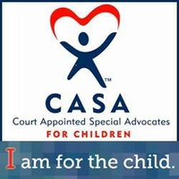
Court-appointed Special Advocates of Summit County (CASA) recruits and trains community members to advocate for abused and neglected children, both inside and outside of court.
We provide CASA’s twelve through seventeen-year-old clients with young adult books.
https://summitcasagal.org/

East Community Learning Center
East Community Learning Center (East CLC) is one of several groundbreaking high schools in Akron Public Schools. It offers students vocational programs, tutoring, experiential learning opportunities, and advanced placement courses.
Bright Star Books regularly supplies the students enrolled in East CLC with young adult books.
https://eastclchigh.akronschools.com/

Catholic Charities of Summit County
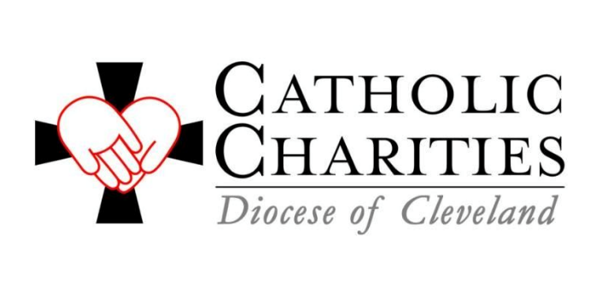
Catholic Charities of Summit (non-profit organization) provides various services for limited-resource families in Summit County, including; adoption/foster care, childcare, domestic violence assistance, marriage/family counseling, support for immigrants/refugees, employment and emergency assistance, and youth education, activities and athletics.
We provide the clients of Catholic Charities of Summit with Christian-themed books.
https://ccdocle.org/summit-county

Catholic Charities of Medina County
Catholic Charities of Medina County (non-profit organization) provides counseling, disability assistance, parental education, early interventions services, social and emotional education for young adults, and elder care for communities with the greatest needs in Medina County.
We provide Catholic Charities of Medina’s clients with Christian-themed books.
https://ccdocle.org/facility/catholic-charities-medina-county

Catholic Charities of Portage County
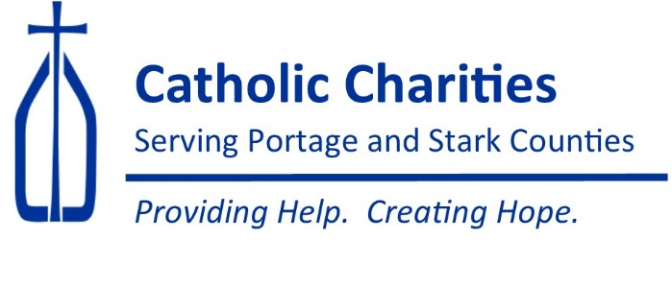
Catholic Charities of Portage and Stark Counties (non-profit organization) serves limited-resource families in both counties. However, Bright Star Books only supplies books for the Catholic Charities of Portage because (currently) we only serve Greater Akron. The organization supplies women with professional clothing, donates furniture, provides emergency assistance and food (in addition to its several other services for people in need).
We provide Catholic Charities of Portage County with Christian-themed books.
https://www.ccdoy.org/locations/catholic-charities-serving-portage-stark-counties/

Jewish Family Services
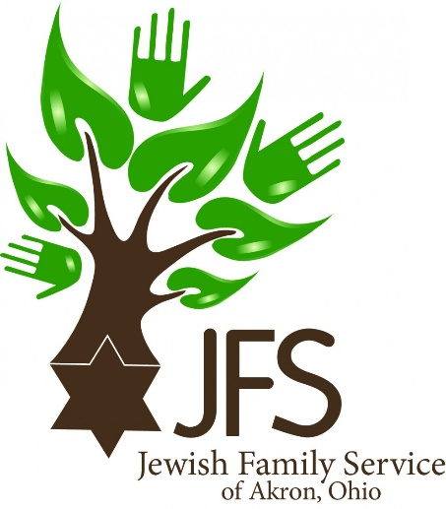
Jewish Family Services (JFS) of Akron (non-profit) provides education, counseling, and care management to help adults who are 45 years old and older and their families improve their emotional, social, and mental wellbeing. JFS’s services align with Jewish values, however the organization serves Jewish and non-Jewish people in Greater Akron.
Bright Star Books gives JFS Jewish-themed books.
https://www.jfsakron.org/

Kids-Play Childcare Learning Center (Kids-Play)
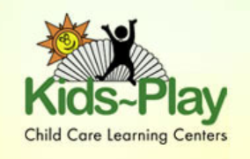
Kids-Play Childcare Learning Center provides childcare for infants and toddlers, programs for school children, and is a preschool. The center fosters a safe and fun environment to meet each child’s physical and emotional needs and nurtures children’s ideas and interests.
Bright Star Books gives Kids-Play workbooks and coloring books.
http://www.kidsplaychildcare.com/

