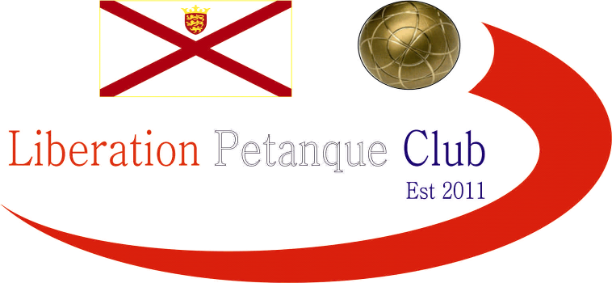

2025
Charity Triples Open

Just 4 teams took part in this year’s competition, entries and helping raise money towards their own nominated Charities.

Round one was probably the closet round as Geoffroy, Callum & Andrew just beat John, Gavin & Ross to 11. Whilst a 13 – 7 win for Gary, Wendy & Brian over Daniel James & Keith.

Round 2 saw John, Gavin & Ross just get over the line this time 11 – 10 over Daniel, James & Keith whilst Geoffroy, Callum & Andrew beat Gary, Wendy & Brian to 4.

Round 3 saw Geoffroy, Callum & Andrew make it three wins from three against Daniel, James & Keith whilst Gary, Wendy & Brian beat John, Gavin & Ross to make the final.

Congratulations to Geoffroy Buffetrille & Callum Stewart & Andrew Bellamy-Burt who won a close final 13 - 11 over Gary Cowburn & Wendy Ritzema & Brian Harris.

Gavin Scott & John Lane & Ross Churchill took third over Daniel & James Villalard & Keith White.

Well Played everyone and thank you for taking part helping raising money for their charities.

£60 - (DURRELL WILDLIFE TRUST)
£36 - (EDS-UK)
£24 - (Mustard Seed Jersey)

WINNERS

Andrew Bellamy-Burt, Geoffroy Buffetrille & Callum Stewart

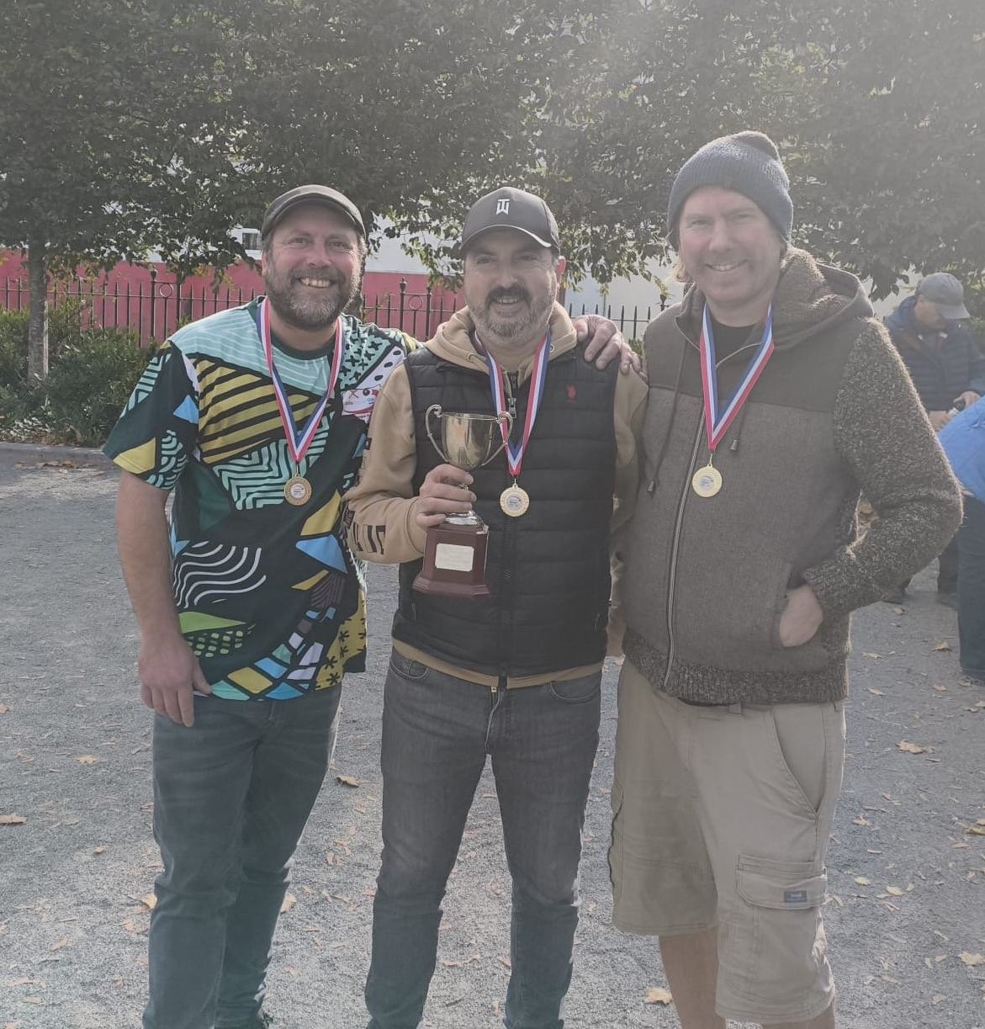

Special thanks to everyone who took part in the competition and helped raise money for a good cause and also those who donated and helped organise the competition.

Kind Regards

Toby Northern

Chairman

Liberation Petanque Club

