Kiley’s “Fish Finz” Sculpin

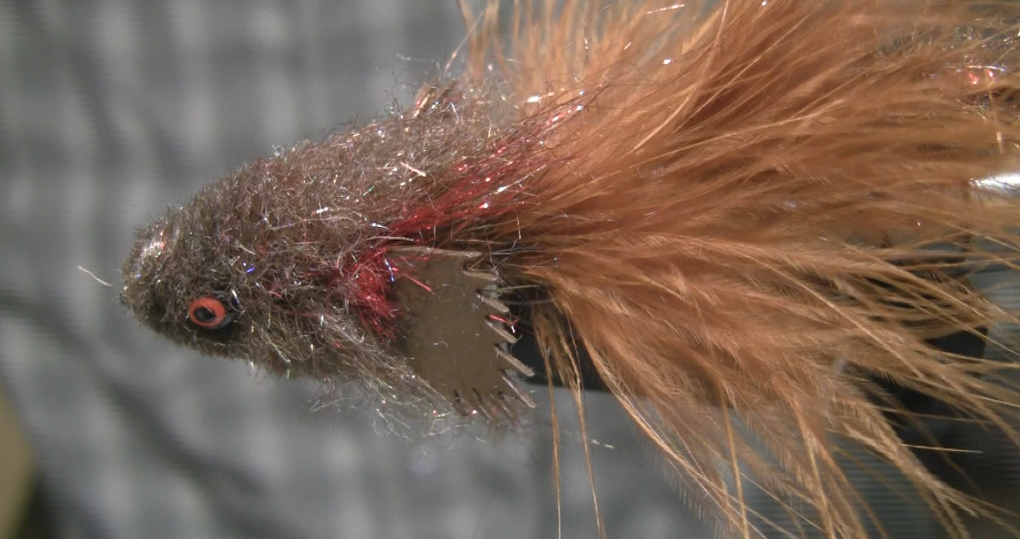

Kiley’s Fish Finz are available in three sizes and a variety of colors. This fly is a articulated sculpin pattern and with the addition of the “Fish Finz” to make the fly more realistic looking.

Kiley’s Fish Finz Sculpin
Back Half
Hook: Diachii 2461, U301 Size 2
Thread: Veevus Brown 8/0
Tail: Fish Finz
Base: Brown Ice Dub or Haretron
Body: Complex Twist – Using:
Orange and Olive Schlappen
Dubbing Loop with Senyo’s Dubbing crusty nail
Head: Rusty Marabou

Front Half:
Hook: Diachii 2461, U301 Size 2
Thread: Veevus Brown 8/0
Eyes: Dumbell Eyes Orange with Black Pupil
Tail: Rusty Marabou
Base: Brown Ice Dub or Haretron
Body: Complex Twist – Using:
Orange and Olive Schlappen
Dubbing Loop with Senyo’s Dubbing crusty nail
Fins: Fish Finz
Gill Plates: Red Ice Dub
Head: Wool

Articulation Joint
Wire: Beadlon 19 strand
Beads: 2 Copper Brass beads sized for a size 3.0mm.
Back Half
- Start by attaching the thread at the hook eye and lay down a thread base to the ben of the hook.

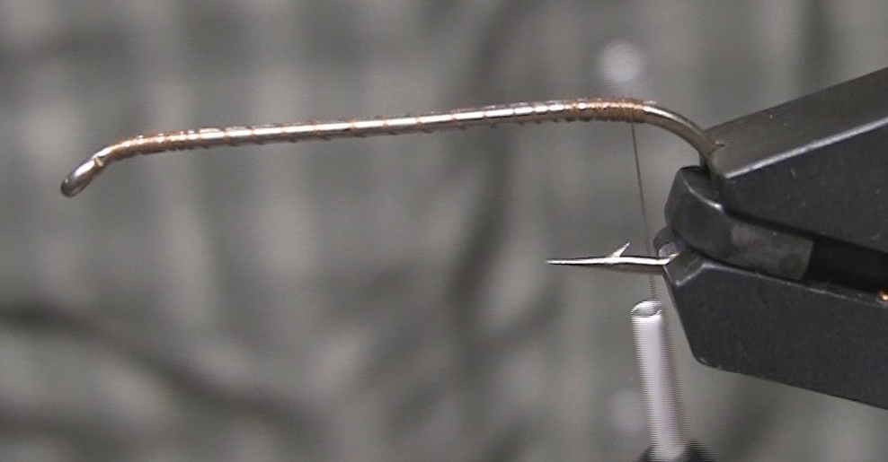

- Add dubbing to create a base for the fly. Dub to the 50% point and then return the thread to the bend of the hook.
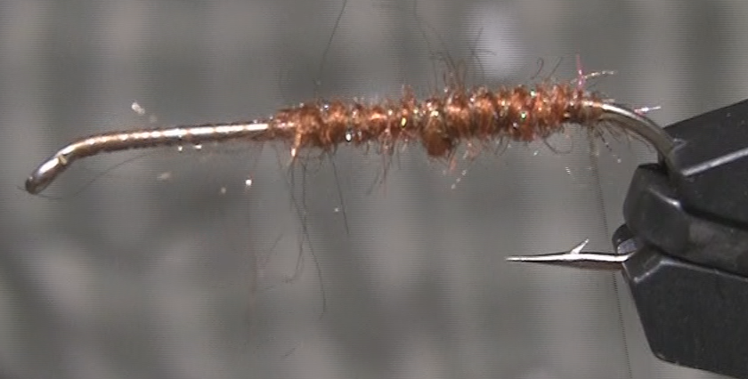

- Tie in the Fly Finz tail. Return the thread to the bend of the hook.
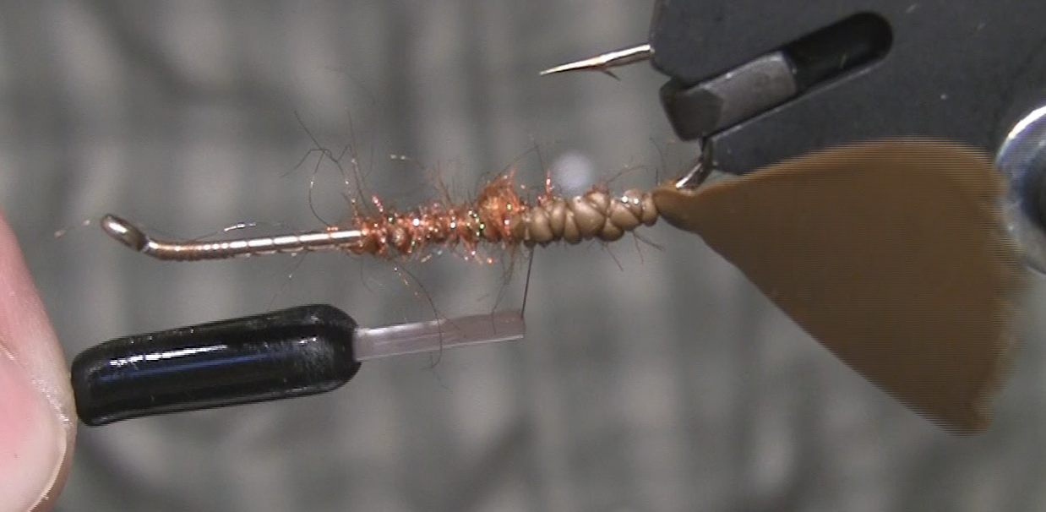

- Tie in one Olive and one Orange piece of schlappen by the tips.

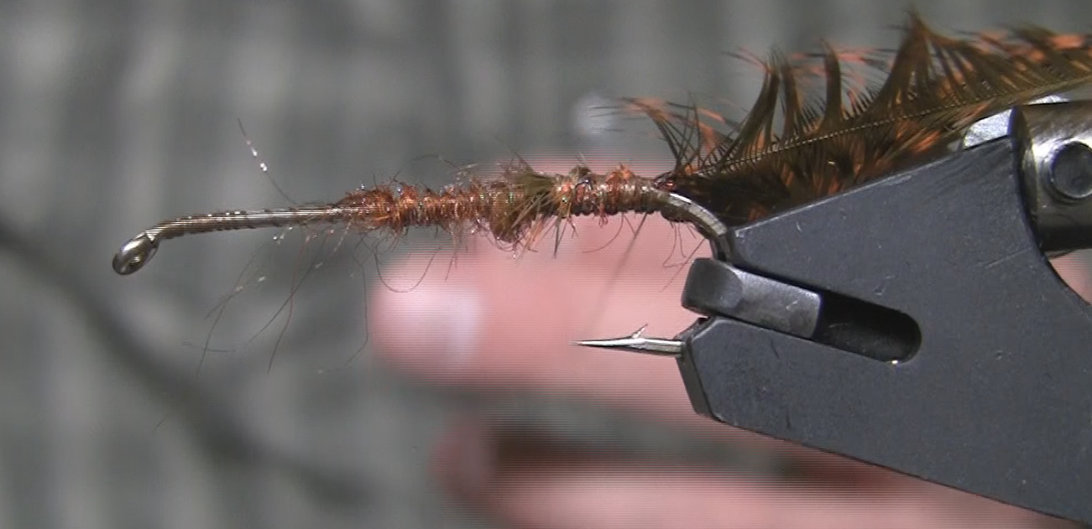

- Create a dubbing loop at the bend of the hook and then palmer the thread to the 80% point of the hook.
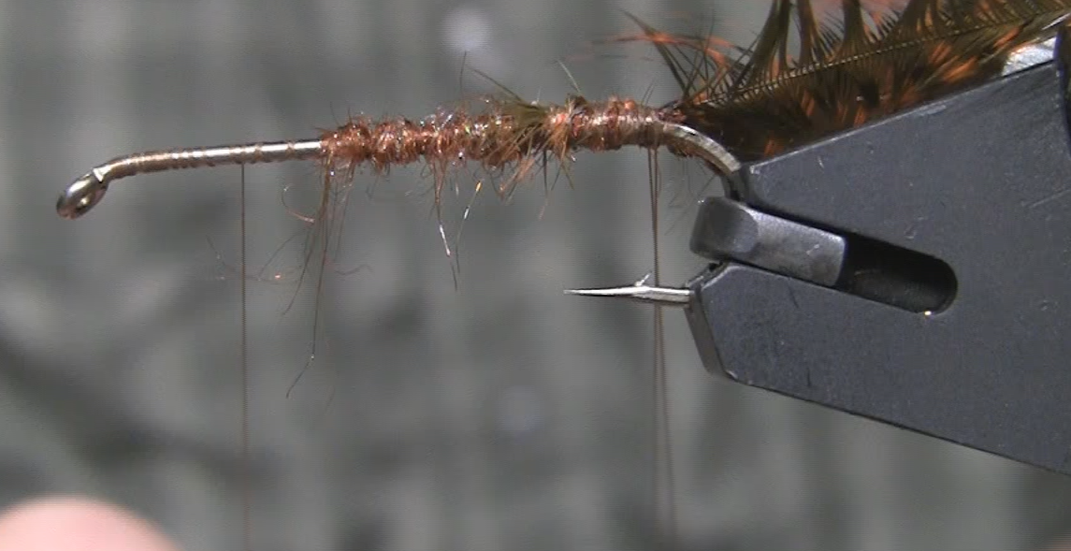

- This step has several sub steps to create the complex twist:
  - Add Senyo’s dubbing (or ice dub) to the dubbing loop and spin the loop. Brushing the dubbing out while spinning.
  - Next gather the schlappen and the dubbing loop and twist them together to create a hackle and dubbing brush. Brush out the dubbing and hackle to free up trapped fibers.
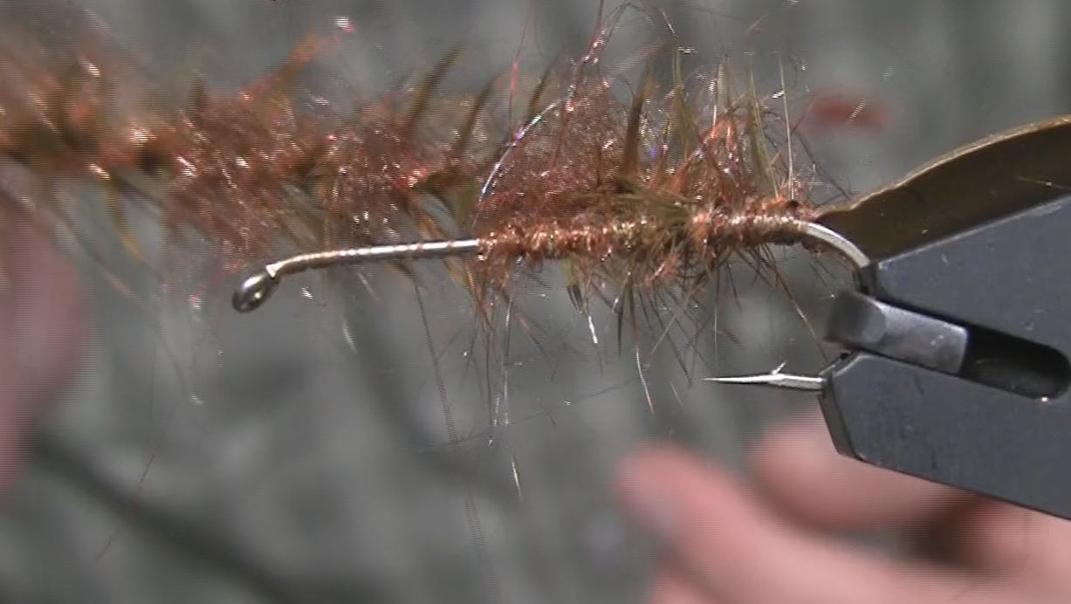

- Wrap the complex twist forward using a Palmer or spiral wrap. Use a brush to brush out the body.
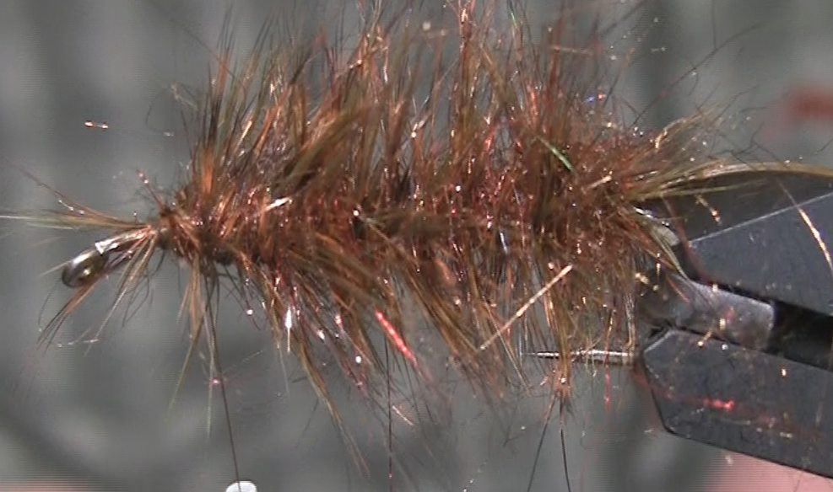

- To finish the back half of the fly use clumps of marabou on top and bottom of the hook. Whip Finish and use Loon UV to secure the head of the back half of the fly.
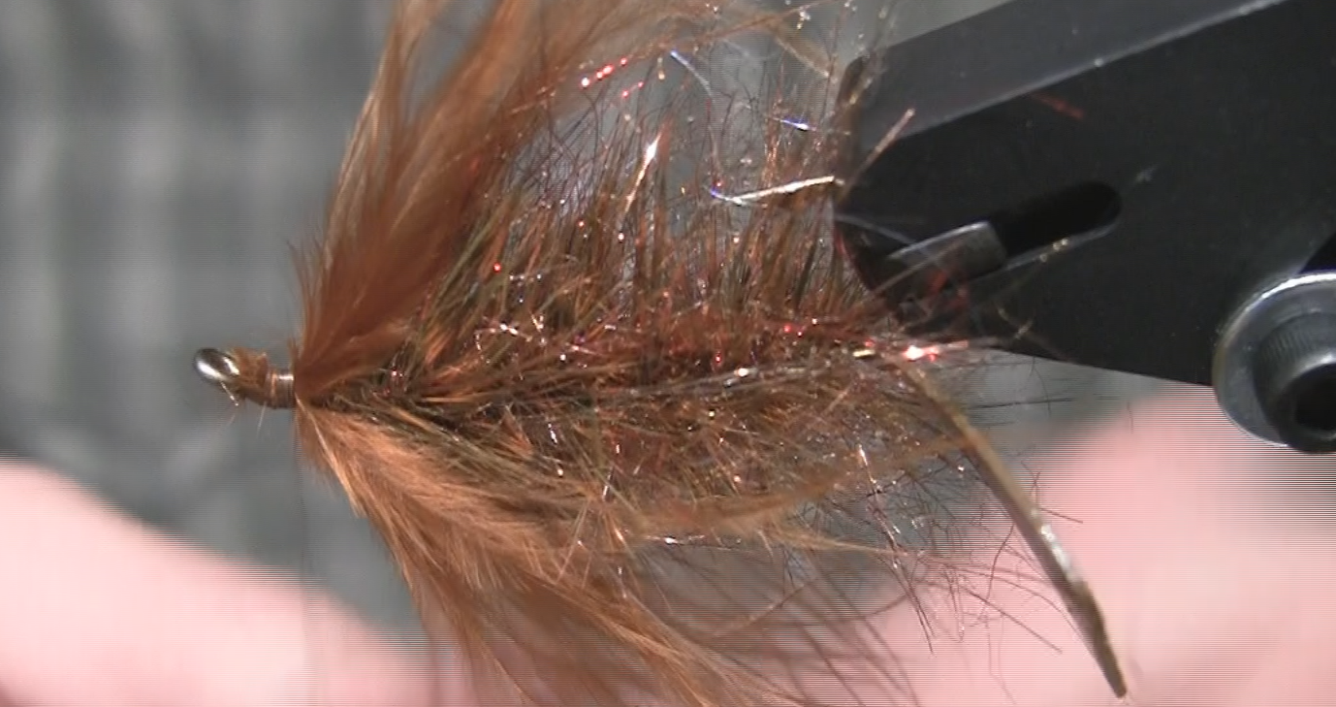

Front Half
- Mount the hook in the vise and create a thread base starting at the hook eye back to the 80% point of the hook
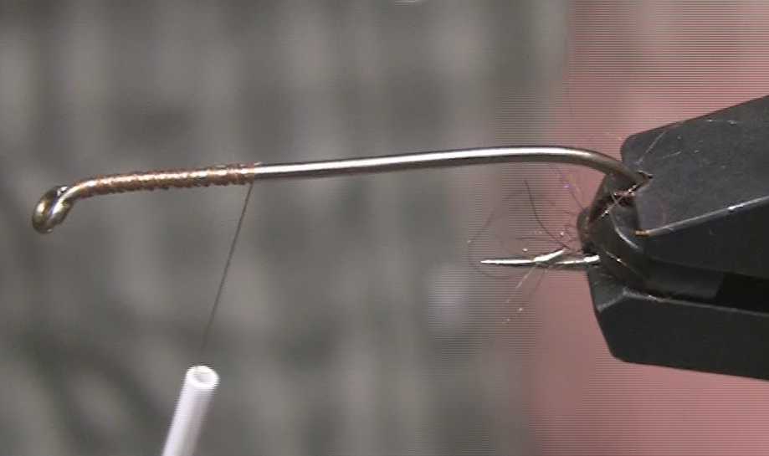

- Mount the dumbbell eyes at the 90% point on the bottom side of the hook using figure 8 wraps.
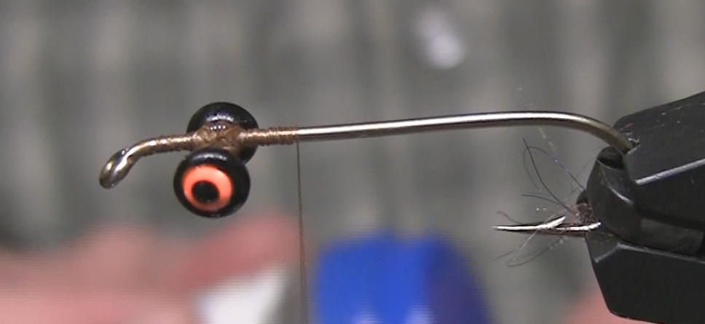

- Tie in the articulation wire on top of the hook and wrap down onto the bend of the hook. Leave the thread behind the dumbbell eyes.
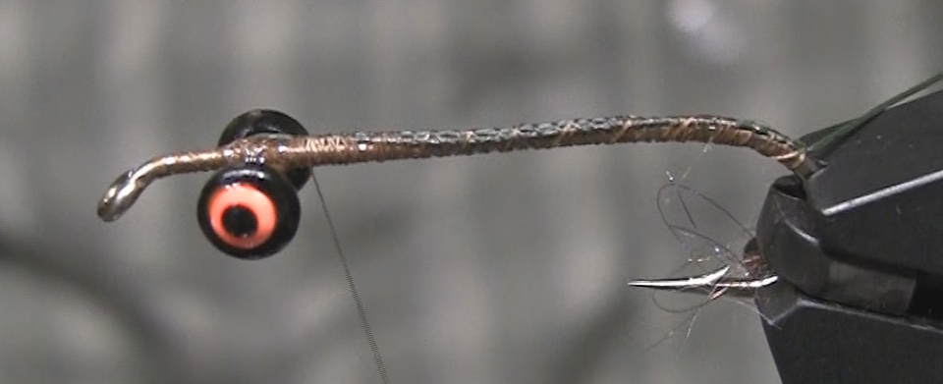

- Run the wire through the two copper brass beads and then through the hook eye of the back half. The wire will then pass back through the beads and tie the tag end down working the thread back to the hook bend.
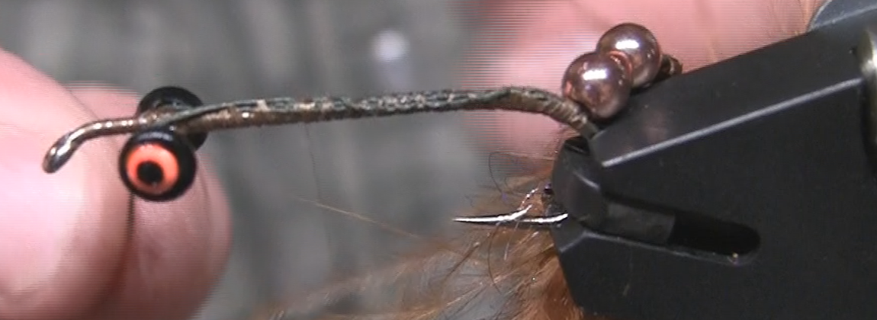

- Tie in a clump of Rusty Marabou at the hook bend on top and bottom of the hook. This will help to conceal the articulation joint.
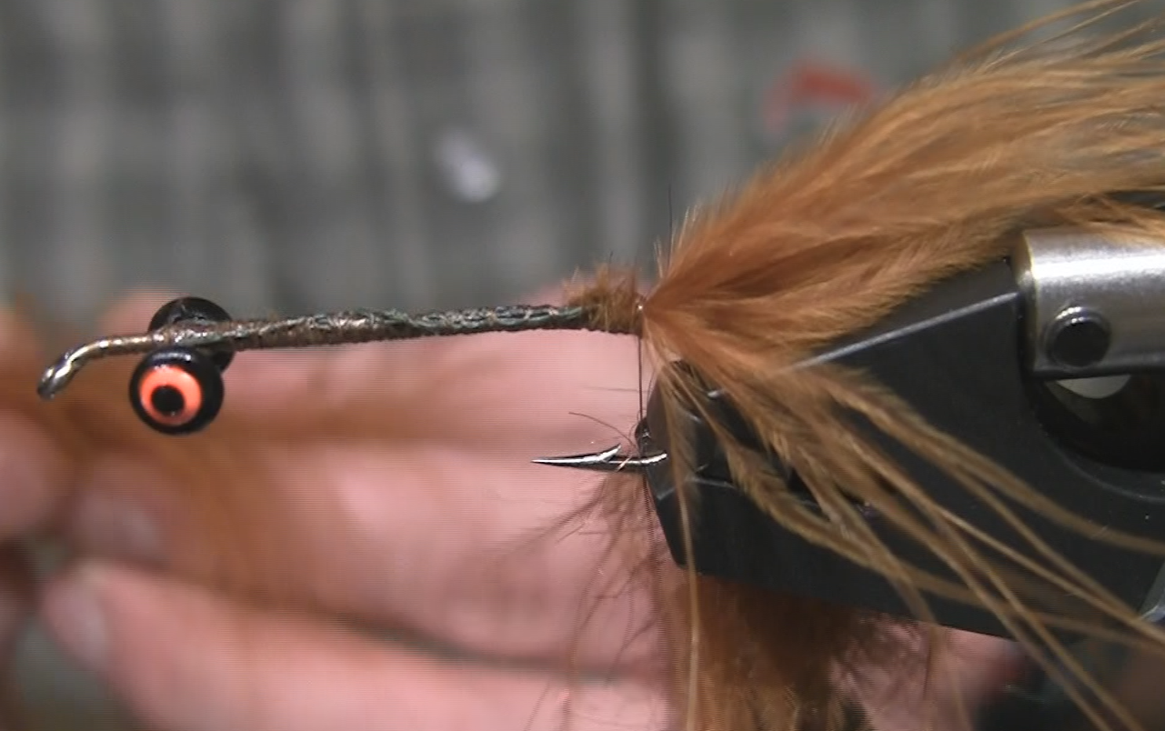

- Tie in Olive and Orange schlappen by the tips
- Create a Dubbing Loop using the same Dubbing as used on the back half
- Create a complex twist like we did for the back half.
- Palmer wrap the complex twist forward to and leave a three to four hook eye width behind the dumbbell eyes. We need to leave room to tie in the Fish Finz
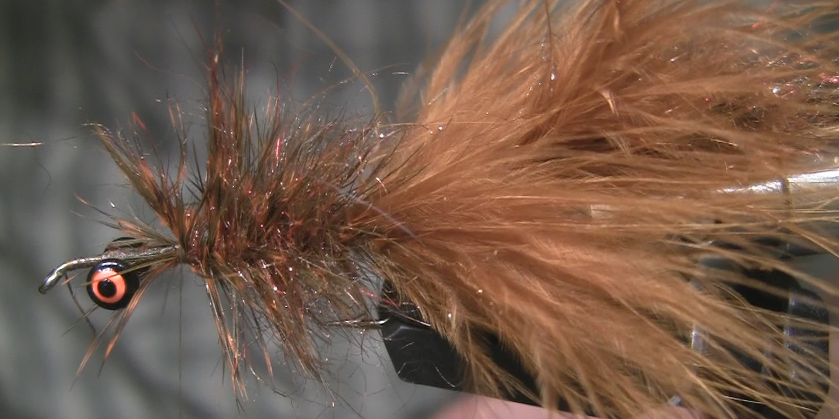

- Tie in the Fish Finz on each side of the hook.
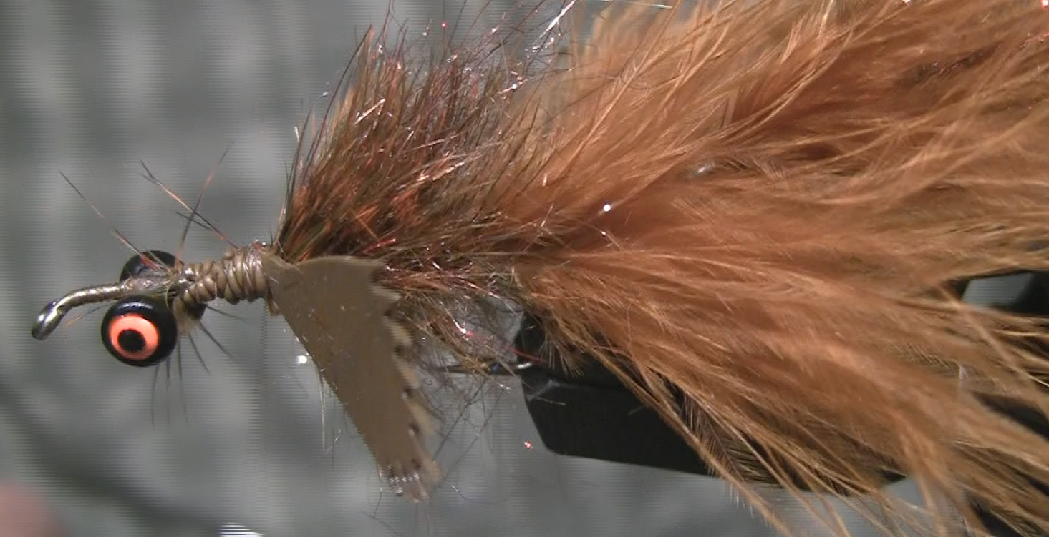

- Add a clump of red ice to each side of the hook just in front of the Fish Finz. Just Lay the dubbing where you want it and tie it in.
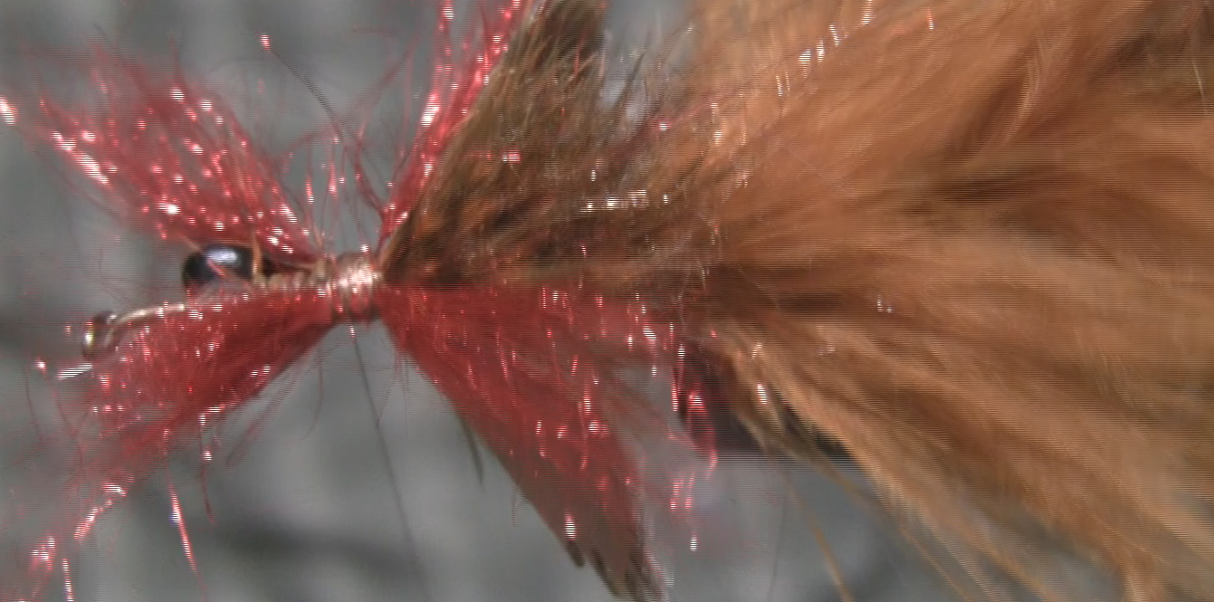

- Stack Either Dubbing or Wool to Create the head. Pull the Fibers so that there are aligned. Lay the wool on the hook behind the dumbbell eyes and ties in. Repeat for the bottom of the hook. Pull The wool back and make several wraps behind the dumbbell eyes.
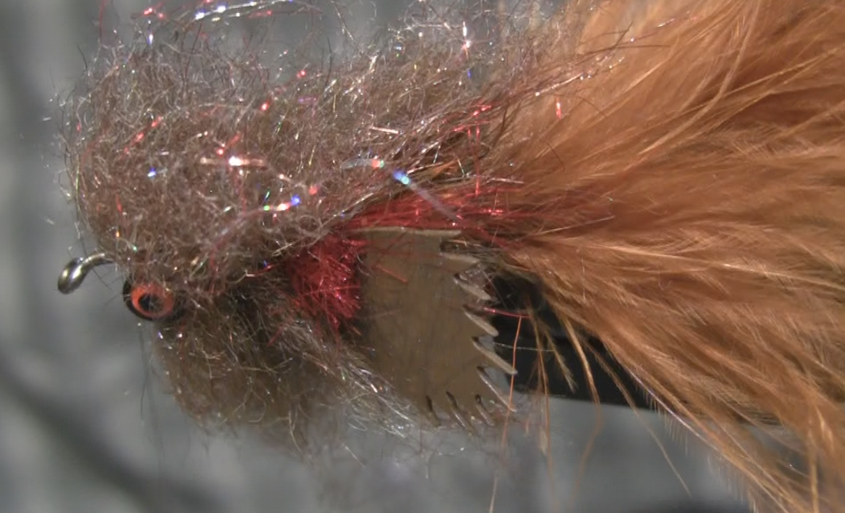

- Repeat the previous step in front of the dumbbell eyes and then whip finish. When you done you will have this big hairy clump of the front of the fly.
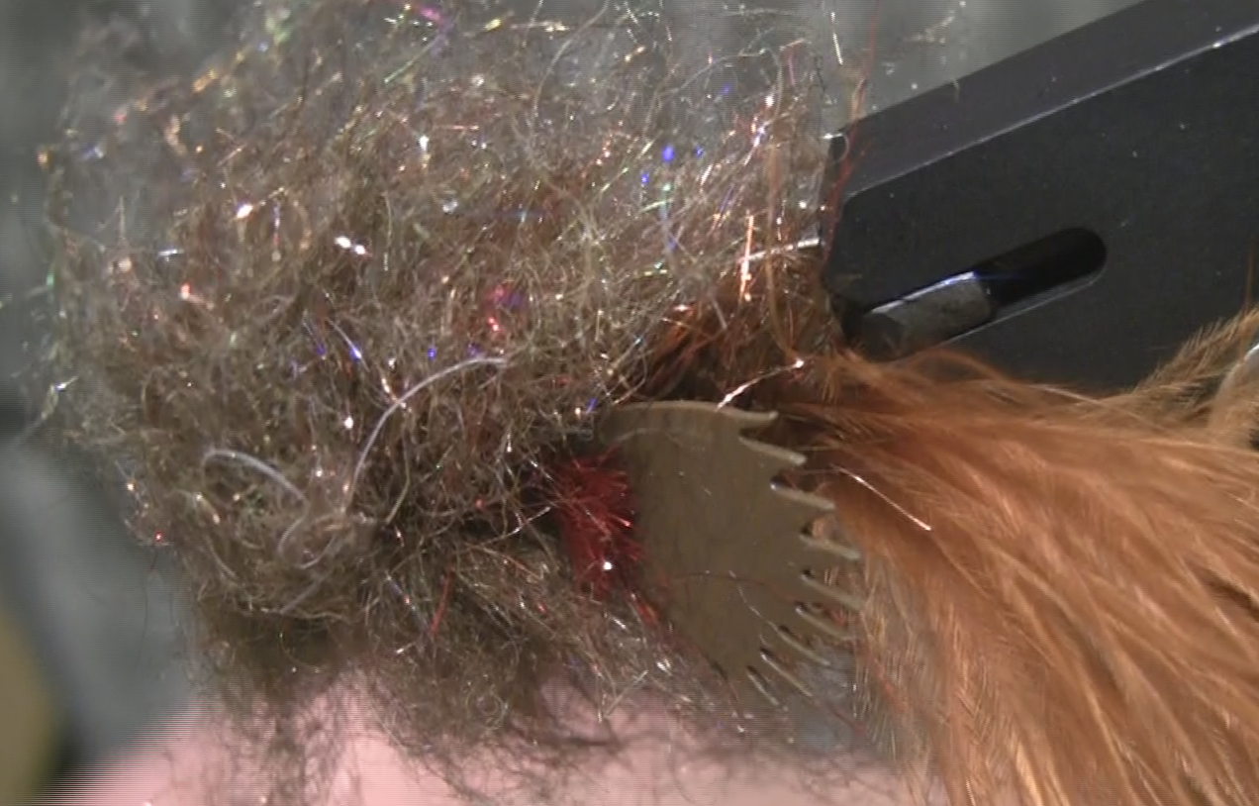

- Time to use the scissors and give this fly a haircut and make him more presentable. Just trim a nice tapered head for the fly.
