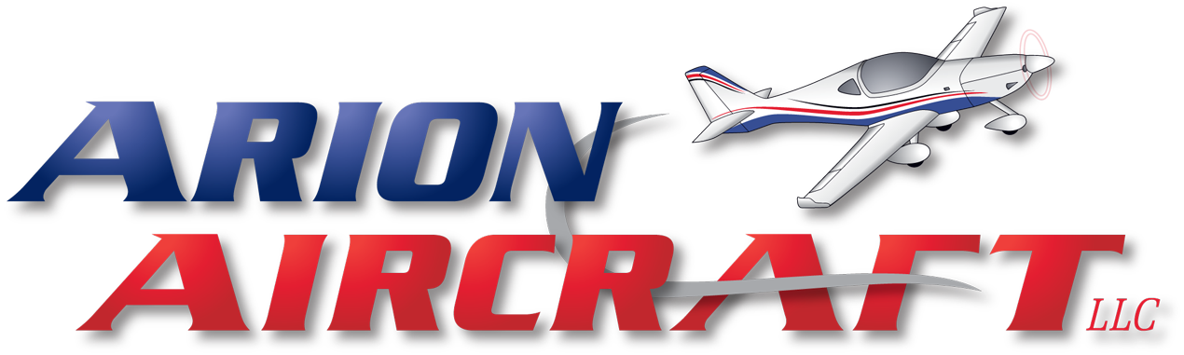
Service Request
Date of Initial Request |  |  |  |  |  | Request from Owner or Mechanic
Owner’s Name
Contact Number |  |  |  | Email:
Mechanic Name / Company
Mechanic Contact # |  |  |  | Email:
Engine Serial Number |  |  |  | Total Time:
Aircraft Make |  |  | Model: |  |  |  |  | N#:
 |  | Describe Observed Concern
Circle all items included
Carburetor | PD42J / 94-40 / TBI
Exhaust | Muffler / Extractors
Oil Cooler | Cooler / Adapter / Thermostat / Hoses
Starter | Motor / Clutch
Throttle | Arm / Extension / Farrell
Intake | Plenum / Pipes
Ignition | Caps / Leads / Magnetos / Rotec /  Jabiru Cold Start
Alternator | Jabiru / Rotec / B&C
Engine received on or in | Pallet / Tire / Box
Air Ducts | Gen 1 / Gen 2 & 3 / Gen 4
Fuel Pump | Jabiru Pump / Block Off Plate
Prop Flange | Prop bushings / Hub
Logbooks | Engine / Airframe / Prop

