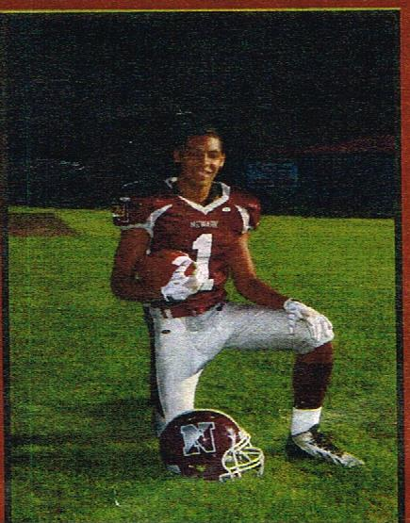

A signing ceremony was held on February 5, 2014 for Newark athletic standout Micah Wright. Micah received a full scholarship to play football at the University of Maine. Congratulations Micah!

