## St. Luke’s Episcopal Church

## The First Sunday after the Epiphany

## (Baptism of Our Lord)

## 9 January 2022  10:00 A.M.

### Holy Eucharist

The Reverend Michael L. Delk, *Celebrant & Preacher*

***Thank you for abiding by our social distancing policies, and for wearing a mask over nose and mouth for the entirety of the time you are on St. Luke’s campus.***

#### **THE WORD OF GOD**

**Organ Voluntary “When Jesus went to Jordan’s stream” J. S. Bach**

**Processional Hymn**

**“Brightest and best are the sons of the morning” Hymnal, 117**

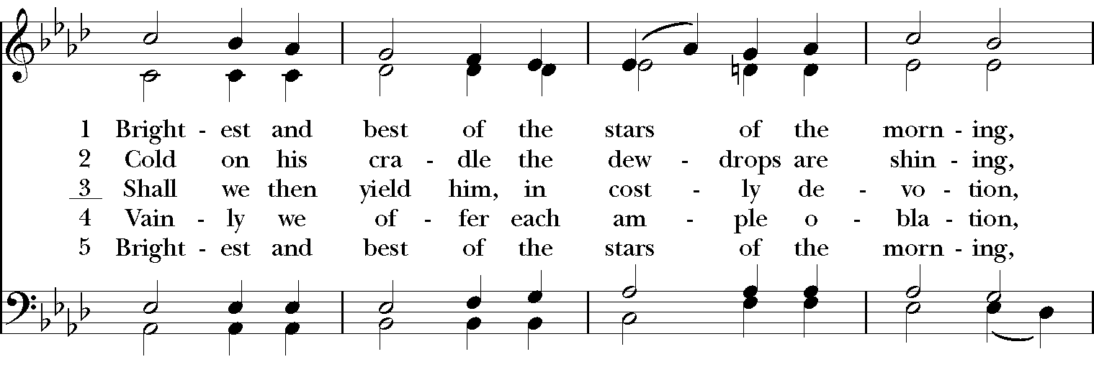

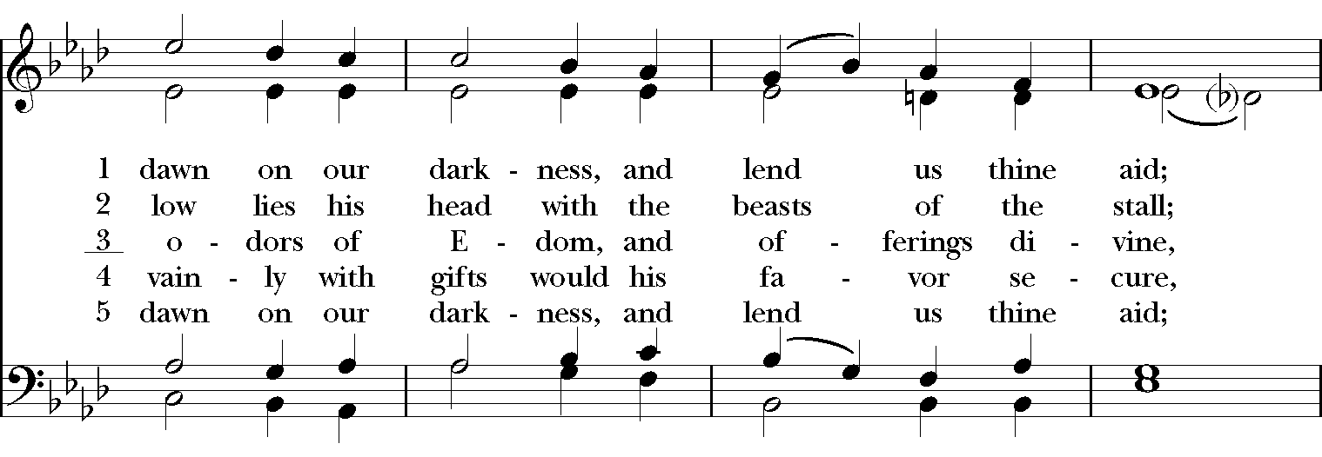

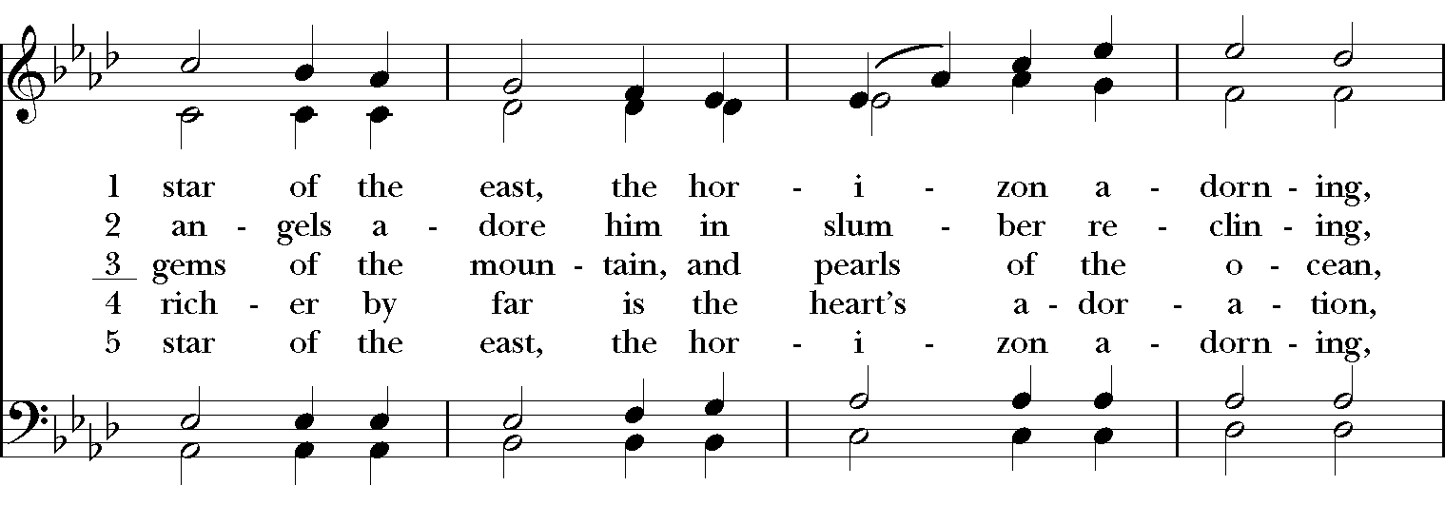

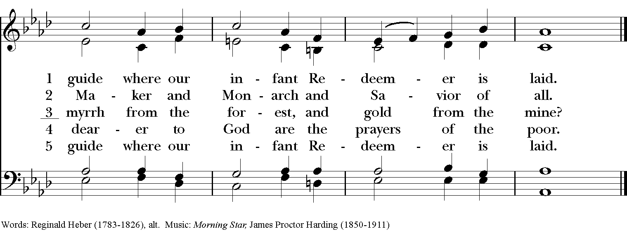

**The Opening Acclamation Page 355**

**Celebrant** Blessed be God: Father, Son, and Holy Spirit.

**People And blessed be his kingdom, now and for ever. Amen.**

**Celebrant** There is one God and one Spirit;

**People There is one hope in God’s call to us.**

**Celebrant** One Lord, one Faith, one Baptism;

**People One God and Father of all.**

##### The Salutation & Collect of the Day Page 357

***Celebrant*** The Lord be with you.

***People* And also with you.**

***Celebrant*** Let us pray.

O God of unchangeable power and eternal light: Look favorably on your whole Church, that wonderful and sacred mystery; by the effectual working of your providence, carry out in tranquility the plan of salvation; let the whole world see and know that that things which were cast down are being raised up, and things which had grown old are being made new, and that all things are being brought to their perfection by him and through whom all things were made, your Son Jesus Christ our Lord; who lives and reigns with you, in the unity of the Holy Spirit, one God for ever and ever. ***Amen.***

**The First Lesson Isaiah 43:1-7**

But now thus says the LORD, he who created you, O Jacob, he who formed you, O Israel: Do not fear, for I have redeemed you; I have called you by name, you are mine. When you pass through the waters, I will be with you; and through the rivers, they shall not overwhelm you; when you walk through fire you shall not be burned, and the flame shall not consume you. For I am the LORD your God, the Holy One of Israel, your Savior. I give Egypt as your ransom, Ethiopia and Seba in exchange for you. Because you are precious in my sight, and honored, and I love you, I give people in return for you, nations in exchange for your life. Do not fear, for I am with you; I will bring your offspring from the east, and from the west I will gather you; I will say to the north, "Give them up," and to the south, "Do not withhold; bring my sons from far away and my daughters from the end of the earth-- everyone who is called by my name, whom I created for my glory, whom I formed and made."

The Word of the Lord.

***People* Thanks be to God.**

**Psalm 29 chant: Percy Buck**

Afferte Domino

1 Ascribe to the LORD, you gods,  *  
      ascribe to the LORD glory and strength.

2 Ascribe to the LORD the glory due his Name;  *  
      worship the LORD in the beauty of holiness.

3 The voice of the LORD is upon the waters; the God of glory thunders;  *  
      the LORD is upon the mighty waters.

4 The voice of the LORD is a powerful voice;  *  
      the voice of the LORD is a voice of splendor.

5 The voice of the LORD breaks the cedar trees;  *  
      the LORD breaks the cedars of Lebanon;

6 He makes Lebanon skip like a calf,  *  
      and Mount Hermon like a young wild ox.

7 The voice of the LORD splits the flames of fire; the voice of the LORD shakes the

wilderness;  *  
      the LORD shakes the wilderness of Kadesh.

8 The voice of the LORD makes the oak trees writhe  *  
      and strips the forests bare.

9 And in the temple of the LORD  *  
      all are crying, "Glory!"

10 The LORD sits enthroned above the flood;  *  
      the LORD sits enthroned as King for ever-more.

11 The LORD shall give strength to his people;  *  
      the LORD shall give his people the blessing of peace.

**The Second Lesson Acts 8:14-17**

Now when the apostles at Jerusalem heard that Samaria had accepted the word of God, they sent Peter and John to them. The two went down and prayed for them that they might receive the Holy Spirit (for as yet the Spirit had not come upon any of them; they had only been baptized in the name of the Lord Jesus). Then Peter and John laid their hands on them, and they received the Holy Spirit.

The Word of the Lord.  
***People* Thanks be to God.**

**The Sequence “When Jesus went to Jordan’s stream” Hymnal, 139**

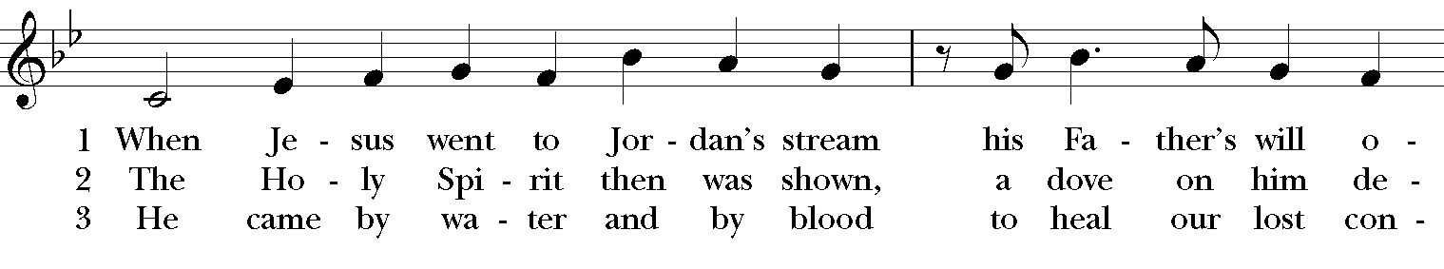

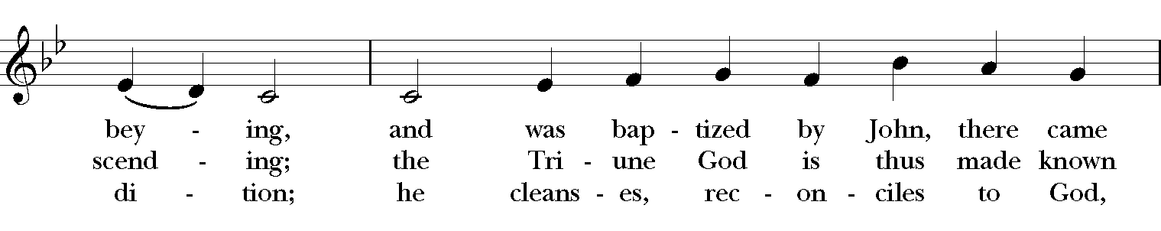

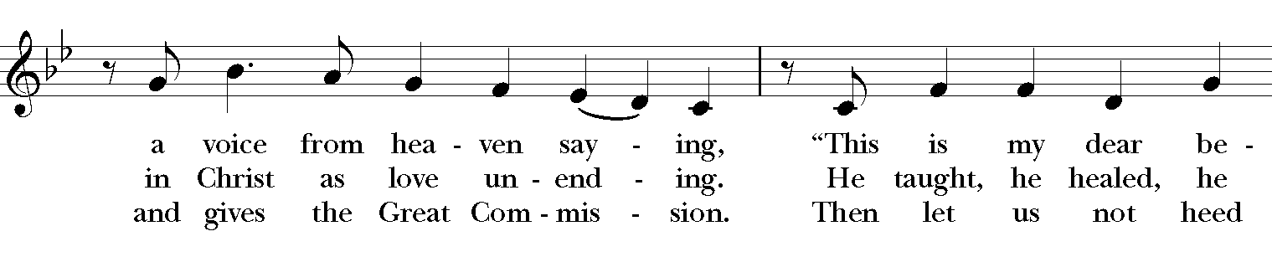

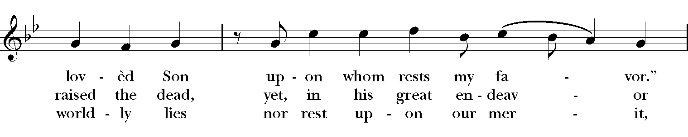

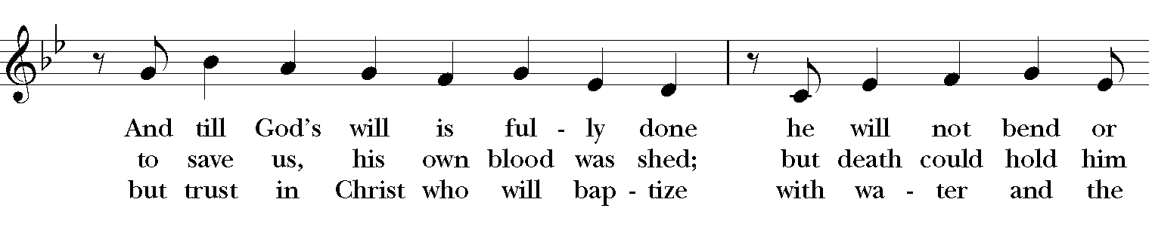

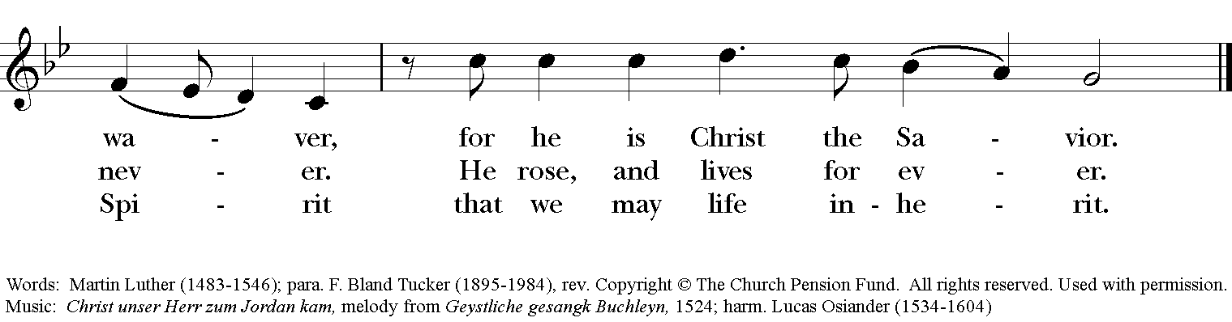

**The Holy Gospel Luke 3:15-17, 21-22**

***The people remain standing. The Celebrant says***

The Holy Gospel of our Lord Jesus Christ according to Luke.

***People* Glory to you, Lord Christ.**

As the people were filled with expectation, and all were questioning in their hearts concerning John, whether he might be the Messiah, John answered all of them by saying, "I baptize you with water; but one who is more powerful than I is coming; I am not worthy to untie the thong of his sandals. He will baptize you with the Holy Spirit and fire. His winnowing fork is in his hand, to clear his threshing floor and to gather the wheat into his granary; but the chaff he will burn with unquenchable fire." Now when all the people were baptized, and when Jesus also had been baptized and was praying, the heaven was opened, and the Holy Spirit descended upon him in bodily form like a dove. And a voice came from heaven, "You are my Son, the Beloved; with you I am well pleased."

***After the reading, the Celebrant says***

The Gospel of the Lord.

***People* Praise to you, Lord Christ.**

**The Sermon**

**The Nicene Creed**

*Said by all, standing*

**We believe in one God, the Father, the Almighty, maker of heaven and earth, of all that is, seen and unseen.**

**We believe in one Lord, Jesus Christ, the only Son of God, eternally begotten of the Father, God from God, Light from Light, true God from true God, begotten, not made, of one Being with the Father. Through him all things were made. For us and for our salvation he came down from heaven: by the power of the Holy Spirit he became Incarnate from the Virgin Mary, and was made man. For our sake he was crucified under Pontius Pilate; he suffered death and was buried. On the third day he rose again in accordance with the Scriptures; He ascended into heaven and is seated at the right hand of the Father. He will come again in glory to judge the living and the dead, and his kingdom will have no end.**

**We believe in the Holy Spirit, the Lord, the giver of life, who proceeds from the Father and the Son. With the Father and the Son he is worshiped and glorified. He has spoken through the Prophets. We believe in one holy catholic and apostolic Church. We acknowledge one baptism for the forgiveness of sins. We look for the resurrection of the dead, and the life of the world to come. Amen.**

**The Prayers of the People, Form VI Page 392**

*The Leader and People pray responsively*

In peace, we pray to you, Lord God.

*Silence*

For all people in their daily life and work;

***For our families, friends, and neighbors, and for those who are alone*.**

For Joe our President, Andy our Governor, and Neil & Greg our Mayors, and for this community, the nation, and the world;

***For all who work for justice, freedom, and peace.***

For the just and proper use of your creation;

***For the victims of hunger, fear, injustice, and oppression*.**

For all who are in danger, sorrow, or any kind of trouble;

***For those who minister to the sick, the friendless, and the needy*.**

For the peace and unity of the Church of God;

***For all who proclaim the Gospel, and all who seek the Truth.***

For Justin, the Archbishop of Canterbury, Michael, our Presiding Bishop, Terry, our Bishop, for Michael, Anne, Art, and Jim, our clergy and all bishops and other ministers;

***For all who serve God in his Church*.**

For the special needs and concerns of this congregation. For **Al, Amy, Barbara, Beecher, Bethann, Beverly, Calvin, Carol, Christy, Dan, Danny, Darla, David, Debbie, Diana, Dorothy, Dot, Doug, EJ, Gene, Helga, Herb, Hugh, Ira, Janice, Jenni, Jerry, Jewell, Joan, Joe, John, Kathy, Ken, Kirk, Lee, Lisette, Lorraine, Lynn, Mark, Martha, MaryBeth, Maureen, McDonald, Monica, Nelson, Nick, Nina (Nine-ah), Phillip, Sharon, Steve, Sue, Susie, Terry, Tim, Ursula, Velda, Veronica, Walt, Winston, Yvonne; for the men and women of our armed forces, especially Alex, Casey, Griffin, Pat, Seth, Trey.**

*Silence*

*The People may add their own petitions*

Hear us, Lord;

***For your mercy is great*.**

We thank you, Lord, for all the blessings of this life.

*Silence*

*The People may add their own thanksgivings*

We will exalt you, O God our King;

***And praise your Name for ever and ever*.**

We pray for all who have died, **..** , that they may have a place in your eternal kingdom.

*Silence*

*The People may add their own petitions*

Lord, let your loving‑kindness be upon them;

***Who put their trust in you*.**

We pray to you also for the forgiveness of our sins.

*Silence may be kept*.

*Leader and People*

Have mercy upon us, most merciful Father; in your compassion forgive us our sins, known and unknown, things done and left undone; and so uphold us by your Spirit that we may live and serve you in newness of life, to the honor and glory of your Name; through Jesus Christ our Lord. Amen.

The Celebrant concludes with an absolution or a suitable Collect.

**A Service for the Ending of a Pastoral Relationship**

**& Leave-Taking from a Congregation**

*Celebrant*  On the 12th day of November, 2014, I was inducted by Bishop White as rector of St. Luke’s. I have, with God’s help and to the best of my abilities, exercised this trust, accepting its privileges and responsibilities.

After prayer and careful consideration, it now seems to me that I should leave this charge, and I publicly state that my tenure as rector of St. Luke’s will end on January 15th.

Do you, the people of St. Luke’s, recognize and accept the conclusion of this pastoral relationship.

*People* We do.

*Everyone* O God, you have bound us together for a time as priest and people to work for the advancement of your kingdom in this place: We give you humble and hearty thanks for the ministry which we have shared in these years now past.

*Silence*

*Everyone* We thank you for your patience with us despite our blindness and slowness of heart. We thank you for your forgiveness and mercy in the face of our many failures.

*Silence*

*Everyone* Especially we thank you for your never-failing presence with us through these years, and for the deeper knowledge of you and of each other which we have attained.

*Silence*

*Everyone* We thank you for those who have been joined to this part of Christ’s family through baptism. We thank you for opening our hearts and minds again and again to your Word, and for feeding us abundantly with the Sacrament of the Body and Blood of your Son.

*Silence*

*Everyone* Now, we pray, be with those who leave and with us who stay; and grant that all of us, by drawing ever nearer to you, may always be close to each other in the communion of your saints. All this we ask for the sake of Jesus Christ, your Son, our Lord. Amen.

*Silence*

**The Peace**

*Celebrant*  The peace of the Lord be always with you.

*People* And also with you.

**Prayers for Healing**

**Birthday and Anniversary Prayers**

#### **THE HOLY COMMUNION**

**Offertory Anthem F. Mendelssohn**

**“Say where is he born – There shall a star”**

**The Great Thanksgiving: Eucharistic Prayer B Page 367**

*S120a*

*Celebrant* It is right, and a good and joyful thing, always and everywhere to give thanks to you, Father Almighty, Creator of heaven and earth.

*Here the Celebrant adds a Proper Preface*

Therefore we praise you, joining our voices with Angels and Archangels and with all the company of heaven, who for ever sing this hymn to proclaim the glory of your Name:

*Celebrant and People*

**Sanctus: S-125 in the Hymnal 1982**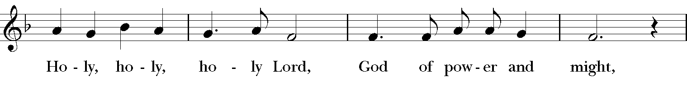

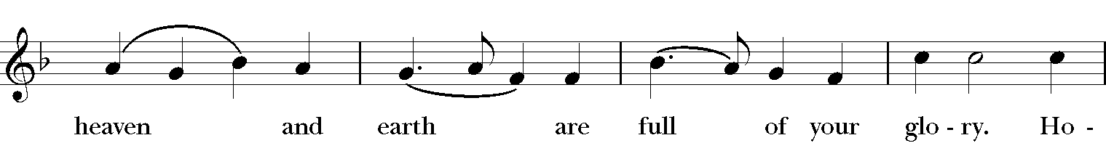

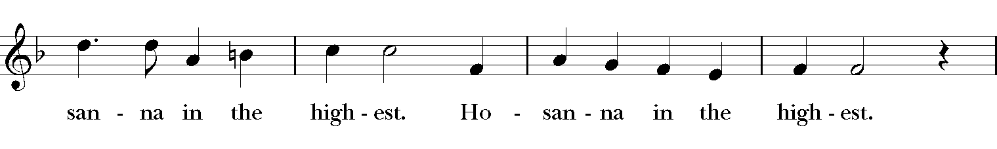

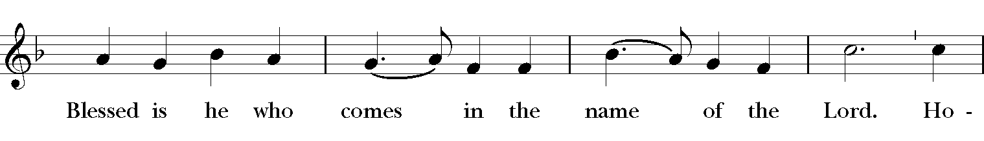

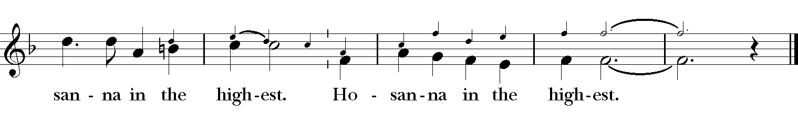

*The people stand or kneel.*

*Then the Celebrant continues*

We give thanks to you, O God, for the goodness and love which you have made known to us in creation; in the calling of Israel to be your people; in your Word spoken through the prophets; and above all in the Word made flesh, Jesus, your Son. For in these last days you sent him to be incarnate from the Virgin Mary, to be the Savior and Redeemer of the world. In him, you have delivered us from evil, and made us worthy to stand before you. In him, you have brought us out of error into truth, out of sin into righteousness, out of death into life.

On the night before he died for us, our Lord Jesus Christ took bread; and when he had given thanks to you, he broke it, and gave it to his disciples, and said, "Take, eat: This is my Body, which is given for you. Do this for the remembrance of me."

After supper he took the cup of wine; and when he had given thanks, he gave it to them, and said, "Drink this, all of you: This is my Blood of the new Covenant, which is shed for you and for many for the forgiveness of sins. Whenever you drink it, do this for the remembrance of me."

Therefore, according to his command, O Father,

*Celebrant and People*

**We remember his death,  
We proclaim his resurrection,  
We await his coming in glory;**

*The Celebrant continues*

And we offer our sacrifice of praise and thanksgiving to you, O Lord of all; presenting to you, from your creation, this bread and this wine.

We pray you, gracious God, to send your Holy Spirit upon these gifts that they may be the Sacrament of the Body of Christ and his Blood of the new Covenant. Unite us to your Son in his sacrifice, that we may be acceptable through him, being sanctified by the Holy Spirit. In the fullness of time, put all things in subjection under your Christ, and bring us to that heavenly country where, with [St. Luke, __________ and] all your saints, we may enter the everlasting heritage of your sons and daughters; through Jesus Christ our Lord, the firstborn of all creation, the head of the Church, and the author of our salvation.

By him, and with him, and in him, in the unity of the Holy Spirit all honor and glory is yours, Almighty Father, now and forever. ***Amen****.*

And now, as our Savior Christ has taught us, we are bold to say,

The Lord’s Prayer

Our Father, who art in heaven, hallowed be thy Name, thy kingdom come, thy will be done, on earth as it is in heaven. Give us this day our daily bread. And forgive us our trespasses, as we forgive those who trespass against us. And lead us not into temptation, but deliver us from evil. For thine is the kingdom, and the power, and the glory, for ever and ever. Amen.

**The Breaking of the Bread**

A period of silence is kept.

Fraction Anthem: S-155 in the Hymnal 1982

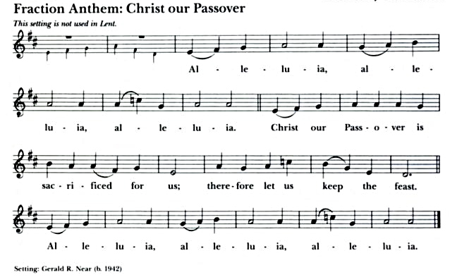

***Hand sanitizer can be found in each pew and is recommended***

***before and after receiving communion.***

Communion Anthem “The blessed Son of God” R. Vaughan Williams

**The Healing Hymn “Humbly I adore Thee” Hymnal, 314**

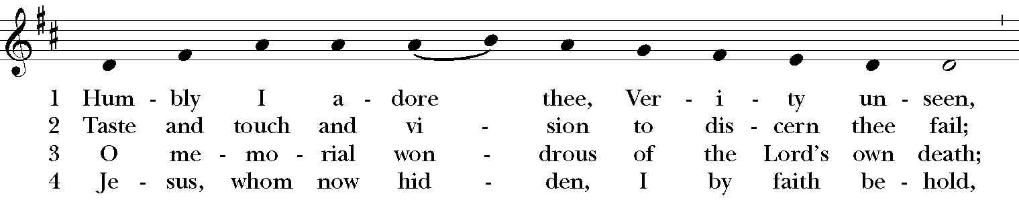

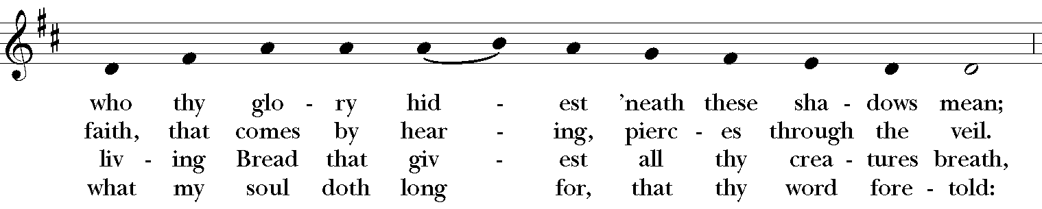

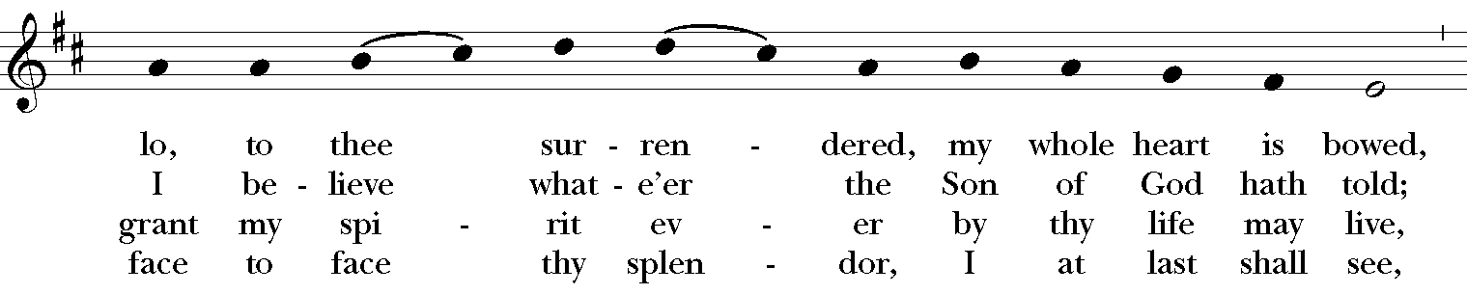

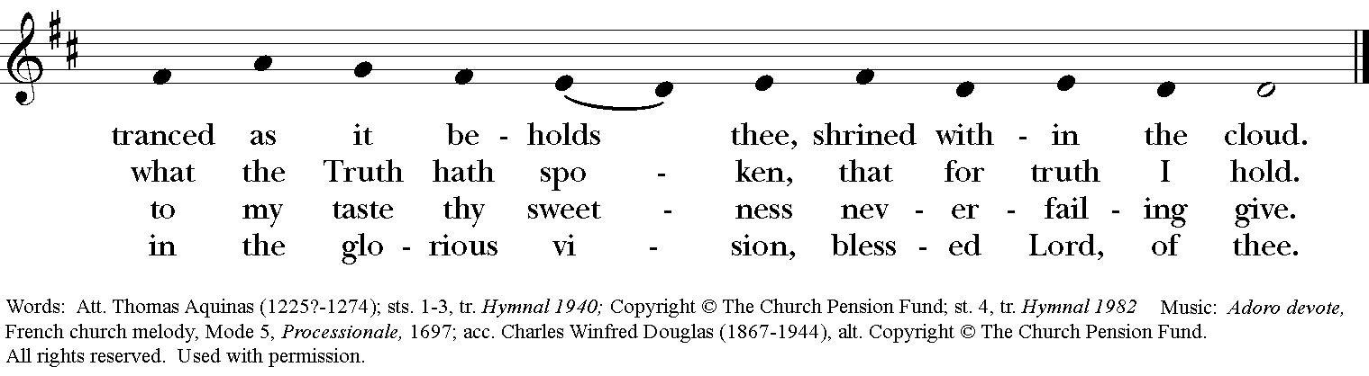

The Post-Communion Prayer Page 365

***All* Almighty God, we thank you for feeding us with the holy food of the Body and Blood of your Son, and for uniting us through him in the fellowship of your Holy Spirit. We thank you for raising up among us faithful servants of your Word and Sacraments. We thank you especially for the work of Michael among us, and the presence of his family here. Grant that both he and we may serve you in the days ahead, and always rejoice in your glory, and come at length into your heavenly kingdom; through Jesus Christ our Lord. Amen.**

**Sending Forth of Lay Eucharistic Ministers**

***Celebrant*** In the name of God and of St. Luke’s, we send you forth bearing these holy gifts, that those to whom you go may share with us in the communion of Christ’s Body and Blood.

***People* We who are many are one body, because we all share one bread, one cup.**

*Prayers and laying of hands for healing are available after worship*

*in the back of the Church at the statue of the Virgin Mary.*

The Blessing

May God, who has led us in the paths of justice and truth, lead us still, and keep us in his ways. Amen.

May God, whose Son has loved us and given himself for us, love us still, and establish us in peace. Amen.

May God, whose Spirit unites us and fills our hearts with joy, illumine us still, and strengthen us for the years to come. Amen.

And the blessing of God Almighty, the Father, the Son, and the Holy Spirit, be upon you and remain with you for ever. Amen.

The Processional “Songs of thankfulness and praise” Hymnal, 135

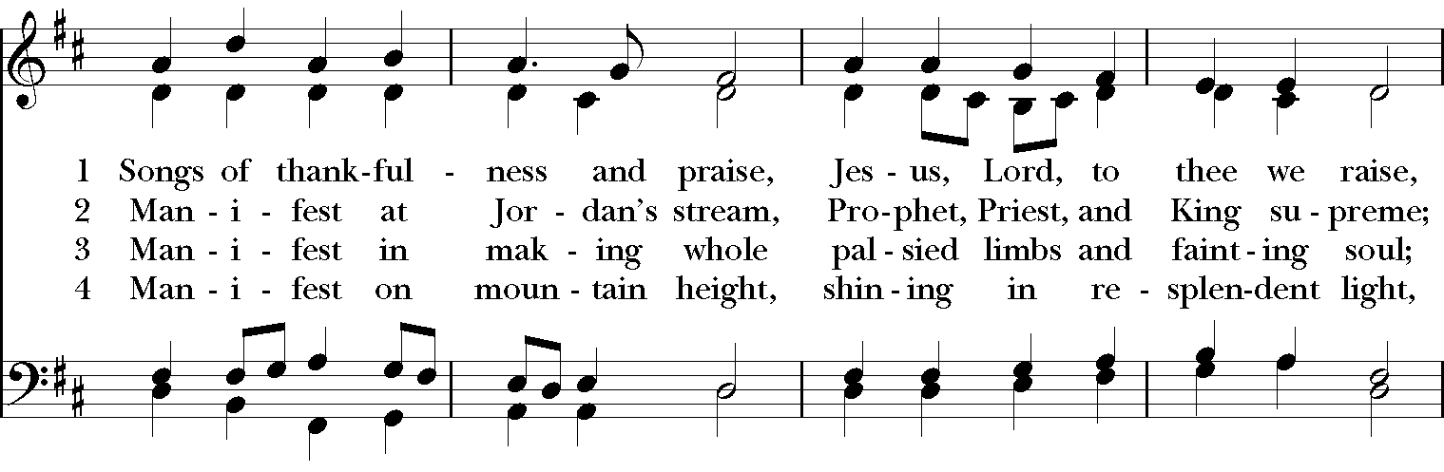

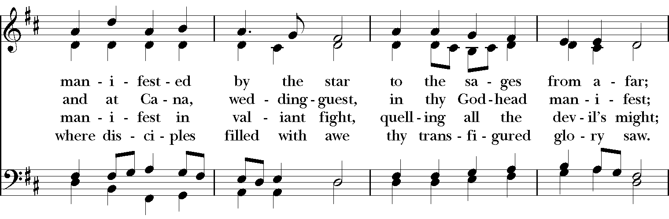

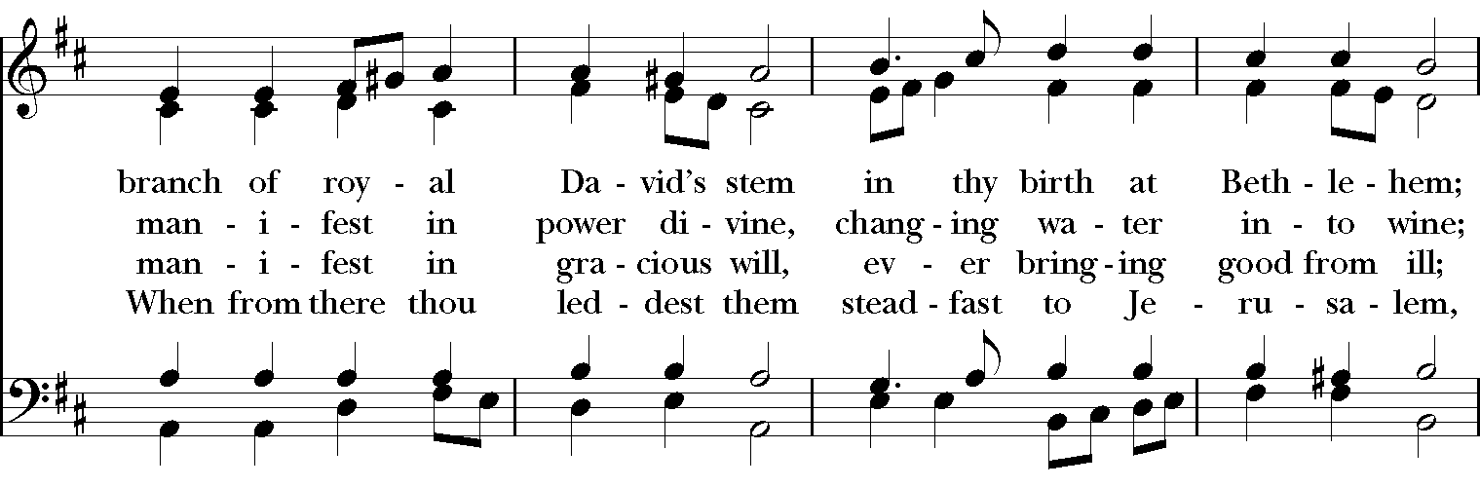

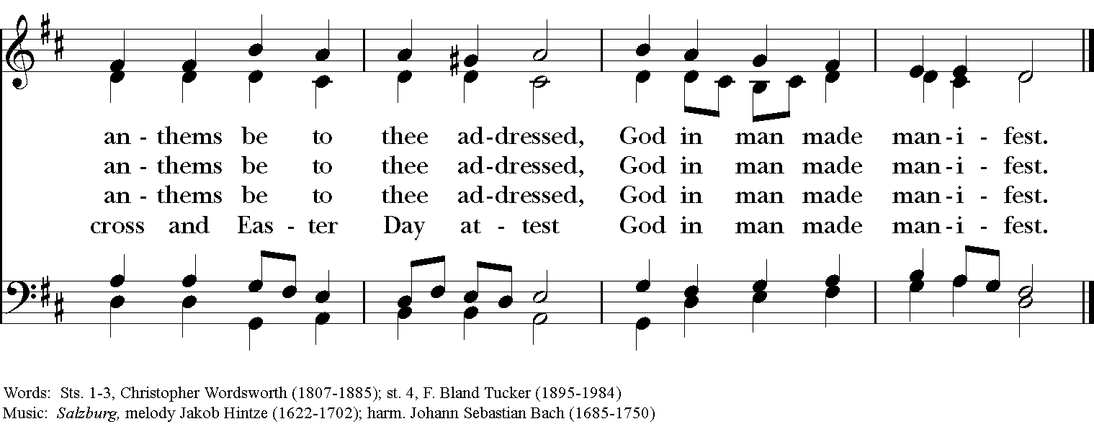

***Feel free to quietly leave worship or remain in your pew to enjoy the Postlude.***

***We are so grateful you have joined us today and look forward***

***to gathering again very soon.***

The Dismissal

*People* Thanks be to God.

**Organ Voluntary Dietrich Buxtehude**

**“How brightly shines the morning star”**

Permission to reprint, podcast, and/or stream the music in the service obtained from ONE LICENSE # A-736775. All rights reserved.

To Give, go to

**https://www.stlukesanchorage.org/giving.html**

ANNUAL PARISH MEETING SUNDAY SCHEDULE

**January 16, 2021**

**ANNOUNCEMENTS**

*Here at St. Luke’s, we welcome everyone to participate in everything freely, member or non-member. If you are a visitor, please fill out one of the visitor cards and place it in the offering plate. If you would like to become an official member of our parish family, please call our office, 245-8827, or speak with Father Michael.*

**DOK Announcement**

On **Tuesday, January 11, at 7pm**, The Daughters of the King invite you to join us for an overview of the Stain Glass Windows, presented by FoFo Johnson.

**2022 Offering Envelopes**

Envelopes are available at both main entrances to the church. *Please be sure to sign your name (legibly) AND the envelope box number on the sheets provided*. **If you don’t, we have no way of identifying your cash donations**. If the container runs out of boxed envelopes, we will refill for next week, but check at the other entrance for more. Thank you!

**Wednesday AM Bible Study**

The Wednesday morning 9:45 am bible study **will be in person in the Lyman House (down the hill from the church)**. You can join this lay-led discussion of the core stories of our faith **either in person or on Zoom** every Wednesday at 9:45am. We are currently using The Path, a Bible Study published by Forward Movement, as a guide among other sources. It is not necessary to have a copy of The Path to participate. Just bring your Bible.

**Roots in our Liturgy**

**We meet in person in the church OFFICE (the Lyman House) down the hill from the Dudley House**. We will continue to broadcast on Zoom for those who do not or cannot come in person, to create a Hybrid class. **For those meeting in person, please wear a mask.**

Our series is now on Desmond Tutu.

The link to the class has been **UPDATED** : [**https://us02web.zoom.us/j/** [**82160795302**](https://us02web.zoom.us/j/85144530030?pwd=aEFNUnFEcForL1dwbmZUTnRzeTNMdz09)](https://us02web.zoom.us/j/85144530030) / Meeting ID: **821 6079 5302** If prompted to enter a password, please enter  798722

**Centering Prayer**

Centering Prayer has changed to every **FIRST** and **THIRD** Tuesday. Join us on **January 4 and 18 from 6 – 7pm** in the Lyman Office.

**Birthdays & Anniversaries**

**If you've had a birthday or anniversary over the past several weeks, or have one coming up in the weeks ahead,** please let the office know, [admin@stlukesanchorage.org](mailto:admin@stlukesanchorage.org).  Let them know your birthday, or the date of your wedding anniversary and how many years you've been married, and we will offer a blessing over you during our recorded worship.

***The Flowers on the Altar*** are given by Brooks & Calvin Riley Pinney in loving memory of Dorothy Moremen Pinney.

In our prayers for **Al, Amy, Barbara, Beecher, Bethann, Beverly, Calvin, Carol, Christy, Dan, Danny, Darla, David, Debbie, Diana, Dorothy, Dot, Doug, EJ, Gene, Helga, Herb, Hugh, Ira, Janice, Jenni, Jerry, Jewell, Joan, Joe, John, Kathy, Ken, Kirk, Lee, Lisette, Lorraine, Lynn, Mark, Martha, MaryBeth, Maureen, McDonald, Monica, Nelson, Nick, Nina (Nine-ah), Phillip, Sharon, Steve, Sue, Susie, Terry, Tim, Ursula, Velda, Veronica, Walt, Winston, Yvonne;** and our men and women serving in our armed forces and their families. We offer prayers of blessing and thanksgiving for all men and women serving in the armed services, especially these persons known to us: **Alex, Casey, Griffin, Pat, Seth, Trey**. We pray that they have safe journeys and know the loving concern of friends and family. May God watch over them and grant them strength and courage to face perils which beset them.

**Readings : January 16 Isaiah 62:1-5; Psalm 36:5-10;**

**Epiphany 2 I Corinthians 12:1-11; John 2:1-11.**