12/05/2016 The Tav at the End of 6,000 Years

James Ussher is widely regarded by bible scholars to have arrived at a date, 4004 BC, for the creation of the heavens and the earth according to the genealogies listed in the bible. Many scientists disagree with the outright biblical account because the earth appears to be much older, millions of years older.

We need to remember that the bible is a supernatural book, authored by a Supernatural Being, YaHuWaH Elohim, who claims to have created the universe.

Science will only accept as valid what it can get its hands on and measure. Supernatural occurrences and supernatural beings can't be measured scientifically in a consistent and reliable manner. Scientists using mathematics have discovered the existence of many invisible dimensions beyond what we can see, but science presently has no means of conducting tests to actually prove and scientifically test the existence of those invisible dimensions. Remember that modern atomic energy came from the ethereal concepts of a few mathematicians just a century ago.

Because the bible indicates the creation event to have occurred around 4004 BC, we'll use that as a starting date to arrive at other dates that might be prophetically significant.

The specific date that was arrived at by James Ussher and others for the beginning of creation was October 23, 4004 BC.

Keep in mind that other researchers have arrived at other dates for creation, but most are within 75 years or so of 4004 BC. We should at least be in the "ballpark" by using 4004 BC for timeline calculations.

One of the main principles of the bible is the 7th day Sabbath. The 7th day Sabbath was immediately observed by our Creator Elohim themselves at the end of 6 days of creation. We are to memorialize our Creator by continuing to observe the 7th day by ceasing from work.

10/23/4004 BC + 6,000 prophetic years (6,000 x 360 days = 2,160,000 days) = 8/9/1911 AD

10/23/4004 BC + 6,000 365 day years = 10/23/1996 AD

The Tav at the End of 6,000 Years from 4,004 BC

We might expect our Creator to have marked the end of 6,000 years from creation with a Paleo Hebrew alphabet letter "Tav", an "X", and the beginning of a 7th 1,000 year period of rest, a 1,000 year Sabbath.

I remember seeing a comet in the evening sky as I was commuting to and from work in 1996. It was comet Hyakutake which was discovered 1/31/1996. Then a year later another comet could be seen in the sky. It was comet Hale - Bopp. The comets were named after the people who discovered them. Most comets can't be seen visually.

An odd thing had happened. The prominent comets crossed paths in the sky, forming an "X" in the sky, with the second comet crossing the path of the first on the same day a year later. Comet Hyakutake was at the junction point on 4/11/1996, the same place that comet Hale - Bopp would cross 365 days later on 4/11/1997.

Here's a graphic depicting the paths of the visually prominent comets of 1996 and 1997, marking 6,000 years from the date of creation indicated in the bible:

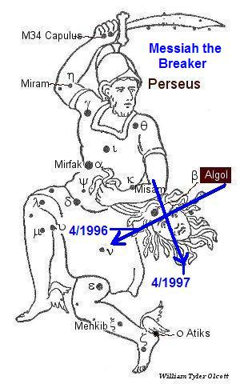
The two comets crossed paths exactly 365 days apart on the forehead of the decapitated head of the goddess Medusa who has snakes for hair.

David, the young shepherd from Bethlehem, decapitated the nephilim giant Goliath after killing him with a stone from a sling that sank into the nephilim's forehead. The constellation Perseus, symbolizing David's descendant YAHUSHUA the Messiah, decapitated the Medusa whose head is filled with serpents (devils). The head of Medusa was marked by our Creator Elohim, in the way that Goliath's head was marked by David's stone, exactly 6,000 years from 4004 BC.

The above sign in the sky remains unknown by most people. Only our Creator Elohim can structure the timeline of the bible and then order astronomical events to coincide with the culmination of that bible timeline.

Our Elohim exist in invisible dimensions that are not currently accessible at will by most humans. Our invisible prayers are a component of those dimensions, as are the angelic beings who surround the people of YaHuWaH Elohim, insuring our well being and protection.

Psalm 34:7 The angel of YaHuWaH encampeth round about them that fear Him, and delivereth them.

