Sea Dragon’s AUGUST 2025 Summer Fun!
SUNDAY |  |  |  | MONDAY | TUESDAY | WEDNESDAY | THURSDAY | FRIDAY | SATURDAY
 |  | 27 |  | 28 | 29 | 30 | 31 | 1 | 2
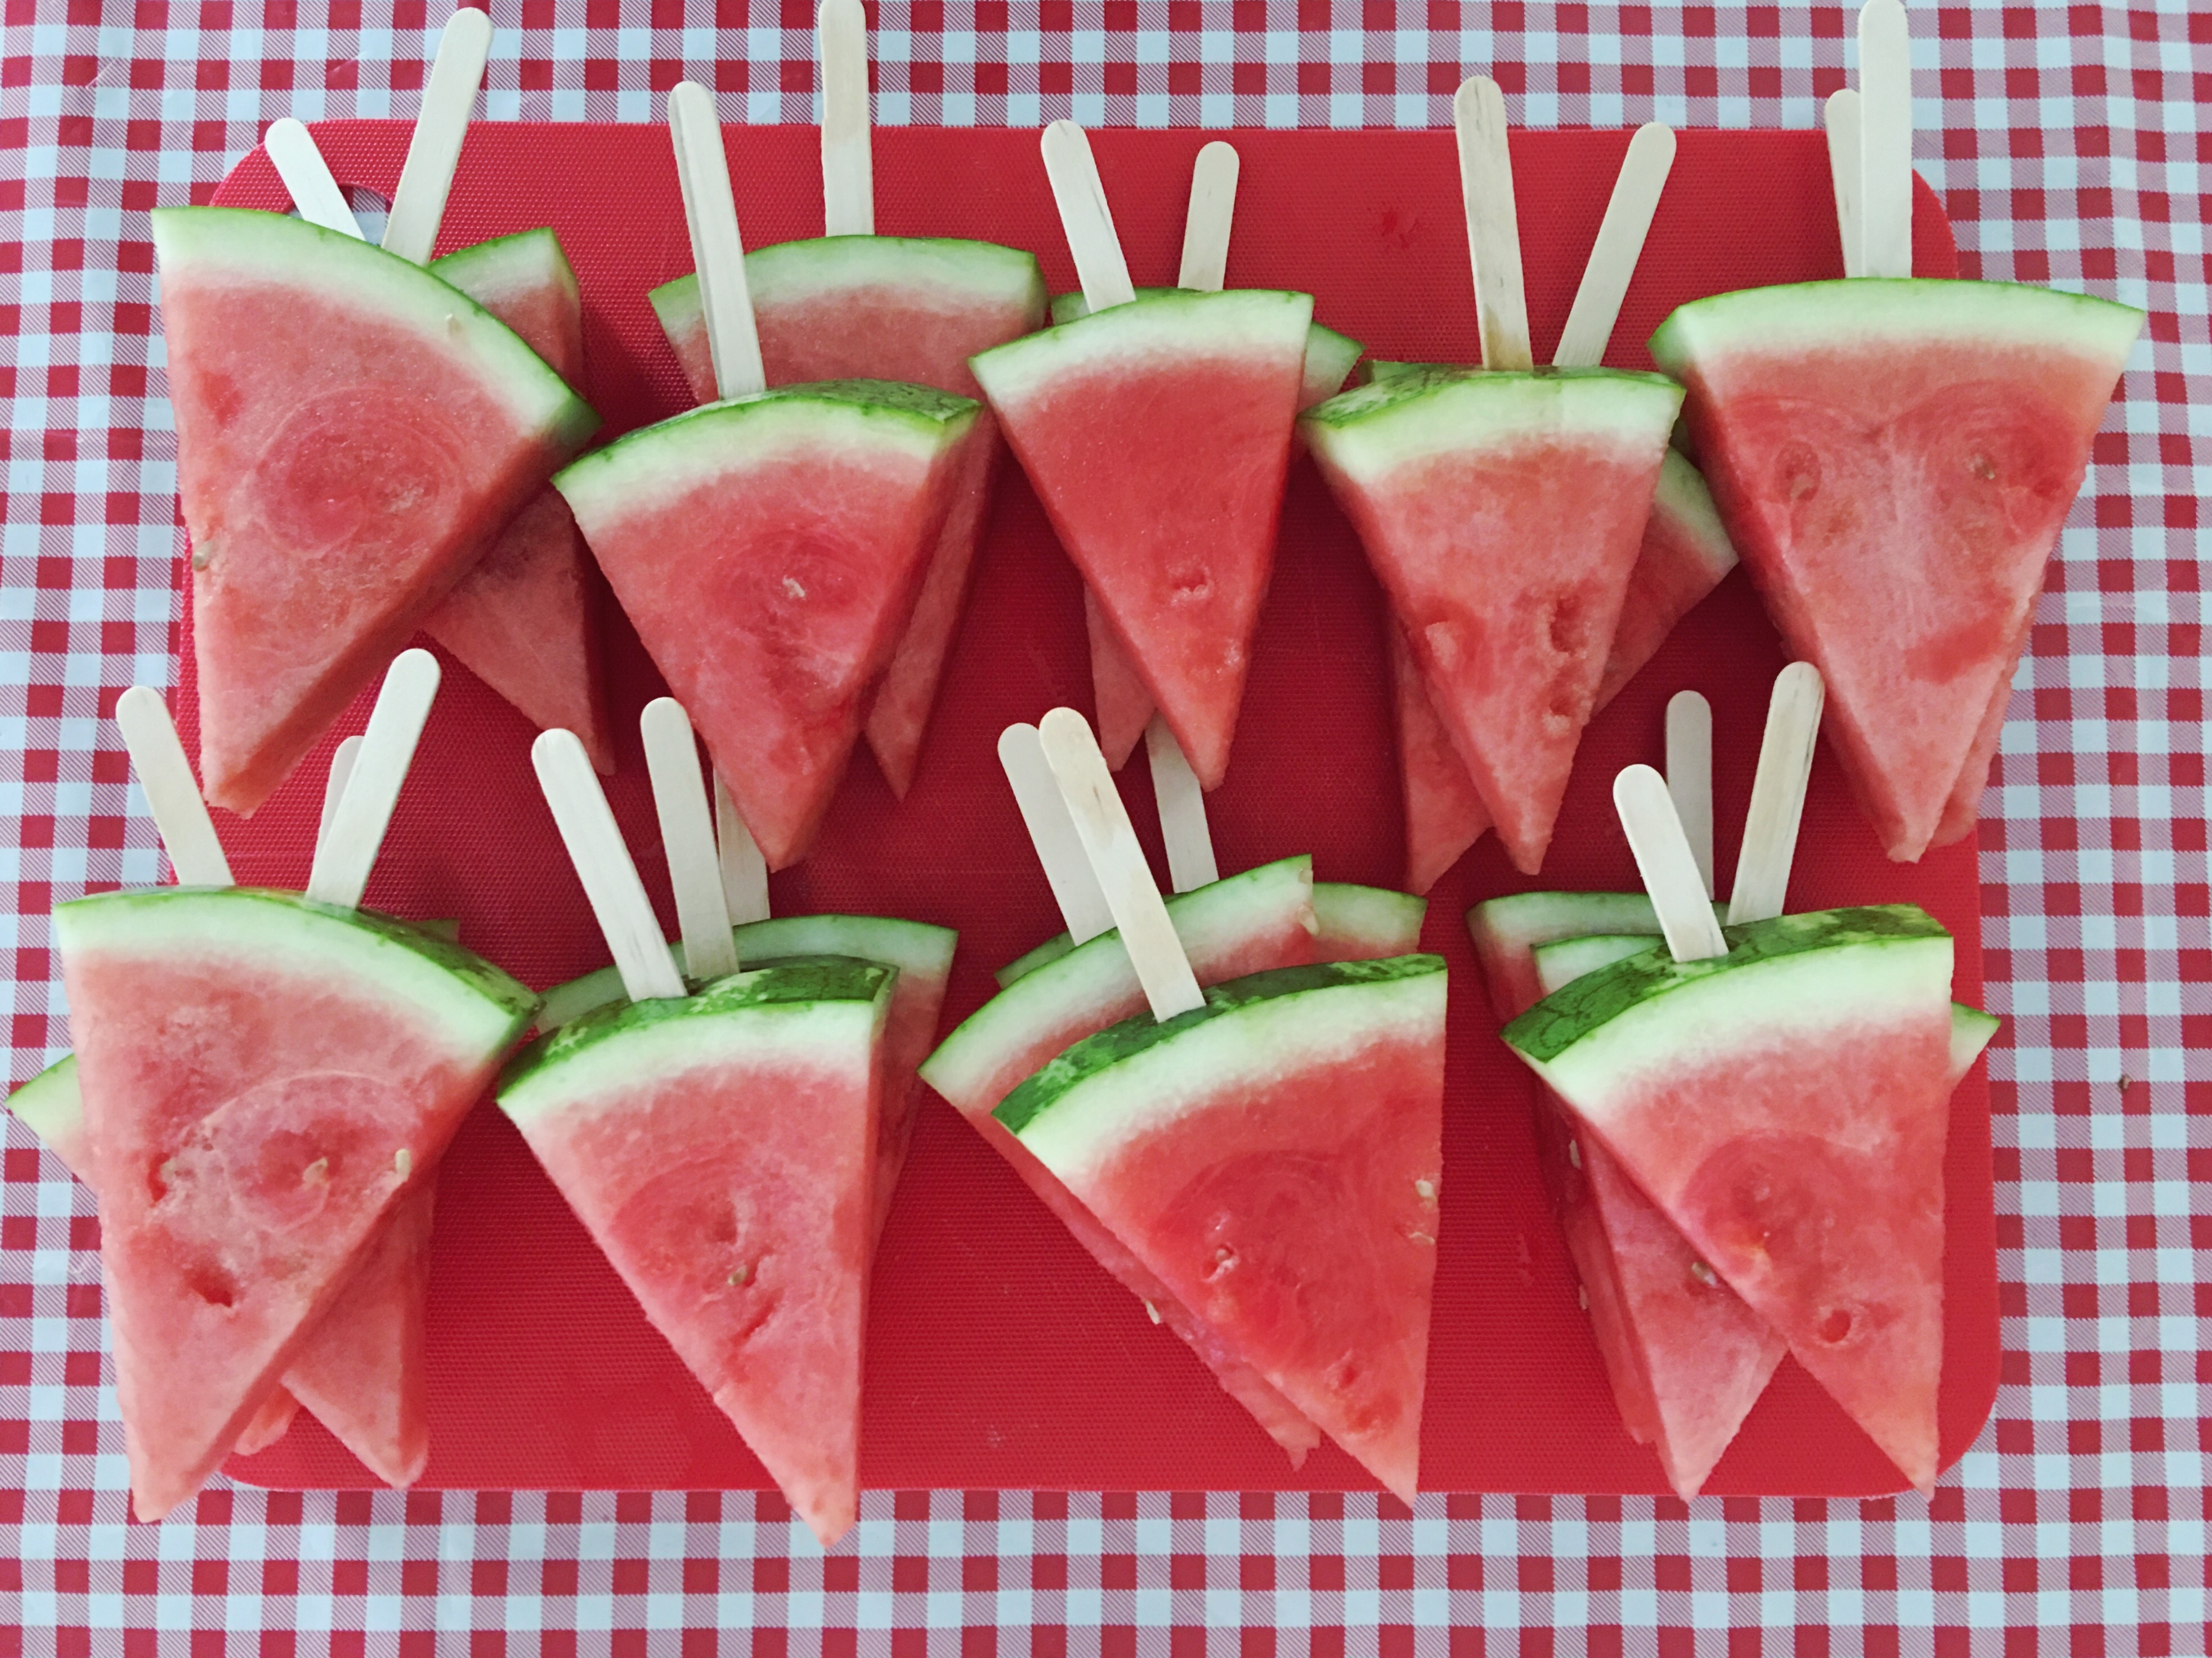
 | 3 |  |  | 4 | 5 | 6 | 7 | 8 | 9
 |  |  |  | Closed  BC Day | Colwood Park Walk | Tinker Town Forest | Central Saanich Water Park | Esquimalt Lagoon  PM Trip
 | 10 |  |  | 11 | 12 | 13 | 14 | 15 | 16
 |  |  |  | Cook St  Park | Langford Water Park | View Royal Park | Island View Beach | Beckwith Water Park  PM Trip | 
 | 17 |  |  | 18 | 19 | 20 | 21 | 22 | 23
 |  |  |  | BC Museum $5  Buddy Day | JDF Sports Day $2 | Peter Pan Water Park | Gyro  Park | Albert Head Beach  PM Trip
 | 24 |  |  | 25 | 26 | 27 | 28 | 29 | 30
 |  |  |  | Esquimalt Water Park | Raptors  Tour $ 10 | Witty’s  Lagoon | Glen Lake Water Park | Aylard  Farm
 |  |  | 31
 |  |  |  |  |  |  |  | 