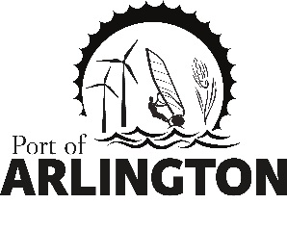

Budget Workshop Agenda
Wednesday, February 19, 2020
3:00 pm
Meeting Location:
Port of Arlington -100 Port Island Rd.
Arlington, OR 97812

- Big Picture Spreadsheet Discussion
- Port Project Discussion
2.1 Island Park Bathroom Project
2.2 Capital Projects
3. Funding Request to Gilliam County Court
4. Budget Committee Meeting Date Proposed May 12, 2020 at 4 pm

Upcoming Meetings:
Regular Commission Meeting on Tuesday, March 10, 2020 Gilliam County Courthouse, Condon, Or.
This meeting location is accessible to persons with disabilities. A request for an interpreter for the hearing impaired or for other accommodations for persons with disabilities should be made at least 48 hours before the meeting by contacting Kelly.margheim@portofarlington.com / 541-454-2868
Posted: Wednesday, February 12, 2020: Bank of Eastern Oregon - Condon & Arlington; U.S. Post Office - Condon & Arlington;
Condon Times-Journal; Arlington City Hall; Port Office and Website.
PO Box 279, Arlington, Oregon 97812

