

Summer 23 Season

Pre – Season Report

Welcome to the Summer 2023 season.

Current Summer league champion Andrew Bellamy-Burt is back to defend his title as he aims to catch the Winter League champion Toby Northern who now holds six titles to Andrew five.

Geoffroy Buffetrille will be looking to challenge again having last won the summer title in 2017 along with Laurent Pellaton who won it in 2021, all four players regular members of the Euro Cup team.

Neil Selby was another player having a great 2022 and will surely again be in the mix in the Summer League. Brian Harris finished fourth last Summer followed by a top three finish in the Winter could make further strides this season.

Ross Payne, Alice Dilks and Alex Stewart all finished in the bottom half of the table and will need to improve results to make headway in a very tough league.

Gaining promotion from last Summer with the Division 1 title was Andrew Limbrick with Callum Stewart, Tim Jackson, Paul Bell and David Ibitson also moving up in an expanded league to complete a quality line up in the Premier League.

Two big players not playing this Summer in Gavin Scott and Matt Buesnel mean some changes to the potential line up as Joey Le Clech will start favourite after as a former Premier League champion.

Jean Stewart had a great Winter gaining promotion to the Premier League so will be hoping to repeat that again this Summer and could push Joey all the way. Cassie Stewart-Le Gallais should also be pushing for a top three finish.

Coming up from Division 2 is James and Daniel Villalard and Lorna Limbrick, along with all of Division 2 as we reduce to 2 Divisions this Summer. This means a reprise for Mo who was relegated and a chance for Colin Floyd and Jim Waddell to test themselves against some better opposition.

Newcomers Keith White, who has played for a number of years at Carrefour could be in with a shout and first timer Daniel Deveau will be looking to build experience and cause a few upsets.

Let us know on Facebook who your top three will be.

Doubles Premier League Champions Laurent Pellaton & Matt Pinel look unstoppable having taken the last three titles.

Geoffroy Buffetrille & Matt Buesnel, Andrew Bellamy-Burt & Callum Stewart and Neil Selby & Ross Payne look the best bets to challenge them for the top spot.

Making up the teams in the topflight from last Summer is Alan Oliveira & Joey Le Clech, Alex & Jean Stewart and Graeme Follain & Keith Pinel, all of which could be anyone on their day.

Promoted teams of Andrew & Lorna Limbrick, Alice Dilks & Brigitte Ibitson and Branden De La Haye & Tim Jackson will be looking at cause one or two upsets throughout the season.

Let us know on Facebook who your top three will be.

In Division 1 relegated Cassie & Chris Stewart-Le Gallais and Alan Mitchel & Mike Robinson will be looking to bounce straight back up.

Regular teams of Dawn Buckley & James Gennoe, John McGaw & Nick Pallot, Daniel & James Villalard, Colin Floyd & Jim Waddell all in with a shout of the title.

New teams joining the league with new members joining existing ones with James Rondel joined by Ross Churchill and Mo De Gruchy joined by Keith White and Toby Northern joined by Daniel Deveau- playing in his first ever league.

Let us know on Facebook who your top three will be.

Good Luck to everyone.

Please like and follow us on Facebook.

League tables will be posted on Facebook each week (Thursday) as well as on the club website which will have all the scores and reports as well, each week.

WEBSITE www.liberationpetanque.co.uk
EMAIL liberationpc@gmail.com

SUMMER 2023 SEASON
WEEK 1 – 5th April 2023
SINGLES LEAGUE

The new season has begun on our newly laid terrains.

A number of matches off as some players made the trip to Barcelona for a competition.

Champion Andrew Bellamy-Burt started his defence of the title against David Ibitson with a big win as he tops the table after week 1 extending his unbeaten run to 28 matches.

Andrew Limbrick played his first Premier League match against Alice Ibitson, also with a fairly big win as Alice struggled on the difficult terrain.

Brian and Alex who were both in the mix in the Winter Premier league falling just short at the end played each other with Brian picking up the three points as he aims for his maiden Premier League title.

Neil Selby couldn’t get the three points he wanted despite winning the first game lost the second one to Tim Jackson for a draw.

In Division 1

Former Premier League champion Joey Le Clech played newcomer Daniel Deveau in his first match with Daniel pushing Joey all the way but losing 13 – 11, 13 - 9.

Lorna Limbrick took the battle of two of the top female players against Jean Stewart, whose 11 match unbeaten run ends of day one of the season.

Brigitte Ibitson played Colin Floyd, with the latter picking up three points against the more experience Brigitte.

Mo De Gruchy played Jim Waddell with a good draw for both players in match one.

Outstanding Matches

Ross Payne v Toby Northern

Callum Stewart v Paul Bell

Geoffroy Buffetrille v Laurent Pellaton

Branden De La Haye v Keith White

Daniel Villalard v James Villalard

John Flaherty v Cassie Stewart-Le Gallais

SUMMER 2023 SEASON
WEEK 2 – 12th April 2023
DOUBLES LEAGUE

Horrendous conditions so far at the start of the season did not help the champions Laurent & Matt who started their defence of the Premier League title against Alice & Brigitte. How many matches can they go unbeaten in their quest for a fourth straight title, well they extended it to twenty-eight matches despite losing heavily in the first match 13 – 5, recovered well to win 13 – 3.

Geoffroy & Matt Buesnel resume their partnership again as the aim to topple the champions. They played fellow title rivals Neil & Ross. The latter won convincingly in the first game but a great comeback by Geoffroy & Matt to win 13 – 12 for a valuable draw.

Graeme & Keith took a points advantage draw over Branden & Tim to lead the league at this stage.

Andrew & Callum v Alex & Jean and Alan & Joey v Gary & Wendy un-played.

In Division 1, some new teams playing this season which is great to see. Would week one’s matches give us an earlier indication of the ones to watch.

Experience pair Dawn & James took on brand new player Daniel who was playing with the much more experience player in Toby. Despite leading early on in game one Daniel & Toby lost 13 – 6, but they recovered with Daniel placing well in difficult conditions to win 13 – 7 for a good draw.

James Rondel also had a new partner in Ross Churchill, they played out a draw against ever improving Colin & Jim, but Alan & Mike top the league with the only win over both divisions this week as Cassie & Chris continue to struggle.

Keith White joined Mo v Kat & Paul and Colin & Steve v Daniel & James un-played.

Outstanding matches

Andrew & Callum v Alex & Jean

Alan & Joey v Gary & Wendy

Keith White joined Mo v Kat & Paul

Colin & Steve v Daniel & James

SUMMER 2023 SEASON
WEEK 3 – 19th April 2023
SINGLES LEAGUE

The weather improved this week with a pleasant evening of pétanque in the spring sunshine.

Champion Andrew B took on Alice who struggled in week one, but the ever-changing terrains may help. Well, it helped Andrew to another win as he leads the league early on in his quest to retain his title.

Geoffroy won his catch-up match against Laurent to get his season underway but his match against Andrew L was postponed.

Tim played David and another draw for the pair who both have two draws each so far.

Ross played Laurent getting a big win and then a catch-up match played Toby but could only draw this as Toby took the points advantage. Toby had played Alex first missing a fire in the first game losing it 13 – 12 before recovering to win 13 – 7 to extend his unbeaten run to eighteen matches.

Paul got his league campaign off and running in his first match against Neil getting a valuable draw but then lost his catch-up match against Callum, losing the first game 13 – 12.

Brian v Callum un-played.

Laurent won a match against Alex played in advance to recover from two straight losses.

In Division 1

John played Jim in his first match of the campaign and got off to a great start winning and moving into third place.

James played Mo and the closest of matches in Mo 100th league match with a 13 – 12, 12 – 13 draw! Congratulations to Mo, amazing support for the club.

Joey played Cassie in a big match in Division 1 and another 13 – 12 scoreline went Joey way as he made it back-to-back wins.

Keith played Daniel V with the latter picking up a rare win against newcomer Keith.

Jean played Daniel D picking up the expected three points with Daniel not making it easy for the experienced players.

Colin played Branden with another draw and another 13 – 12 scoreline.

Brigitte v Lorna un-played.

SUMMER 2023 SEASON
WEEK 4 – 26th April 2023
DOUBLES LEAGUE

Week two of the Doubles League, with probably the biggest fixture of the week would have seen Callum & Andrew take on champions Laurent & Matt but this was postponed for another day.

Could Alice & Brigitte capitalise on their fine performance against Laurent & Matt in week one, but face another top side in Geoffroy & Matt. The answer was a resounding no losing 13 – 2, 13 – 6 and were extremely fortunate to get six points in the second game as a bad fire from Alice hit a boule a foot away from her target but some how bounced off taking the coche with her boule to get four points!

Neil & Ross would have been disappointed to have dropped two points in their draw against Geoffroy & Matt, could they get three points against Gary & Wendy. Again, another draw as despite winning the first game and leading 11 – 10, lost a three on the final end as it finished all square,

A big match for Branden & Tim against Alex & Jean as they aim for their first ever Premier League win. It started off in great style as they won 13 – 0! But then miraculously lost 13 – 0 in the second game as both teams get a certificate.

Graeme & Keith topped the league on points difference after week one, could they get the win over Andrew & Lorna to remain there. Well, another draw in the division leaves Geoffroy & Matt top after week two.

Alan & Joey with a bye.

In Division 1 Alan & Mike, the only doubles team to get a win in week one took on Daniel & Toby who got a good point against Dawn & James in week one in their first ever match together. Both Toby with his shooting and Daniel with his impressive placing taking to the sport like a duck to water won comfortably 13 – 2, 13 – 5.

Colin & Steve finally played their 200th Doubles League match but suffered a surprise loss against Keith & Mo who were playing their first match together.

John & Nick played Daniel & James and in a marathon match took all three points for a good win over the Villalards.

Dawn & James match against Colin & Jim postponed as was Kat & Paul match against James & Ross.

SUMMER 2023 SEASON
WEEK 5 – 3rd May 2023
SINGLES LEAGUE

As the season is now under full swing every point counts. This weeks highlights were Brian against Neil, would the usual draw be the result? The answer was a yes. Callum played Toby ending Toby 18 match unbeaten run, Callum then drew with Brian to move second in the league.

Andrew B played Tim with an expected three points but only 13 – 12 in one game. Andrew leads they way with three wins from three.

Would Alice continue to struggle against Geoffroy, no as Alice faired much better on the ruined terrains beating Geoffroy in a surprise result.

A big match lower in the table between David & Paul with either player picking up three points making a huge difference, it wasn’t to be though as a draw was the result.

Laurent the 2021 champion needed three points against Alex to get on track for another title push and he did just that for his first win of the season.

In Division 1

New doubles teammates Mo and Keith played each other with a win for Mo.

Joey should have picked up three points against John in his push to return to the Premier League and he did so.

Daniel D played Brigitte picking up his first ever win, 13 – 6, 13 – 6. Congrats Daniel. Daniel followed this up also beating Colin in a match played in advance.

James played Jim getting a good win and Lorna also won over Branden.

Outstanding Singles League Matches

Premier League

Geoffroy Buffetrille v Andrew Limbrick

Ross Payne v Andrew Limbrick

Division 1

Branden De La Haye v Keith White

Cassie Stewart-Le Gallais v Jean Stewart

Daniel Villalard v Colin Floyd

SUMMER 2023 SEASON
WEEK 6 – 10th May 2023
DOUBLES LEAGUE

The weather continues to cause issues with the terrains especially after the last two weeks of events.

Alex & Jean causing problems for the big teams as they took points off Neil & Ross, winning their game 13 – 2, they also beat Andrew & Callum in a catch up match.

Andrew & Callum recovered though to beat Alice & Brigitte 13 – 1, 13 – 6 for their first win of the season. A good win also for Aln & Joey over Graeme & Keith but only just with one game going to 12.

Geoffroy & Matt remaining top despite them also drawing with Gary & Wendy.

In Division 1 a huge win for Colin & Jim 13 – 2, 13 – 0 over Kat & Paul, puts them in the top three and Cassie & Chris won their first match over Daniel & James.

James & Ross drew with Colin and Steve leaving both teams without a win.

SUMMER 2023 SEASON
2023
Precision Shooting Cup

19 Players took part this year, one more than last year with some new players taking part which is good to see.
Five separate disciplines are undertaken in the Precision Shooting with a maximum available score of 100 points, although the world record is 67 achieved by Christophe Sevilla in July 2011.
After Round 1 the scores were as follows:
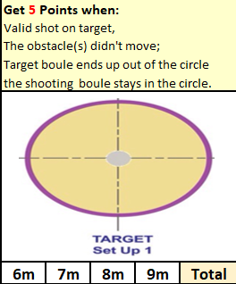
Andrew Bellamy-Burt | 0
Andrew Limbrick | 1
Branden De La Haye | 0
Brian Harris | 0
Callum Stewart | 9
Cassie Stewart-Le Gallais | 6
Daniel Deveau | 3
David Ibitson | 0
Gary Cowburn | 0
Geoffroy Buffetrille | 0
Jean Stewart | 0
Keith Pinel | 0
Keith White | 0
Matt Pinel | 8
Paul Bell | 3
Ross Payne | 6
Tim Jackson | 0
Toby Northern | 0
Wendy Ritzema | 0

An impressive start for Callum with 9 points and Matt with 8, but shows the importance of starting off well with several players failing to score.

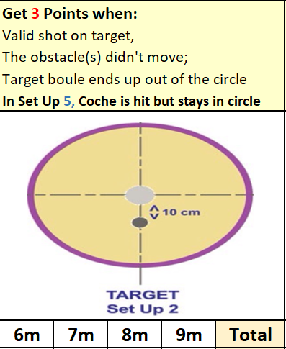
 | Round 2 Score | Total
Andrew Bellamy-Burt | 3 | 3
Andrew Limbrick | 5 | 6
Branden De La Haye | 0 | 0
Brian Harris | 0 | 0
Callum Stewart | 3 | 12
Cassie Stewart-Le Gallais | 0 | 6
Daniel Deveau | 1 | 4
David Ibitson | 0 | 0
Gary Cowburn | 0 | 0
Geoffroy Buffetrille | 1 | 1
Jean Stewart | 0 | 0
Keith Pinel | 0 | 0
Keith White | 0 | 0
Matt Pinel | 3 | 11
Paul Bell | 0 | 3
Ross Payne | 6 | 12
Tim Jackson | 0 | 0
Toby Northern | 6 | 6
Wendy Ritzema | 6 | 6

A good score of 6 points for a number of players in this round with a much more difficult shot required.
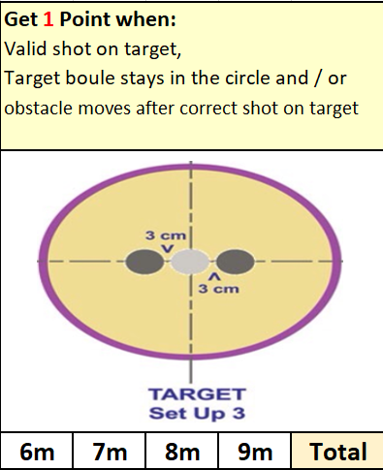
 | Round 3 Score | Total
Andrew Bellamy-Burt | 0 | 3
Andrew Limbrick | 0 | 6
Branden De La Haye | 0 | 0
Brian Harris | 3 | 3
Callum Stewart | 4 | 16
Cassie Stewart-Le Gallais | 0 | 6
Daniel Deveau | 0 | 4
David Ibitson | 3 | 3
Gary Cowburn | 4 | 4
Geoffroy Buffetrille | 3 | 4
Jean Stewart | 0 | 0
Keith Pinel | 5 | 5
Keith White | 0 | 0
Matt Pinel | 1 | 12
Paul Bell | 6 | 9
Ross Payne | 4 | 16
Tim Jackson | 0 | 0
Toby Northern | 3 | 9
Wendy Ritzema | 1 | 7

Callum and Ross were tied after the third round but Paul Bell had the best score on this one.

 | Round 4 Score | Total
Andrew Bellamy-Burt | 0 | 3
Andrew Limbrick | 3 | 9
Branden De La Haye | 0 | 0
Brian Harris | 1 | 4
Callum Stewart | 3 | 19
Cassie Stewart-Le Gallais | 0 | 6
Daniel Deveau | 0 | 4
David Ibitson | 0 | 3
Gary Cowburn | 4 | 8
Geoffroy Buffetrille | 3 | 7
Jean Stewart | 3 | 3
Keith Pinel | 1 | 6
Keith White | 0 | 0
Matt Pinel | 1 | 13
Paul Bell | 3 | 12
Ross Payne | 1 | 17
Tim Jackson | 0 | 0
Toby Northern | 3 | 12
Wendy Ritzema | 0 | 7
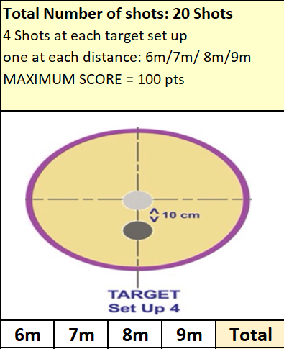
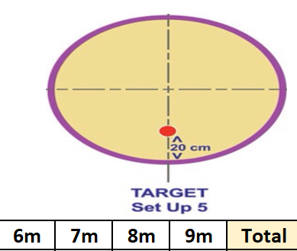
Probably the most difficult one of the five disciplines saw low scores but Callum and Ross made the required score to go through with still the cochonnet to go.
 | Round 5 Score | Total
Andrew Bellamy-Burt | 8 | 11
Andrew Limbrick | 0 | 9
Branden De La Haye | 0 | 0
Brian Harris | 5 | 9
Callum Stewart | 0 | 19
Cassie Stewart-Le Gallais | 5 | 11
Daniel Deveau | 5 | 9
David Ibitson | 0 | 3
Gary Cowburn | 0 | 8
Geoffroy Buffetrille | 5 | 12
Jean Stewart | 0 | 3
Keith Pinel | 0 | 6
Keith White | 0 | 0
Matt Pinel | 0 | 13
Paul Bell | 5 | 17
Ross Payne | 0 | 17
Tim Jackson | 0 | 0
Toby Northern | 0 | 12
Wendy Ritzema | 0 | 7

Andrew Bellamy-Burt was the cochonnet master hitting 2 to score very well in this round with 8 points to recover some pride with 11 in total. Some half decent scores from a few players with Daniel Deveau getting 9 points on his first ever go having just started playing. Some disappointing scores though with Matt Pinel, Geoffroy Buffetrille and last years winner Keith Pinel all surprisingly failing to get the minimum required. Several players one hit away from getting through though.

So this year 3 players qualified for the knockout stage compared to just one player last year with Callum going straight to the final with the highest score of 19. Paul Bell and Ross Payne both with 17 played off in their semi-final.
Ross lead 4 – 3 after round one but a 6 – 1 score in Paul favour in round two gave him a 9 – 5 lead which extended to 10 – 5 after round three. Round 4 went Paul way as he moved to 13 – 5 but Ross hit the first cochonnet scoring three to move within 5 points of Paul but no further hits were recorded so Paul made the final with Ross taking third place.
The final was incredibly low scoring with Callum leading 3 – 0 after round 2 and 4 – 0 after round 3.
Paul then won round 4, 3 – 0 to make it 4 – 3 to Callum going into the final round, but just one hit as Callum hit the 7m cochonnet to make it a final score of 7 – 3 to Callum who lifts the trophy for the first time.
Winner

Huge thank you to Geoffroy Buffetrille, Matthew Pinel and for helping run the event, very much appreciated by all those taking part.

SUMMER 2023 SEASON
WEEK 8 – 24th May 2023
SINGLES LEAGUE

The first double fixture week of the season on very difficult terrains.

Current champion Andrew Bellamy-Burt was flying high with three wins from three and played Paul who was struggling so should have been confident of four straight wins before playing Brian. However Paul pulled off a great draw and another one followed for Andrew.

Andrew has now played 199 league matches and is on a 32 match unbeaten record, 1 shy of the record set by his next opponent Toby Northern!

Geoffroy played a resurgent Ross in game one needing a win and the valuable three points but a fair draw for both players. Geoffroy then played Alex getting a win to move up the table.

Ross second game was against Alice who had drawn against Tim in game one. But Alice lost against Ross who is now tied at the top.

David had a very good week drawing with Brian before beating Toby who is struggling this season didn’t and he didn’t help himself against Neil also losing that one.

Neil had drawn all three matches going into this week, could he turn the tide in a positive way against Laurent? Well a draw also, but a good 4 points for Neil.

Andrew Limbrick played Alex and then Callum, with Callum on form but a draw against Laurent in match 1. Both draws for Andrew and Callum.

Paul played Tim in his second match with a win valuable for both players at the bottom half of the table and it was Tim who got all those points.

In Division 1 leader Joey played Jim first losing heavily in a shock result 13 – 5, 13 – 2. Joey then drew with Jean to drop off the top spot.

Jean then played John getting the win to sit just outside the top 3.

Newcomer Daniel Deveau fresh on the back of two wins last time out played Branden getting a draw but could have won before playing Daniel V who was unbeaten going into this week but a great win for the newcomer who now sits top of Division 1!!. Daniel V also played Lorna winning that one.

Colin then drew with Mo before beating James and another newcomer in Keith White who had been struggling so far, could he get his first win of the season? He played James getting a draw, and another player unbeaten with his match against Jim but despite Jim great win over Joey he lost to Keith who gets his first league win.

A big match at the top of the table between Brigitte and Cassie went Cassie way.

Lorna was in contention early in the season but needed points against Daniel V and Mo but lost both to drop to 11th place in the league.

OUTSTANDING MATCHES

Division 1 – Week 5 – Cassie v Branden

SUMMER 2023 SEASON
WEEK 9 – 31st May 2023
DOUBLES LEAGUE

The terrains continue to challenge players but not the champions Laurent & Matt who made fairly light work of Andrew & Lorna to move back to the top of the league after they also beat Andrew & Callum in a catch up match.

Neil & Ross title hopes suffered with a heavy loss to Graeme & Keith which was their first win of the season.

Alex & Jean still unbeaten in second place with a draw against Alan & Joey. A draw also for Gary & Wendy against Alice & Brigitte. Gary & Wendy losing game one 13 – 12.

In Division 1 Colin & Jim cemented their place at the top of the league with a win over Alan & Mike.

Another marathon match for John & Nick, this time against James & Ross, with John & Nick taking the last game 13 – 12 for a draw.

Cassie & Chris got another win to move into the top three at the expense of Keith & Mo and Daniel & James got their first win to move out of the relegation zone.

SUMMER 2023 SEASON
2023
Club Doubles Cup

Twelve teams took part this year in one our usually most popular competitions.

Round 1 saw a close win for Alice & Brigitte 7 – 6 over Alex & Jean and Kat & Paul beat Neil & Ross 13 – 11 and Geoffroy & Matt beat Alan & Mike 9 – 6.

Big wins for Andrew & Callum 13 – 3 over Branden & Tim and Gary & Wendy beat Alan & Joey 13 – 2.

A win also for the champions Laurent & Toby 13 – 6 over Keith & Mo.

Round 2 saw the champions Laurent & Toby win big over Andrew & Callum 13 – 5 and Alice & Brigitte also made it two from two with a 13 -12 win over Kat & Paul.

Two other close matches as Keith & Mo beat Branden & Tim 10 – 8 and Geoffroy & Matt won 6 – 4 over Gary & Wendy.

Alex & Jean and Neil & Ross got their first wins.

Round 3 saw the champions qualify for the quarter finals with a round to spare beating Alice & Brigitte 13 – 1. Geoffroy & Matt also won their third match beating Alex & Jean.

A big 12 – 1 win for Gary & Wendy over Neil & Ross and another one 13 – 3 win for Andrew & Callum over Kat & Paul.

Keith & Mo lost to Alan & Mike and Branden & Tim beat Alan & Joey!

The final round saw the top two play each other with Geoffroy & Matt beating Laurent and Toby to top the rankings.

Andrew & Callum lost to Gary & Wendy but still finished fifth with Gary & Wendy in third place.

Alice & Brigitte finished fourth with a win over Alan & Joey who finished bottom and the only team not to win.

Alex & Jean lost a close match to Keith & Mo who qualified for the quarter finals in eighth place. Kat & Paul beat Alan & Mike 10 – 9 to go through in sixth place whist Neil & Ross big 13 – 3 win gave them seveth place.

FINAL SWISS RANKINGS

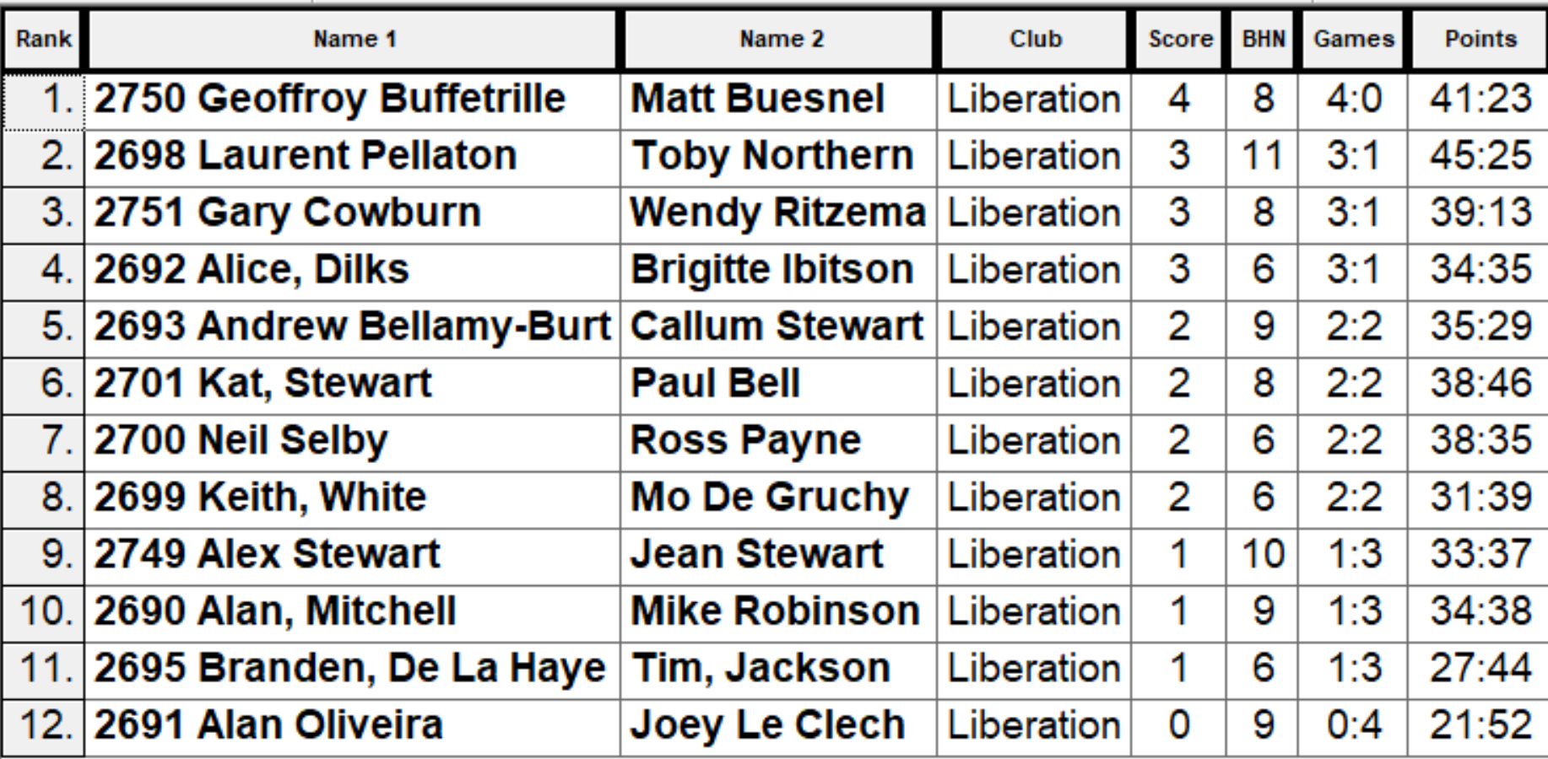

QUARTER FINALS

Ranked 1st Geoffroy & Matt v Keith & Mo Ranked 8th

Ranked 2nd Laurent & Toby v Neil & Ross Ranked 7th

Ranked 3rd Gary & Wendy v Kat & Paul Ranked 6th

Ranked 4th Alice & Brigitte v Andrew & Callum Ranked 5th

The Swiss curse struck again as ranked eight Keith & Mo shocked one of the best teams in the Island in Geoffroy & Matt winning 13 – 6.

Alice & Brigitte also shocked Andrew & Callum taking their place in the semi finals winning 10 – 8.

Laurent & Toby chances of retaining their title went with a 13 – 7 loss to Neil & Ross and Gary and Wendy beat Kat & Paul 10 – 4

So the Semi-Finals were as follows:

Ranked 8th Keith & Mo v Alice & Brigitte Ranked 4th

Ranked 3rd Gary & Wendy v Neil & Ross Ranked 7th

Gary & Wendy yet again beat Neil and Ross, this time 8 – 6 to make the final and Keith & Mo also made the final beating Alice & Brigitte 8 – 5.

Third place for the second year running went to Neil Selby & Ross Payne who beat Alice Dilks & Brigitte Ibitson 13 – 12!

The final was a surprisingly one way affair as exceptional pointing from Mo & Keith out did the shooting from Gary & Wendy with the result a 13 – 2 win for Keith White & Mo De Grucy a fantastic performance.

2023 LIBERATION CUP DOUBLES WINNERS

KEITH WHITE & MO DE GRUCHY



SUMMER 2023 SEASON
WEEK 11 – 14th June 2023
SINGLES LEAGUE

The Summer is well under way now and hotting up for some great summer evenings of pétanque.

Andrew Bellamy-Burt draw against Toby and win over Laurent saw him break the unbeaten record, now on 34 matches and in fact his match against Toby was his 200th league match. Huge congratulations to Andrew.

This was Laurent only match and the defeat now see’s him in the relegation zone!

Toby though gained a different record as he beat Tim Jackson 13 – 0, 13 – 0 to hand out the first double certificate result in over 10 years in the Singles Leagues, Toby now holds the record for most 13 – 0 wins handed out with eight. This result also lifted Toby out of the relegation places.

Geoffroy had a double win to move within one point of league leader Andrew BB, he beat Callum and Neil to move into second place.

A difficult week for Ross as he could only manage two draws meaning he drops two points off top spot in third place. Ross played Alex and Callum.

Callum dropped out of the top three after getting only one point and Brian Harris also lost ground drawing with Tim and Paul Bell, but is still undefeated with six draws!

Alice 13 – 12 win in game one helped her to an important win over Paul and a draw with Alex for a good four points this week.

In Division 1 there is no stopping Daniel Deveau as he record two more wins and in impressive style beating newly crowned club doubles champion Mo 13 – 2, 13 – 4 followed by a win over James Villalard 13 – 1, 13 – 1! Daniel remains top with an impressive points difference but he has played more matches than those below him.

Joey could only draw with Brigitte before beating Branden to maintain his push for the top spot and promotion back to the Premier League.

Jean beat Brigitte to keep pace at the top end of the league. Cassie beat Mo and drew with Daniel V.

Lorna lost to James V and then drew with Keith dropping off the pace after a promising start to the season. Keith also drawing with Colin.

Daniel V beat John to also stay in contention of a top three place. Mo defeats see’s her drop out of the top three to just above relegation!

SUMMER 2023 SEASON
WEEK 12 – 21st June 2023
DOUBLES LEAGUE

The record is gone as coming into this season current three times in a row champions Laurent Pellaton & Matt Pinel were undefeated all the way through but Neil & Ross ended this run with their first win of the season!

Laurent & Matt also dropped points in a draw with Alan & Joey, whilst Neil & Ross drew with Alex & Jean. Alex & Jean made it two draws with another good result against Geoffroy & Matt B and now top the table but having played more matches.y

Geoffroy & Matt did beat Graeme & Keith to get three valuable points and sit in third with 2 matches in hand on the leaders.

Alice & Brigitte scraped a win against Branden & Tim winning the first game 13 – 12 which meant Branden & Tim dropped below them and into the relegation zone.

Branden & Tim also lost a game 13 – 12 to Andrew & Callum but did also lose the first game 13 – 0, this is Tim’s fourth certificate of the season!!. A big three points for Andrew & Callum but a 13 – 12 went against them in their game against Alan & Joey resulting in a draw.

In Division 1 two wins for Dawn & James means they are the only undefeated team in the league, they beat Daniel & James and Keith & Mo but still not top but two points behind Colin & Jim but do have a match in hand.

Colin & Jim beat Colin & Steve in a very close match with the latter also drawing with John & Nick.

Kat & Paul hit form though handing out a certificate to John & Nick on their way to three points.

Keith & Mo drew with Daniel D and Toby just losing the first game after leading 12 – 9 gave away a four point end to lose it.

Daniel & James also lost to Alan & Mike and Cassie & Chris drew against James & Ross who are struggling for wins.

SUMMER 2023 SEASON
WEEK 13 – 28th June 2023
SINGLES LEAGUE

The Singles league fixtures have been coming thick and fast this month with back to back double fixture weeks.

This is the last Singles fixtures for four weeks so who will make it count.

A big match in the Premier League as leader and title holder Andrew Bellamy-Burt played Geoffroy who was just one point behind. This was as expected very close with Andrew taking the first game 13 – 11, and Geoffroy getting two points on the final end in game two to win 13 – 12.

Geoffroy played David first dropping two points so sits in third as a result.

Laurent only had one match with his one against Tim being postponed so played Paul needing three points but could only draw so remains in the bottom three but two matches in hand. Paul had lost his first game to Toby heavily 13 – 2, 13 – 2.

Toby then also beat Brian for a big six points which moves him up to 5th in the table. This was Brians first loss in 27 matches! Brian also played Alice winning this one.

Ross was also in the chance of the title, and he played doubles partner Neil first taking a big three points winning 13 – 11, 13 – 11 before playing David but dropped two points with a draw.

Neil also played Alex with the result a loss for Neil who is now just outside the relegation zone. Alex had also lost against son Callum with Callum also playing Alice but drew this one.

In Division 1 the battle at the top continued with leader Daniel Deveau having already beaten Colin needed to beat Keith to have a chance of retaining top spot. Daniel won easily 13 – 5 and then came back from 11 – 5 down to win the second game 13 – 12 to remain top of the league.

Joey played Daniel Villalard in a second verses third match first winning this one before playing Mo, but dropped points in a draw so stays second.

Daniel V then played Jean who was in great form with Jean taking this one, but Jean drew with Branden and Jim. This meant Cassie moved to third on points difference despite two draws against James and Keith

Brigitte played Branden & Jim winning both to jump back up the table to fifth place and just two points off a promotion place.

Lorna played Jim winning a close match to move away from the bottom three and John Flaherty drew both his matches against Mo & James

SUMMER 2023 SEASON
2023
CLUB HANDY CAP CUP

The Annual fun cup saw 18 players take part, with the lower ranked players getting points head start who would the top players fair playing catch up.

2022 champion Neil Selby started off 2 – 0 behind in his first match against Jean Stewart but managed to win 13 – 8. 2022 runner up Callum Stewart didn’t fair as well losing 13 – 12 to Mo De Gruchy who started off + 3.

Top Swiss ranked player in 2022 Toby Northern started off 2 – 0 behind Lorna Limbrick but won 13 – 6, Lorna unfortunately had to withdraw after this match due to injury.

Keith White pushed Geoffroy all the way to 13 – 12 as did Cassie Stewart against Brian Harris.

Ross Payne avoided any shocks as he ran out 13 – 5 winner over last years third place Kat Stewart who started with +4.

Big shock though as Andrew Bellamy-Burt lost 13 – 6 to Jim Waddell who was helped with a +4 start.

Ross made it two in a row with a 12 – 10 win over Neil and Toby won big over Tim 13 – 4.

Jim just lost 13 – 12 to Mike Robinson and Callum just beat Branden 13 – 11. Kat provided another shock with a 13 – 12 win over Jean. A big win also for Keith 13 – 4 over Brian.

Round 3 of the Swiss system saw to Premier league giants play each other with Toby winning 13 – 5 over Geoffroy. Ross Payne also made it three wins with a 13 – 8 score over Mike.

Three 13 – 9 scores as Neil beat Paul, Andrew beat Callum and Jim beat Mo.

Keith just beat Kat 13 – 11.

In the final round Toby beat Ross to top the rankings for the second year running with Ross finishing 3rd. Brian Harris just beat Neil Selby 11 – 10 with both players going through in 5th and 7th respectively.

Keith beat Jim to finish 2nd with Jim squeezing in 8th place. Geoffroy beat Tim to go through in fourth and Andrew beat Mike to finish 6th.

Kat Stewart and Mike Robinson both just missed out on points difference.

Final Rankings

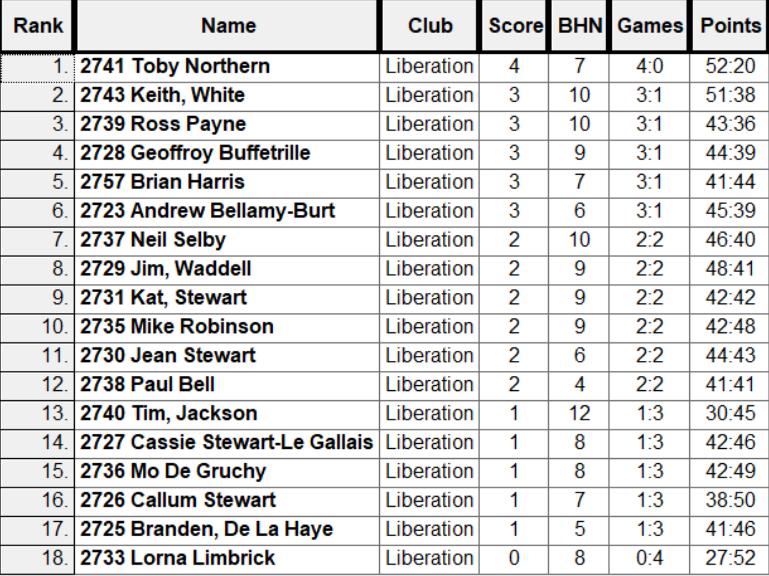

The Swiss curse struck again as a four point lead and three points of the first end saw Jim 7 – 0 up against Toby who fell 12 – 2 behind before fighting back to 12 – 10 only for a great shot by Jim take his through 13 – 10.

Keith White also had a big win knocking out holder Neil 13 – 11. Andrew beat Ross 13 – 9 and Geoffroy overcame Brian 13 – 10.

Incredibly close semi finals saw Jim repeat his quarter final start going 7 – 0 up before Geoffroy fought back and lead 12 – 11 but a coche move by Jim saw him holding two close boules and Geoffroy tried to fire to break the points but missed meaning Jim made the final 13 – 12.

Keith also started well against Andrew who was losing heavily before coming back but too little too late as Keith made his second successive club cup final winning 13 – 11.

The final saw Keith lead all the way taking the title 13 – 10 and Geoffroy beat Andrew 13 – 7 for third place.

Winner – 2023 – Keith White



Thank you to all those who helped out making another great competition.

SUMMER 2023 SEASON
12.7.2023
FREE WEEK

SUMMER 2023 SEASON
WEEK 16 – 19th July 2023
DOUBLES LEAGUE

The Premier League table is taking shape in the second half of the season but not the shape expected as Alex & Jean win over Gary & Wendy puts them top and undefeated.

Andrew & Callum move second despite having lost two matches this season and drew against Neil & Ross who sit mid table. Alan & Joey also in the top three after a win over Branden & Tim who look odds on for relegation.

Andrew & Lorna fought back well from 9 – 0 down to get a draw against Alice & Brigitte.

A big win for Daniel & Toby handing out a third certificate to Kat & Paul puts them in third and a game in hand over leaders Colin & Jim who lost to John & Nick.

Dawn & James remain unbeaten after a draw with James & Ross, whose sixth draw leaves them two points off promotion places having played two matches more than second and third.

Keith & Mo win over Alan & Mike moves them to fourth, still in with a shout of a top three position. Cassie & Chris draw with Colin & Steve puts them on nine points also as all the way to nineth position are just three points off a top three place.

SUMMER 2023 SEASON
WEEK 17 – 26th July 2023
SINGLES LEAGUE

The Singles League was back after a four week absence as the battles for titles, promotions or just staying up resumed.

Premier League leader Ross played current champion Andrew BB in a huge match. Ross came close to ending Andrew unbeaten run but in the end had to settle for a draw.

Geoffroy was sitting in third place and had the easy match on paper so a win could move him up above Ross and Andrew if they drew. Geoffroy did beat Tim, who gave him a good game in the first one losing just 13 – 11.

Callum had a big game against Neil with a win keeping him in with a chance of the title, where as Neil needed the points to move clear of relegation. A draw the result though.

Toby move up the table to mid table safety was going well, but needed to beat Alice to keep that going. He did that to record his fourth straight win and move up to fourth in the table and just four points off the top spot.

Brian Harris played Laurent who needed a big win to move towards safety with Brian in sixth place. Laurent couldn’t get the win he wanted with a draw the result, Laurent did beat Tim though to move four points clear of the drop zone.

A win for Alex of David would move him above David in a very close bottom half of the table, but another draw see’s him dop to bottom, this was after Andrew Limbrick lost to Paul Bell who was bottom before this weeks fixtures but now out of the relegation zone.

In Division 1 Daniel D needed to beat Lorna to maintain his push for the title, he just managed it winning 13 – 12 in the first game before winning 13 – 5 in the second.

Joey needed to beat James V to keep pace with Daniel and did so with a perfect shot to maintain the pressure in the title race.

Cassie and Jean were both on sixteen points, three off the top spot. Cassie played Colin and Jean played Mo but both players lost and drop six points off the top spot.

Brigitte was also on the cusp of the top three could she beat Daniel V and did so winning her third straight match and this was Daniel’s third straight loss!

Bottom two played each other in Branden and Jim with a draw helping neither player.

Keith and John unplayed.

SUMMER 2023 SEASON
WEEK 18 – 2nd August 2023
DOUBLES LEAGUE

Well there was actually no matches played this week despite a full calendar of matches due!

SUMMER 2023 SEASON
2023
CLUB SINGLES CUP

22 Players took part this year on a beautiful evening.

Round 1 saw Andrew BB lose a clos match to Paul Bell 13 – 11 and current champion Geoffroy beat Daniel V 13 – 9.

Two 13 – 12 wins win the way of James G over Brian and Jean over Joey. Biggest win of the round saw Keith beat James V 13 – 2 and only one match didn’t make 13 and this was an 11 – 5 win for Callum over Ross C.

Round 2 saw Laurent beat Toby 13 – 10, Callum made it back to back wins 13 – 2 over Paul and this was the same score as Alan beat Jean.

James G made it two wins with a big win over Keith 13 – 4.. Five matches didn’t make it to 13 in this round as Joey won 10 – 8 over Lorna, James V beat Branden, Mo beat Jim and Geoffroy Beat Alex 12 – 9, the same score for Andrew L over Tim.

Callum won 11 -10 over Andrew L to make it three wins and Geoffroy also moved onto three wins with a win over Alan.

James V beat Paul for his second win as did Toby over Keith and Tim over Joey.

Mo beat Jean 12 – 9 and Lorna 9 – 8 over Jim. Laurent also made it three beat James G 13 – 5

In the final round Toby Northern beat James Villalard 13 – 1 to finish fifth and Andrew Bellamy-Burt beat Alan Oliveira 13 – 7 to finish fourth.

James Gennoe lost again to Tim Jackson to go out with Tim finishing sixth. Laurent lost to Callum to finish third which meant Callum finished top of the Swiss Rankings with four wins from four, a feat also achieved by Geoffroy over Andrew Limbrick so Geoffroy finished second. Andrew L finishing seventh.

Eighth spot went to Paul Bell by one BHN over Alan Oliveira.

Swiss Rankings

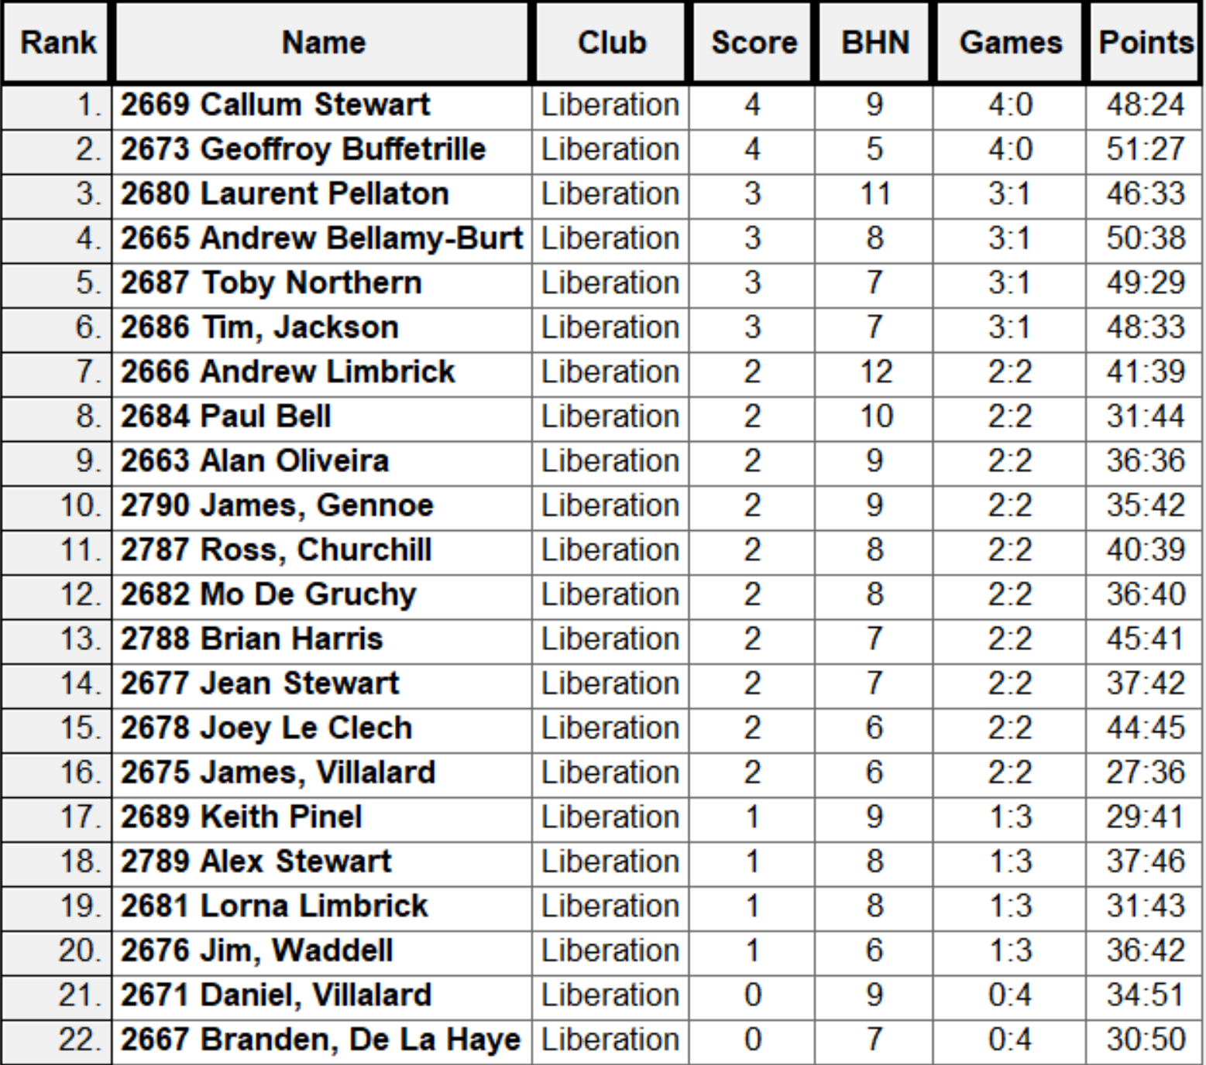

Quarter Finals

Ranked 1st Callum Stewart v Paul Bell Ranked 8th

Ranked 2nd Geoffroy Buffetrille v Andrew Limbrick Ranked 7th

Ranked 3rd Laurent Pellaton v Tim Jackson Ranked 6th

Ranked 4th Andrew Bellamy-Burt v Toby Northern Ranked 5th

Callum got the best of Paul for the second time in the competition winning 13 – 3, the biggest win in the Quarter Finals. A surprise as Andrew Limbrick who had just lost to Geoffroy Buffetrille in the last qualifying round, turn it around to get to the semi finals with a 13 – 9 win.

Tim Jackson pushed Laurent Pellaton all the was but lost out 13 – 11 and Andrew Bellamy-Burt beat Toby Northern 13 – 12 on the last end.

Semi Finals

Ranked 1st Callum Stewart v Andrew Bellamy-Burt Ranked 4th

Ranked 7th Andrew Limbrick v Laurent Pellaton Ranked 3rd

Semi Final one never went Callum way as he struggles against Andrew, who won comfortably 13 – 3.

Laurent seemed in control of his match against Andrew but it was close with Laurent just winning 13 – 10.

Third Place went to Andrew with a 13 -10 win over Callum.

The final, which you can see in full on our facebook page. Was pretty one sided as Laurent played exceptionally well before a comeback by Andrew but not enough as Laurent sealed his first win in the competition 13 – 9.

Thanks to Laurent, Geoffroy and anyone else who helped Toby run the competition.

Winner



SUMMER 2023 SEASON
WEEK 20 – 16th August 2023
SINGLES LEAGUE

The Singles league is in the final stretch and the Premier League title is all in the hands of Andrew BB following wins over Andrew L and Alex means if he wins his final two matches he will retain the title.

Nearest challenger Geoffroy won comfortably against Paul Bell to stay one point behind Andrew.

Toby won his fifth straight match against Laurent to move into the top three. Ross dropping out but has a match in hand due to not playing this week along with Andrew L v Brian.

Callum was beaten comfortably 13 – 2 by David in their first game but came back well to win 13 – 4 in the second for a draw.

Neil Selby won just his second match of the season but against Alice means he moves clear of the relegation zone with Alice close to the drop.

In Division 1 Daniel Deveau looks unstoppable, winning comfortably against Jim, his seventh in a row to move four points clear at the top of Division 1 as Joey didn’t play.

Brigitte fourth win in a row against Mo see’s her remain in third place and in the promotion places, just one point above Jean who beat James.

Daniel Villalard lost his 100th league match against Branden and has only won 12 matches out of the 100 played, the lowest win rate in the 100 Club.

Colin v John, Cassie v Lorna and Keith v Joey all unplayed

SUMMER 2023 SEASON
WEEK 21 – 23rd August 2023
DOUBLES LEAGUE

With just three scheduled matches left every team must put their best games in to get the rewards.

In the Premier League leaders Alex & Jean had to win against Graeme & Keith to keep the chasing pack away but suffered their first loss of the season. One of these teams chasing was Andrew & Callum who also needed to win over Gary & Wendy but this was called off.

Gary & Wendy did however play a catch up match against Laurent & Matt with a draw leaving the league wide open.

Alan & Joey coming into this week with a match in hand and just three points off top spot played Alice & Brigitte but this was also postponed.

Geoffroy & Matt lost heavily in a catch up match against Laurent & Matt so a must win match against Branden & Tim which they did

Andrew & Lorna playing catch up faced tough opponents in Neil & Ross but this was also postponed.

In Division 1 just three points separated third and nineth place.

A win in a match played in advance had left Colin & Jim top but second placed Dawn & James were unbeaten, they played Colin & Steve who had been struggling and continued to do so losing heavily.

Daniel & Toby also looking to move top played hard to beat Nick & John and it proved just that as some excellent placing from John and Nick helped them get a draw.

Alan & Mike versus Kat & Paul was a chance for one team to climb the table with a win but a draw was the result.

Keith & Mo versus Daniel & James postponed.

SUMMER 2023 SEASON
WEEK 22 – 30th August 2023
SINGLES LEAGUE

The penultimate Singles league week (before the last one on the 4th October) saw everything on the line.

League leader and current champion Andrew B played doubles team mate Callum whose season had been faltering after a promising start. Andrew won the first game but a big swing in the second one saw Callum win 13 – 5 for the match to end in a draw.

Geoffroy played Brian who had only lost one match all season so a tough one to play. However Geoffroy played well to win and move top of the league.

Ross had a catch up game as well as playing Paul who won his first match of the season last time out but still in the relegation zone. Ross needed to win both matches and hope results went his way for any chance of a title win going into the last week of the season. Paul form has turned around though as he handed Ross his first defeat of the season which ends his title hopes and will need to beat Tim in his catch up match to maintain a push for the top three.

Toby beat Andrew L for his 100th League win, the first player in the clubs history to achieve such a feat. This was also Toby sixth straight win after a poor start to the season which see’s him move into the top three.

Laurent resurgence has seen him move clear of relegation, but his opponent Alice needs the win to avoid potentially falling into the relegation zone. This match was unplayed. This was the same for David who needed points against Neil, in fact a win would have seen him move above Neil but a draw was the result and both players not quite safe yet.

Alex played Tim who was bottom of the league so a real relegation battle, a must win match for both players if they hoped to avoid the drop. It was Alex who took the points to give him a great chance of avoiding the drop.

In Division 1, leader Daniel Deveau was under pressure to keep his run going and played Cassie who was also in the mix for promotion. Match unplayed though.

Joey match against Colin postponed to later in the season. Jean who was just outside the top three played Keith White in her bid for promotion but could only draw and with Brigitte winning her fifth straight match, against James moves into second and a commanding position for promotion.

Three players in the relegation zone were all on eight points as Keith who drew above, Branden who lost to Mo and John Flaherty whose match against Lorna was unplayed.

Daniel and Jim playing out a draw in the bottom half of the league.

SUMMER 2023 SEASON
2023
SUPER 7’S CUP

The 6th Super 7’s Cup got underway in beautiful Summer weather with 18 players taking part.

2022 champion Toby got off to a good start winning his first match 9 – 4 against James Villalard despite being 4 – 0 down after the first two ends.

2018 winner Geoffroy beat Tim 7- 2 for a good start and Andrew BB beat Jim 10- 3 for the biggest win of the round.

Cassie with a big win over Ross and Alan over Neil.

Round 2 saw two wins to nil as Toby beat Alan 10 – 0 and Andrew BB beat Branden 13 – 0.

Alex made it two wins with a big win 8 – 1 over Paul and Jean got 12 points in her win over Daniel Villalard.

Daniel Deveau beat Jim 6 – 5 for his first win and James Gennoe beat Neil also by one point.

Round 3 saw Toby beat Ross 6 – 5 and this was the same score as Andrew BB beat Alex with Geoffroy beating Jean for three wins for these three players.

Daniel Deveau beat James Villalard for back to back wins. Neil got his first win over Jim and Paul and Cassie both got their second wins.

Round 4 saw Andrew beat Toby by one point. This was the same as Geoffroy beat Alan 5 – 4.

James Villalard beat dad Daniel 12 – 0! For some bragging rights, the rest of the matches were much closer as Jim beat James G 5 – 2, Alex beat Jean 7 – 5.

Ross beat Neil 6 – 3 and wins for Cassie, Paul and Tim.

Round 5 saw a shock result as Daniel Deveau beat Ross 12 – 0! A big win also for Alan 13 – 3 over Jean.

Andrew BB beat Geoffroy to move onto five wins from five. Paul win over Toby moved him onto four wins from five.

Tim made it back to back wins with a win over Neil who was struggling. Daniel Villalard got off the mark beating Keith 5 – 4. Alex beat Cassie, Branden beat Jim and James G beat James V.

Round 6 saw James G record the biggest win 11 – 1 over Tim and Andrew 8 – 1 over Paul.

Closer matches as Geoffroy beat Alex 9 – 8, Cassie beat Alan 8 – 7 and Ross beat Jean 7 – 6 and Daniel V beat Jim 5 – 4!

Wins also for Toby over doubles team mate Daniel Deveau despite Daniel shooting well. James V beat Branden and Neil beat Keith.

In the seventh and final round Daniel Deveau beat Tim 12 – 0, the second time he recorded this score which ultimately put him through in 8th place by three points on points difference over Alan Oliveira despite him beating Daniel Villalard 10 -1.

Andrew Bellamy-Burt beat Cassie Stewart Le Gallais 7 – 4 to top the rankings with seven out of seven wins! Cassie finishing 6th place with 4 wins.

Paul Bell win over Geoffroy saw him finish fourth one place behind Geoffroy on points difference. Toby win over Alex saw him finish second with Alex finishing fifth.

Ross Payne beat James Gennoe to finish 7th with James not making the cut.

Big wins for Neil, Jean and Jim were just consolation prizes.

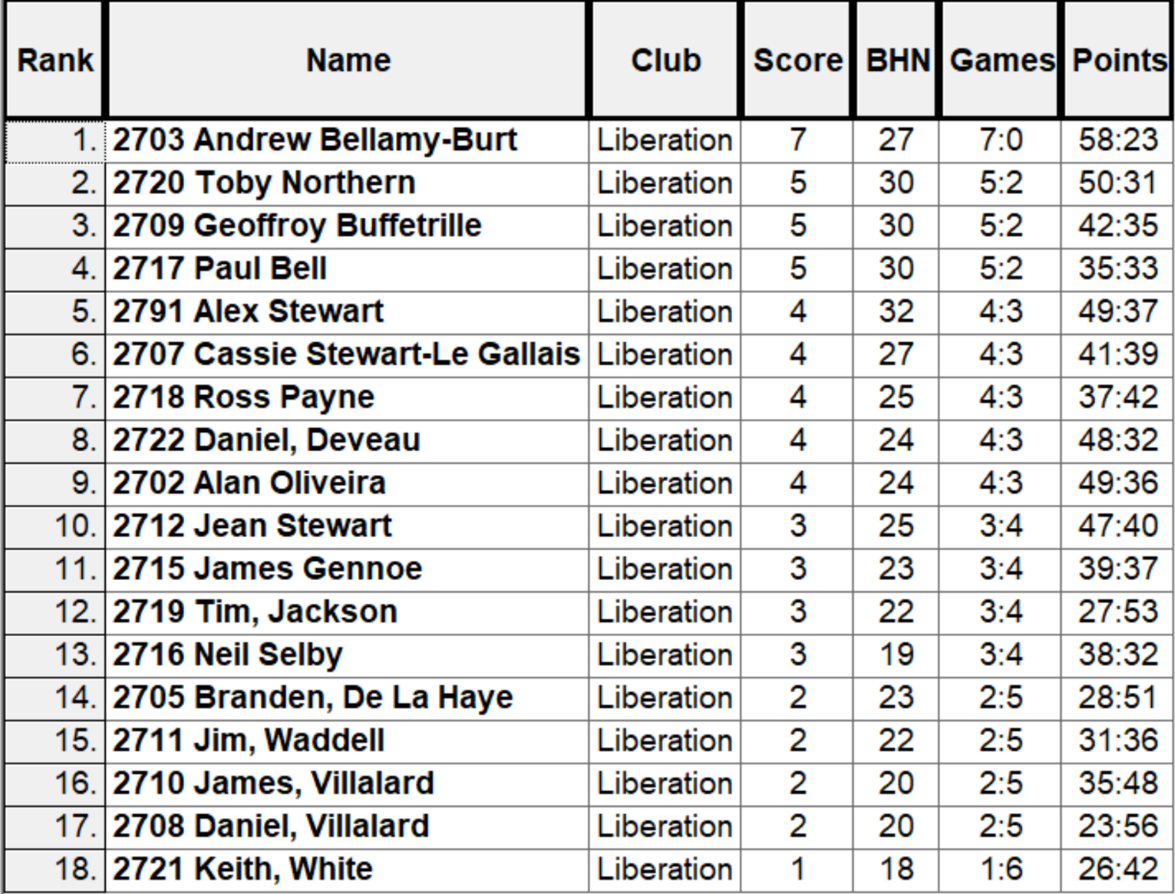

QUARTER FINALS

Ranked 1st Andrew Bellamy-B v Daniel Deveau Ranked 8th

Ranked 2nd Toby Northern v Ross Payne Ranked 7th

Ranked 3rd Geoffroy Buffetrille v Cassie Stewart LG Ranked 6th

Ranked 4th Paul Bell v Alex Stewart Ranked 5th

A comfortable win for Andrew over Daniel (8 – 1) who should be happy making it through to the knockout stages in his first Singles competition.

Toby knockout out Ross in the quarter finals for the second successive year, but this was because Ross wasn’t paying attention to the score after firing Toby boule out was holding second and third so needed to fire Toby only boule on the terrain out to win, but instead pointed for one point when he was 5 – 3 down handing the win to Toby.

Geoffroy beat Cassie for the second time in the competition and Paul Bell beat Alex to get revenge for his 8 – 1 defeat to Alex in round 2, winning 7 – 4.

So the Semi-Finals were as follows:

Ranked 1st Andrew Bellamy-B v Paul Bell Ranked 4th

Ranked 2nd Toby Northern v Geoffroy Buffetrille Ranked 3rd

Andrew continued his top form scoring heavily in a 10 – 3 win over Paul but the match between Toby and Geoffroy was much closer than last years semi final between the two which Toby won 11 – 0!

Tied at 5 – 5 after the seven ends meant one extra end. Geoffroy pointed a good first boule which took two boules from Toby to beat but Geoffroy firing the coche out with Toby boule which had to be replaced leaving him holding again, Toby placed in again only for Geoffroy to repeat the feat meaning the coche was replaced again which Geoffroy boule holding and giving him the win.

Third place went to Paul Bell.

It was a close final between Andrew and Geoffroy with an unfortunate fire taking the target boule and his own boule out on the penultimate end gave Andrew a 5 – 4 lead going into the final end.

This is when decisions can make all the difference with Andrew placing a six metre coche which he can place really well at but also makes it much easier for the shooter and this was the case as Geoffroy fired all three of Andrew boules out to pick up thee points and win his second Super 7’s title winning 7 – 5.

Special thanks to Laurent Pellaton for staying around and helping out, the club needs more people like Laurent.

2023 - Winner - Geoffroy Buffetrille



NEXT WEEK - DOUBLES LEAGUE

Club email address - liberationpc@gmail.com

Club Website - www.liberationpetanque.co.uk

Kind Regards

Toby Northern

Chairman - Liberation Petanque Club

SUMMER 2023 SEASON
WEEK 24 – 13th September 2023
DOUBLES LEAGUE

The penultimate Doubles league fixtures were played this week with everything hanging in the balance in both Premier and Division one leagues.

The Premier League is up for grabs this season despite Champions Laurent & Matt leading the way going into this weeks matches.

Having already played their last fixture due on the 20th September they needed a win against Graeme & Keith to give them the best chance of staying at the top. They did just that so now have to wait.

Neil & Ross could make the jump into the top three with a win over Alan & Joey who themselves were in with a chance of the title, they did just that as Alan & Joey season turns to tatters.

Geoffroy & Matt could also take advantage of the title with a win over Andrew & Lorna and then with a catch up match against Andrew & Callum. They beat Andrew & Lorna but lost to Andrew & Callum who can now win the league.

Alex & Jean title hopes faltered again in the latter stages of the league could they beat Alice & Brigitte. Yes but by default as Alice is unable to complete the season.

Gary & Wendy in a relegation battle with Branden & Tim, with the former winning and Branden & Tim going down.

In Division 1 leaders Dawn & James could take a huge step towards the title and guarantee promotion with a win over John & Nick, who themselves were going for promotion. They did to seal the title and end John & Nick promotion hopes.

Colin & Jim unfortunately had to withdraw giving wins to their remaining opponents.. Daniel & Toby had a must win match over Cassie & Chris in order to maintain a top three position, they could only draw but secured second spot. They also played Colin & Steve in a catch up match but could only draw. Colin & Steve also played Alan & Mike losing that to finish bottom of the leagues.

Slim hopes of promotion for James & Ross who played Daniel & James who needed to win to avoid relegation. James & Ross won but wasn’t enough in the end as too many draws saw them miss out.

SUMMER 2023 SEASON
WEEK 25 – 20th September 2023
DOUBLES LEAGUE

The final scheduled week of doubles league fixtures took place this week.

Andrew & Callum sealed their first ever Doubles Premier League title with a win over Graeme & Keith who have a nervous wait to see if they stay up.

Neil & Ross draw against Alice & Brigitte means they must win their last match of the season in a catch up against Andrew & Lorna to make the top three.

Alan & Joey drew with Geoffroy & Matt for a disappointing second half of the season for both teams.

Only one match played in Division 1 saw Keith & Mo draw with James & Ross, this saw Keith & Mo make third place.

SUMMER 2023 SEASON
WEEK 26 – 27th September 2023
FREE WEEK

NEXT WEEK - SINGLES LEAGUE

Club email address - liberationpc@gmail.com

Club Website - www.liberationpetanque.co.uk

Kind Regards

Toby Northern

Chairman

Liberation Petanque Club

SUMMER 2023 SEASON
WEEK 27 – 4th October 2023
SINGLES LEAGUE

The final schedule week of the season saw Geoffroy fail to beat Toby to seal his sixth Premier League title. But unfortunately Andrew misses out as he could only draw with Neil.

Ross played Brian knowing a win could give him third place, little consolation considering he was top of the league for a while. Brian though as ever hard to beat gaining a draw so Ross finished fourth.

Laurent had a much better second half of the season but his match against Andrew L delayed. Callum v Tim also delayed.

Paul needed to beat Alex in a relegation decider, with Paul in good form winning his last two matches would have been confident but lost to Alex.

Alice & David had drawn earlier meaning Alice was relegated but David just surviving.

In Division 1 Daniel was three points away from the title, a win over John would seal a remarkable first season of pétanque. Daniel also had a catch up match against Cassie. He got the win against John and the draw against Cassie to seal the title.

Joey needed to beat Lorna and hope Daniel dropped points. He did beat Lorna but it was only enough to finish second.

Cassie needed to win all three of her remaining matches but this didn’t happen as her match against Lorna was not played in time resulting in both players being given a defeat and deducted points. Cassie match against Jim ended as a defeat which meant Jim survived relegation.

Brigitte therefore took third place with a draw against Keith.

James needed to beat already relegated Brandon to have a chance of staying up and he did just that. Mo drew with Daniel.

SUMMER 2023 SEASON
WEEK 28 – 11th October 2023
FREE WEEK

