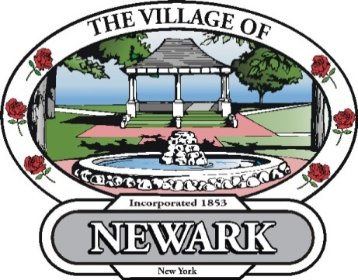
August 1, 2013

Re: Payment Agreements for Unpaid, Overdue water bills.

The Village of Newark has reinstituted a previously approved Village Board policy that customers with an unpaid water/sewer bill will be allowed only one payment agreement per 12 month calendar period, effective with the August 2013 billing cycle.

Thank You.

Sincerely,

Steve Murawski
Clerk/Treasurer

