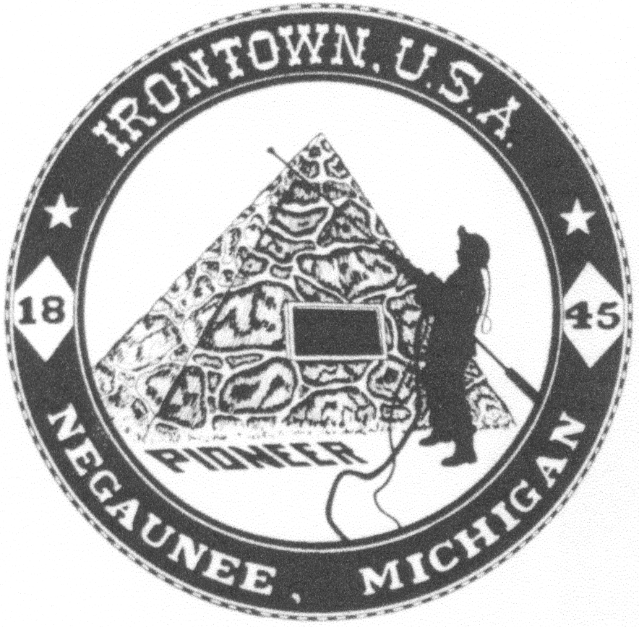
Negaunee Irontown Association

P.O. Box 128 Negaunee, MI 49866
www.negauneeirontown.com

2025 Community Service Scholarship Application

Full Name_________________________________________________Birth Date: ___________

Address_______________________________City, State Zip____________________________

Phone Number________________________E-mail ___________________________________

Hobbies______________________________________________________________________

_____________________________________________________________________________

School activities________________________________________________________________

_____________________________________________________________________________

Church / Community Activities___________________________________________________

_____________________________________________________________________________

Honors won___________________________________________________________________

_____________________________________________________________________________

What are your immediate plans following high school Graduation? ______________________

_____________________________________________________________________________

What are your long-term career Goals? _____________________________________________

Other materials needed:
• Two letters of recommendation from adults who are directly involved in your volunteer efforts.
• A letter from you detailing your community activities and involvement.

Signed_________________________________________________Date___________________

Parent_________________________________________________Date___________________
(only if applicant is younger than 18)

