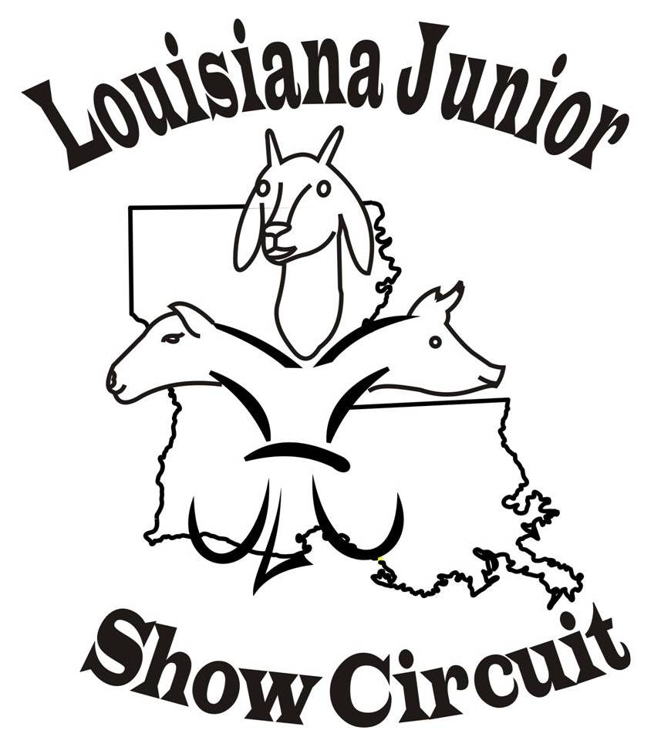
Red River Showdown
718 Fairground Rd, Coushatta, LA Red River Parish Fairgrounds

Friday and Saturday …… July 7 - 8, 2023
LJSC Sanctioned Hog, Sheep, and Goat Show
Market Classes & Showmanship
Friday, July 7th, 2023 5:00 – 6:30 P.M. Market Swine Check in / Weigh- in
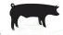
6:30 P.M. Swine Scales Close
6:45 P.M. Swine Showmanship: oldest to youngest *Market Swine Classes follow showmanship.
Saturday, July 10th,2023 8:15 – 10:00 A. M Sheep Check in / Weigh- in
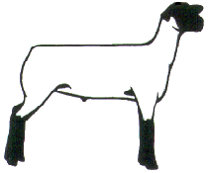
10:00 A. M Sheep Scales Close
10:00 A. M Market Sheep Showmanship: oldest to youngest
*Market Sheep Classes follow showmanship Saturday, July 10th, 2023 10:30 – noon Goat Check in / Weigh in
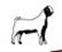
12:00 P. M Goat Scales Close
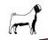
Noon Market Goat Showmanship: oldest to youngest
*Market Goat Classes follow showmanship

Entry fees: $21.00 per animal $ 11.00 per exhibitor for showmanship
Early Bird Discount……Must be postmarked by June 30, 2023
Entries day of show: $31.00 per animal for classes $16 per exhibitor for Showmanship
CLASS & SHOWMANSHIP PREMIUMS Cash, Buckles & other Prizes

Open to anyone that is 19 & under, must be eligible to show at State fairs with exception of novice & peewee.
*All species show by weight only – no weigh back – no breeds.
*No intact males may be shown – ewes, gilts, does all eligible. *LA Bred must be marked on entry form and weight card to be eligible for those awards at end of season.
* Please no ringworm or wool fungus.
*No Painting, Adhesive, Powdering, or Artificial coloring allowed.
*Health papers subject to be checked by LA. Dept of Ag
CONCESSIONS AVAILABLE Shavings Available

Sponsored by Red River Livestock Supporters
FOR MORE INFORMATION CONTACT:
Nancy Nettles cell (318) 455-2905 Email: Membynancy1@aol.com

Motel: Woodland Inn, 5150 Cutoff Rd, Coushatta, LA 71019 Phone: 318-932-4400

Red River Showdown Entry Form
Pre-Entry Fees for Swine, Sheep, and Goats - $21.00 FOR CLASS AND $11.00 FOR SHOWMANSHIP. Paid early entries must be postmarked by June 30, 2023.
Entries day of show: Class $31.00, Showmanship $16.00. Peewee no charge

MAKE CHECKS PAYABLE TO: MAIL TO:
Red River Livestock Supporters P. O. Box 1296, Coushatta, LA 71019
Exhibitor Name ____________________ _____________________ Phone__________ _____________
DOB _______________________ Age as of January 1, 2023 _____ ______
Address _______________ ________________ City & State ___________________________ Zip _____ _____
Email Address: _______________________________________ LJSC Member: Yes No
ONE ENTRY FORM PER EXHIBITOR
Species | QTY | Tag # | LA Bred Tag # | Price/ ea. | Total
Hog |  |  |  | $21.00
Lamb |  |  |  | $21.00
Goat |  |  |  | $21.00
Showmanship |  |  | Y/N
Entries @  $21.00 = ________ |  | Showmanship  Entries @ $11  = ________ |  | Total amount  paid | $ ________

Release disclaimer: The undersigned does hereby understand and agree the Red River Livestock Supporters, Red River Fair Board, Red River Police Jury, or any person associated with the show will not be held responsible for accidents, injury, illness, loss of items, etc. in anyway, and that I am attending at my own risk. I agree to follow and adhere to all Louisiana Junior Show Circuit rules and bylaws and Louisiana Junior Show Circuit Code of Ethics.

__________________________ _____________________________
SIGNATURE OF EXHIBITOR NAME OF EXHIBITOR

_____________________________________ _______________
SIGNATURE OF PARENT OR GUARDIAN DATE

