Naunton Parish Council
Clerk’s Report for March 2025 Meeting

Supporting documents for meeting on 11th March 2025
Please note that documents required for the meeting may be included as links to OneDrive. If possible, please read the document using the link rather than printing the documents. This is to save paper.

Agenda item 3 | January minutes for approval and signing | 2 - 4
Agenda item 5 (a) | Planning application 25/00502/FUL | 5
Agenda item 6 | Dog waste disposal signs | 5
Agenda item 7 | 20’s plenty signs | 7
Agenda item 11 | Information Commissioner’s Office | 8
Agenda item 12 | Risk Assessment Register | 9
Agenda item 13 | Asset Inspection Checklist | 13

Agenda item 3 – Minutes of the November meeting of NPC
Note: Please sign the copy of the document included in the file of documents for signing, not this one, which is included for information only.
Control click to see Minutes NPC meeting 30th January 2025 for signing.docx

MINUTES: of the Naunton Parish Council Meeting held on Thursday 30th January 2025 at 7.00 pm.
PRESENT: Parish Councillors: Nicki Gibberson (Chairman), Keith Russell, David Pickup.
GCC Councillor MacKenzie-Charrington, CDC Councillor Wilkins
APOLOGIES: Received in advance from Charles Hanks (Chairman).
IN ATTENDANCE: Maxi Freeman, Clerk
MEMBERS OF THE PUBLIC: One

- To receive Declarations of Interest in items on the Agenda (Localism Act 2011) None.
- To hear representations from the public regarding items on the agenda. One member of the public asked to speak to item 6 regarding dog waste.
- Approval of minutes of the previous meeting (November 2024) The meeting approved the minutes, and the Chairman signed them. Action: Clerk to post to website.
- Matters arising/ Chairman’s Report. The Chairman asked GCC Cllr MacKenzie-Charrington to deliver his report.
- GCC’s share of Council Tax would increase by only £6.65 for a Band D dwelling as it had low borrowings compared to other councils.
- Spending on road maintenance had increased and the focus now was on rural roads. Works in Bourton were taking place during the quiet period. A new material – tarmac combined with recycled tyres – is being more effective but could only be done in warmer months. Replacing whole stretches of road surface was still the best solution though expensive and time consuming.
- Elections may not take place in May, as scheduled, due to the proposed move to a unitary system of local governance. GCC has requested a delay until the unitary system is fully agreed, which may take 2 years. There could be 1 or 2 unitary authorities in Gloucestershire - each must have ½ million residents. A mayoral system must have 1½ million so Gloucestershire does not qualify for this system on its own. However, it may join one or more other authorities to form the required size. GCC will decide over the next few weeks.

The Chairman then invited CDC Cllr Wilkins to read from his report.

- Waste collection was still an issue in some parts of the Cotswolds, although Naunton did not seem to be affected.
- Two waste vehicles had caught fire due to batteries hidden in toys which had been put in the general refuse. Resident were reminded to recycle batteries at the recycling points provided e.g. supermarkets, DIY stores etc. The vehicles are custom made and so have a long lead time.
- CDC’s share of the Council Tax would increase by 5% next year. If the Council had agree to large borrowing programme it would have had to raise the tax considerably more due to interest rate rises.

- Planning applications
To confirm comments made between meetings:
24/0067/CWMAJM Grange Hill Quarry. Consolidation of current permissions. Councillors to consider comments on the application. Councillors agreed with the comments. Action: Clerk to post to CDC Planning site.
25/00020/TCONR Littons, Church Lane, Naunton. Pollard 2 white poplars for safety reasons. Councillors confirmed that the ‘Naunton PC has no objections’ comment was correct.
24/03824/TCONR Sunny House, Naunton Reduce 1 conifer by 3 m, reduce 4 yews by 1m. Councillors confirmed that the ‘Naunton PC has no objections’ comment was an accurate reflection of their views.
Councillors noted that application 24/02355/FUL Formation of a 3 furlong all-weather oval gallop, Summerhill Farm, Naunton GL54 3AZ had been refused due to failure to show that the biodiversity net gain objective would be met.
- Dog waste disposal
Councillors considered emails from a resident asking for help in reducing the large number of dog waste bags left beside the Indian trail. Councillors considered various options including providing a bin, but CDC would not collect and there were already bins close to the trail. Although councillors agreed that excessive signage was not appropriate in the village, they decided to provide small signs reminding dog owners to pick up, bag up and take waste to the nearest bin – appx 50 yards away - or home with them. Action: Clerk to request prices for appropriate signs.
- CPRE campaign in support of the Climate and Nature Bill. This bill strongly supports achievement of the 1.5% global warming goal. Councillors decided to support the bill by writing to the local MP. Action: Clerk to use CPRE template to write to local MP in support of the bill.
- Speeding. Cllr Gibberson reported that the village perceptions survey would not be progressed due to likely lead time to implement and future national changes. However councillors approved ‘20’s Plenty’ signage on lamp posts and at their end of the village and on the wide section of the road near the village hall. Action: Cllr Gibberson to provide number of signs required. Clerk to request quotes for suitable signage and fixings. GCC had not provided a date for speed monitoring at Summerhill (but need to check speed limit) and on the road from the B4068 into the village (also check speed limit). Action: Clerk to check limits and chase GCC Highways.
- Neighbourhood plan. Cllr Gibberson reported that progress on formulating the work required for a plan was continuing. A report would be provided at the next meeting.
- Internal Financial controls. Councillors Pickup and Russell agreed to compete the form and scan the results to the Clerk by 14th February. Action: Cllrs Pickup and Russell to complete form.
- Financial Regulations. Current Financial Regulations require three signatories for each online transaction. Councillors agreed to change this to two signatories to make approval quicker, and approved the revised Section 7 of the Financial Regulations document. Action: Clerk to amend bank mandate and post revised regulations to the website.
- Bank charge card. Current Financial Regulations permit a bank card with a limit of £500 for the use of the Clerk. Councillors agreed to allow the clerk to have a bank card to make payments easier, and approved Section 9 of the Financial Regulations document. Action: Clerk to request card from the bank.
- Emergency Plan. Details for the draft Emergency Plan needed to be checked. Action: Cllr Gibberson to check whether using the Village Hall as the main ‘place of safety’ was acceptable to the village hall committee and to check the contacts on the draft plan. If adopted at the next meeting, the plan should be forwarded to CDC for use in an emergency.
- Assets and risk assessment. To receive reports on council assets and decide on any action.
Recreation field (including dog waste) & benches | Councillors noted that the surface of the recreation field needed some attention and that Cllr Hanks would carry out minor repairs.
Play area (including dog waste) | Councillors noted that the play area was in good condition.
Flood Monitoring | Cllr Russell reported that the river was flowing well and that the sluice was cleaned about every 10 days. The drains at the bridge near the bottom of Grange Hill were blocked again. Action: Clerk to ask GCC Highways to clear them.
Village Hall | Cllr Russell reported that the village hall was well used and that the financial position is sound.

- Finances
- To receive current accounts and bank reconciliation
Councillors noted the balances of £20869.91in the current account and £489.78 in the deposit account. The Chairman signed the reconciliation.
- To approve payments and note receipts. The following payments were approved:

Epay | M Freeman |  |  | Clerk’s salary December/January @ £254.67 p m | LGA 1972 s.112 (2) |  | 509.34
Epay | M Freeman |  |  | Underpayment for November (new rate) | LGA 1972 s.112 (2) |  | 19.50
Epay | PATA |  |  | Additional cost for salary & arrears calculation | LGA 1972 s.111 |  | 15.00
The following credits have been received:
 |  | Deposit a/c | Interest December 2024 |  |  |  | 0.38
 |  | Deposit a/c | Interest January 2025 |  |  |  | 0.42
 |  | Current account | VAT |  |  |  | 384.00
 |  | Current account | Baptist bench contribution |  |  |  | 193.75
Note: Payment of invoice 5/2005 (Paul Johnson rec field hire £50 23/11/24) is still outstanding.
Payments between meetings:
Epay | PATA |  | Quarterly payroll services |  |  | LGA 1972 s.111 | 31.05
DD |  | St Andrews | Annual rec field lease payment |  |  | LGA 1972 s.134(4) | 1.00

- Items for the next meeting:
NOTE: No decisions can be made on items raised in this section. Discussions can lead to items being included on the agenda for the next meeting only.

Cllr Gibberson reported that the defibrillator battery had been showing a fault code and would be investigated. A new battery may be needed and will be bought between meetings if required.

Councillors noted that the Chairman would be unable to attend the next meeting, which was scheduled for 17th March. Councillors agreed to move the next meeting to Tuesday 11th March.

The next meeting will be held on Monday 11th March 2025 at 7.00 p.m. in the village hall.

Agenda item 5 (a) – Planning application 25/00402/FUL Roundhill Farm, Lower Harford GL54 3AQ. Change of use from agricultural outbuilding to holiday let, extension and associated works. Deadline 2nd April. Points of interest:

- The Heritage Statement notes that the building is sited between two listed heritage farm buildings. The impact of any building works must be considered in the context of pre-existing heritage assets and their contribution to the heritage architecture of the setting.
- The plan proposes that 10 windows are inserted into the roof and that a further 5 windows are built into the new kitchen extension. This is likely to radically alter the suitability of the area for bat roosting and nesting, whether bat boxes are installed as mitigation or not.
- The presence of these windows will also affect the quality of the night sky, and would not support the Council’s commitment to the Dark Skies initiative. Automatic blinds could help mitigate the impact.
- The location is secluded and unlikely to be visible to other residents in the area.
- One building has already been converted
- The proposal uses sympathetic materials.

Agenda item 6 – ‘Pick it up and bin it’ signs (as per Feb 20 email)

Supplier | Size and material | Price
UK Safety Store  also offer galvanised posts | 150 x 200, 4 drilled holes  Recycled plastic | £10.95 x VAT each = £32.85 ex VAT with free delivery  Total = £39.42
The Sign Shed | 150 x 200, 4 drilled holes  Recycled plastic | £8.65 x VAT each = £25.95 ex VAT plus £4.95 delivery  Total = £36.09

One company proposed a lamp post banner - https://uksignshop.co.uk/commercial/mistral-lamp-post-banner. However the price is £178.

Mock ups of the proposed signs:
UK Safety Store:
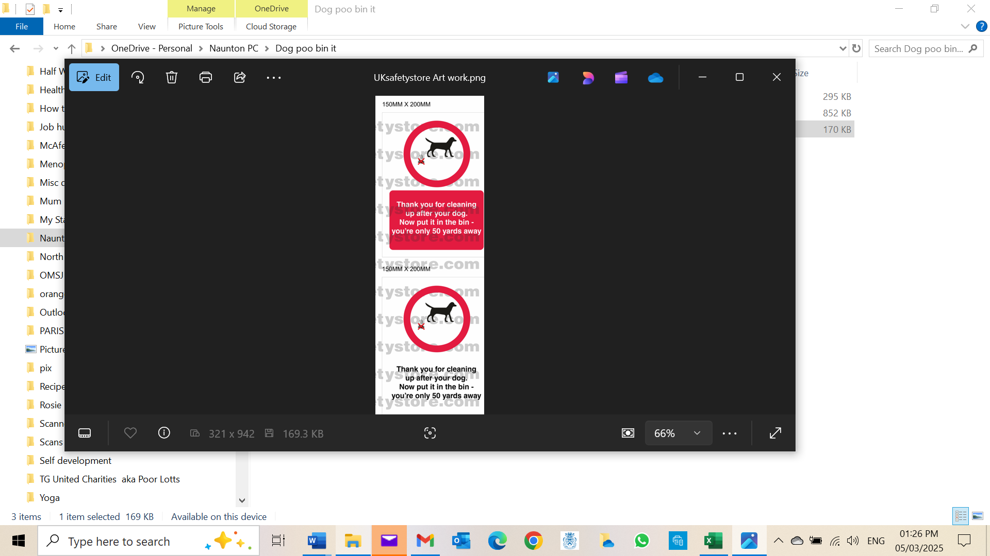

The Sign Shed:
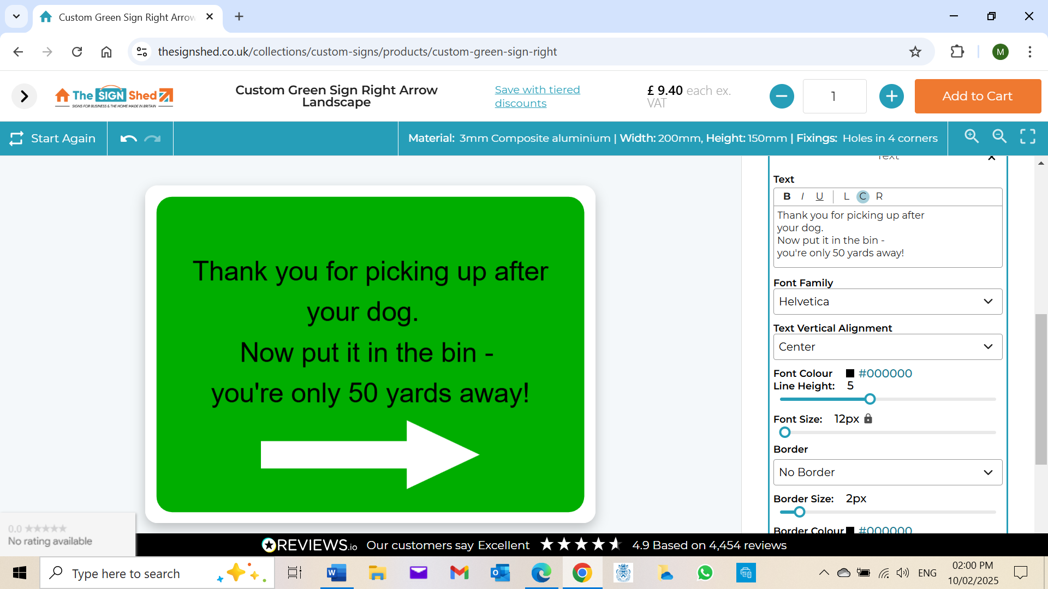

Agenda item 7– 20’s Plenty signs
There are no pre-printed lamp post sized versions of the '20 is plenty' signs but the PC could make its own signs using the high def logo. You could also buy sticky backed versions of the sign, which comes in several sizes and could be applied to a metal or plastic backing. This is the logo that anyone can incorporate into their own signs:



Window/bumper stickers – 200 x 70mm in sticky backed vinyl £2.40 for 1, £4.80 for 5, further reductions the more you order.
Bike stickers – 100 x 35 in sticky backed vinyl £2.16 for 1, £3.60 for 5 etc.
All stickers have this design.



This is the link to the signs pages of the 20’s plenty website: Stickers and Campaign Materials - 20's Plenty for Us

There would be a further cost of making the blank signs and buying clamps to fix them to the lamp posts. I have a quote from Safety Signs 4 Less:

200 x 75 aluminium composite | £9.98
Delivery | £3.95
Total | £13.93
VAT | £2.79

£9.98 each plus £3.95 delivery + VAT

The 20's plenty organisation says that it has, in the past, been made aware that Highways aren't keen on having signs on their lamp posts. I have emailed Highways but have not received a reply.

Agenda item 11 - Information Commissioner’s Office registration
Although Naunton PC doesn't generally do the things on the list (e.g. provide local services or generate profit) it may be necessary to register with the Information Commissioners Office because Naunton PC holds details of people who can be identified e.g. councillors, people who have opted in to receive communications from Naunton PC (there are 12). This is the email ICO sent:

A Parish Council is not exempt from having to register and pay the fee. A Parish Council is a statutory body with statutory functions so cannot usually rely on any of the exemptions from having to register and pay the fee.
A Parish Council would usually be required to register as they are processing data for the provision of local services, also campaigns, public relations, and fundraising, all of which are purposes of data which are not exempt from registration. If a Parish Council is processing data electronically, including word processing and the maintenance of a website, which may include advertising and marketing for others, they would be unable to rely on the exemptions and therefore be required to register.
Further to this, as a Parish Council is a statutory body with statutory functions, they cannot be classed as a ‘not for profit’ organisation.
This is the list of exemptions:
Generally speaking, you have to pay a fee if you are processing personal data as a controller. But there are some exemptions. You don’t need to pay a fee if you are processing personal data only for one (or more) of the following purposes:
- Staff administration.
- Advertising, marketing and public relations.
- Accounts and records.
- Not-for-profit purposes.
- Personal, family or household affairs.
- Maintaining a public register.
- Judicial functions.
- Processing personal information without an automated system such as a computer.
- Since 1 April 2019, members of the House of Lords, elected representatives and prospective representatives are also exempt.

Agenda item 12 – Risk Management Register
Control click to see the NPC Risk Assessment register 2024.xlsx

Naunton Parish Council Risk Management Register
Approved at the March Council meeting 2025
Agenda item 12
Assessment Scoring: 1 = low; 2 = low/medium; 3 = medium/high; 5 = high
Activity | Risk | Cause | Effect | Likelihood | Severity | Score | Actions
1. Finances | Sudden large expenditure required or excessive under budgeting | Unforseen problem / Poor budgeting | Service not provided. Lack of confidence in council. Inability to carry out functions. Insufficient funds for contingencies | 2 | 3 | 5 | Council has some reserves. Insurance in place to cover major risks. Careful budget planning and review of adequate reserves at budget planning time in November
2. Finances | Fraud | Inadequate controls | Loss of funds | 1 | 5 | 6 | Annual internal audit (if income/expenditure is lower than £25,000). Bank balances reported at every meeting with bank reconciliation. Internal audit control policy adopted by Council and audits to take place twice a year by councillors. (See internal audit policy for detail.) Cheques signed by 2 councillors /online payments approved by two signatories once payments have been approved by the Parish Council.
3. Contractors | Contractors not supplying services | Unavailable due to illness, poor weather | Poor Services | 2 | 4 | 6 | Contracts are defined. Contracts are informally monitored by Clerk & Councillors. Corrective action taken as required
4. Parish Council records and archives | Loss of Parish Council records and archives | Fire, Flood, theft |  | 2 | 4 | 6 | Lodge archived records with Gloucestershire County Council's Archives Office. Document stored security at Clerk's address.
5. Records | Loss of documents on Clerk's computer | Computer crash, fire, theft, flood | Loss of records | 2 | 5 | 7 | Back-up copies on portable memory stick. Originals on OneDrive for access by all in emergencies. Agendas and minutes on the website, and copied to all councillors. Signed hard copies filed and scanned. Policies also held on parish council website.
6. Clerk to the Parish Council | Unavailability | Resignation, illness | Work of the Parish Council cannot be carried out | 2 | 5 | 7 | Urgent work carried out by the Chairman and other Councillors. Contact GAPTC about availability of temporary cover. OneDrive enables the Parish Council to access files and work in case of emergencies. Email address and password available to councillors.
7. PC Meetings | Accommodation unavailable for meetings | Damage to Village Hall | Meeting room unavailable | 1 | 2 | 3 | Use nearby village hall or similar amenity e.g. St Andrews church.
8. Membership of the Parish Council | Vacancies on council | Resignation, retirement, insufficient nominations at elections | Meetings cannot be held due to not being quorate | 2 | 5 | 7 | Identify on an unofficial basis local residents who might be interested in becoming councillors.
9. Assets | Damage | Vandalism, Accident, Storms | High cost of repair. Loss of Assets. Disruption. Damage to public property or person | 2 | 2 | 4 | Insurance Cover. Maintain up-to-date register of assets. Regular maintenance of physical assets. Annual review of risk and condition of assets and adequacy of insurance cover.

Agenda item 13 – Asset Inspection Checklist
Control click to see the NPC Asset inspection template.docx

Checklist for risk inspection of assets

Carried out on: ………………………………………………………………
By: ………………………………………………………………..
Asset | Checked | Comments
Defibrillator, and telephone box
Playground Equipment
- Tunnel Mound
- Set of Swings
- Steel slide
- Climbing frame
- Goal posts

Wooden picnic-style table on the playing field
Two wooden benches:
  - One near the entrance to the Village Hall
  - A second on the parish land at the west entrance to the Church yard.
Three dog waste bins and bag dispensers:
- one at the main entrance to the Recreation Ground
- one at the far end of Dale Street.
- one on Summerhill at the gate to the footpath
- 5 x old cast-iron water pumps.
  - sited by the Blackhorse Pub (this pump is sited and built in to the wall of the adjoining garden)
  - sited opposite Parkers Cottage against the wall of the Manor Garden
  - sited opposite Valley View
  - sited outside the entrance to Old Well Cottage.
  - sited at the west entrance to the Parish Church
Cast-iron street lamp
Cast-iron water tap and stand (Dale Street)
Stone bench
Kissing Gate
Noticeboard – outside the Village Hall
The following flood/river equipment is now the property of the Flood Monitoring Group and is stored at the Dovecote:
Waders x 9, 3-prong cultivators x 3, Spade x 1, Hook x 1, Loppers long x 1, Loppers anvil x 3, Bowsaws x 2, Hacksaw x 1, Curved saws x 2, HIgh Viz Jackets x 5, High viz Vest x 1,
Sand bags - approx 50, Barrow x 1,
Buckets x 3
50 aquasacks are the property of Naunton Parish Council and are also stored at the Dovecote.

