Know Christ! Grow in Faith! Serve Others!
Mission Statement of LTUMC (adopted 6/5/2024)

WELCOME—ANNOUNCEMENTS Mary Fulton
JOYS AND CONCERNS
INVITATION TO WORSHIP/OPENING PRAYER Pastor Rod
PRELUDE Jenny Claybaugh, Jane Wildermuth
SONG LEADERS Diane Lewis, Jason Brunson
LITURGIST Roberta Hart
* Indicates To Stand in Body or Spirit.
*Call to Worship: Psalm 40:1-3 NLT A Psalm of David. May it be our song.
L: I waited patiently for the LORD to help me,
P: and He turned to me and heard my cry.
L: He lifted me out of the pit of despair,
out of the mud and the mire.
P: He set my feet on solid ground
and steadied me as I walked along.
L: He has given me a new song to sing,
a hymn of praise to our God.
All: Many will see what He has done and be amazed.
They will put their trust in the LORD.

*Hymn: Sweet, Sweet Spirit #334 UMH
Great Is Thy Faithfulness #140 UMH

Unison Prayer: based on Isaiah 49:1-7
Listen, you who reside in the distant lands of your soul, whose heart is a desert, you who feel useless and “have spent your strength for nothing and to no purpose.” The Lord calls to you---He who is from everlasting and fills the present moments of our lives calls you to draw near and hear His words when He proclaims “I will make you a light and bring my salvation to the ends of the earth through you.” You are chosen to share Love, Grace, and Mercy: the source of your gifts are from the Holy One who calls you. Share His Truth among those of your World. Follow Him and do His Word. Amen.
Scripture Reading: John 1:29-42

Prayers of The People Jason Brunson
Lord’s Prayer: Our Father who art in heaven, hallowed be Thy name. Thy kingdom come, Thy will be done on earth as it is in heaven. Give us this day our daily bread, and forgive us our trespasses as we forgive those who trespass against us. Lead us not into temptation, but deliver us from evil. For Thine is the kingdom, and the power, and the glory forever. Amen.

*WORSHIPPING GOD WITH TITHES & OFFERINGS/DOXOLOGY
*Prayer of Thankfulness: Accept these gifts, O God, as testimonies of our love for You and our desire to serve You. Let these offerings be an affirmation that we are bound to one another as Your people. In Your generous name we pray. Amen.

Children’s Moments: Junior Church follows

*Hymn Jesus, Name above All Names #2071 FWS

*Prayer for Illumination: G.W.E.
Change us, Holy Spirit. Open our ears, Healing God. With our eyes closed, may we see Your presence. In our speaking, we proclaim Your profound Love for all Creation. May we who are made in Your image witness to Your Living Glory in Our World. Help us Jesus. May it be so! Amen.

Scripture: 1 Corinthians 1:1-9
Message: Giving Witness on A Lectionary Day! Pastor Rod
Response: Listen As Holy Spirit Whispers, “What will you do?”

*Hymn: I Know Whom I Have Believed #714 UMH

*BENEDICTION & SENDING Our “World” Is Our Mission Field
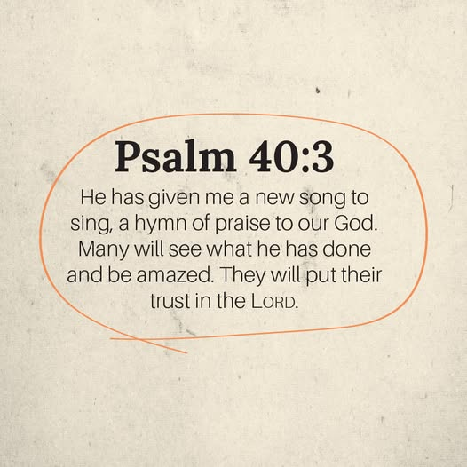

THOSE ASSISTING IN CREATING OUR SERVICE:
Musicians: Jenny Claybaugh, Jane Wildermuth
Sound/Video: Andy Wildermuth, Kathy Berg
Online: Tracey Notestine, Sandy Shaner
http://www.facebook.com/LewistownTrintyUnitedMethodistChurch
Church Office email: ltumc8088@gmail.com
Ushers: Don Lewis, Bill Fulton, Denny Stryker, Lynn Snipes, Mike Brunson, Jason Brunson
Please send Bulletin Insert information to Lorna Brunson.
Internet Prayer Chain: Lorna Brunson—doone533@gmail.com
All-Call Prayer Chain: Julia Armstrong—Call her at 937-844-7964
Please use WIFI setting for the Community Center while we are worshipping there. Internet login: TPLink_70B0. Password is 15310477. We apologize for any inconvenience in connecting. Please don’t use your internet during worship. It slows down our Facebook feed.
Adult Sunday School Class Leader/Lay Leader: Mary Fulton
Sunday School Superintendent/VBS/God’s Team: Diane Lewis


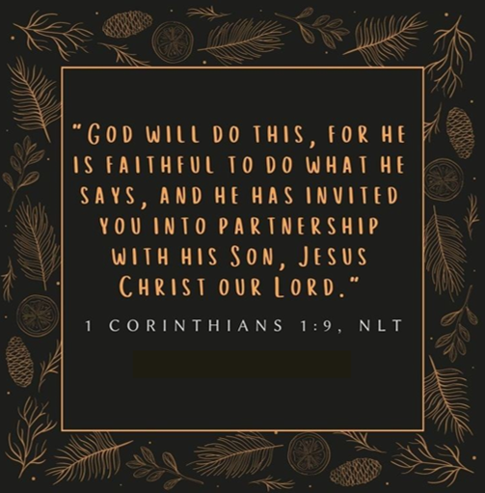
January 18, 2026
Thank You for Choosing to Worship Christ
with Us Today!
LEWISTOWN-TRINITY UNITED METHODIST CHURCH
In-Person Worship Service – 11:00 – 8088 CR 54, Lewistown
Address: P.O. Box 90, Russells Point, Ohio 43348
Worship with us on Facebook
http://www.facebook.com/LewistownTrintyUnitedMethodistChurch
Rod Brower, Pastor
His Contact Info: 740-727-9999 – pastorrodb@gmail.com
Know Christ! Grow in Faith! Serve Others!

