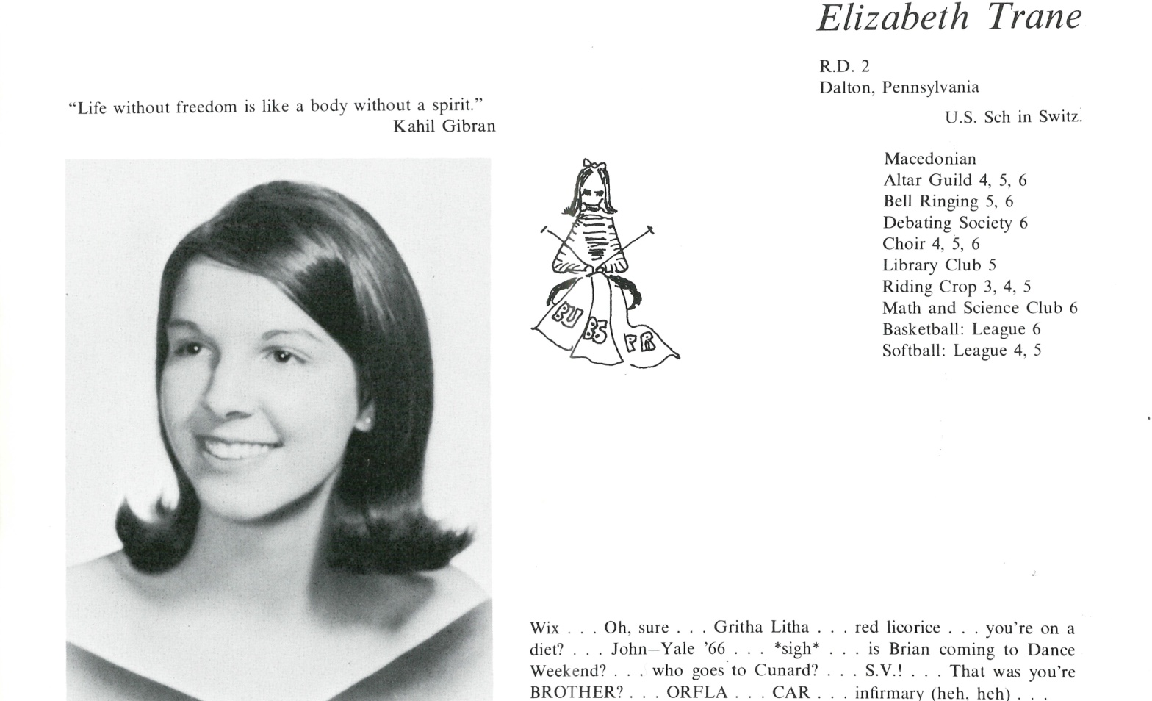

Elizabeth H. Trane Race

I attended the American School in Switzerland after Kent. I had wanted to go to UNC, but my mother felt that I was too young for college, so she sent me to Europe. Go figure.

Studied Elementary Education at the University of Miami.

My husband Don and I will celebrate our 44th anniversary in July. We have two beautiful daughters and four grandchildren.

I never once regretted my time at Kent and I am proud to be a graduate.



______________________________________________________________

______________________________________________________________ ______________________________________________________________ ______________________________________________________________ ______________________________________________________________ ______________________________________________________________ ______________________________________________________________ ______________________________________________________________ ______________________________________________________________

Attach Picture in .jpg Format

______________________________________________________________

______________________________________________________________

___________________________________________________________________________________ _________________________________________________________________________________________________________________________________________________________________________________________________________________________________________________________________________________________________________________________________________________________________________________________________________________________________________________________________________________________________________________________________________________________________________________________________________________________________________________________________________________________________________________________________________________________________________________________________________________________________________________________________________________________________________________________________________________________________________________________________________________________________________________________________________________________________________________________________________________________________________________________________________________________________________________________________________________________________________________________________________________________________________________________________________________________________________________________________________________________________________________________________________________________________________________________________________________________________________

___________________________________________________________________________________