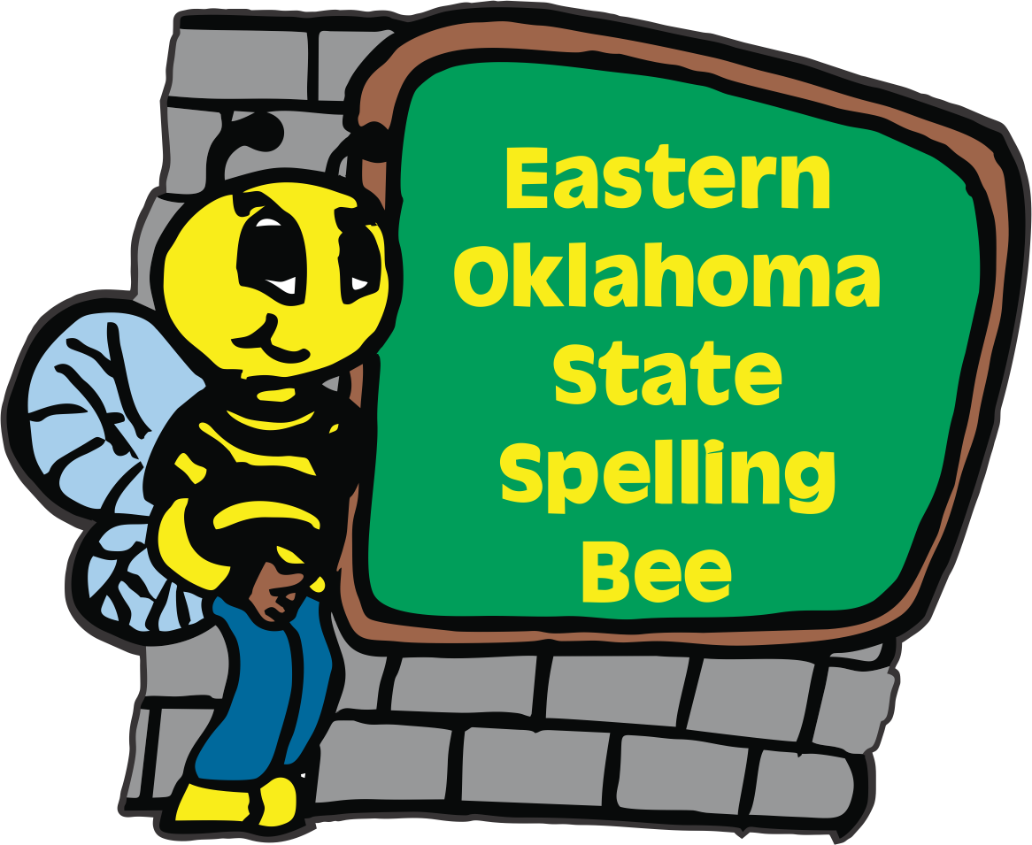
2022
Eastern Oklahoma State Spelling Bee Event
Registration Form

Welcome to the 12th Annual Eastern Oklahoma State Spelling Bee Event. The Bee will be held on Friday, April 22th at the Muskogee Civic Center. To participate in the competition, please e-mail or send this form in the U.S. mail with your entry fee payable to the Eastern Oklahoma State Spelling Bee. The cost remains at $50.00 per school site. Purchase Orders will be accepted. Please let us know if you will need an invoice. We are not able to take credit cards.
We will be able to register the first 100 schools. The deadline to register your school is Monday, December 6, 2021.

_____ I would like to register our school. Check is included.
_____ I would like to register our school. We will be using a Purchase Order.

Name of School __________________________________________________
School Phone ____________________________________________________
School Address __________________________________________________
City ___________________________________ Zip Code _______________
County ________________________________
Spelling Bee Coordinator__________________________________________
Spelling Bee Coordinator Cell Phone Number ______________________________________
Spelling Bee Coordinator’s Email Address_________________________________________
Contact Person for Purchase Order_______________________________________________
Purchase Order Person’s Email Address___________________________________________
You may e-mail this entry form to sehoog@gmail.com or send us in the US mail to:

Eastern Oklahoma State Spelling Bee
Attn: Registration Form
1404 East Broadway
Muskogee, OK 74403

