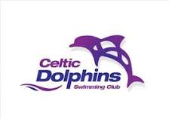
NOMINATION FORM
FOR THE ELECTION OF THE 2018/2019 COMMITTEE

Nominations are invited from Members of the Celtic Dolphins Swimming Club for the following Committee positions which will be considered at the Club’s Annual General meeting to be held at 17.00pm on Sunday 25 March 2018 at Pontardawe Leisure Centre.

Available Committee Positions
- Chair
- Treasurer
- General Secretary
- Welfare Officer (executive non-voting member)
- Fixtures Secretary
- Membership Secretary
- Committee Member (x1)

Deadline for Nominations
Please complete and return this nomination form by email to celticdolphins@hotmail.co.uk no later than 12 noon on Sunday 25 March 2018.
Confidentiality
All nominations received will be treated in confidence.

COMMITTEE NOMINATION
Name of person nominating:

Name of nominee:

Committee position selected:

Name of person seconding the nomination:

