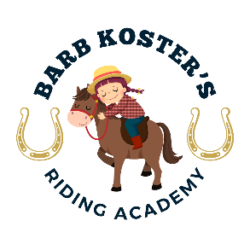
Welcome to Barb Koster’s Riding Academy riding program!
Thank you for choosing Barb Koster’s Riding Academy at Winters End Farm, where we focus on creating a welcoming barn family that fosters a safe environment to learn and improve horsemanship and riding skills. We look forward to you and your family joining our barn family!
Here are some reminders and some tips about how to get the most out of our program:
Your Instructor’s Name: Barb Koster ∙ (754) 234 -5981
Property Owner: Nancy Meyer
Assistant: Evangeline Sydor-Journet ∙ (954) 857-6101
Located at: 5250 Melaleuca Rd., Southwest Ranches, FL 33330
Show up a few minutes early to your lesson. You want to have the most time in the saddle with our instructors as possible, so make sure you get to the barn a little early so that you have plenty of time.

Now that your student is getting more serious- we recommend you buy them their own helmet, boots, and riding breeches. You can purchase them online or at local stores like Tractor Supply.

Scheduling:
Reminder- missed lessons can only be made up in the month they are current. The way to get the most out of the program is to commit to being there for your weekly time. Your balance is still due in full if you miss your lesson(s).

If you would like to make any changes to your regular lesson time, you must give ample notice (minimum of 24 hours), otherwise you will forfeit your lesson with no refund. We do this, not to be mean, but because we want to have our groups be as consistent as possible. We would also like to spend as much time as possible helping you with your riding, and as little time as possible scheduling and rescheduling. If you need to make a long-term change to your weekly time, please text (954) 234-5981 and include 2 or 3 days that would work better for you.

We are building a community that encourages each other where people feel safe to become their absolute best. We encourage camaraderie, congratulating each other, and asking for solutions when you are stuck. And the horse always comes first. Alternatively, we have a zero tolerance for any bullying, gossipy, or mean-spirited behavior.

Price Sheet for 2025-2026 Season
ALL BALANCES MUST BE PAID BEFORE SERVICES ARE RENDERED
Special August and September Package at a major discount of $240 for 4 lessons per month for the remainder of the school year.
Group Lessons:
1 lesson____________________________________________________________$75
1 private lesson______________________________________________________$65
MONTHLY Lesson Packages: *Does not include Saturday Camp or Breaks
4 lessons/month_____________________________________________________$260
8 lessons/month_____________________________________________________$520

QUARTERLY Lesson Package (4 months) *Does not include Saturday Camp or Breaks
16 lessons________________________________________________________$1,040
*Includes 2 unmounted lessons
SATURDAY CAMP:
1 day______________________________________________________________$75

SHOW FEES:
1 day_____________________________________________________________$150
*this fee ONLY covers coaching, horse trailering, horse rental.

Riders and Parents cover all show fees, except for stall rental which is spilt between the riders of said horse.

