Mars UP Church

Apostles’ Creed
I believe in God the Father Almighty, Maker of heaven and earth; and in Jesus Christ His only Son our Lord; who was conceived by the Holy Ghost, born of the Virgin Mary, suffered under Pontius Pilate, was crucified, dead and buried; He descended into hell; the third day He rose again from the dead; He ascended into heaven, and sitteth on the right hand of God the Father Almighty; from thence He shall come to judge the quick and the dead. I believe in the Holy Ghost, the holy catholic church; the communion of saints; the forgiveness of sins; the resurrection of the body; and the life everlasting. Amen.

Gloria Patri
Glory be to the Father, and to the Son, and to the Holy Ghost. As it was in the beginning, is now and ever shall be,
world without end.
Amen. Amen.

Come Holy Spirit, Come
Before the Service – Speak to God!
During the Service – Let God speak to you!
After the Service – Speak to each other!

(*Please stand, if able)
Welcome and Mars Messages

Prelude

*The Call to Worship
Leader: We come together as one,
People: United in our common loyalty to Jesus Christ.
Leader: We come to worship and praise the God who calls
us here.
People: Let’s open our hearts to one another, just as
Christ has opened his heart to us, and God will
be glorified.

*Hymn “This is the Day”
“I Stand in Awe of You”

Call to Confession

Prayer of Confession
Almighty God, we confess that we have taken Your commandments and turned them into rules. We have criticized those who have fallen short and selfishly proclaimed ourselves righteous. We have failed to understand the spirit of the commandments and the Way that was shown by You to live, loving God and loving our neighbors. Forgive us for turning Your law into burdens for others and ourselves, instead of a Way to love and freedom in You. In the name of Christ, who has given us the Way and leads us on, we pray. Amen.
The
Lord’s Prayer

Our Father,
who art in heaven,

hallowed be Thy
name,

Thy kingdom come,
Thy will be done,
on earth
as it is in heaven.

Give us this day
our daily bread;

and forgive us
our debts,
as we forgive
our debtors;

and lead us not
into temptation,
but deliver us
from evil.

For Thine
is the kingdom,
and the power,
and the glory,
forever. Amen.

The Doxology

Praise God
from whom
all blessings flow;
praise Him
all creatures
here below;
praise Him above,
ye heavenly host;
praise Father, Son,
and Holy Ghost.
Amen.

Assurance of Pardon

Gloria Patri
Children’s Chat

Scripture 1 Corinthians 3:1-9
Matthew 5:21-37

Morning Message Rev. Brian Hauser
“Erev Yom Kippur”

*Hymn 630
“What a Friend We Have in Jesus”

Prayers of the People and Lord’s Prayer

Offering
Offertory
*Doxology
*Offering Prayer

*Hymn 731
“Onward Christian Soldiers”

*Benediction

*Postlude

Church Staff
Rev. Brian Hauser
Pastor
pastor@mars-up.org
724-689-3412

Mrs. Shelly Bocheff
Administrative Assistant
marsup@mars-up.org

AV TEAM
Alma Staskiewicz, Lisa Barbour, Marie Matthews, Bill Guesman, John Ivory, Keith Nichols, Mike Bocheff, Herb Wellman

Mars United Presbyterian Church

232 Crowe Ave
PO Box 805
Mars, Pennsylvania 16046
724-625-1365
www.mars-up.org
marsup@mars-up.org

Church Office Hours:
Mon -Thurs from 9 a.m. -2:30 p.m.

MUP Session

Class of 2025 Class of 2024 Class of 2023
John Ivory Alma Staskiewicz Lisa Barbour
Susan Cox Louise Fox Mary Ann Croop
Jay Wilson Marie Matthews Don Lewis
Herb Wellman

Clerk of Session: Herb Wellman

MUP Deacons

Class of 2025 Class of 2024 Class of 2023
Jill Cooper Steve Martin Sharon Gibbs
Robyn Beckwith Marge Nicklas Carol Kopar
Missy Wells Pat Auld Alice Leonberg

Moderator: Steve Martin

MUP Music Committee
Keith Nichols – Chair
Sally Olsen – Clerk
Alma Staskiewicz
John Ivory
Linda Lees
Karl Kennedy

Morning Worship:
10:00 am

3rd Sunday after the Epiphany

Prayer of Preparation
Lord, we come to you today with so many things on our hearts.

You call us to be in relationship of trust and love with you and you offer healing to us for those portions of our lives that are broken and injured.

Help us to be open to your mercy and healing love. For we ask this in Jesus’ Name.
AMEN.

Mars United Presbyterian Church
Welcome!

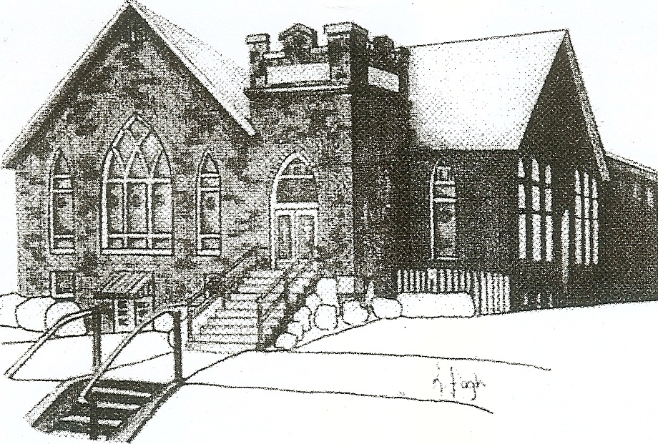
We are your hometown church: Faithful to Tradition, Loving in Fellowship, & Reaching for Tomorrow!

January 22, 2023

We welcome you and we are glad you’ve chosen to Worship with us today!

CALENDAR: January 22nd– January 29th

Church Office Hours: Monday -Thursday from 9 a.m. – 2:30 p.m.

Today, January 22, 2023
VOLUNTEERS☺

LAST SUNDAY’S In-House ATTENDANCE: 72

LAST SUNDAY’S OFFERING:
Operating Funds: $4375.00
Kindness: $150.00
Mission: $10.00
Per Capita: $175.08
Bldg. Improv: 10.00
Hard Tack Candy: $20.00
Total: $4740.08

Tarry N Talk Hosts
Stewardship Committee

9:00 am Sunday School Hour
10:00 a.m. THE MORNING WORSHIP SERVICE
Monday, January 23, 2023
6:00 pm Boy Scout Troop 400
7:00 pm Cub Scout
Tuesday, January 24, 2023
9:00 am A team
7:00 pm Cub Scouts 413
7:00 pm AA
Wednesday, January 25, 2023
9:00 am Material Girls
Thursday, January 26, 2023
6:00 pm Girl Scout troop
7:00 pm Cub Scout
Friday, January 27, 2023
Saturday, January 28, 2023
Sunday, January 29, 2023
9:00 am Sunday School Hour
10:00 am THE MORNING WORSHIP SERVICE

Welcome to all who are Worshiping with us today!

Guests
We sincerely hope our service is a blessing to you. We ask that our guests please take a few minutes to complete one of the Connect Cards found in the pew holder.

Should you have questions regarding any aspect of our church, including membership, please contact Pastor Brian or the church office during the week at 724-625-1365. Thank you for being with us today.

PRAYER – JOYS & CONCERNS
Lou Beckwith Paige Lauten
Paige Barbour (daughter of Andrew and Steph Barbour) Sandy Wahl
Reid Christopher Hall (June Stirling’s nephew)
Lindy McCartney (Lisa Barbour’s Sister)

ANNOUNCEMENTS
Bulletins are printed Thursday mornings; let us know if you have an announcement
…
2022 GIVING STATEMENTS are available in Tarry N Talk. To help defray mailing costs please take your copy with you. Thank You

PER CAPITA ASSESSMENT
It is that time of year, our individual Per Capita Assessment is due to the Butler Beaver Presbytery. We are requested to pay $43.77 to them per member of congregation of confirmation age and older. You can place your assessments in the offertory and ear mark it for your Per Capita Assessments. The BBP help provide support in negotiating salaries, insurances and pensions with our pastors and employees. Most importantly they provide a resource for us to tap into when we are in need of guidance. Please consider paying your Per Capita Assessment as soon as possible as we partner with our Presbytery to become stronger, smarter and more cohesive. As always, we give thanks for your generosity and support.
KITCHEN CLEANING DAY It has been quite a while since the church kitchen has had a good cleaning. The Deacons have decided to meet on Monday, January 30th at 9am to clean and organize the church kitchen. They are hoping to only need a couple of hours to make the kitchen sparkling new again. Hope to have many hands to help. All welcome!!
CONGREGATIONAL MEETING There will be a Congregational meeting on February 5th, 2023 after worship to discuss the annual report from 2022.
MUP SKI TRIP It’s that time again! Time for Mars UP Church to take to the slopes for an exciting day of fun and fellowship together at Peak N Peak Ski Resort! The date of the ski trip will be Saturday, February 11th. This event is open to all!!! We will leave the church at 7:00am and ski/snowboard for the day. Watch for more details to follow or talk to Pastor Brian.
THANK YOU My School Preschool staff and families would like to say a huge THANK YOU for the donation of $100 to the school at Christmas time. We are beyond blessed to be an outreach ministry of MUP and are thrilled to serve children and families in our community. Thank you again for the donation! In Christian Love, Heidi Beahm, MSPS Director

