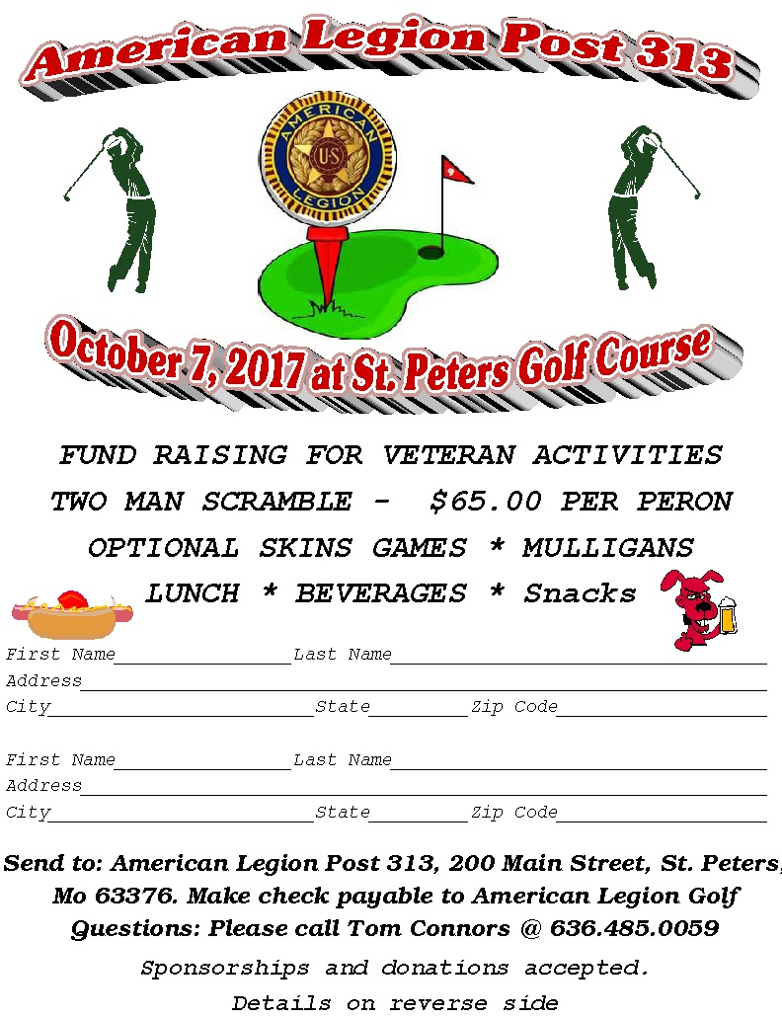

Details

- Two Man Scramble
- Check-In @7:00 AM, Carts leave clubhouse at 8:00 AM SHARP. All players must check in
- $65.00 per person includes:
  - Greens Fees + Cart
  - Limited Beverages On Course
  - Meal after tournament
  - Prizes
  - Optional Skins Game * $10.00 / Team of two
- No refund policy: No refunds, for any reason, after September 30, 2016
- All alcohol must be obtained at the course. No personal coolers, No exceptions
- Ties broken by lowest hole score based on course handicap
- 18 holes, Rain or Shine (Cancellation by course, contract rules apply)
  - Contact course for questions @ 636-397-2227
St. Peters Golf Course
200 Salt Lick Road, St. Peters, MO 6337
- Alternate Date - To be determinded
- Entry Deadline: First 120 Players or September 23, 2017
- Late entry only if space is available. Cash entry form
Individual players are solely responsible for damages. All players must check in at the registratrion table before playing
Sponsorship & Donations
Hole Sponsorships are available for $50.00 You will receive a sign placed on a tee box and your name or logo on the sponsors page of the website.
Prize and monetary donations are also accepted. We will recognize you on the website and on a placard displayed at the tournament.
We would like to thank the people and businesses that help make this a great event. If you are interested in becoming a sponsor, or simply would like to make a donation to the cause, contact Tom (636-485-0059 cell)

