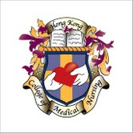 | HONG KONG COLLEGE OF MEDICAL NURSING  香港內科護理學院
17th Educational Seminar
Topic: Patient Education on Asthma
Speaker: Ms. Mandy Tai
Date : 10 April, 2015 ( Friday)
Time : 6:30-8:00 pm
Fee : Free of Charge
Venue : GH206 (Podium Level),
The Hong Kong Polytechnic University

Enrollment: Please fax reply slip to HKCMN at 2838 5501 on or before 6 April 2015
1.5 CNE
Enquiry: email hkcmn2010@yahoo.com
*FELLOWS & POTENTIAL FELLOWS OF HKCMN ARE WELCOME*

