12/26/2018 The Signs of the Two Presidents

This current article will concern the recent agreement between President Donald J. Trump of the United States and President Recep Tayyip Erdogan of Turkiye.

Recep Tayyip Erdogan is the current President of Turkiye. There are some indications that he is trying to re-establish an Islamic Caliphate in the region.

Info Link: https://en.wikipedia.org/wiki/Recep_Tayyip_Erdo%C4%9Fan

The Recent Agreement

President Trump handed Syria into President Erdogan's hands during a phone call between the two Presidents on December 14, 2018.

Info Link: https://www.cnn.com/2018/12/23/politics/donald-trump-erdogan-turkey/index.html

President Trump then announced on December 19, 2018, that he had ordered a rapid withdrawal of troops from Syria.

Info Link: https://www.cnn.com/2018/12/19/politics/us-syria-withdrawal/index.html
According to reports, Turkish troops will take over the fight against ISIS in Syria as American troops withdraw.

This agreement between President Trump and President Erdogan will allow more freedom for the descendants of ancient tribes mentioned in Ezekiel chapters 38 & 39 to gather on the northern border of Israel. An invasion of Israel will eventually occur and YaHuWaH Elohim Himself will destroy the invading armies.

Below is a graphic showing the distribution of some of the ancient tribes mentioned in Ezekiel 38 & 39 according to some biblical scholars, with some others locating a tribe or two further north in Russia:
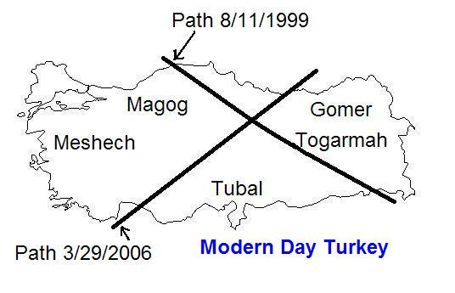
Above: The "X" in the graphic is an ancient Paleo Hebrew "Tav" (end mark) recently placed on the region of some of the ancient tribes of Ezekiel 38 & 39 by YaHuWaH Elohim using total solar eclipses.

The Signs of the Two Presidents

The previous article of 12/22/2018, "The Trap is Now Being Set", concerned the dreams of Joseph, the wheat harvests of the Shavuots being accompanied by the tribulum of the tribulation period. That article also concerned the later coming of Israel's Messiah to trample the grapes of wrath, being accompanied by signs in the heavens.

The Ordained Births

We know that YaHuWaH Elohim ordains the conceptions, births, and deaths of those in His creation, and that He also rules and overrules in the affairs of nations.

Below: A graphic showing that the peak gestational period for human beings is about 40 weeks (40 x 7 days = 280 days). Note that 280 inclusive days (280 i) would be 279 days on the graph below, just 1 day short of 40 weeks, and very near the peaks of the two measurement periods.

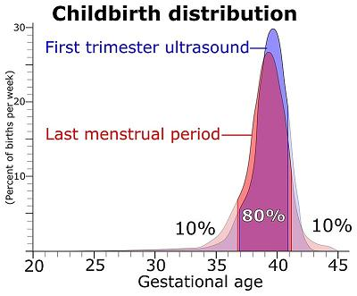

Below is a graphic showing the birth and conception dates of Presidents Trump and Erdogan:

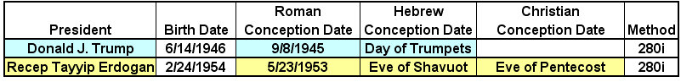

Above: The peak possible conception dates for President Trump and President Erdogan both fall on days that were appointed by YaHuWaH Elohim as special Sabbaths.

It's significant that President Erdogan, according to the gestational graph above, was most probably conceived on the eve of Shavuot (Pentecost) in 1953, with the Karaite Feast of Shavuot beginning at sunset on 5/23/1953.

YaHuWaH Elohim has purposely linked the probable conception date of President Erdogan with YaHuWaH 's Feast of Shavuot in order to alert us to be on watch and to be prepared for unexpected events that will take most of the rest of the world by surprise. YaHuWaH appears to be shouting "Shavuot, Shavuot, Tribulation, Tribulation" to us at this time.

There's also a double significance with President Trump in that his name is "Trump" and that he was also probably conceived on or near the Day of Trumpets in 1945, a day specifically reserved by YaHuWaH Elohim for the Trumpeting of alarms.

An Additional Note

There's also another current major world leader who's calculated conception date also falls on one of YaHuWaH Elohim's special appointed days.

Above: Aviv 10 is the special day reserved by YaHuWaH Elohim for the selection of the Passover lamb. It was the Hebrew date when YaHuShua rode into Jerusalem on a donkey and drove the money changers from the temple.

For other of today's world leaders having birth dates related with the modern nation of Israel, see this link: https://www.joybysurprise.com/the-emphasized-events-of-1948-and-11-13-2017.html

These birth and conception signs are beginning to stack up at this particular time in history (2018). When taken in context with bible prophecy and current events they help to attest to the dangerous times ahead.

