Veterans Memorial Brick Program
P.O. Box 1933, Bluffton, S.C. 29910

Name
Address
Phone Number#
Brick Message:

Monetary Donation $

DO NOT WRITE BELOW THIS LINE
Brick Number#
** Spaces and Punctuation marks are considered a character
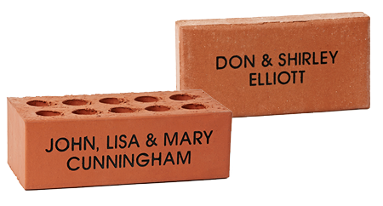
14 Characters per line 3 Lines
Price - $100 per Brick
Check #
Cash
Note: Donations are tax deductible 501(c)3

