Know Christ! Grow in Faith! Serve Others!
Mission Statement of LTUMC (adopted 6/5/2024)

WELCOME—ANNOUNCEMENTS Mary Fulton
INVITATION TO WORSHIP (Our Day Together) Martie Hough
SONG LEADER Diane Lewis, Jason Brunson
LITURGIST Roberta Hart
* Indicates To Please Stand If Able

*PRELUDE: Victory Medley with the Band & Congregation

*Call to Worship: Psalm 126:1-3
L: When Yahweh restored those who returned to Zion, we were like those who dream.
P: Then our mouth was filled with laughter and our tongue with shouts of joy;
L: Then they said among the nations, “Yahweh has done great things for them.
”All: Yahweh has done great things for us; we are glad.

Hymn To God Be the Glory #98 UMH

Unison Prayer: Rev. Emily Phillips Lloyd, Rector: St. Peter’s Episcopal Church, April 16, 2023
May the troubles of all your people be soothed, blessed, and comforted by your holy presence. May we each find the
laughter within us that sets our spirits free, and in that freedom, may we take your love into every part of our lives. Amen.

Hymn Since Jesus Came into My Heart #2140 FWS

Scripture: Psalm 100:1-5
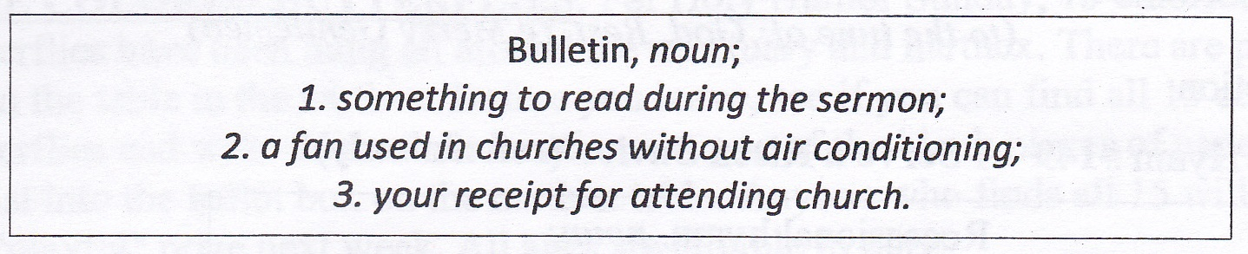
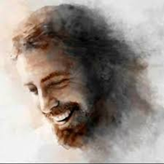

Prayers of the People Arno Klaas
LORD’S PRAYER:
Our Father who art in heaven, hallowed be thy name. Thy kingdom come, thy will be done on earth as it is in heaven. Give us this day our daily bread, and forgive us our trespasses as we forgive those who trespass against us. Lead us not into temptation, but deliver us from evil. For thine is the kingdom, and the power, and the glory forever. Amen.

*WORSHIPPING GOD WITH TITHES & OFFERINGS/DOXOLOGY:
*Prayer of Thankfulness:
Accept these gifts, O God, as testimonies of our love for You and our desire to serve You. Let these offerings be an affirmation that we are bound to one another as Your people. In Your generous name we pray. Amen.

Hymn Stand Up, Stand Up for Jesus #514 UMH
Story Fun: Martie Hough
One Liners: Joyce Shirk and Jason Brunson

Hymn He’s Got the Whole World in His Hands Screen
Story Fun: Arno Klaas
One Liners: Mariah LeVan and Libby Toussant

Hymn When We All Get to Heaven #701 UMH
Story Fun: Don Lewis
One Liners: Nova Mowery and Jayne Kinney

Hymn Go Tell It on the Mountain #251 UMH
Story Fun: Roberta Hart
One Liners: Andy Wildermuth and Mary Baker

Story Fun: Richie Shaner
One Liners: Kris Crockett and Lorna Brunson

*Hymn Shine Jesus Shine (Band) #2173 FWS

*BENEDICTION: Mary Fulton
SENDING Our “World” Is Our Mission

THOSE ASSISTING IN CREATING OUR SERVICE:
THOSE ASSISTING IN CREATING OUR SERVICE:
Musicians: Jenny Claybaugh, Jane Wildermuth
Sound/Video: Andy Wildermuth, Kathy Berg
Online: Tracey Notestine, Sandy Shaner
http://www.facebook.com/LewistownTrintyUnitedMethodistChurch
Church Office email: ltumc8088@gmail.com
Ushers: Don Lewis, Bill Fulton, Denny Stryker, Lynn Snipes, Mike Brunson, Jason Brunson
Please send Bulletin Insert information to Lorna Brunson.
Internet Prayer Chain: Lorna Brunson—doone533@gmail.com
All-Call Prayer Chain: Julia Armstrong—Call her at 937-844-7964
WIFI setting for the Sanctuary is: Mesh 25. Password is basiccartoon424. The Community Center is: TPLink_70B0. Password is 15310477. We apologize for any inconvenience in connecting. Please don’t use your internet during worship. It slows down our Facebook feed.
Adult Sunday School Class Leader/Lay Leader: Mary Fulton
Sunday School Superintendent/VBS/God’s Team: Diane Lewis

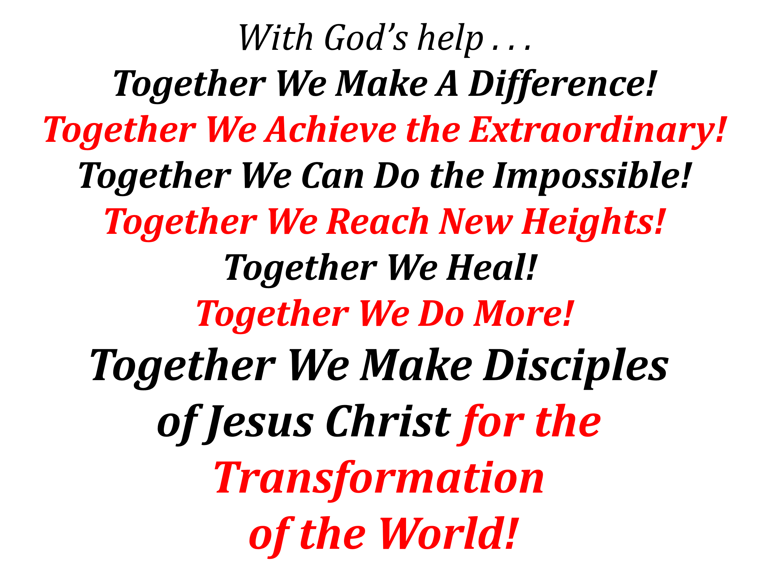


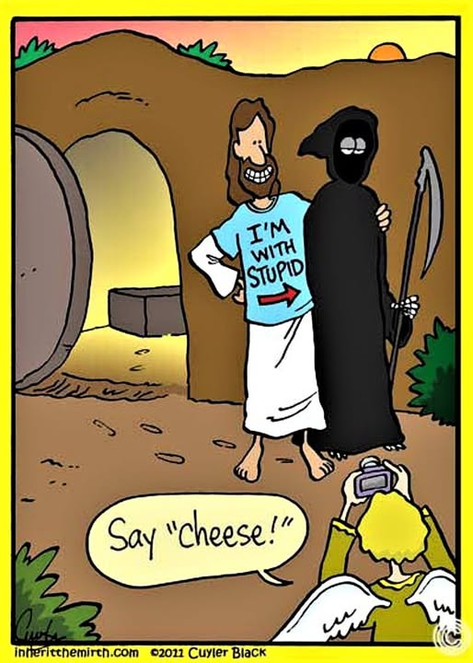
Happy, Holy Humor Sunday
April 26, 2026
Thank You for Choosing to Worship Christ
with Us Today!
LEWISTOWN-TRINITY UNITED METHODIST CHURCH
In-Person Worship Service – 11:00 – 8088 CR 54, Lewistown
Address: P.O. Box 90, Russells Point, Ohio 43348
Worship with us on Facebook
http://www.facebook.com/LewistownTrintyUnitedMethodistChurch
Rod Brower, Pastor
His Contact Info: 740-727-9999 – pastorrodb@gmail.com

Know Christ! Grow in Faith! Serve Others!

