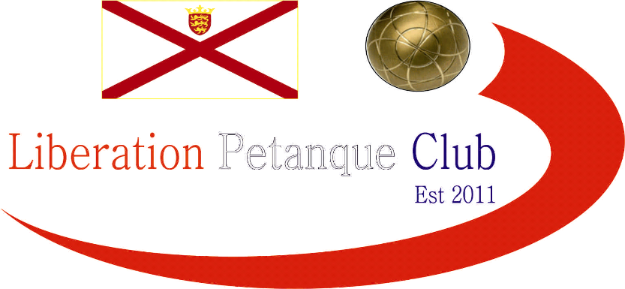

Summer 2025
End of Season
Report
What another great season it has been again this season with more new faces creating waves amongst the experienced members, we hope you all enjoyed it.
Premier League Singles Champion
Geoffroy Buffetrille

Winning his 8th Premier League title after a neck and neck battle all the way through the season with Toby Northern who finished Runners Up.
Third place went to Andrew Bellamy-Burt
Commiserations to John McGaw & Jim Waddell who were relegated.
Singles Division 1 Champion
James Gennoe
A great season this Summer taking the Division 1 title joining those players finishing with over +100 points difference. This meant Cassie Stewart-Le Gallais had to settle for second place.
Third Place and the last promotion place went to Joey Le Clech.
Commiserations to Branden De La Haye, Francis Corbally and Tommy Walsh on being relegated.

Premier League Double Champions
Geoffroy Buffetrille & James Gennoe
Well, it could have gone to three teams in the last two weeks but both Andrew Bellamy-Burt & Callum Stewart and Neil Selby & Ross Payne both blew their chances with Geoffroy & James team rolling over opponents with an impressive +122..
Andrew Bellamy-Burt & Callum Stewart Runners up with third place going to Neil Selby & Ross Payne.
Commiserations to Graeme Follain & Keith Pinel along with Alan Mitchel & Mike Robinson who all dropped down to Division 1.

Division 1 Double Champions
Alex Stewart & Dawn Buckley
Well done to Alex & Dawn who won the title unbeaten. Keith White & Mo De Gruchy also went unbeaten finishing Runners Up with Colin Floyd & Jim Waddell taking third.
Commiserations to Lorna Limbrick & Tommy Walsh who were relegated.

Club Singles Cup Winner
Toby Northern
Toby Northern beat Callum Stewart in the final, his first win, with Ross Payne third.

Club Doubles Cup Winners
Geoffroy Buffetrille & James Gennoe
Geoffroy & James beat 2024 winners Neil Selby & Ross Payne in the final. final over Lorna Limbrick & Brian Harris. Andrew Bellamy-Burt & Callum Stewart taking third.

Club Super 7’s Cup Winner
Jean Stewart
Jean won his first ever competition beating Toby Northern in the final with Keith White taking third.

Club HandyCap Cup Winner
Neil Selby

Neil Selby took his second HandyCap cup title beating Brian Harris in the final with Ross Payne taking Third place.

Club Precision Shooting Cup Winner
Ross Payne
Ross Payne finally got his maiden title beating Ross Churchill in the final with James Gennoe taking third.

Liberation Singles Open Winner
Geoffroy Buffetrille
Liberation Doubles Open Winner
Geoffroy Buffetrille & Toby Northern

Liberation International Singles Open Winner
Stephen Daykin
England
Liberation International Doubles Open Winners
Jake Romeril & Julian Lamour
Jersey & France

Liberation International Triples Open Winners
Damien Hureau & Philippe Quintais and Eric Boudier
France

Player of the Seasons

Find out at the End of Season Presentation



None club tournaments won by members
Island Doubles Championship (Men)
Gary Cowburn & Toby Northern
Island Doubles Championship (Women)
Lorna Limbrick with Judy Andrews-Callec
Island Mens Triples Championship
Andrew Bellamy-Burt, Jake Romeril & Laurent Pellaton
Island Open Triples Championship
Geoffroy Buffetrille, Matthew Pinel & Laurent Pellaton
Guernsey Singles Championship
Andrew Bellamy-Burt
Guernsey Doubles Championship
Andrew Bellamy-Burt & Geoffroy Buffetrille
Guernsey Triples Championship
Alan Oliveira, Jake Romeril & Ross Payne
Carrefour Doubles Championship
Andrew Bellamy-Burt & Jake Romeril
Carrefour Triples Championship
Andrew Bellamy Burt, Alan Oliveira & Jake Romeril

Carrefour Indoor Open
Lorna Limbrick with Gavin Scott

JPA Winter League

Keith & Matt Pinel, Matt Ryan, Geoffroy Buffetrille, Graeme Follain and Toby Northern

JPA Summer League

Keith & Matt Pinel, Matt Ryan, Geoffroy Buffetrille, Graeme Follain and Toby Northern

JPA Knockout Cup

Andrew Bellamy Burt, Alan Oliveira, Callum Stewart, Ross Payne, Jean Stewart, Joey Le Clech & Jake Romeril

Special Thanks

Club Committee – Toby Northern, Matt Ryan & Geoffroy Buffetrille

Other Helpers –Laurent Pellaton for their hard work on the terrains and support throughout the season. Dawn Buckley for the International Open. Gary Cowburn and Wendy Ritzema, Katrina & Trevour Holden and anyone else who has helped out setting up the terrains for competitions/leagues etc and running competitions, very much appreciated.

Well, I hope you have all enjoyed the season and are looking forward to playing again in the Winter 2025 / 26 season.

Kind Regards

Toby Northern

Chairman

Liberation Petanque Club

