April 2022 Member Program

Visit Aurora

WHAT: RMGA Membership Meeting & Program

WHEN: April 11, 2022
6:00 pm – Networking (come early to enjoy a bite at the Marketplace restaurants)
6:30 pm – Short Meeting
6:45 pm – Program

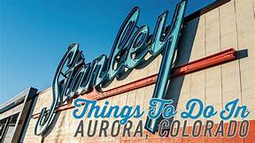
WHERE: Suite 209
Stanley Marketplace
2501 Dallas Street
Aurora, CO

The Stanley Marketplace is a community of 50+ independently owned Colorado businesses collectively offering a place for you to eat, drink, shop, exercise, play, work, and more.

Directions: Located in Northwest Aurora, three blocks north of Montview Boulevard on Dallas Street. Free Parking

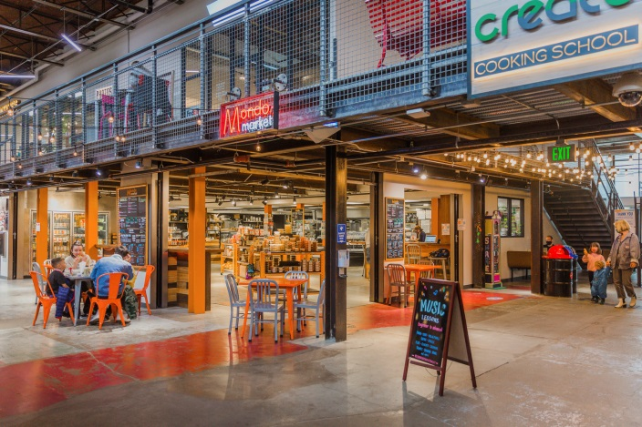
PROGRAM: Excited for our first official in person Meeting since March of 2020. Enjoy networking face to face and hear a program from Visit Aurora updating us on recent developments. Tour the market place and see the various retail, recreational and dining/drinking options in this thriving marketplace. It is well placed for a motor coach stop coming or going to the airport.

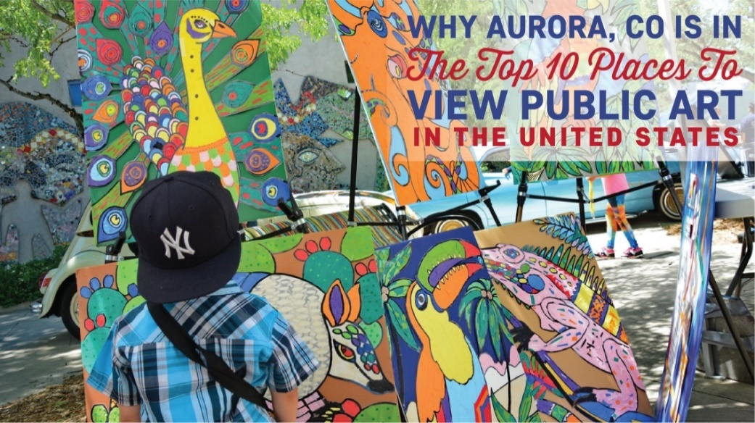

GUESTS: Members are encouraged to invite potential members as a guest to the meeting.

MEETING NIGHT CONTACT: J. Mark Blaising, Program Chair 303-830-8440 (voice) 303-263-8647 (text)

