
RICK A SHACKET
DO, MD(H)
Main Office:

Rick A. Shacket
Office: 602.492.9919 Mobile: 602.920.1023

Name: _______________________________________ DOB: ___________ Date: ___________

PLACE OF PROCEDURE

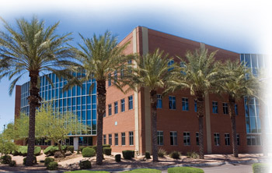
Abrazo Central Campus Hospital
2000 W. Bethany Home Rd
Phoenix, Arizona 85015
602.249.0212

Your colonoscopy or upper endoscopy (EGD) is scheduled on:
Date: _________ Time: _________ Arrival Time: _________
Your surgery is scheduled on:
Date: _________ Time: _________ Arrival Time: _________

❑ If you do not have a scheduled time written above, and you do not get a call from us within five working days, please call Dr. Shacket’s office to schedule your procedure.
Scheduling Number (602) 492-9919

