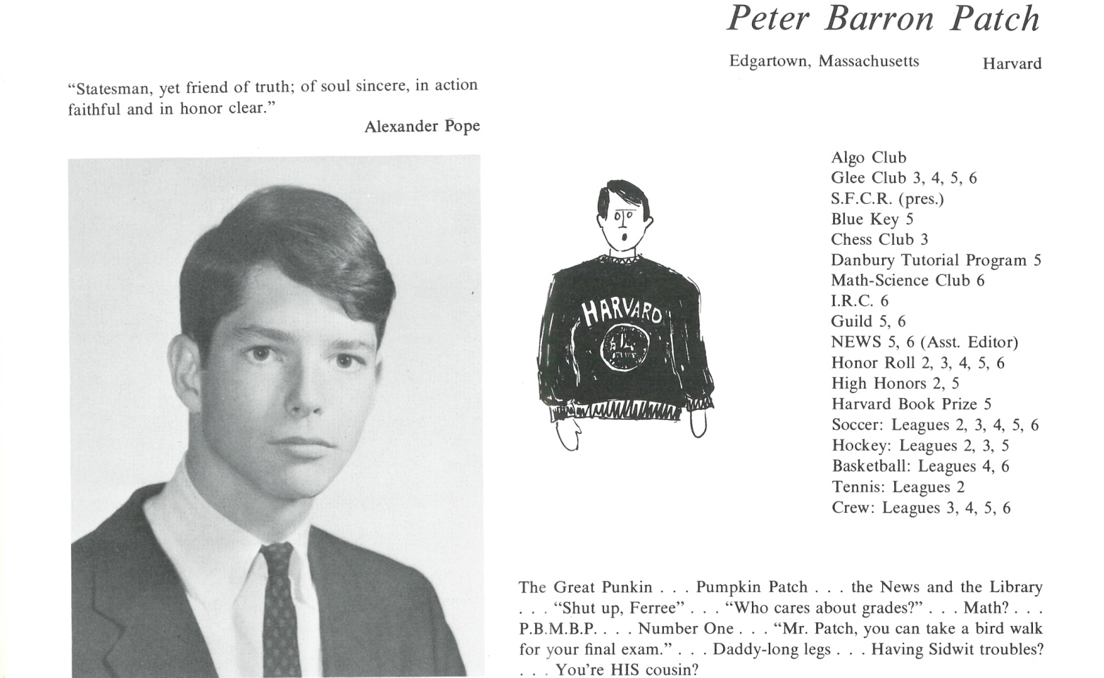

Peter B. Patch

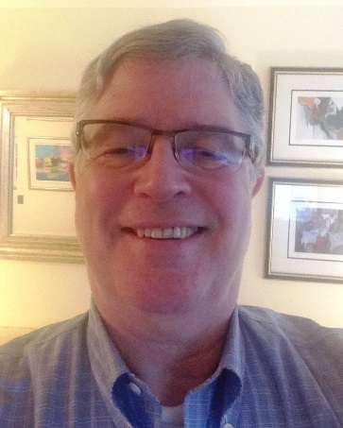After college, I went into the Peace Corps - Ivory Coast - partly out of idealism, and partly realism. Then Stanford Business School – consulting with Peat Marwick, and the doctoral program in Business Economics at Harvard (all coursework, even a draft dissertation but not ultimate sheepskin). Career in management consulting with the likes of Citibank, Pepsi and others.

Discovered 10 years ago, I am really a teacher, teaching business, economics, entrepreneurship and leadership at the college level. Love it!

Love my students! Love my subjects! Love my schools: City University of NY, Stony Brook, Molloy College (a college version of Kent 'in the Dominican tradition'), and Seton Hall. These schools make college available to many first generation college students, and give them their shot at the American Dream! The students are respectful, hardworking, and caring about their community.

I want every college to have a program on entrepreneurship, along with a business incubator/accelerator - so that every student has the choice and opportunity to experience what it means to start up an organization - for profit, non-profit - all good. Whatever motivates and inspires them.

As many of you know, I spent six years on the Kent Alumni Council - two years leading it - trying to do my part to support our alumni socialize, engage, and support the School. I feel there is a great opportunity for the Alumni, for the School, and for the Students - which we have only partially begun to realize. That would include online programs, life-long learning, career mentorship, programs in entrepreneurship and leadership...  I am still hopeful we will make more progress in that direction...

I also want to recognize Dick Schell for his contribution in supporting the School. Not many of you know how challenging the past 30 years have been. If it were not for Dick, the School would not be nearly as strong academically as it is today - as good as ever - actually I think, better than ever.

I hope and trust you are all doing well, you are pursuing your dreams, and you are fully nurtured by family and friends.

And in whatever sense is right for you, I hope you find ways to support your family, your community, and your School - our School. I believe I owe Kent - the faculty, the staff - and you, my classmates - a debt of gratitude.  I aim to make good on that - to 'pull my oar.' If you feel the same way, I hope you will 'pull an oar' as well. Hopefully, Kent will thrive in the future, just as it has supported us, and given us the opportunity to thrive right up to the present.

I look forward to seeing you all in June!



______________________________________________________________

______________________________________________________________ ______________________________________________________________ ______________________________________________________________ ______________________________________________________________ ______________________________________________________________ ______________________________________________________________ ______________________________________________________________ ______________________________________________________________

Attach Picture in .jpg Format

______________________________________________________________

______________________________________________________________

___________________________________________________________________________________ _________________________________________________________________________________________________________________________________________________________________________________________________________________________________________________________________________________________________________________________________________________________________________________________________________________________________________________________________________________________________________________________________________________________________________________________________________________________________________________________________________________________________________________________________________________________________________________________________________________________________________________________________________________________________________________________________________________________________________________________________________________________________________________________________________________________________________________________________________________________________________________________________________________________________________________________________________________________________________________________________________________________________________________________________________________________________________________________________________________________________________________________________________________________________________________________________________________________________________

___________________________________________________________________________________