Maximizing Comfort and Minimizing Discomfort in the Wilderness
(Provided by: HighCountryExplorations.com)

For me hiking, camping, climbing or whatever is not to see how much discomfort you can endure but how high you can raise the comfort level with the least amount of stuff. What "comfort" is to me may be different to what it is to you and may vary from trip to trip.
—B. M. Dyleski, Backpackinglight.com

Psychological well-being is important too. You need to have confidence in the gear and the skills to maximize your use of everything in your pack.
—Mike Clelland, NOLS Instructor,
“The Leader Online,” Spring 2006

Central Questions Addressed in This Article
How important is maximizing comfort and minimizing discomfort on wilderness adventures? In the frontcountry? What is the best way(s) to deal with the discomfort and adversity experienced in the wilderness? What is my philosophy of comfort in both the front and backcountry? How important is it to get out of my comfort zone?

Important Distinctions and Clarifications
The following five distinctions are important to think clearly about the subject of comfort and discomfort in the wilderness.

Camp vs. Trail: When thinking about this subject, we often think about the comforts of camp (or lack thereof) after putting in a hard day on the trail. Consider that comfort on the trail might be even more important. Does my pack fit? Is it too heavy? Are my feet sore and blistered? Is my body sore and tired? Will I become exhausted before reaching my objective? Will I be so tired as not to enjoy camping?

Discomfort vs. Misery: There is a big difference between experiencing some pain and discomfort and experiencing real misery and suffering. Just so there is no misunderstanding, this article is not dealing with those who are masochistic, who enjoy pain and suffering on some level for its own sake. Also not at issue are those irrational folk who attempt trips well beyond their skill and experience level—becoming miserable in the process. Put even more strongly, this article does not deal with the notion of survivability where the suffering and misery turn out to be so great as to threaten one’s life.

Comfort and Luxury Are Relative: One distinction conducive to much debate is between comforts and luxuries. For one person, a comfortable sleeping pad in the mountains might be 1.0-1.5 inches of thickness. For another, it might be a pad or mattress two or more inches in thickness. To the ultralighter, both of these might be seen as luxuries. A true luxury for most would be a portable camp chair, but others might see this as necessary for a comfortable camp. One person’s comfort is another person’s luxury.

Beginners vs. More Advanced: Another distinction is between the comfort levels of beginning, intermediate and advanced backpackers. Consider that beginners often have a much lower tolerance for discomfort because of their lack of knowledge, experience and skill. They might become extremely upset (i.e., might suffer emotional discomfort) in situations to which the advanced packer would give little thought. As we gain more experience and skill, we usually expand and broaden our comfort levels. The focus in this article is on the more experienced hiker and backpacker, not on beginners.

Physical vs. Emotional Comfort Levels: Most comforts on the trail and in camp are physical in nature, but what about psychological or emotional concerns? Will I get attacked or hurt or lost? Do I have the skills and experience and gear necessary to achieve my objective? Will my backpacking friends find me good company? Will I be able to get back home in time to fulfill my frontcountry obligations?

Common Physical and Psychological Discomforts
Common physical discomforts in the wilderness include being too hot or too cold, too thirsty or too wet, too sweaty and dirty, too sore and achy, or too tired and exhausted. Sometimes the pack is too heavy, the feet too sore, the sleeping bag too confining, the ground too hard. Sometimes it is dragging yourself out of a warm bag to pee on a cold night. Other times it is the smoke from a campfire that is hard to get away from. Still other physical discomforts involve insects: being attacked by mosquitoes, flies, bees, ticks and ants. The fundamental problem is not getting away from physical discomfort, but deciding how much to put up with. Each of us will come to different conclusions. Often these conclusions change with age and experience. Another factor is the distance from the comforts of the frontcountry; the further away the easier it often becomes.
Even though emotional or psychological discomforts are not always easy to separate from the physical, they also come with the territory. Common emotional or psychological discomforts are fear of falling in the river, twisting an ankle, getting lost; or in some parts of the country of getting hit by lightning or attacked by wild animals. Another more subtle type of emotional discomfort is experiencing uncertainties about a new route or a new piece of gear. Even subtler are the discomforts of being forced to stay in a small tent for too many hours or being surrounded by too many people or being around a disagreeable personality. Another potential for emotional discomfort can be my knowledge, skill and experience levels relative to the type of trip I have chosen. How much psychological or emotional discomfort am I willing to put up with? One unknown writer came up with the following: "Get psychologically comfortable with the expected; be safe even though not comfortable with the unexpected."

Philosophies of Physical Comfort: Thumbnail Sketches
Comfort and discomfort is not an either/or, but a full range—a continuum. Following is one breakdown of this continuum starting at the maximum comfort end and progressing to those who learn to tolerate extreme discomforts. Where do you fit? Which of the following styles or sketches (stated in first person) ring most true?

Day Hiking While Sleeping and Eating in Town: I really like my creature comforts. I pick trails that are close to towns or trailheads where I can get a lift to town. I eat most of my meals in restaurants and sleep in real beds at hostels, bed and breakfasts or motels. I am super comfortable on the trail carrying little more than a snack, water and a rain jacket. [Note: click on the following link for more information on this philosophy and style of hiking: Slackpacking and Slow Walking.]

Day Hiking out of Comfortable Base Camp: I like my comforts both on the trail and in camp. I am willing to carry a heavy pack into a base camp and then day hike out from there. For day hiking, I carry a very light daypack and keep the distances relatively short. For camping, I bring camp shoes, a portable chair, a good book, two full-length sleeping mats, and an extra warm sleeping bag. I carry an extra set of clothes for sleeping. I like a good fire. I wear high top boots to keep out the snow, rain and dirt. I have a full storm suit for when the weather turns bad. Sometimes I take fishing gear. I will usually take a camera, binoculars, cell phone, AM-FM radio and a GPS. I carry a full set of emergency and repair gear for the unexpected. For example, my first aid kit weighs over two pounds and will be adequate for most accidents and illnesses. You get the picture.

Situational Comfort: My philosophy is to take some creature comforts (like those listed above) proportional to the weight of consumables I am carrying. For example, on short trips (both distance and duration) I will carry more comforts. For longer trips, I carry less. For dry desert trips where it is necessary to carry a lot of water, I cut the comfort items down to almost zero.

Basic Comforts: Regarding the basics, I demand as much comfort as is reasonable. The basics for me are: foot comfort; sleep comfort; shelter comfort (where you can sit up and cook while waiting out storms); a comfortable pack that carries well; a good stove for hot food and drink. The challenge for me is to minimize weight but maximize basic comforts. One unknown writer put it thus:

Lightweight backpacking is not about discomfort. It’s about being comfortable with less weight on your back. The gear can be very simple and basic, but it needs to provide shelter, a good night’s sleep, appetizing food and appropriate clothing for the conditions.

Minimum Comforts: Comfort is not a big deal to me, but there are a few exceptions. For example, my morning coffee and evening tea is a have-to-have. My extra clothes (a minimum essential) are also my sleeping clothes; I will not sleep dirty or cold! I always wear underwear since I will not go “commando.” Everyone has his or her can’t-do-withouts. These are mine. What are yours?

Fast and Light But Safe: I save my creature comforts for the frontcountry. I have too much to see and do and experience to be concerned about comfort in the wilderness. I carry an ultralight pack to be able to be more mobile and to experience more without being dead tired when I get to camp. For example, I sleep under a eight-ounce tarp and locate a soft place to sleep without a sleeping pad. My philosophy is to sacrifice comfort in order to carry a few more survival essentials (i.e., be safe). If I get too uncomfortable, I quickly head out to the trailhead or I drop down into a valley where I can build a fire.

Minimalist Sacrificing Both Comfort and Safety: Everything in my pack is down to the bare minimum. I do not carry any extras I would call comforts. During the warm summer months, I do not carry much of what most people would call the “essentials” for emergencies. No flashlight other than a small LED. I have no problems being wet for a while, so no storm gear. I do carry a large garbage sack for shelter and I can make a fire in emergencies. I sometimes bivouac without a sleeping bag. I take less than a pound of food per day. Consequently, I lose weight on most trips. No big deal. One can survive quite a while without food so I carry no extra. I carry chemical water treatment tablets in case I am short of water. Unless going off trail in new territory, I carry little or no navigation equipment. If I am lost for a day or two it is no big deal. My first aid kit is a few bandages and pain relievers. That is most of my minimalist gear.

Ascetic Wilderness Style: I often practice a form of asceticism, which can be defined as “severe self-discipline and abstention from all forms of indulgence, typically for religious reasons” (New Oxford American Dictionary). I will often go with only the clothes on my back, without a tent or sleeping bag, sometimes go barefoot or with moccasins, carry little or no pack, and go without food for several days.

Eclectic: I practice a wide variety of comfort styles (i.e., different styles for different goals and situations). I don’t have any one comfort style or philosophy. I have purposely experienced most of those styles listed above at different times in my life. I will continue to experiment and seek out variety in my life.
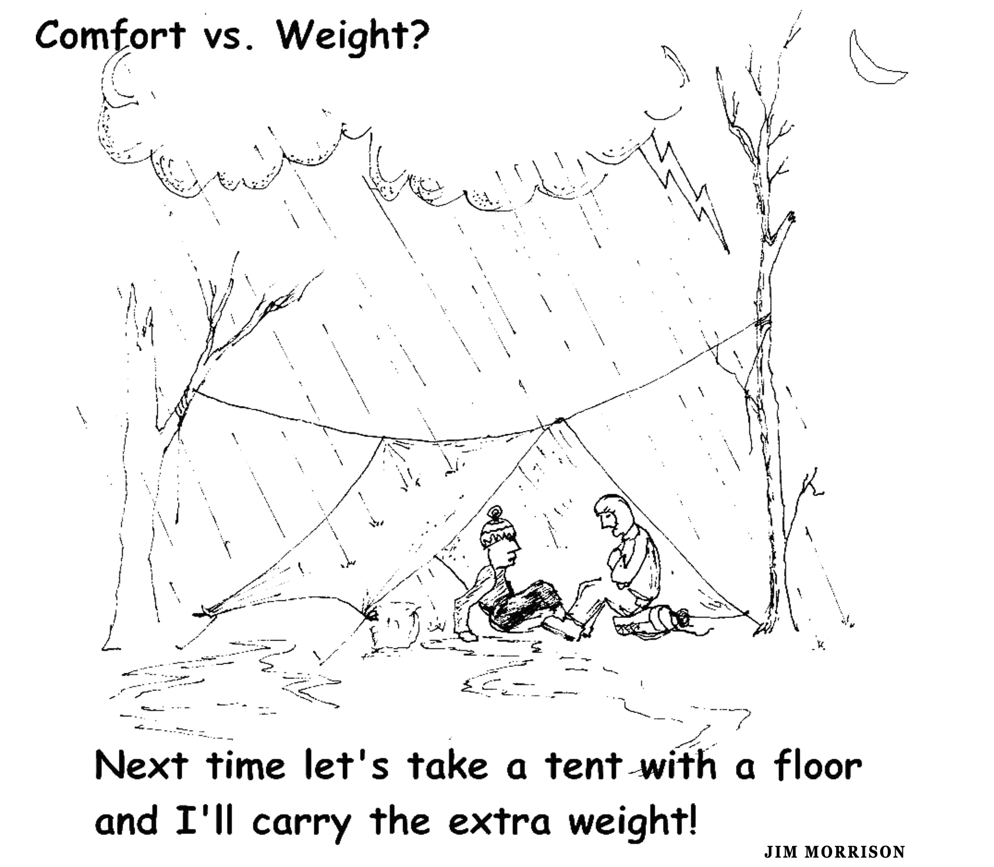

Reader Participation: Philosophy of Comfort in the Wilderness
Where are you on the above continuum of philosophies about comfort? First, add any philosophies of comfort and discomfort that have been missed, especially those for which you have a different preference. Second, circle the style(s) that best fit your personality.

Getting Out of One’s Comfort Zone: Reasons and Motivations
Those who do a lot of hiking and backpacking naturally learn to deal with at least some discomfort. Why go beyond this? Why consciously decide to expand one’s comfort zone or get out of it completely? Why choose to take some risks and push some limits? There are many reasons and motivations to get out of one’s comfort zone. They cover a wide range. Do any of the following jump out at you?

Accepted By Peers: I value acceptance by my peers; living out of our comfort zones is the current “in” thing among my close hiking friends. We compete with each other on how far we can go.

Break with Social Conditioning: Even though comfort, safety and security is a universal human need, it has become an obsession of contemporary society. Too many are too comfortable and unwilling to take any real risks. Pushing outside one’s comfort zone is necessary to break the bonds of society. It is necessary to experience real freedom and to live fully.

Happiness Involves Struggle and Discomfort: Many hold that comfort equals happiness and discomfort, pain and adversity equal unhappiness. Nothing could be further from the truth. To feel fully alive and be truly happy we need struggle and adversity and discomfort. Dean Karnazes, accomplished ultra runner, states this philosophy well:

I think Western culture has things backwards. We equate comfort with happiness, and now we’re so comfortable we’re miserable. There’s no struggle in our life, no sense of adventure. I’ve found that I’m never more alive than when I’m pushing and I’m in pain and I’m struggling for high achievement. In than struggle, I think there’s a magic.
—Outside magazine, January 2007

Evolving Personal Comfort Levels: Taking some risks is essential to the learning process. In this context, learning to deal with some discomfort in the wilderness can lead to greater comfort in the long run, especially emotional comfort. Jim Nelson, owner of Pro Mountain Sports in Seattle, expresses this philosophy relative to climbing light and fast:

Every climber goes through a learning process in deciding what is too much and what is not enough. My advice is to experiment—leave a few things out, consider every single item, dare to be a little cold (you may surprise yourself . . . and learn some new tricks). The rewards of packing light are greater comfort and safety.

Even though it initially sounds contradictory, we can learn to be comfortable with increasing levels of discomfort.

Skill Development: A similar reason to kick it up a notch, to take comfort and discomfort to the next level, emphasizes greater skill development and creativity. An unknown source says it this way:

My philosophy is to carry no more than I need and usually a little less than I think I will need. Dealing with some adversity will challenge my backpacking skill, knowledge and creativity and push it to higher levels. This is a good thing.

Sadistic Pleasure from Pain: Quite a different reason to push well out of one’s comfort zone is given by the Marquis de Sade (French aristocrat, revolutionary and novelist): “There is no more lively sensation than that of pain; its impressions are certain and dependable, they never deceive.”

The Contradiction of Wilderness Comfort: To some, being comfortable in the wilderness contradicts why people go there in the first place. It is somewhat like purchasing a large, motorized and fully equipped camper unit and then camping in it on the edge of the wilderness. Ian Baker, Buddhist scholar and expedition leader, puts it thus: “The more our camping style depends on the paraphernalia of the world we are leaving behind, the more we dwell in contradictions.” (Outside magazine, April 2000)

Reader Participation: Experimentation and Getting Out of One’s Comfort Zone in the Wilderness
First, assuming you are at least open to experimenting out of your comfort zone, circle the reason(s) in the previous section that are strongest for you. Second, if you are not at all in tune with this philosophy, write out one or two primary reasons opposing it.

Author’s Philosophy of Wilderness Comfort
Here is my philosophy broken into four sections.

Experiment with Comfort and Discomfort
I agree with most of the reasons given above for getting out of one’s comfort zones. To do this, consider taking on challenges, doing things differently from the usual, pushing limits, stretching horizons. In this context consider experimenting a lot with discomfort, pushing to the edge of one’s comfort zone. Becoming comfortable with one’s gear and its limits is a learning process. Even though it initially sounds contradictory, consider this as a process of “becoming comfortable with increasing levels of discomfort.” Some of my own interesting experiments over the years have involved frameless backpacks, single-wall tents, floor-less tents, tarp camping, sleeping quilts, sleeping mats, wool base layers, hiking sandals, no cook meals, and chemical fuel tablet stoves. In the words of B. M. Dyleski, “For me every hike is an experiment, probably trying to find the perfect mix that really doesn't exist. It's hard to find the right thing.” (backpackinglight@Yahoo.com) Experimenting a lot doesn’t mean automatically being uncomfortable. With a background of experience and knowledge and skill, failed experiments in the wilderness by experienced packers will not lead to major discomforts (mostly just inconveniences).

Improving Comfort and Safety While Reducing Pack Weight
There is no debate that the heavier our pack the more comforts we can take with us into the wilderness. For me the issue is how light can I pack and still be safe, keeping the discomforts to a minimum. My advice for the relatively experienced backpacker is to take only enough gear to be relatively safe, comfortable and confident. The more experienced we are, the less we need. I enjoy taking on this challenging task. Answering the question, “What is enough gear to be safe, comfortable and confident?” is a very subjective and individual matter. However, the more experience we have, the more confidence we will have in the answers.

Learning That Comfort Is Mostly a State of Mind
Comfort and discomfort are relative to what is available. For example, few of us would put up with an uncomfortable bed at home, but often accept sleeping on a thin mat out in the wilderness. An extreme example illustrating a similar point is that of planning on a comfortable sleeping mattress, but forgetting to pack it (or having it develop a leak). If this happens, I will make do (e.g., locate soft ground, add leaves and duff, sleep on clothes, dig a hip hole, take a sleeping pill). To be successful in more extreme situations, I need to change my expectations midstream and be resourceful. Less experienced campers will often hold tight to their original expectations and end up experiencing great discomfort (and being awake most of the night). The issue of comfort and discomfort is largely a mental thing, a mindset. It is being disciplined enough to focus on being creative and resourceful rather than on the discomforts we are expecting or actually experiencing. It is focusing on the positive rather than the negative. Some thrive on toughness; I thrive on resourcefulness.

Drawing the Line on Discomfort
Even though the goal should not be to recreate the level of comfort we experience at home, I refuse to be physically uncomfortable in key areas. One is my sleeping system. I insist on a comfortable sleeping bag or quilt, a thick air mattress and an adequate shelter. An ultralight sleeping system can be put together that weighs as little as two pounds total. Another area is with pack weight. I am not a beast of burden; I will no longer burden myself with a back breaking pack load. A third area is foot comfort. Quality shoes and boots with comfortable inserts (orthotics) are the rule of the day. I expect my feet to not hurt even after many miles and many days on the trail. Fortunately, shoe and boot manufacturers are making this easier for most feet. A final required area of comfort is warmth. For example, if I start to get chilled, I will go for a vigorous stroll, crawl in my sleeping bag and prepare hot comfort drinks. When possible, I pitch my tent or tarp facing the early morning sunrise and wait for the sun before arising. There are plenty of discomforts in the wilderness; demand the small comforts!

Additional Issues for Reflection
- Lightweight Backpacking and Comfort: How far can you cut your pack weight and still be reasonably comfortable, both emotionally and physically? Could you become an ultralight (UL) or extreme ultralight (EUL) backpacker and still be comfortable? Which comfort items are on your “no sacrifice” list?

- Gender and Genetic Differences: Do males and females differ in their ability to tolerate physical and emotional discomfort? Do individuals differ greatly in their ability to tolerate discomfort, differences that can not be explained as being learned or the result of some current physical condition?

- Cultural Differences: Do whole cultures and subcultures differ in their tolerance to discomfort and their need for comfort?

- Physical vs. Psychological Discomforts: Which are more of an issue: physical or psychological discomforts? Can these be clearly separated? Which is easier to deal with?

- Learning to Adapt: What are the best ways to learn to accept and adapt to discomforts in the wilderness? Practice at home in the front country? Practice in the wilderness? Meditation? Develop a clear philosophy of comfort and discomfort?

- Philosophy of Comfort and Discomfort: How important is it to develop a comprehensive philosophy of comfort and discomfort? How well did this article succeed at addressing the critical issues underlying such a philosophy?

- Leave Comforts Behind: How important is it to separate from the comforts and conveniences of modern living by going on extended trips into the wilderness without many comforts?

- Frontcountry Comforts: How important is comfort when not in the wilderness? What levels of discomfort do you tolerate well when in the frontcountry?

- Self-Destructive Behaviors: Do you have some of the traits common to self-destructive behavior? Are you realistic about your own mortality? Do you often find yourself in situations where you put your own survivability into question?

- Off-Trail Exploration: How important is the comfort and security of a known trail and other hikers? How strong is the urge to explore and get away from the beaten path?

- Campfires: Campfires can warm one physically and emotionally. How important is it to camp mostly where fires are allowed?

- Chronic Pain: How much chronic pain (e.g., knees, back, feet) am I willing to put up with in the wilderness? To what extent am I willing to drug myself to dull the pain of chronic conditions?

- Cleanliness: How important is regular washing of one’s body and clothing while on extended trips? Do you have a problem with hiking and sleeping in some of the same clothes? Do fellow hikers who care little about cleanliness bother you? Are you or your subculture overly concerned (obsessed?) about cleanliness? Is cleanliness next to godliness? [Note: the issue of cleanliness is not the same as that of personal hygiene.]

