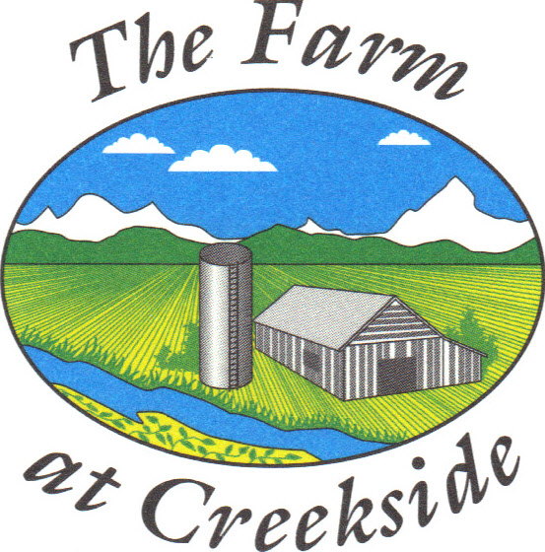 Project Approval Form
The Farm at Creekside HOA
www.fachoa.org
arch@fachoa.org
___________________________________________________________________

For any projects that require Building Permits, you must obtain them from the City of Longmont. Our Architectural Guidelines may be more restrictive, but will never be more lenient. All Architectural Guidelines for the Farm at Creekside Home Owners Association are intended to maintain the attractive community that we all live in. Thanks for your cooperation!

Email this form to the Architectural Committee (arch@fachoa.org) If you cannot email the completed form, leave a message at 720-442-0987 to request a meeting.
__________________________________________________________________

Brief Project Description: ____________________________________________
(use additional pages for drawings, pictures, and detailed description)

Planned Start Date: ________________________________________________

Property Owner: ________________________________________________

Property Address: ________________________________________________

Contact Phone/email: _____________________________________________

(HOA use below this line)

Approved By / Date: _____________________________________________

_____________________________________________

Comments: ________________________________________________________
__________________________________________________________________
__________________________________________________________________
__________________________________________________________________
__________________________________________________________________
__________________________________________________________________

