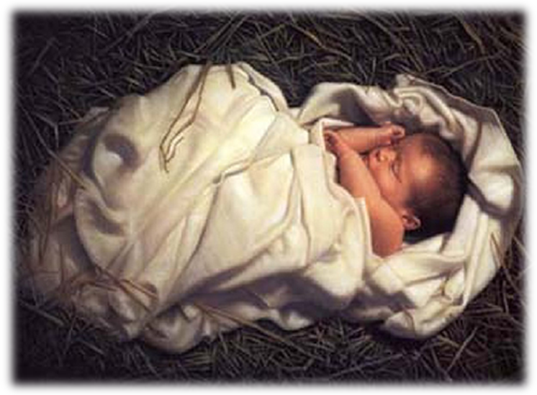
Please enfold my gift of love,
Hold him close to you,
He needs your warmth to be alive,
I need my heart be heard

Anonymous

