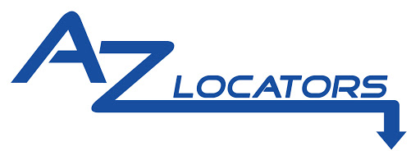

Finance the Equipment You Need Today
To Increase Revenue Tomorrow!

- Alpine Equipment Funding is a direct funding source offering "lease to own" financing for service and repair contractors

- We are not brokers and do not sell your financing contract to a 3rd party

- We fund, service our leases and allow early payoffs after 6 months for the principal balance due + $100
Lease Rate Examples
 |  | Term
 |  | 24 mo. | 36 mo. | 48 mo.
Equip. Cost
$5,000 |  | $ 243 | $ 175 | $ 140
6,000 |  | 291 | 210 | 168
7,000 |  | 340 | 245 | 196
8,000 |  | 388 | 280 | 224
9,000 |  | 437 | 315 | 252
10,000 |  | 485 | 350 | 280
11,000 |  | 534 | 385 | 308
12,000 |  | 582 | 420 | 336
