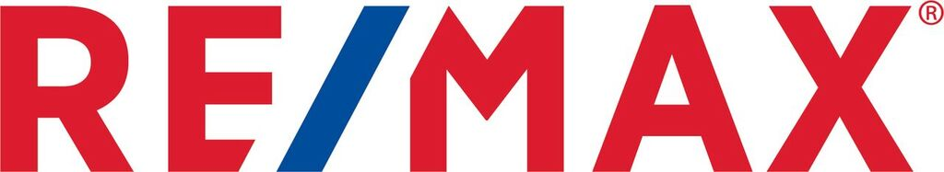My Community Writing Contest

1. Theme
“The one thing that would make my community a better place”

2. Rules
a. The contest is open to all grade 4, 5 and 6 students in the greater Edmonton area.
b. Compositions can be up to 500 words, and no less than 150 words.
c. Your work can be in the form of an essay, short story or poem.
d. Submissions must be received no later than April 26th, 2019 at 4:30pm

3. The Prize
All submissions will be ranked by a panel of judges. The top 3 authors will each receive an Apple® iPad® and a $1,000 donation to their school.

Please see the attached files which contain the original contest poster and individual submission forms. Or view online RE/MAX Writing Contest

Any questions, please contact contest coordinator at either: ngraham@rosetowngroup.com
or (780)497-8519

