WELCOME TO
HOLY SPIRIT LUTHERAN CHURCH
A Member of the Evangelical Lutheran Church in America, New Jersey Synod
1220 Bayshore Rd., Villas, NJ 08251, 609-886-2414,
holyspiritlutheran@comcast.net, holyspiritvillas.com, facebook.com/holyspiritvillas
Vicar Vince Piekarski can be contacted at any time for conversation or prayer through call or text at 412-225-0287, or through email at vpie8282@gmail.com.
SUNDAY, NOVEMBER 23RD, 2025
24TH SUNDAY AFTER PENTECOST
LAST SUNDAY AFTER PENTECOST
CHRIST THE KING SUNDAY
10:30AM WORSHIP SERVICE WITH HOLY COMMUNION 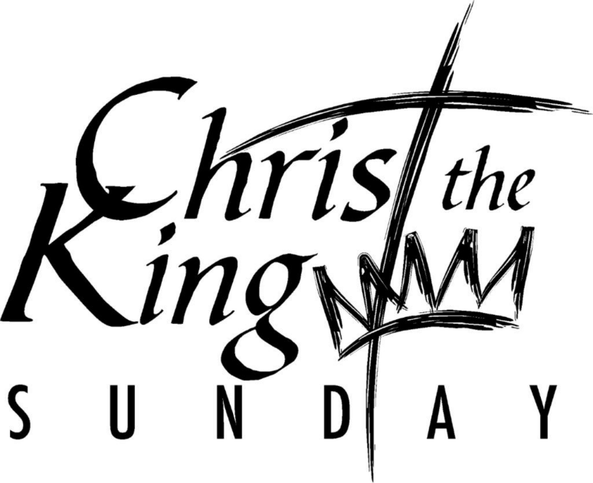

We, the Evangelical Lutheran Church of the Holy Spirit, are People of God, who
are called by the Holy Spirit to pray, worship, joyfully proclaim Jesus Christ,
and compassionately witness and serve others in Christian Love.


We are glad that you joined us for Worship today! Thank you for enriching our time together! We would like to get to know you better, and for you to get to know us better too. Brochures, welcome gifts, prayer shawls, Bibles, and other items are available throughout the church. We would be happy to show you around and share about our ministries. Please do not hesitate to speak up and ask questions.
Also, please make sure you sign-in on our clipboard on the podium in the lobby.


Our Worship Services are conducted in coordination with our Conference Call.
Join us at 657-390-7423 or 701-802-5170, with access code 8221190#.
You may need to dial 1 first depending on your phone plan. After logging in please announce your name and feel free to talk with others until we get started.

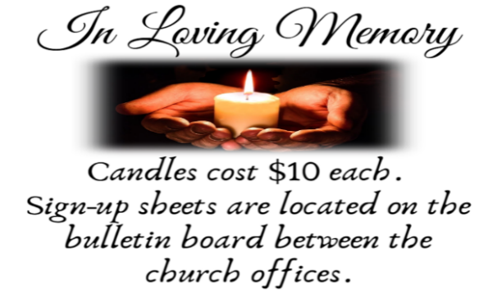
SANCTUARY CANDLE FOR NOVEMBER
Given to the Glory of God & In Memory of ED GREEN by Fran Green & Family.
ALTAR CANDLES FOR NOVEMBER
Given to the Glory of God & In Memory of PHILIP ZIMMERMAN, JR.
by Jean Zimmerman.
CONFERENCE CALL CHECK-IN, WELCOME, & ANNOUNCEMENTS
(Vicar (V), Assistant (A), Reader (R), and Congregation (C).)

INTRODUCTION
A. Jeremiah’s promise of the execution of “justice and righteousness in the land”
finds ironic fulfillment in the execution of Jesus of Nazareth, the King of the Jews.
It appears utterly contradictory that a king should be crucified with a criminal. This
victory appears for all the world as humiliating defeat. Yet through the gate of
death Jesus opens the door to paradise.

PRELUDE
(Music offered by our Organist at the start of our Worship Service.)
Let All Things Now Living

CHIMES
(Music offered by our Organist at the start of our Worship Service.)
Come Ye Thankful People Come

V. We invite you to stand as you are able.

CONFESSION & FORGIVENESS
(All may make the sign of the cross, the sign that is marked at baptism.)
V. Blessed be the holy Trinity, ☩ one God,
who forgives all our sin,
whose mercy endures forever.
C. Amen.

V. Let us confess our sin in the presence of God
and of one another.

(Silence is kept for reflection.)

V. Faithful God,
C. you have shown us the ways of your heart,
yet we stray from your paths.
We are stuck in sinful systems of oppression
and do not embrace the freedom
of your faithful promises.
We ignore our neighbors.
We exploit the earth.
We reject your abundance,
trusting our impulses instead of your steadfast love.
Repair our relationships,
restore what we have broken,
renew our hearts,
and bring us to new life.
Amen.

V. Hear the good news:
God the Faithful One loves you,
☩ in Christ Jesus your sins are forgiven,
and by the power of the Holy Spirit you are set free.
C. Amen.

GATHERING HYMN
(We invite you to sing along.)
Lutheran Book of Worship—Green Book
518—Beautiful Savior

APOSTOLIC GREETING
V. May the grace of our Lord Jesus Christ, the love of God,
and the communion of the Holy Spirit be with you all.
C. And also with you.

KYRIE
V. In peace, let us pray to the Lord.
C. Lord, have mercy.

V. For the peace from above, and for our salvation, let us pray to the Lord.
C. Lord, have mercy.

V. For the peace of the whole world, for the well-being of the church of God,
and for the unity of all, let us pray to the Lord.
C. Lord, have mercy.

V. For this holy house, and for all who offer here their worship and praise,
let us pray to the Lord.
C. Lord, have mercy.

V. Help, save, comfort, and defend us, gracious Lord.
C. Amen.

HYMN OF PRAISE
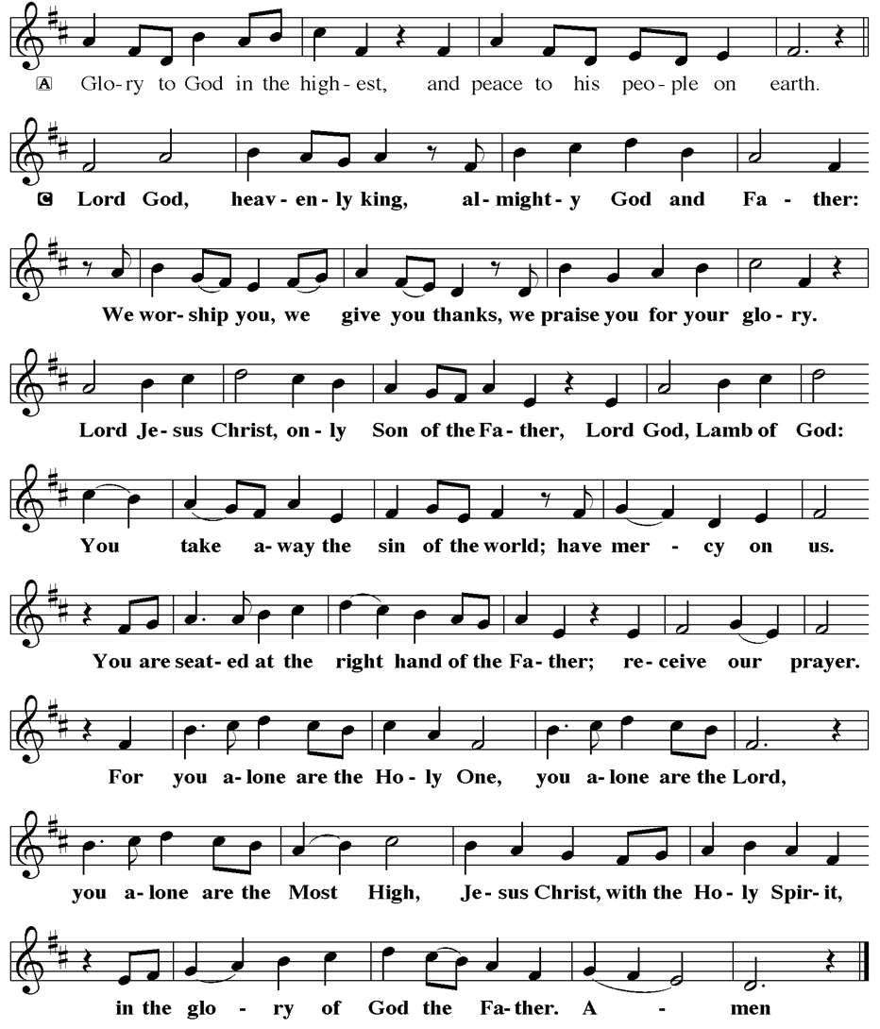
PRAYER OF THE DAY
V. The Lord be with you.
C. And also with you.

V. Let us pray,
O God, our true life, to serve you is freedom, and to know you is unending joy.
We worship you, we glorify you, we give thanks to you for your great glory. Abide
with us, reign in us, and make this world into a fit habitation for your divine
majesty, through Jesus Christ, our Savior and Lord, who lives and reigns with you
and the Holy Spirit, one God, now and forever.
C. Amen.

(We invite you to be seated for our Readings and Psalm.)

FIRST READING
Today’s reading builds on the common, ancient Near Eastern metaphor of the
king as shepherd. Judah’s unjust rulers have caused their people, their “flock,” to
be scattered. Nevertheless, God will raise up a new and righteous shepherd who
will rule a restored Judah.

R. Our First Reading is from the 23rd Chapter of Jeremiah (Verses 1-6).

R. 1 Woe to the shepherds who destroy and scatter the sheep of my pasture! says
the Lord. 2 Therefore thus says the Lord, the God of Israel, concerning the
shepherds who shepherd my people: It is you who have scattered my flock and
have driven them away, and you have not attended to them. So I will attend to
you for your evil doings, says the Lord. 3 Then I myself will gather the remnant of
my flock out of all the lands where I have driven them, and I will bring them back
to their fold, and they shall be fruitful and multiply. 4 I will raise up shepherds over
them who will shepherd them, and they shall no longer fear or be dismayed, nor
shall any be missing, says the Lord.

5 The days are surely coming, says the Lord, when I will raise up for David a
righteous Branch, and he shall reign as king and deal wisely and shall execute
justice and righteousness in the land. 6 In his days Judah will be saved, and
Israel will live in safety. And this is the name by which he will be called: “The Lord
is our righteousness.”

R. This is the Word of the Lord.
C. Thanks be to God.
PSALM
R. Our Responsorial Psalm is from the 46th Psalm.
C. I will be exalted among the nations. (Ps. 46:10)

R. 1 God is our refuge and strength,
a very present help in trouble.
2 Therefore we will not fear, though the earth be moved,
and though the mountains shake in the depths of the sea;
3 though its waters rage and foam,
and though the mountains tremble with its tumult.
4 There is a river whose streams make glad the city of God,
the holy habitation of the Most High.
5 God is in the midst of the city; it shall not be shaken;
God shall help it at the break of day.
6 The nations rage, and the kingdoms shake;
God speaks, and the earth melts away.
C. I will be exalted among the nations. (Ps. 46:10)

R. 7 The Lord of hosts is with us;
the God of Jacob is our stronghold.
8 Come now, regard the works of the Lord,
what desolations God has brought upon the earth;
9 behold the one who makes war to cease in all the world;
who breaks the bow, and shatters the spear, and burns the shields with fire.
10 “Be still, then, and know that I am God;
I will be exalted among the nations; I will be exalted in the earth.”
11 The Lord of hosts is with us;
the God of Jacob is our stronghold.
C. I will be exalted among the nations. (Ps. 46:10)

SECOND READING
An early Christian hymn praises the mystery of the political, personal, and
mystical Christ, the one who was present at creation and is eternally reigning with
God.

R. Our Second Reading is from the 1st Chapter of Colossians (Verses 11-20).

R. 11 May you be made strong with all the strength that comes from his glorious
power, so that you may have all endurance and patience, joyfully 12 giving thanks
to the Father, who has enabled you to share in the inheritance of the saints in the
light. 13 He has rescued us from the power of darkness and transferred us into
the kingdom of his beloved Son, 14 in whom we have redemption, the
forgiveness of sins.

15 He is the image of the invisible God, the firstborn of all creation, 16 for in him
all things in heaven and on earth were created, things visible and invisible,
whether thrones or dominions or rulers or powers—all things have been created
through him and for him. 17 He himself is before all things, and in him all things
hold together. 18 He is the head of the body, the church; he is the beginning, the
firstborn from the dead, so that he might come to have first place in everything.
19 For in him all the fullness of God was pleased to dwell, 20 and through him
God was pleased to reconcile to himself all things, whether on earth or in heaven,
by making peace through the blood of his cross.

R. This is the Word of the Lord.
C. Thanks be to God.

V. I invite you to stand as you are able, and I invite you to announce the Gospel
Acclamation with me.
GOSPEL ACCLAMATION
C. Alleluia. Blessed is the one who comes in the name of the Lord. Blessed is
the coming kingdom of our ancestor David. Alleluia. (Mark 11:9-10)

GOSPEL READING
Amid scoffing and slander from those who sarcastically call him Messiah and
king, Jesus reveals that to be Messiah and king is to give one’s life for others.
Here he uses his power to welcome a despised sinner to paradise but puts his
own death into God’s hands.

V. The Holy Gospel According to Luke, the 22nd Chapter (Verses 33-43).
C. Glory to you, O Lord.

V. 33 When they came to the place that is called The Skull, they crucified Jesus
there with the criminals, one on his right and one on his left. 34 [[Then Jesus said,
“Father, forgive them, for they do not know what they are doing.”]] And they cast
lots to divide his clothing. 35 And the people stood by watching, but the leaders
scoffed at him, saying, “He saved others; let him save himself if he is the Messiah
of God, his chosen one!” 36 The soldiers also mocked him, coming up and
offering him sour wine 37 and saying, “If you are the King of the Jews, save

yourself!” 38 There was also an inscription over him, “This is the King of the
Jews.”

39 One of the criminals who were hanged there kept deriding him and saying,
“Are you not the Messiah? Save yourself and us!” 40 But the other rebuked him,
saying, “Do you not fear God, since you are under the same sentence of
condemnation? 41 And we indeed have been condemned justly, for we are
getting what we deserve for our deeds, but this man has done nothing wrong.”
42 Then he said, “Jesus, remember me when you come in your kingdom.” 43 He
replied, “Truly I tell you, today you will be with me in paradise.”

V. This is the Gospel of the Lord,
C. Praise to you, O Christ.
(We invite you to be seated.)

SERMON
(Delivered by Vicar Vince Piekarski.)

(Following the Sermon, we invite you to stand as you are able.)

HYMN OF THE DAY
(We invite you to sing along.)
Lutheran Book of Worship—Green Book
170—Crown Him with Many Crowns
(4 Verses)

APOSTLES’ CREED
V. God has indeed made us his people through our Baptism into Christ. Living
together in trust and hope let us confess our faith together using the Apostles’
Creed.

C. I believe in God, the Father almighty,
creator of heaven and earth.

I believe in Jesus Christ, God’s only Son, our Lord,
who was conceived by the Holy Spirit,
born of the Virgin Mary,
suffered under Pontius Pilate,
was crucified, died, and was buried;
he descended to the dead.
On the third day he rose again;
he ascended into heaven,
he is seated at the right hand of the Father,
and he will come to judge the living and the dead.

I believe in the Holy Spirit,
the holy catholic church,
the communion of saints,
the forgiveness of sins,
the resurrection of the body
and the life everlasting.
Amen.

PRAYERS OF INTERCESSION
(The prayers are prepared locally for each occasion.)
V. Gathered with one voice, we offer our prayers for the church, the world, and all
who are in need.

(A brief silence.)

A. We pray for the church in the world, its leaders, and its mission to share the good
news of healing and restoration. Inspire us to embody the beloved community in
ways that faithfully witness to the Holy Spirit. Hear us, O God.
C. Your mercy is great.

A. We pray for the trembling mountains and glad streams of creation. Preserve and
renew your coastlines, deep seas, forests, and grasslands. Guide all who tend
flocks or care for creatures of all kinds. Hear us, O God.
C. Your mercy is great.

A. We pray for leaders and advocates in government, civic life, and public safety.
Support equity across the globe, and heal division with accountability and truth.
Hear us, O God.
C. Your mercy is great.

A. We pray for any who are hungry, living in poverty or desperation, weary in body or
spirit, or sick; especially:
BettyAnn Rich-White (Church Member)
Chip & Marie Hand (Church Members)
Lynn Bargstadt (Church Member)
Frank Ford (Church Member)
Carol Amundsen (Church Member)
Kim McGinley (Church Member)
Anthony DeLuca (Church Member)
Frank Brunner (Church Member)
Joan Sommerman (Church Family)
Arleen Kinka (Church Family)
Rick Lang (Church Family)
Suzie Clark (Rose Lang's Friend)
Francis Clock (Dianna DeNote’s Family)
Andrew Hudak (Rose Lang’s Friend)
Viena Murtha (Bob Fritsch’s Friend)
Sharon Waicus (Skip & Bonnie Millard's Friend)
Karen O'Brien (Paul Bowker's Friend)
Dustin Irizzary (Mary Melnicoff's Family)
The Bryan Family (Wanda Bryan's Family)
Craig Brearey (Judy Brannan & Mary Melnicoff's Friend)
Sarah Dutton (Frank Ford's Family)
Christina McNasby (Fran Green’s Family)
The Kinkson Family (Judy Brannan's Friends)
Mark Stephen Dennis (Diana DeNote's Family)
Bill Lodge (Skip & Bonnie Millard's Friend)
Ron Anderson (Bill Kelly's Friend)
Bud Brearey (Judy Brannan & Mary Melnicoff's Friend)
Mary Skain (Kathy Poehler's Friend)
Robert Chaplin (Mary Melnicoff's Friend)
Jack Wieckouski (Theresa & Kim McGinley's Family)
Carolyn Santarpio (Bob Fritsch's Friend)
Harry (Judy Brannan's Friend)
Janet K (Philomena Noak's Friend)
Michael Hart (Diana DeNote's Friend)
Rocco Leonard DeNote (Diana DeNote's Family)
Al Singer & Family (Frank Ford's Friends)
Sherri Lynn (Bob Fritsch's Friend)
John Bannco (Bob Fritsch's Friend)
Nancy Pazarinie (Bob Fritsch's Family)
Jane & Paul Eiben (Rose Lang's Friend)
Joe DiMassimo (Judy Brannan & Mary Melnicoff's Friend)
Tommy Stanford (Sue Waltz's Family)
Audrey McAlister (Sue Waltz's Family)
Joe Waltz (Sue Waltz's Family)
Denny Papst (Rose Lang’s Friend)
Mike & Alice Rhoades (Rose Lang’s Friends)
Chris (Judy Brannan's Friend)
Helen Ehlers (Judy Brannan's Friend)
Leanne Bueth (Joan Kilcoyne's Family)
Janett MacFarlane (Carol Amundsen's Friend)
Patrick Davenport (Sue Waltz's Friend)
Thish Kelly (Theresa & Kim McGinley's Family)
Edward Chapleski (Allison Call's Family)
Scott Levin (Rose Lang's Friend)
Lynne Curlett (Del McKenna's Family)
Alice Ann Dennis (Diana DeNote's Family)
Nancy Taylor (Ted & Diane Bell's Family)
Santa Isabel Lutheran Church (Elizabeth, NJ)
Messiah Lutheran Church (Oakland, NJ)
Carol Brand (Skip & Bonnie Millard’s Friend)
Joyce Thompson (TDPWC Member)
Barbara Paynter (Leon Stitt’s Family)
Ruth (Anthony & Vincent Bruno's Family)
Tom M (Philomena Noak's Family)
William T Hodgetts (Pastor William Hodgetts’ Family)
Paul Bowker (Church Member)
BettyAnn & Bill Whitman (Mary Melnicoff's Friends)
Bob Poole (Kathy Poehler's Family)
David Smith (Heather & Vicar Vince Piekarski’s Family)
Joe Smith (Heather & Vicar Vince Piekarski's Family)
Barbara Hoitink (Lucas & Sabrina Munson's Family)
Kathy Raynor (Philomena Noak & Mary Melnicoff’s Friend)
Ed Cox (Church Family)
Audrey Knott (Judy Brannan’s Family)
Brownie (Diana & Rocco DeNote's Dog)
Jordan (Carol Amundsen's Friend)
Myrna (Brookdale Resident)
Patti Faikish (Fran Green's Friend)
(Additional Names Added Prior to the Worship Service.)
A. Comfort all in need of your tender care. Hear us, O God.
C. Your mercy is great.

A. We pray for this part of the body of Christ gathered around word and sacrament.
Bring us into authentic community where all ages are valued and experience
God’s faithfulness together. Hear us, O God.
C. Your mercy is great.

A. We give thanks for all who have died in faith. May we remember them faithfully
until we are gathered with you in the paradise you promise. Hear us, O God.
C. Your mercy is great.

(Here other intercessions may be offered.)

V. Watch over all of us who are worried and suffering, and especially those whose
names we now say aloud or hold within our hearts (pause). Hear us, O God.
C. Your mercy is great.

V. We offer these and all our prayers to you, O God, trusting in your grace and
unyielding love; through Jesus Christ, our Lord.
C. Amen.

SHARING OF THE PEACE
V. May the peace of the Lord be with you always.
C. And also with you.
V. Now, let us share God’s Peace with one another.



(Please respect your neighbor if they desire to still only offer a peace sign or wave.)

(Following the Sharing of the Peace, we invite you to be seated.)

OFFERING
V. We now worship God with our tithes and offerings, wine and bread for use in holy
communion, and monetary gifts to support our ministry for service in God’s name.
Our Ushers will be around to your pews to pass the Offering Plates.

(Ushers come forward to get the Offering Plates from the Assistant.)

(Vicar and Assistant prepare the Altar for Communion.)
OFFERING SONG
(We invite you to sing along.)
Worship & Praise
156—What Have We to Offer?
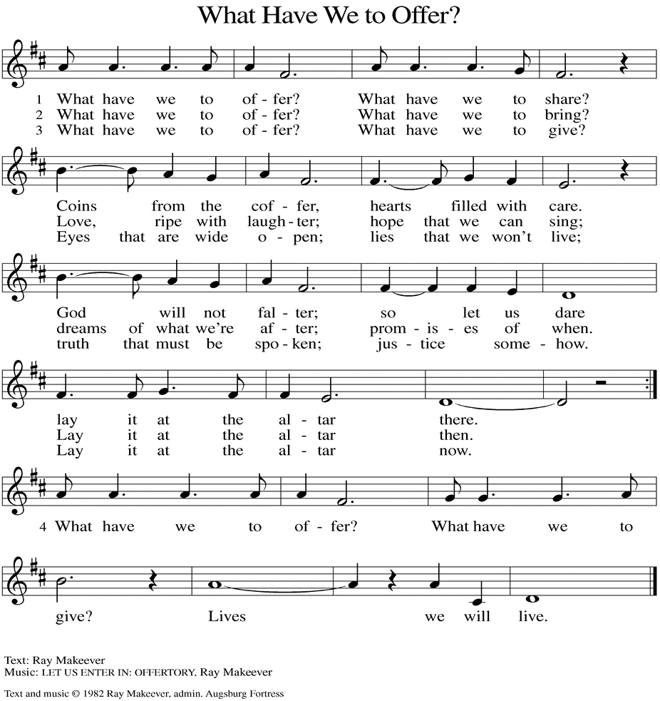
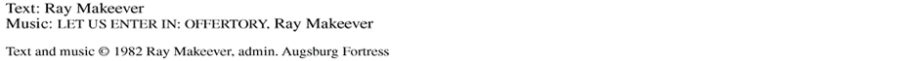

(Usher(s) brings the Tithes and Offerings up front to the Assistant.)

V. We invite you to stand as you are able.
OFFERING PRAYER
V. Let us pray,
God of healing and hope,
you bless those who are hungry,
promising to fill them with good things.
Fulfill that promise through us and these your gifts.
Nourish us with the abundance of your feast
and unite us into the blessed body of Jesus Christ our Savior,
now and forever.
C. Amen.

GREAT THANKSGIVING
V. The Lord be with you.
C. And also with you.

V. Lift up your hearts.
C. We lift them to the Lord.

V. Let us give thanks to the Lord our God.
C. It is right to give him thanks and praise.

V. It is indeed right and salutary that we should at all times and in all places offer
thanks and praise to you, O Lord, holy Father, through Christ our Lord; who rose
beyond the bounds of death and, as he promised, poured out your Spirit of life
and power upon the chosen disciples. At this the whole earth exults in boundless
joy. And so, with the Church on earth and the hosts of heaven, we praise your
name and join their unending hymn:

SANCTUS
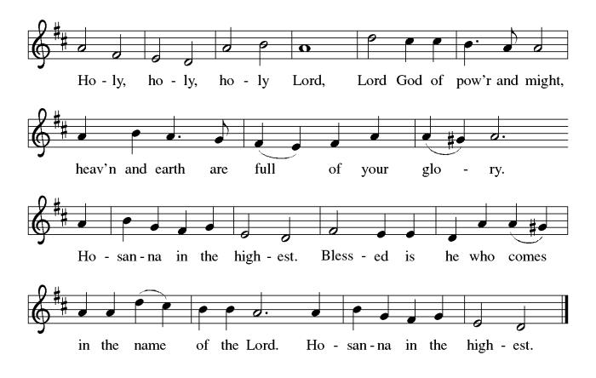

THE EUCHARISTIC PRAYER
V. Blessed are you, Lord of heaven and earth, in mercy for our fallen world you gave
your only Son, that all those who believe in Him should not perish, but have
eternal life. We give thanks to you for the salvation you have prepared for us
through Jesus Christ. Send now your Holy Spirit into our hearts that we may
receive our Lord with a living faith as He comes to us in His holy supper.
C. Amen. Come, Lord Jesus.

V. In the night in which he was betrayed our Lord Jesus took bread,
he gave thanks; broke it, and gave it to his disciples, saying:
Take and eat; this is my body, given for you.
Do this for the remembrance of me.

V. Again, after supper, He took the cup, he gave thanks,
and gave it for all to drink, saying:
This cup is the new covenant in my blood,
shed for you and for all people for the forgiveness of sin.
Do this for the remembrance of me.

THE LORD’S PRAYER
(We ring the bell throughout the Lord’s Prayer at all services to
invite those in the community to join in praying the Lord’s Prayer.)
V. May we now join with one another and pray together as Jesus has taught us.
C. Our Father, who art in heaven, hallowed be thy name, thy kingdom come,
thy will be done, on earth as it is in heaven. Give us this day our daily
bread; and forgive us our trespasses, as we forgive those who trespass
against us; and lead us not into temptation, but deliver us from evil. For
thine is the kingdom, and the power, and the glory, forever and ever.
Amen.

LAMB OF GOD

(We invite you to be seated.)

HOLY COMMUNION
V. Communion here is pretty simple, and all who are baptized and believe in Jesus
Christ are welcome at the table.

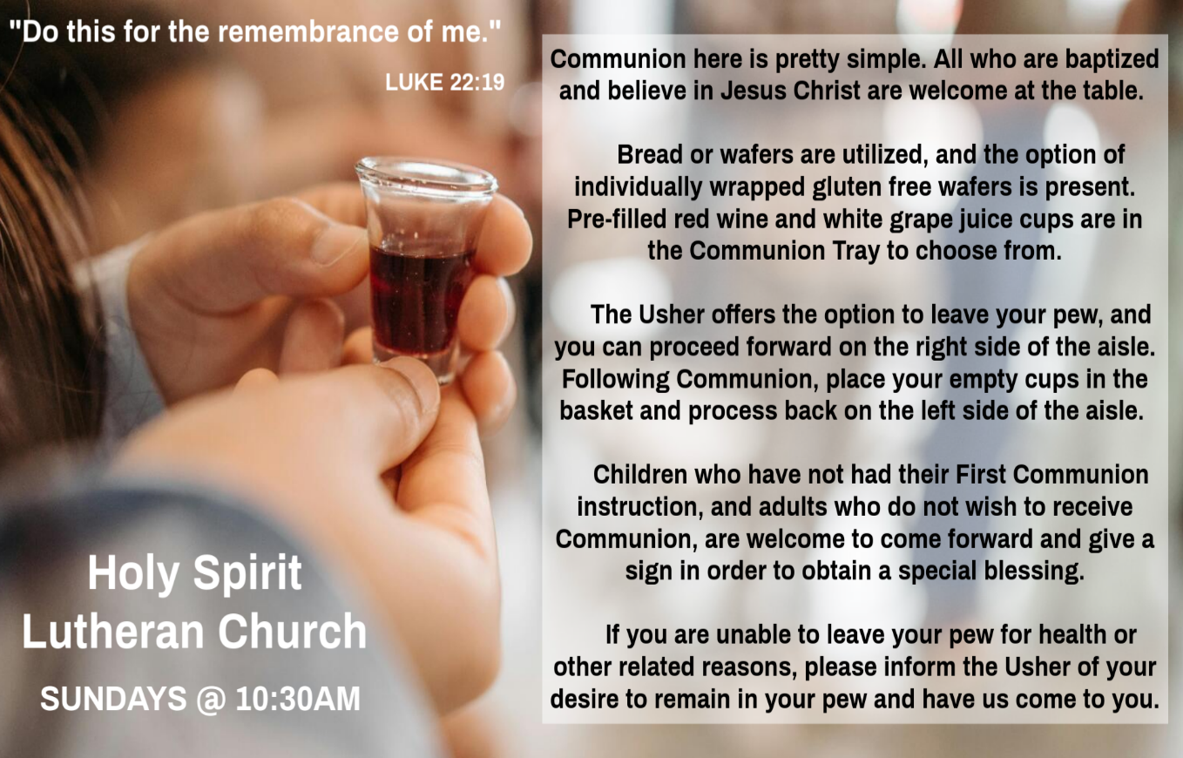

INVITATION TO COMMUNION
V. There is a place for you at the table of God.
Come, receive the food that does not perish,
a taste of life eternal.
C. Amen.

(Distribution of Holy Communion)

COMMUNION HYMN
(Please enjoy various music offered by our Organist during your
quiet time, prayer, and reflection following Holy Communion.)

(Vicar and Assistant remove Communion Vessels from the Altar.)

V. We invite you to stand as you are able.
POST COMMUNION BLESSING
V. May the body and blood of our Lord Jesus Christ strengthen us and keep us
always in His grace.
C. Amen.

POST COMMUNION CANTICLE
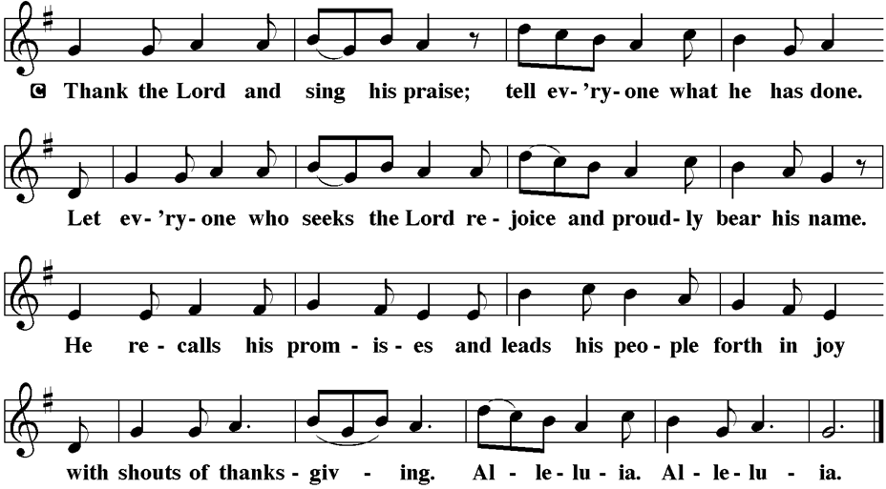

PRAYER AFTER COMMUNION
A. Let us pray,
God of field and flower, wheat and grape,
you have nourished us with the bread of heaven
that gives life to the world.
Strengthened by the body and blood of your Son,
send us out to gather your good gifts for all who
hunger and thirst,
and embolden us to love and serve in Christ’s name.
C. Amen.

BLESSING
V. The love of God the Sovereign strengthen you,
God the Son save you,
and God the Holy Spirit anoint you for the work ahead.
The holy Trinity bless you ☩
and grant you a faithful and courageous heart
now and forever.
C. Amen.

SENDING HYMN
(We invite you to sing along.)
Lutheran Book of Worship—Green Book
377—Lift High the Cross

(Assistant extinguishes the Altar Candles half way through the Sending Hymn.)

(Vicar processes out once the Altar Candles have been extinguished.)

(We invite you to be seated.)

BIRTHDAYS, ANNIVERSARIES, & ANNOUNCEMENTS
(Offered by Assistant and Congregation.)

BIRTHDAY
28th Linda Tatem

DISMISSAL
A. Go in peace. Share the harvest.
C. Thanks be to God.

POSTLUDE
(Music offered by our Organist as we depart following our Worship Service.)
In Thanksgiving, Let Us Praise Him

LICENSES & EXPIRATION DATES
Worship Service Content is used via permission through Augsburg Fortress Liturgies Annual License #SB144368. The next Subscription Renewal Date is 2/28/2026.
Our Hymns and Worship Music are used via permission through CCLI One
License #11327166. The next Subscription Renewal Date is 1/31/2026.


CONFIRMATION & SUNDAY SCHOOL
“Here We Stand” allows our young folks to go through a 2-year process while focusing on the Bible and Luther’s Small Catechism. Studies for year two of our program have resumed, and we meet every Sunday from 9-10AM.

WORSHIP MINISTRY
The most important thing we do each week is gather together as God's people to Worship. God is the center and focus of everything we do. Participating in Worship is active, as Liturgy means the work and actions of the people gathered. Everything we do during the week to prepare for Worship, and everything we do as we Assist in leading Worship is important. We are thankful for all the wonderful work being done. If you have questions, or are interested in any position, reach out to Vicar Vince.
Sign-up sheets are located on the bulletin board between the church offices.

CLINICAL PASTORAL EDUCATION
Vicar Vince has been blessed with the opportunity of joining Chaplain Stephen Faller on-line for CPE classes on Sunday afternoons from 4PM-8:30PM on Zoom. Please be respectful of this if you happen to see his car at the church.
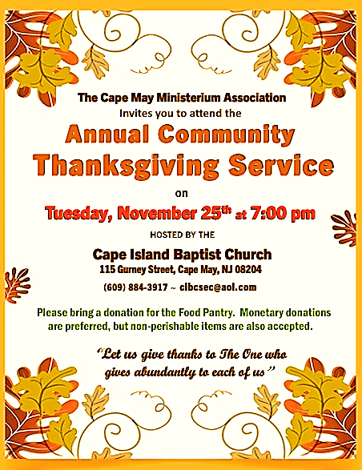
If you are interested in attending, please reach out to Vicar Vince.

BULLETIN ENTRY DEADLINE
The Bulletin will be Printed on Wednesday this week during special Church Office Hours due to Thanksgiving. Changes need to be submitted to Vicar Vince or Heather no later than Wednesday by 4PM. Thank you!

CHURCH OFFICE HOURS
Open Wednesday from 6PM to 8PM to serve the Congregation, the Community,
and to continue handling the business of the Church. Feel free to stop in to talk,
pick-up or drop off something, pray in the Sanctuary, or for whatever reason.

FOOD PANTRY
Open every Thursday, and the last Saturday of every month, from 10AM to 1PM. 96 people were served in October and 734 people have been served in 2025. Donations can be dropped in the outdoor drop-box, in the money jug in the back of the Church, mailed into the Church Office, or placed in the Offering Plate. Volunteers are needed. Sign-up sheets are located on the bulletin board between the church offices. If you have questions or need training see Heather, Vicar Vince, or Bonnie.
A special thank you goes out to all who donate, pray, and help in any way!

Thursday, 11/27 | Saturday, 11/29 | Thursday, 12/4
Closed due to Thanksgiving | Vicki & Bonnie | Tori & Cathie
COMMUNITY FOOD DONATIONS, DELIVERIES, & MORE
Our local North Cape May Acme provides us with Expiring Soon, Recently Expired, and Slightly Damaged Food and Items weekly. Kathy helps those in need by delivering items each Saturday in the community, brings leftover items to the Church for church members in need, and those who visit the food pantry during the week. Additional items are taken over to the Branches Outreach in Rio Grande on Monday.

INTINCTION DURING COMMUNION
Intinction while communing together will occur in the months that have a fifth Sunday. Our next time doing this will be on Sunday, November 30th.

DONATION STATION
Get on the train and place all purchased items in the specified project donation bins located on the counter by the front doors. See Heather for more information.



WOMEN OF THE CHURCH
The next monthly meeting will be on Monday, December 1st, at 6PM. Come join us for our Annual Cookie Exchange. We are also looking for a few more $5 or $10 gift cards for our Christmas Stockings to hand out in December. New members are always welcome to attend! Contact Judy for more information.

BIBLE STUDY & FAITH DISCUSSIONS
Bible Study & Faith Discussions was started in order to focus on various readings,
books, Bible verses, people of faith, and other general topics. Group Members offer
various points of view while reviewing the Bible and various aspects of faith while
being respectful and supportive of each other. We are off Tuesday, November 25th, due to Thanksgiving Week and the Service in Cape May. Please join us during our next “by heart” session on Tuesday, December 2nd, at 6PM.


Please join us this year as we have added well over 10 more trees, and are over 60 total. Check out all the other decorations while enjoying food, refreshments, and fellowship time with one another. We look forward to you, your family, and your friends coming out and joining the fun while getting into the holiday spirit.
Friday, December 5th 6-9PM
Saturday, December 6th 6-9PM
Sunday, December 7th 1-4PM
Our Facebook Live Tree & House Tour will be Sunday Evening, December 7th at 9PM for those that cannot attend in-person. RSVP to Heather 724-875-6895 or Vicar Vince at 412-225-0287. We are located at 16 W Tampa Ave., Villas, NJ 08251.

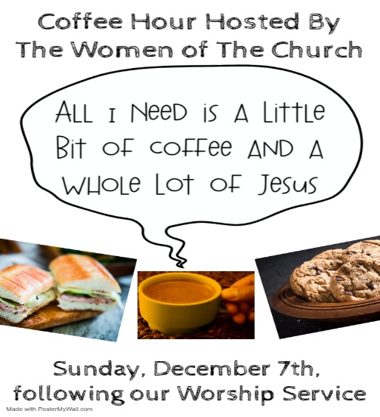

NEWSLETTER
Collect information, stories, pictures, and reports for our next seasonal publication. Winter starts on Sunday, December 21st. All information needs submitted to Vicar Vince in-person or via email at vpie8282@gmail.com no later than December 14th.

PREACHING AT BROOKDALE
Vicar Vince preaches at Brookdale Senior Living in Cape May Court House again on Sunday, December 14th, at 1PM. Holy Communion will follow the service, as well as True Deliverance Praise & Worship Center will be joining us for Caroling.
CHURCH COUNCIL
Share your comments, concerns, questions, or joys with one of our Church Council Members who can bring them back to our meetings. Visitors are always welcome to attend and listen to what is going on in and around the church. Join us In- Person or on our Conference Call at our next Meeting on Tuesday, December 16th, at 6PM.

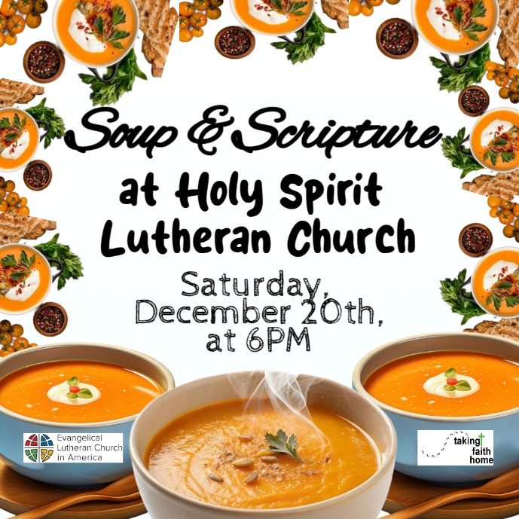

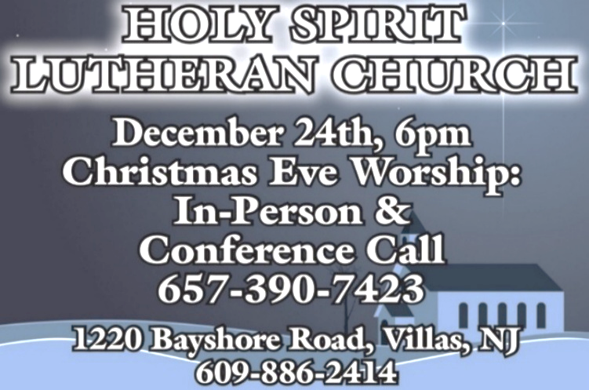

TITHES, OFFERINGS, & ENVELOPES
2026 Offering Envelopes will be available in the back of the church starting on Christmas Eve. We do indeed worship God with our tithes and offerings. We hear this in scripture, “Each of you must give as you have made up your mind, not reluctantly or under compulsion, for God loves a cheerful giver.” (2 Corinthians 9:7) Feel free to drop your envelopes in the offering plate, mail them to the church, or drop them off in the locked mailbox. Thank you for your continued support in the mission of our church, its ministries, the New Jersey Synod, and other needs!

ANNUAL CONGREGATIONAL MEETING
As 2025 winds down we will be wrapping up the books and reports in preparation for a new year. 2026 will bring about several new things and changes I am sure, but one thing is for certain, we will be meeting as a Congregation for our Annual Meeting. We will discuss and review things, as well as vote on a new budget. I know it is rather early to think about things, but please start compiling your committee reports and make sure Sunday, February 8th is on your calendars, in your planners, or in your phones to meet after our Worship Service together.

CHURCH DIRECTORY
The 2025 Church Directory is by the Church Office on the bookshelves. We continue keeping it updated, but we undoubtedly miss a few changes or have made a few errors. The printed church directories have spaces for changes in info, new people’s info, notes, and your favorite Bible verses. If you have changes or updates please inform the Church Office to keep us up to date. Our 2026 Church Directory will be made available to you the week following our Annual Congregational Meeting.


Our Prayer List continues to lengthen and we realize the important need for prayers and healing. Sometimes the unfortunate result is that someone has passed away, and the words “The Family & Friends of” appear before someone’s name. However, sometimes we forget names are still on the list and their health has improved or the they are no longer struggling, and they can be removed. Please share the good and bad stories as we continue to pray for strength and healing. Names can be added or removed from the list on the clipboard in the Narthex prior to the Worship Service, by calling the church office, or addressing it on the Conference Call. Please let us know the relation to the person(s) you listed so we can be more mindful with our prayers. Names will stay on the list until removed by the person(s) who requested prayer.
PRAYER SHAWL MINISTRY
Prayer Shawls, Lap Quilts, Scarves, and other items have been made with love. Blessed items are located in the Narthex, and are free for anyone. Members of the group continue working at home on new stitches and patterns. We are blessed to be able to continue collecting new items. We have a donation station of yarn and other items located in the Narthex. You can find some new supplies for your next creation!

HOME COMMUNION MINISTRY
A Minister is available if you have a loved one, or if you desire services. We look forward in sharing the Word and Holy Communion! Please inform Vicar Vince, Kathy, or the Church Office so plans can be made for visits.


Vicar Vince was introduced to Milestones Ministries weekly guides for faith-filled studies and conversations through a Seminary class. A decision was made to pass these along to you. If you missed a week, or lost your insert, check our website for past issues. Feel free to ask questions and provide feedback to Vicar Vince.

SPACE AVAILABLE
​​​​​Do you know anyone interested in utilizing our Fellowship Hall for a Party or Event?
It is a suggested $50 refundable security deposit, and $250 for facility use. There is no alcohol or games of chance permitted due to ELCA policy. Please contact Vicar Vince or the Church Office with questions, for info, or to reserve a date and time.

ED GREEN CAPITAL IMPROVEMENT FUND
We continue raising money for unforeseen costs or repairs. Kathy has been selling Wawa Tickets for $6, but we have learned the program will end in 2025. Please use your tickets that you have purchased before the end of the year. We will seek out a new fundraiser. We still have the donation bin in the back of the church and our Church Rummage Sale. Thanks for your continued donations, prayers, and support!

INTERESTED IN BECOMING A NEW MEMBER
Have you been attending our church for a while? Have you just recently returned to church after being away for a bit? Maybe you transitioned from another church,
or just started to recently attend our church. We are glad to have you, and would love to have you as a member of our Congregation. See Vicar Vince for more info.

BAPTISM
We are a church whose unity is in Jesus Christ, who gathers us around word and water, wine and bread. Baptism is a significant part of our faith journey as we come from the baptismal waters to live a new life as children of God. Our baptism sets us out on a lifelong journey that is characterized by our relationship to God, our relationship to our faith community, our relationships in our community and the wider world. Living our baptismal covenant means living a life of growth in the faith practices of discipleship. Please see Vicar Vince for more information.

FIRST COMMUNION
Although no particular age for first communion is prescribed by The Use of the Means of Grace, one guideline is offered. Because admission to the Sacrament is by invitation of the Lord to the baptized, "baptized children begin to commune on a regular basis at a time determined through mutual conversation that includes the pastor/vicar, the child, and the parents or sponsors involved, within the accepted practices of the congregation.” Each congregation is encouraged to ask the question of readiness for first communion, establish their own policies regarding age and practice, and accompany that practice with catechesis appropriate to the age of the communicant. If anyone has questions, please see Vicar Vince.

LIBRARY
New books are added to our library from time to time. Several are borrowed and read and exchanged. Who knows, you might find one particularly interesting and share that with someone as well. Reading is a great way to pass spare time, learn, and explore. You may find some fresh ideas for prayer, ways to grow more spiritually, ways to grow closer to God, or some opportunities to understand our faith more. We also have an extended library located in Vicar Vince’s office. There are Bibles of various translations, books from his personal collection, books inherited from Pastor Leah, movies, past Bible Study Curriculums, and more. Visit the library between the church offices, or just ask to be able to check things out.

FAVORITE HYMNS
Carol is willing to play some of your favorite hymns for the Prelude & Postlude each Sunday during our Worship Service. Feel free to let her know of your suggestions.

JERSEY JOTTINGS
There is a weekly e-newsletter connecting our synod together with weekly prayer, upcoming events, synod and churchwide activities, mission stories, congregational activities, & more. Sign up at www.njsynod.org/stay-connected or download the app.

VICAR APPOINTMENT ON MARCH 19TH, 2023
A Memorandum of Understanding on the Matter of Pastoral Appointment
In Theological Education for Emerging Ministries (TEEM) Candidacy
TO: Congregation Council, Holy Spirit Lutheran Church, Villas
FROM: The Rev. Tracie L. Bartholomew, Bishop, New Jersey Synod

Dear Brother and Sisters in Christ,
This memorandum is in support of your discussions with Vincent Piekarski as pastor of Holy Spirit, Villas. Because this is not the usual pattern for completing the educational and candidacy requirements for ordination, it is my hope that this memorandum will both provide guidelines and engage in conversation with those who are invested in this process.

I would say at the outset that because Vincent is an outstanding candidate for the Ministry of Word and Sacrament, we will all want to do whatever is necessary to assure that his placement serves the mission of the church in the best possible fashion.

The following notes reflect my own understanding of this matter:
(1) The appointment for Vincent will begin on April 1, 2023. At this time, Vincent
will assume all responsibilities of a regularly called pastor, including presiding at
the Sacrament of Holy Communion and Baptism at Holy Spirit, Villas.
(2) A pastoral appointment in the TEEM process is an option for completing
seminary educational requirements and the steps of the candidacy process.
Upon completion of the candidacy process and seminary education, the
candidate may receive and accept a call to ordained ministry from the
congregation where the appointment is being served.
(3) This appointment is jointly supervised by the Office of the Bishop and the TEEM
pastor’s seminary. A mentoring relationship with a local pastor is required for the
length of this appointment.
(4) The synod of candidacy origin will be responsible for the approval process.
(5) Upon approval for ordination, the congregation would be expected to extend a
call to the pastoral appointee.
(6) Compensation for the TEEM pastor will be according to the guidelines of the New
Jersey Synod. All normal forms of compensation should be in place for the term
of the appointment, including stipulation that base salary and housing shall be in
accord with synod guidelines for first call at time of ordination.
(7) The ELCA Portico benefit plan for lay persons in full-time church service should
be used for the pastoral appointee up to the time of ordination, whereupon the
benefit package is to be converted to the plan for ELCA clergy.

(8) A decision for Pastoral Appointment is made with the agreement of a synod and
its candidacy committee, and the ELCA, normally represented by the regional
staff person of each in consultation with the seminary and its Director for
Contextual Education.
(9) Pastoral Appointment in a TEEM Candidacy is an option that is to serve the
mission of the Church in a particular and vital way and is not to be viewed or
used as a means to circumvent the normal candidacy process and/or first call
placement process.

In the specific case of Vincent, the New Jersey Synod remains responsible for the candidacy and approval process, and has agreed to this proposal for Appointment at Holy Spirit, Villas.

Continued blessings to both Holy Spirit and Vincent Piekarski as you embark on this journey of mutual ministry. As partners in ministry, we walk with you and rejoice in this new relationship.

VICAR VINCE’S DAY OF REST
A day of rest can have physical, mental, and spiritual beneficial. “Mittwoch,” German for mid-week, or Wednesday, is the day that Vicar Vince will use to recharge and do some other things. Please do not hesitate to reach out if there is an emergency!

VICE PASTOR UPDATE
Pastor William Hodgetts continues to attend our Church Council Meetings
and provides Supervision and Support to Vicar Vince.

TRUE DELIVERANCE PRAISE & WORSHIP CENTER
Reverend Maria Brooks and True Deliverance Praise & Worship Center utilize our facilities from 1-4PM on Sundays. TDPWC hosts or assists with other events throughout the year. TDPWC hosts a Prayer Line on Mondays, Wednesdays, & Fridays at 5PM on the Conference Call 1-657-390-7957; & Bible Study on Thursdays at 6:30PM on Zoom. See Rev. Brooks for more information.

JUST FRIENDS
Promotes a spirit of fellowship among adults 50 years and older. Bring your own lunch to enjoy, beverages and deserts are provided. Everyone is welcome regardless of faith or parish affiliation. The group meets in Our Lady Star of The Sea Parish Hall on the last Wednesday of the month from 12Noon to 2PM from September through May. For more info call Martine Simonis 609-884-5312 x 110.

ADDITIONAL OFFERINGS FROM OUR NEIGHBORS
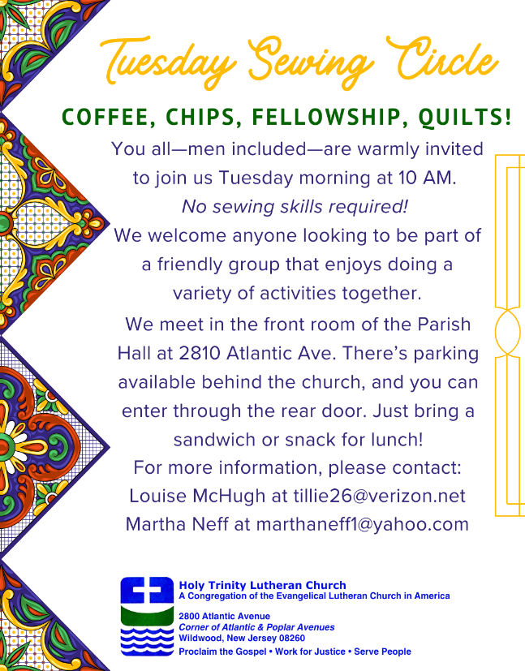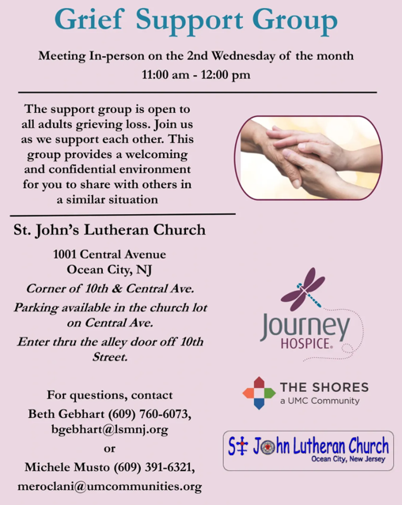

ST. BARNABAS CARES THRIFT STORE
Are you a person who enjoys staying active, interacting with others, likes the flexibility of working an hour or two per month and would like to support a good cause? If so, then St. Barnabas Cares Thrift Store is looking for you! The store in the Villas is looking for friendly, outgoing people to volunteer and sell clothing. There is no heavy lifting, but instead you would be arranging clothing attractively for sale. The Thrift Store is open 11-3 Monday through Saturday so even volunteering a few hours a month will help. If interested, please call Maureen Kersch 609-425-1317.

WHAT IS THE EVANGELICAL LUTHERAN CHURCH IN AMERICA?
The ELCA was formed in 1987 by the merger of three Lutheran Church bodies –
the ALC (American Lutheran Church), the LCA (Lutheran Church in America), and the AELC (Association of Evangelical Lutheran Churches). Learn more at elca.org.
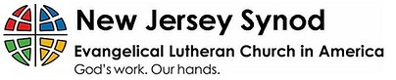
WHAT IS THE NEW JERSEY SYNOD?
The New Jersey Synod is a geographical grouping of Evangelical Lutheran Church in America (ELCA) congregations that share the mission and ministry of the Church on the New Jersey territory. It is one of 65 synods in the ELCA. The NJ Synod is comprised of 143 congregations, which include over 45,000 baptized members.

2025 FINANCIAL STANDING
OCTOBER INCOME | $10,356.00
OCTOBER SPENDING | $16,460.45
OCTOBER GAIN OR (LOSS) | ($6,104.45)
2025 INCOME | $54,214.38
2025 SPENDING | $68,708.32
2025 GAIN OR (LOSS) | ($14,493.94)
ED GREEN CAPITAL IMPROVEMENT FUND | ($546.45)
FOOD PANTRY FUND (SOCIAL MINISTRY) | $11,212.04
CD | $26,245.92
75TH ANNIVERSARY | $4,585.43

CHURCH STAFF & VOLUNTEERS
VICAR, BIBLE STUDY & FAITH DISCUSSIONS, NEWSLETTER, & WEBSITE
Vicar Vince Piekarski
VICE PASTOR
Pastor William Hodgetts
ORGANIST & PIANIST
Carol Amundsen
CHURCH OFFICE, SUNDAY SCHOOL, & FOOD PANTRY
Heather Piekarski
CHURCH COUNCIL PRESIDENT
Mary Melnicoff
CHURCH COUNCIL VICE PRESIDENT
Judy Brannan
CHURCH COUNCIL TREASURER
Bonnie Millard
CHURCH COUNCIL SECRETARY
Vicki Rinier
CHURCH PROPERTY
Frank Ford & Wayne Rand

