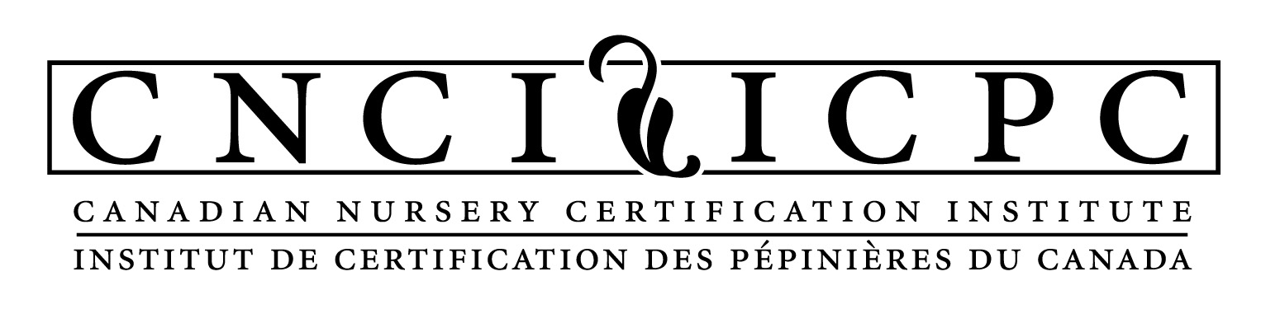

Application for Canadian Nurseries to Participate in the
‘Clean Plants’ Domestic Phytosanitary Nursery Certification Program

Company: _______________________________ Contact: __________________________________

Mailing Address: __________________________ Nursery Owner or GM: ______________________

City: _________________________ Prov:______ General Office Phone: ______________________

Postal Code: ________________ Contact’s Direct Line _______________________

Fax No.: ___________________ Lead Contact Email: ________________________

Certification is also requested for the following Pest Specific Modules (Optional):
 Phytophthora ramorum  Box Tree Moth
 C. buxicola

Nursery Site Location(s):

Address Size Nursery Stock Description
(container, fieldgrown, perennial etc)

- _______________________________________________________________________________

2.__________________________________________________________________________________

3.__________________________________________________________________________________

Conditions for Certification:

By signing this agreement, the facility agrees to follow the terms and conditions as provided on Page 2 of this document.

The fees payable upon application, and annually, are noted on Page 2 of the document.

I, __________________________________ the owner/operator in possession, care or control of the above named facility have read, understood and agree to comply with all terms, conditions, obligations, and requirements described in the Clean Plants Certification Standard and I hereby apply for the above named facility to become a Certified Clean Plants Facility.

Dated __________, 20____ at ___________________________, in the Province of _______________

Applicant Signature: _______________________________

Application and Annual Fees*:

Member Fees: For nurseries who are members of the provincial nursery association:

Category | Annual Sales | Certification Fee
Small | Up to $2 million | $ 250/year
Medium | $2 million to $5 million | $ 500/year
Large | Over $5 million | $ 1,000/year

Non-member Fees: For nurseries who are not members of the appropriate provincial nursery association:
Category | Annual Sales | Certification Fee
Single Operator | Up to $300,000 | $1,000 per year
Small | $300,000 - $600,000 | $1,400 per year
Medium | $600,000 - $2 million | $1,800 per year
Large | $2 million - $5 million | $2,500 per year
Other | $5 million + | $3,500 per year

Additional Fees:
Clean Plants Workshop DVD - $250 +HST/GST
This two-disc DVD package provides step-by-step instructions on the development and implementation of the Clean Plants domestic phytosanitary certification program, and completion of the Clean Plants certification manual. Staff are required to go through this training program.

Annual External Audits
Annual audits are also required for participating nurseries. Audit fees are in addition to the annual fees and will vary with the duration and expenses associated with the nursery.

Payment information:
Applications may be sent via mail, e-mail or fax.

Nursery Name:
Application Fee | $
DVD Quantity ( ___ x $250) | $
Subtotal | $
GST/HST | $
Total | $

Payment Method:  Cheque – Payable to the Canadian Nursery Certification Institute (CNCI)
 Credit Card – Visa or M/C only (below)
Credit Card Number: ___________________________ Exp: ___/___ CVV: ______
Cardholder Name: ________________________________________
Cardholder Signature: _____________________________________

QUESTIONS? Contact Edith Oyosoro, Program Administrator at the number below

*Applicable provincial taxes are in addition to the fees noted.

Conditions for Certification:

- The facility will develop, implement, document and maintain a Phytosanitary Management System (PMS) and a Pest Management Plan (PMP) that complies with the Clean Plants Domestic Phytosanitary Nursery Certification Program.
- The facility must develop and maintain a Clean Plants Manual that describes the PMS and the PMP in place at the facility. The nursery’s manual must be submitted to the Canadian Nursery Certification Institute (CNCI) for approval.
- The facility will ensure that all certified plant material meets the requirements of the Clean Plants program.
- The facility will pay all fees associated and applicable to the CNCI.
- The facility will immediately notify CNCI if a regulated pest is found.
- The facility will immediately stop shipping plants under Clean Plants if a regulated pest is found, or if the facility is suspended by the CNCI.
- The facility will immediately cease the use of their Clean Plants stamp on all documents and cease to market material as certified if they are suspended from the Clean Plants program.
- The facility will notify the CNCI within 14 days of any change in ownership of the facility.
- The name and address of Clean Plants certified domestic production facilities will be listed on the CNCI website. When a facility is suspended from the Clean Plants program, the facility will be removed from the list of Certified Nurseries until remediations are completed as required by CNCI.
- The facility assumes all liability, if any, arising from the movement and sale of plants from the facility which have been grown according to the Clean Plants program.
- Certification is also requested for the following Pest Specific Modules: :
Phytophthora ramorum
C. buxicola
Box Tree Moth

