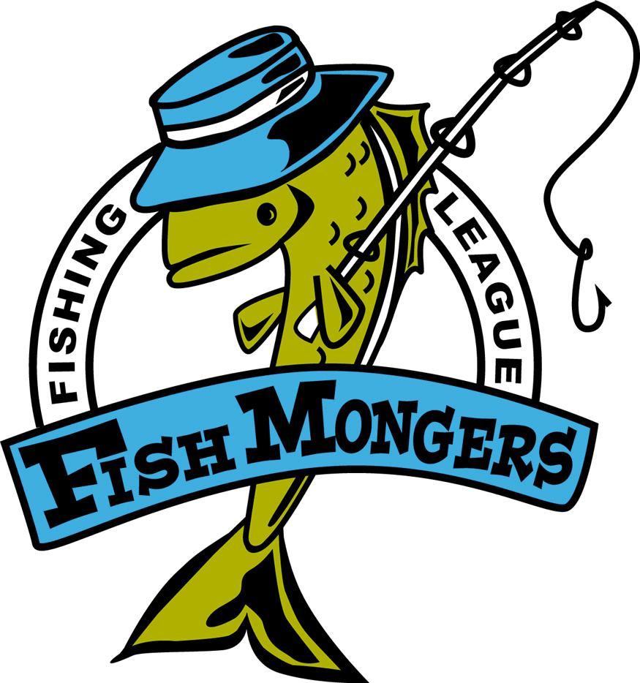
09/16/2010 Gull Final
Team | Skunk | Walleye  27.5 DR Whitefis | Northern  36.5 Jim/Alec | Black Bass  19.5 Jeff and Jim | Rock Bass  9.75 Mult | Weekly Points | Total Points
Chuck /  Dave |  | 20 |  | 17,13 |  | 10 | 52
Andy/Raguse |  | 15,15 | 24,22.75 | 14.5 |  | 12+6 | 48
Dan / Paul | NS |  |  |  |  | 0 | 39
Jeff/Bryan | XX |  |  |  |  | 0 | 38
Jim/Brett |  |  |  | 13,13 |  | 4 | 31
Johnson/ Lueck | NS |  |  |  |  | 0 | 21
Chris/Chris | XX |  |  |  |  | 0 | 2

$50 Gander cards to the big fish winners – nobody caught a Rockie bigger than 9.75 inch so no prize was given for that.

Total dollars collected was $600 - $150 = 450 with the winner getting 300, second getting 100 and third getting 50.

It was a low scoring year – Chuck and I proved that we do better if we don’t fish together and much better if we avoid Mille Lacs!

We will start again next year the 1st or 2nd Thursday after MN fishing opener and we will chose our lakes on that first day at Zorbaz.

Dave

